Communications:
The first step when running Lamtest is establishing communication with the Lambda series controller. For this there are two standard options for communications: USB port and serial (RS-232) port. All lambda series products operate with a default USB data rate of 128,000 bps(Bits per second or “baud’) , and a default serial port data rate of 9600bps. The USB data rate applies to both the USB implementation as well as the virtual com port (VCP). If you wish to run either the USB port or the virtual com port at an alternate data rate such as 9600bps than it is necessary to match this data rate on the Lambda controller as well.
To change the data rate on the LB10-3 go to local mode and press the <MODE> key twice. This will bring up a special menu where the USB data rate may be selected from a list, to access this menu on the LB1-B/IQ first press <F1> then <F2> to bring up this list. This option is not available on the LB-SC, there is however a firmware solution available for production serial numbers LBSC-2150 and above. This new firmware implements an auto baud detection scheme. Auto baud detection is only valid for 9600 and 128k baud. If you are communicating via 9600 baud it will be necessary to send the open com command (128 dec or EE hex) twice to establish communications.
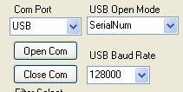
To open communications via the USB port once our driver is installed press the ‘Open Com’ button. This should open the USB port at the specified baud rate. To open communications via the serial port specify the port and press the ‘Open Com’ button. If you are unsure of which port the device is located press the ‘get Com Ports’ button and this should return a list of the available comports. Your device should be located on either COM1 or COM2. COM20 is a virtual com port. To select COM20 enter the value ‘COM20’ INTO THE ‘Com Port’ combo box. Remember that the USB baud rate in the device must match the USB baud rate in the ‘USB baud rate’ combo box; otherwise you will not be able to establish communications. Once communication has been established the dialog box below should say “USB: Is Open” followed by the config string from the device. In the example below that would be a “10-B” for the controller, the wheel ’W-‘ is a ‘25’mm filter wheel, and the shutter’s-‘ is a smart shutter ‘Q’.
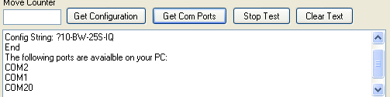
The above dialog box is very useful in tracking the progress of various commands as they are issued. These commands have been translated into a more user friendly format. If you wish to see the actual communications the Com String dialog box is useful.
**Both the LB10-2 and the DG4 / DG5 do not support the get status command. Nor do they echo a response after the ‘Go Online’ command. As a consequence if the program fails to get a response it will default to the presence of the LB10-2. SO if you see the dialog box indicate that the device is a LB10-2 open com again to establish communications. If you still get the response ‘LB10-2’ then serial communications has not been established.
Parallel communications:
The parallel port is primarily useful for the LB10-2 and DG-4 series. But it is here for diagnosing parallel port issues. To use the parallel port you must install the driver ‘INPOUT32.DLL’ in the Win32 system directory. This file can be found in the ‘Release’ folder. Simply copy and paste it to Win32 system directory so that windows can find it.
http://www.codeproject.com/Articles/15020/Reading-from-Parallel-Port-using-Inpout32-dll
Tracking your communications:
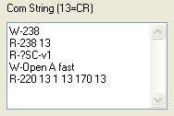
The “W” indicates the string written out. The return string designated with an “R”. All commands are echoed back. In the above example the ‘open shutter a fast’ routine was called. This routine consisted of the following commands ‘220’ =open fast <CR>1= shutter 1 <CR> 170= open shutter <CR>. This can be very useful for developing your own commands to control the Lambda or even just following the communications.
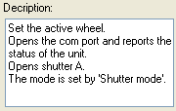
Another useful dialog box is the Description dialog box. Many of the text boxes and buttons will display their function when the cursor “hovers” over them. This can be very useful for a quick reference to the various functions.
Front Panel:
Once communications has been established you can send commands to your Lambda. The most straight forward way to test the movement of the filter wheel is simply to click one of the radio buttons.
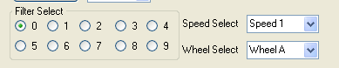
The home position of the Lambda is filter ‘0’ so by default this checkbox is selected, and the filter wheel will not move unless you select another filter position. The combo boxes above will dictate the speed of the filter move as we as the selected wheel, A, B, or C.
Shutter Tab:
To open one of the shutters simply click on the open / close radio buttons. The default mode is fast movement. In addition soft and neutral density modes can be selected. Values of 0-144 uSteps are valid neutral density values. It should be noted that there is a safety margin of approximately 20 uSteps on either end of travel so you can expect values of 20-120 to produce results with the greatest change in light output occurring in the middle range of travel.
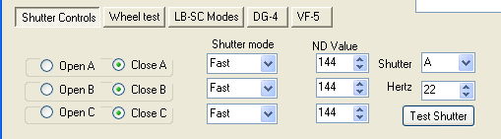
You will also notice a special “Test Button” to the right. This button is useful for testing the stability of the shutter running a certain number of cycles per second (Hertz). St approximately 20 Hertz there will be constructive and destructive harmonics which could hinder the proper operation of the shutter. For instance the top frequency of the 25mm shutter is 42 Hertz. It can run very reliably at this rate, if however you move a little slower at 38 hertz it will behave very poorly and erratically.
Wheel Test Tab:
The next tab “Wheel Test” has many useful test routines such as this. The first test “Test Wheel” is the production test. This test will run through the speeds “Top Speed” to “Last Speed”. The default top speed of the filter wheel is speed 1. Speed should not be used without a lightened wheel such as the 4 position wheel or a wheel loaded with Semrock’s thin filters. There are two factors to produce error free filter moves. One is the speed of the filter wheel; the other is the delay between the filter moves. As with the shutter there are constructive and destructive harmonics in the movement. These harmonics are dependent upon the load of the filter wheel which changes with the number of filters installed. This delay may be increased by a “Delay Multiplier” for the speeds marked in the check box, for instance in the example below the delay at speed 1 would be 120mSec. At speed 2 the delay multiplier would kick in and the new delay would be 120mSaec X 5= 600mSec. This can be useful for determining a good speed to move your filter wheel.
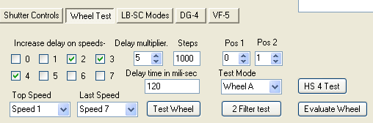
The production test employs a random position algorithm. If you are primarily interested in 2 filter moves such as between position 1 and position 2 then the 2 Filter Test . The HS 4 test is a special version of this test that names 2 specific filters to perform this test on. There is also a test to evaluate the wheel which will perform the random position test at increasing delays at increasing speeds. This can be useful in evaluating what speeds will work for you. The “Test Mode” combo box lest you choose which wheel to run the preceding tests on, batch mode for both the LB10-3 and the LB10-2 is available as well. In batch mode if an error occurs the test will do a follow up test to determine which wheel the caused the error.
LB-SC Modes Tab:
To access any of the “special modes” of the LB-SC you will have to use the LB-SC Modes tab. The default setting on the LB-SC is to open on TTL high. If you wish to change this setting you can opt to have the shutter open on a TTL low. In addition you can also open on a high or low transition. By opening on a transition the TTL can act like a toggle mode. For instance if you change the shutter state only on a high transition the shutter will open on low-high transition and close on the next transition. In addition the settings for the sync out pulse may be changed as well. The options for the sync out pulse are high on shutter open, low on shutter open, or disabled. Press the “Set TTL Modes” button to save the changes as the controller default.
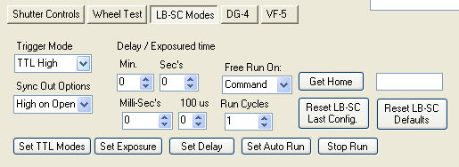
The second set of important features to be found on this tab involves the “Free Run Mode”. In the “Free Run Mode” there are three parameters that can be set, Exposure, Delay, and repeat cycles. If you want to set the shutter to open for 20ms after a Delay of 60ms you would first enter 20ms into the timer counters and the press “Set Exposure”. Next you would enter 60ms into the timer counters and then press “Set Delay”. The order of these two steps is irrelevant. This is a special case of the free run mode when either of these buttons is pressed the auto run mode is activated with a single cycle. We can also set repeated cycles by increasing the run cycles. Any number above 65,000 is considered to be continuous mode. Once the LB-SC is set in free run it will not respond to any commands until either the “Stop Run” button is pressed or the “Reset LB-SC Defaults” is pressed, If you just stopped auto run then the controller will revert to auto run mode on power on.
The last button “Get Home” is primarily of use when the shutter has become misaligned and needs realignment. There are some subtleties to correctly setting up the shutter so if you need to perform this procedure call Sutter and speak to a Technician.
DG4 Tab:
The functions specific to the DG-4 / DG-5 can be found in the DG-4 tab. The shutter is closed on power on. Since the shuttering is controlled by the internal mirrors a movement to any position effectively opens the shutter.
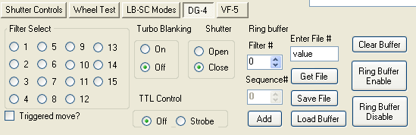
The first set of controls on the left simply move the DG-4 to the programmed filter position. The factory defaults for the DG-4 are 1-4 are filters 1-4 at 100% intensity, 5-8 are filters 1-4 at 66% intensity, and lastly filter values 9-12 are filters 1-4 at 33% intensity. The values programmed into the DG-5 follow a similar pattern where values 1-5 are at 100% intensity, 6-10 are at 66%, and 11-15 are at 33% intensity. By default these moves are performed once a radio button is selected. You can also opt to have a trigger initiate the movement.
BY default the turbo blanking mode is off. What this means is that both internal switching mirrors will switch simultaneously for the fastest switching time. This may produce a brief pulse of unfiltered light. To avoid this occurrence turbo blanking can be switched on, and one mirror will shutter the other during movement producing a ‘clean’ filter switch.
The next series of buttons deal with the ring buffer. To achieve the absolute fasted filter switching the filter values are preloaded into a buffer. This buffer sequence can then triggered using the strobe input. Each strobe pulse will increment through the ring buffer sequentially. The ring buffer can be programmed into the DG-4 using this utility. In addition the ring buffer sequence can be saved or retrieved from a file. Lastly the ring buffer can be enabled, disabled or cleared from this tab.
VF-5 Tab:
The last Tab if for the new Versa Chrome filter wheel is the VF-5 tab. In many respects the VF-5 is similar to a monochromatic. The VF-5 employs 5 variable filters covering from 60-100 nanometers in wavelength. The initial or base value of the filter is at zero degrees of tilt. The rage of each filter is variable and based upon the base value, the shorter the wavelength the narrower the spectrum of the variable filter.
Filter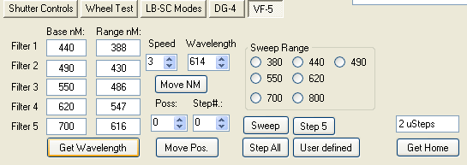
To determine which filters are in place it first necessary to store the value into the VF-5. In most cases the VF-5 will come preprogrammed at the factory. To get the setup using this utility, press the Get Wavelength button. This will populate the filter fields with the base value of the filter. The range is calculated based upon the specifications of the filter. There is some overlap in the range. The VF-5 will resolve these discrepancies internally and move to the optimal filter and angle for the wavelength. To move to the desired enter the wavelength and the tilt speed and press the “Move NM” button. Zero is the fastest speed and can cause considerable vibration at long moves so by default the speed value is set to “3” for a smooth transition. You can also opt to move to a specific position and angle using the “Move Pos.” button. There is a look up table that should tell you the expected wavelength based upon the filter bas e value and angular tilt. Lastly there are some built in routines that will sweep through a filter one in one wavelength increments or you may opt to step through all 5 filters one wavelength at a time. These routines are primarily used for testing as is the get home button.

