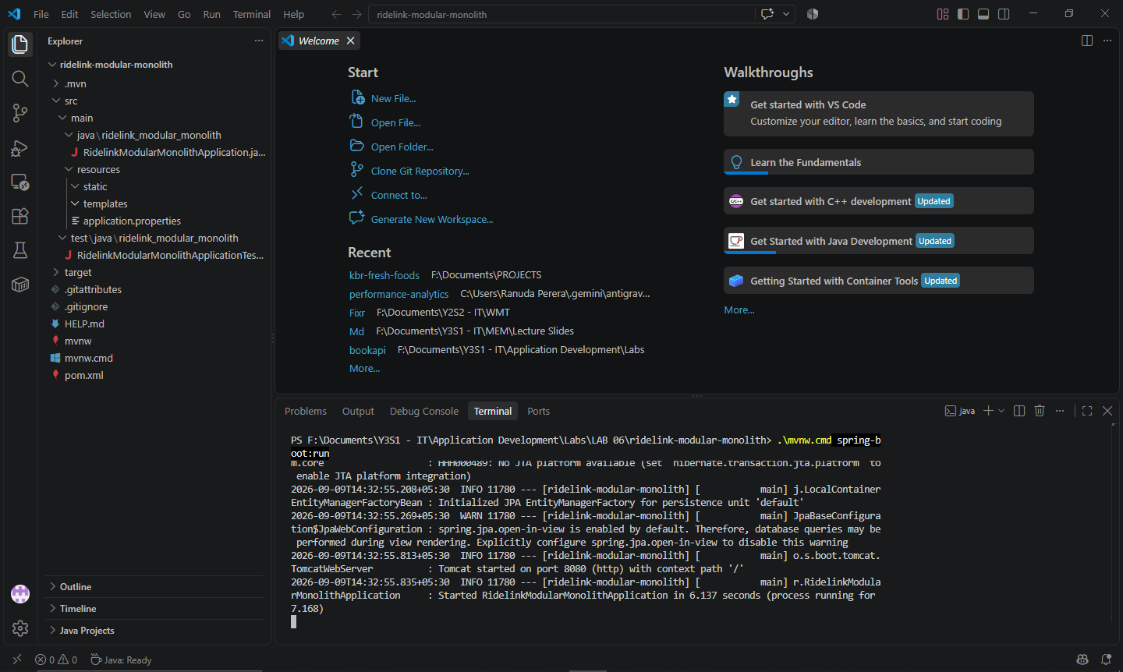

Two drivers created:
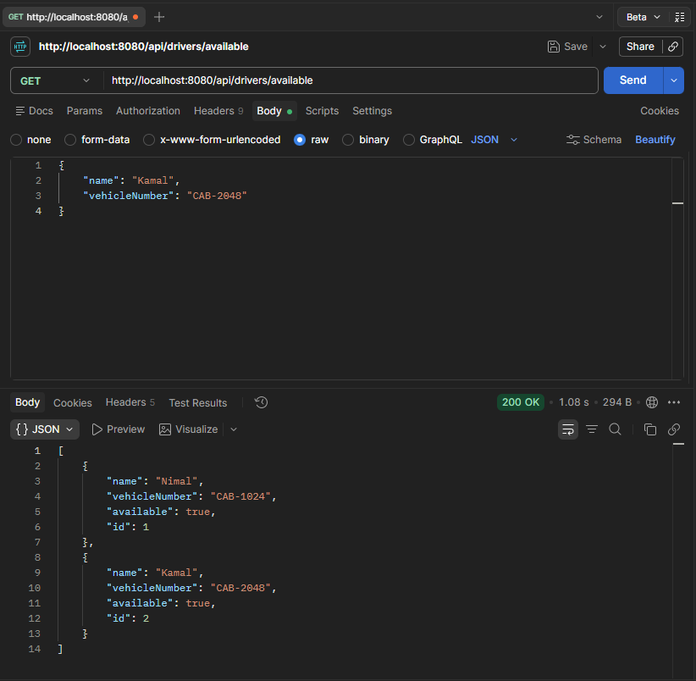

Ride assigned:
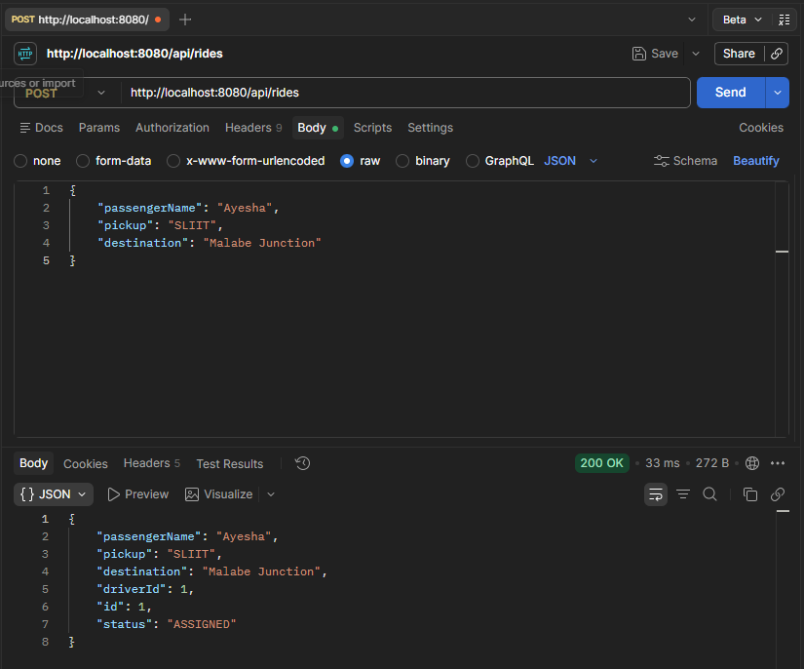

Assigned driver unavailable:
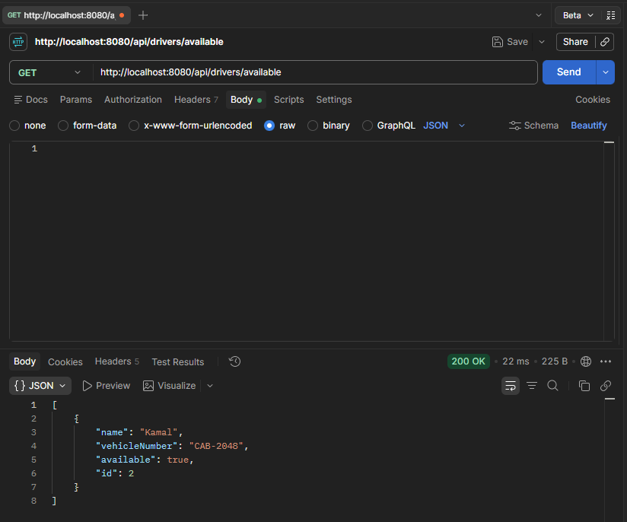

Ride completed:
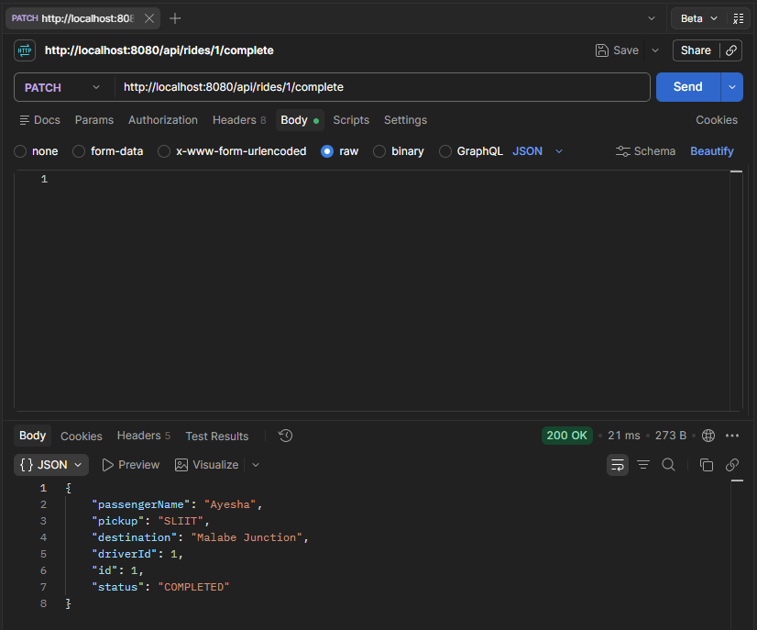

Driver available again:
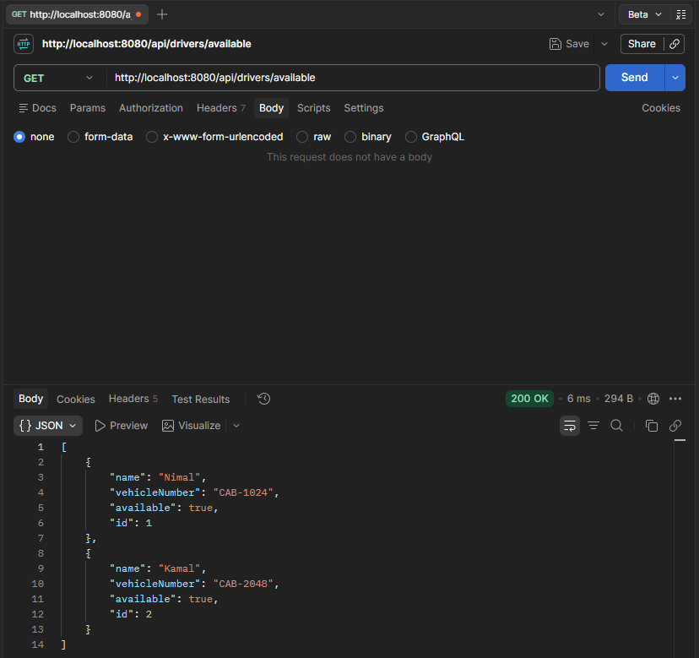

Making both drivers unavailable:
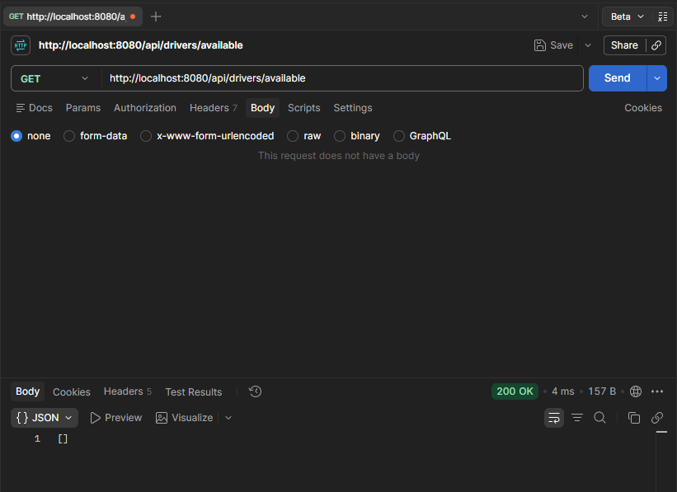

Questions
- Draw or describe the request flow for POST /api/rides using controller → service → repository responsibilities.
Postman
↓
RideController
↓
RideService
↓
DriverRepository → Find available driver
↓
RideRepository → Save ride
↓
Response to Postman

- Why is driver assignment placed in RideService rather than RideController?
Driver assignment is a business rule so it belongs in the service layer.

- Why is this solution both layered and monolithic?
It is layered because the application separates responsibilities into:
- Controller - handles HTTP requests
- Service - handles business logic
- Repository - handles database operations
- Model - represents the data
It is monolithic because Driver and Ride are part of one Spring Boot application and one deployment.

- What makes the solution a modular monolith rather than a Big Ball of Mud?
Because Driver and Ride are kept in separate modules with clear responsibilities.

- What response does your API return when no driver is available? Explain why it is suitable.
The API should return a 409 or 422 error because the ride cannot be assigned when no driver is available.
- Name one change that would be easier because Driver and Ride are separated into modules.
We can change the Driver module without changing most of the Ride module.

