Test 1 - /public
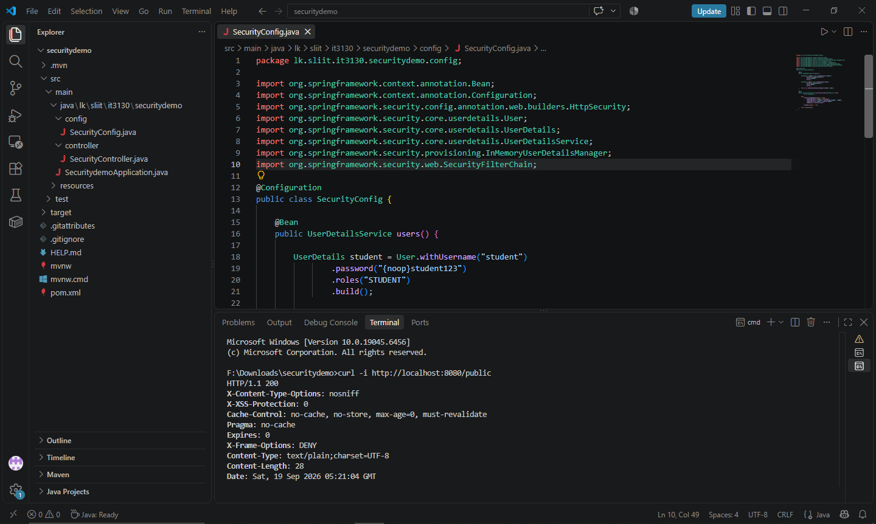
Test 2 - /student without login
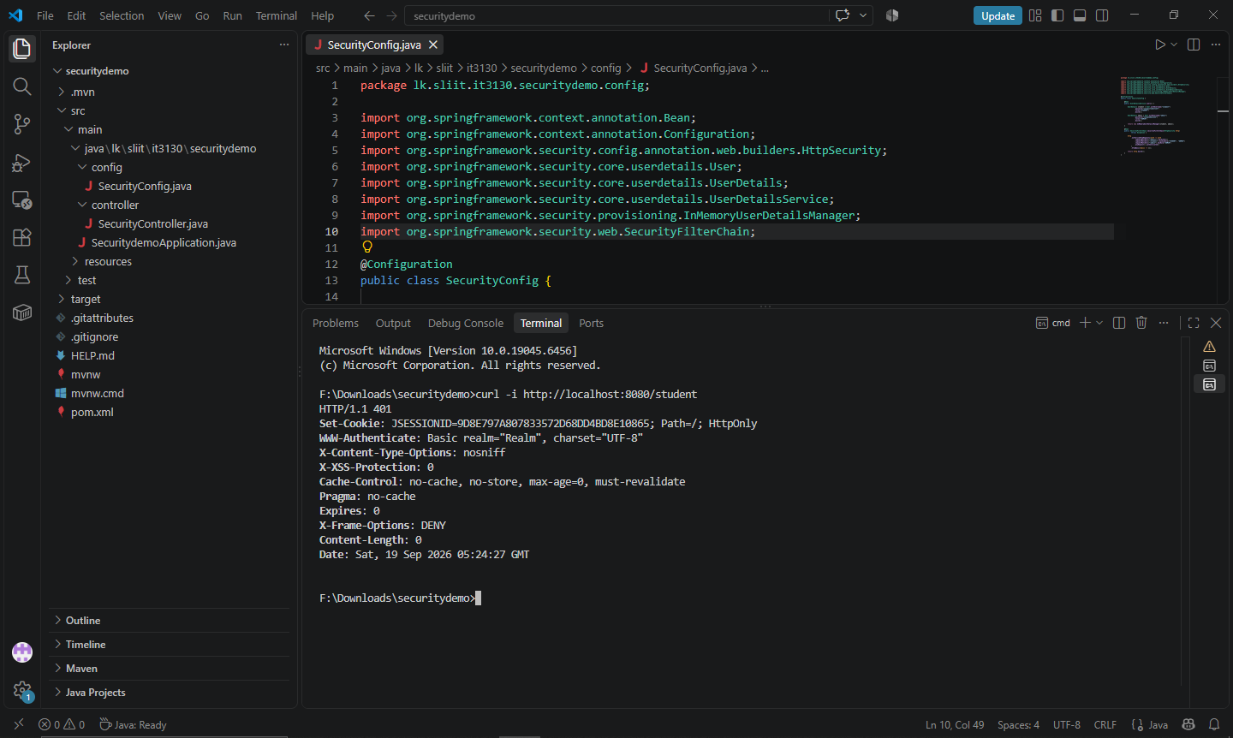
Test 3 - Student accessing /student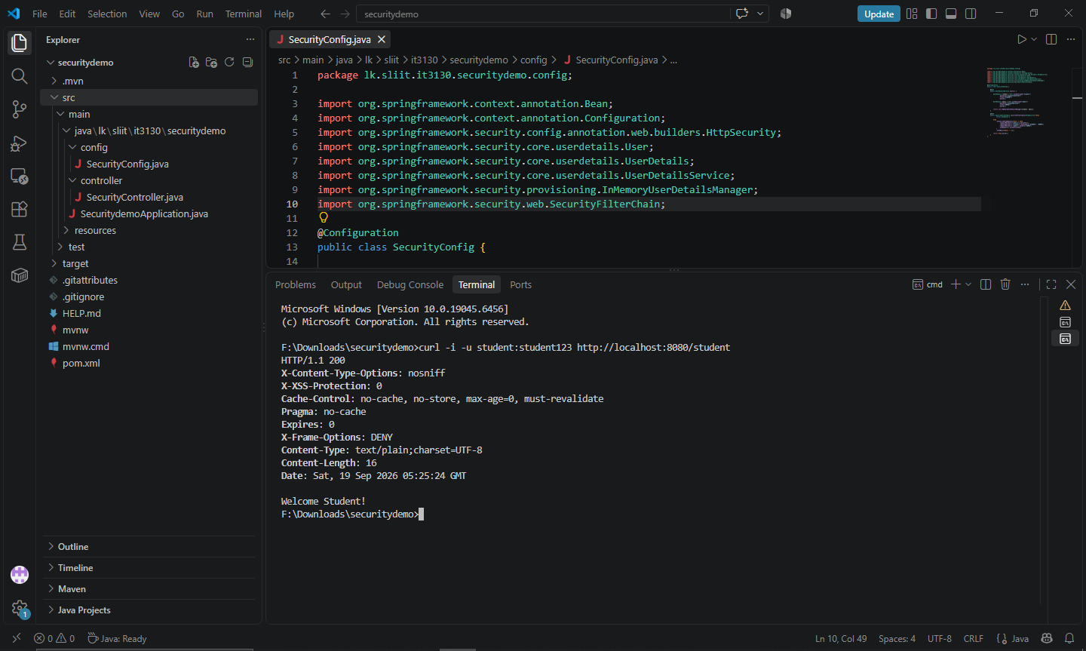

Test 4 - Student accessing /admin
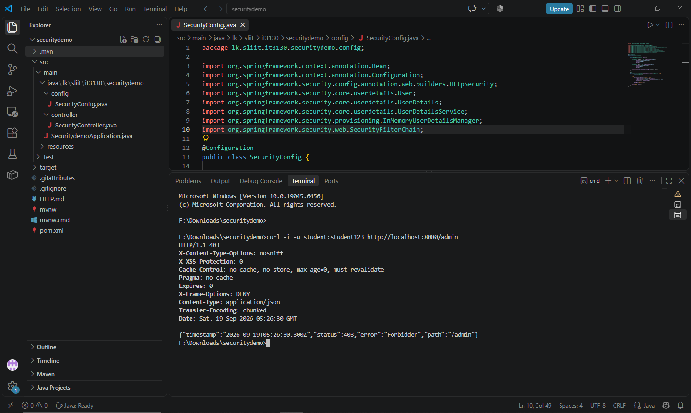
Test 5 - Admin accessing /admin
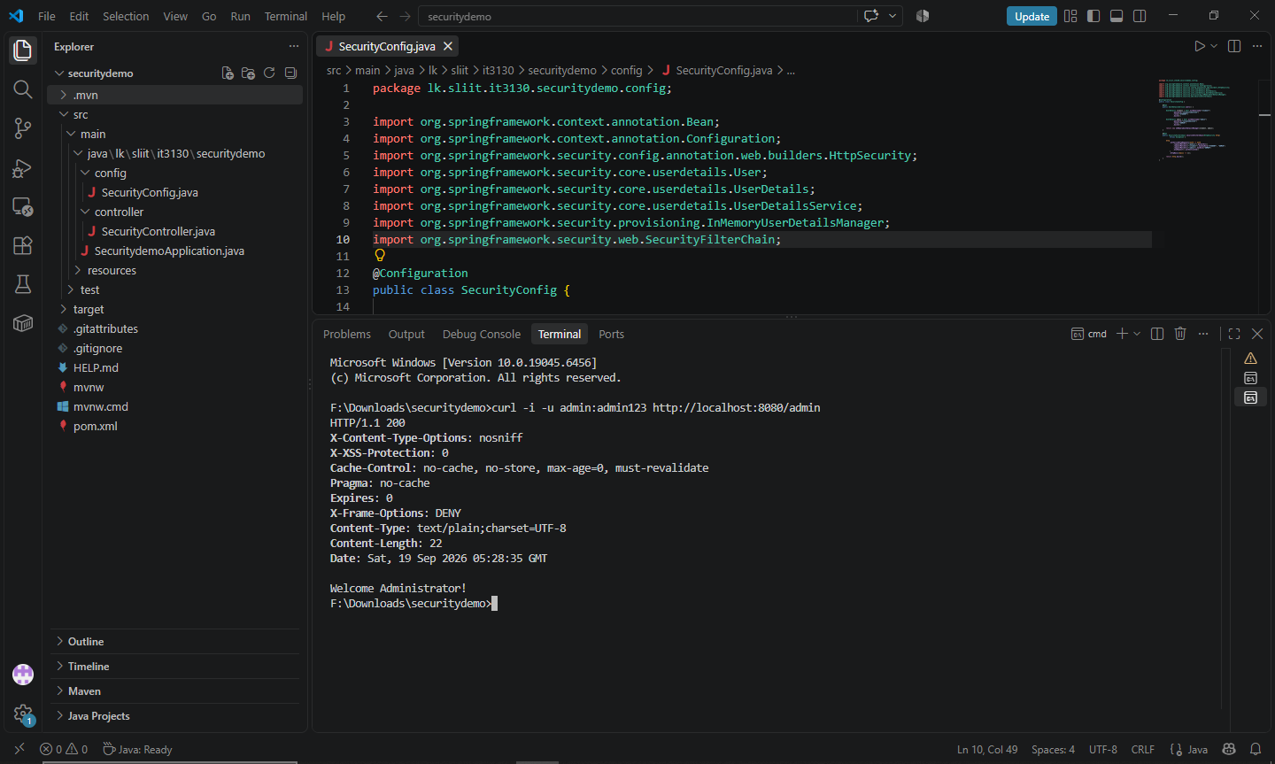

Request | Credentials | Expected HTTP status/ Results
/public | None | 200 OK
/student | None | 401 Unauthorized
/student | student / student123 | 200 OK
/admin | student / student123 | 403 Forbidden
/admin | admin / admin123 | 200 OK

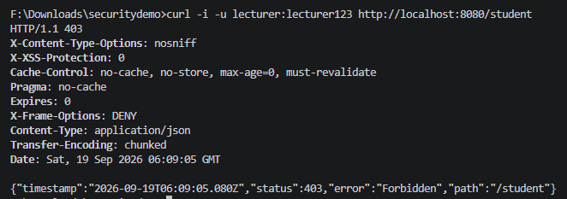
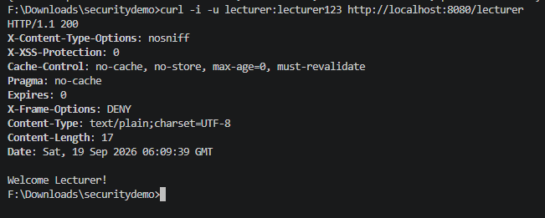
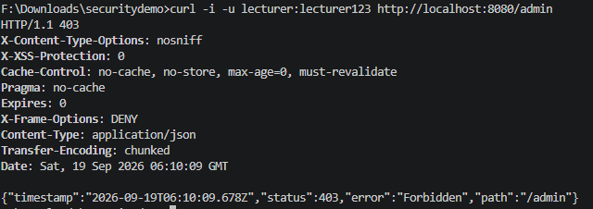

OAuth Observation Questions
- Did the OAuth Playground receive or display your Google password?
No.

- Which party performed the actual login/authentication?
The Google provider performed the actual login/authentication.

- What was produced after the authorization/consent step?
An authorization code

- What token was produced after the authorization code was exchanged?
An access token was produced.

- Why is an access token preferable to giving a third-party application your account password?
An access token allows limited delegated access without giving the third-party application the user's password.

Quick Review Questions
1. What is authentication?
Authentication is the process of checking who the user is, such as checking a username and password.
2. What is authorization?
Authorization determines what the authenticated user is allowed to access or do.
3. Can an authenticated user still be denied access? Explain.
Yes. A user can be authenticated but still denied access if their role does not have permission for that resource. For example, a STUDENT can be authenticated but cannot access /admin.
4. What is the practical difference between HTTP 401 and HTTP 403?
- 401 Unauthorized: The request has not been successfully authenticated.
- 403 Forbidden: The user is authenticated but does not have the required permission or role.
5. What is the purpose of an OAuth access token?
An OAuth access token allows an application to access a protected resource on behalf of the user after authorization.
6. Why should an application never ask for your Google/Microsoft/GitHub password in order to obtain delegated access?
Because OAuth allows the application to obtain limited delegated access without receiving the user's password.

