Maxbupa Health Insurance Ltd.

19
Infinity API
Integration Rule


Table of Contents
I. Member Push 3
a. URL 3
b. Header Values 3
c. Request Parameters 3
d. Response Results 3
II. Download COI 4
a. URL 4
b. Request Parameters 4
c. Response Result 4

User Authentication and Token Generation
URL https://instasaral.nivabupa.com/bfl/IntegrationServices/api/Authentication/Login
Request Type “POST”
Request Body
{"UserName": "bfl","Password": "bfl@2019"}
Response
{
"Code": "200",
"Message": "Token generated successfully",
"Status": "success",
"Data": " ed522c0c-2b87-4774-bab1-4d0984d084c8"
}

Member Push
URL https://instasaral.nivabupa.com/bfl/IntegrationServices/api/IntegrationServices/PushMembers
Request Type “POST”
Request Header {“token”:” e06f5a0b-2852-451b-8033-d9803bade94e”} – received from authentication service
Request Parameter Body attached parameters
Response
{
"Code": "200",
"Message": "Successfully saved.",
"Status": "success",
"Data": " 172000024249"
}

Success Response Screen

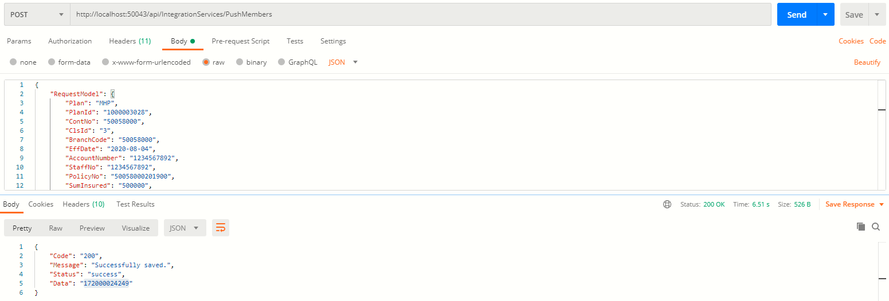

Error Response
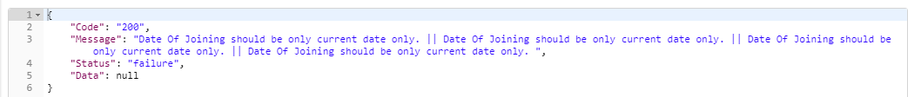

Download COI
URL https://instasaral.nivabupa.com/InfinityServices/coiservices/api/COIService/DownloadEncryptedCOI?coiNumber=xxxxx&dob=dd-mm-yyyy
Request Type “GET”
Response Result
COI Letter will download in pdf format as response.
Herewith attaching Screen for your reference with request data parameters:
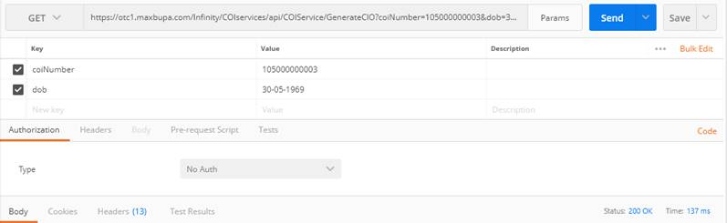

coiNumber : xxxxxxxxx (COI number will be provided here which has been received at the time of pushing member), dob: dd-mm-yyyy

