Lab 4 Behavioral Report
Student Name: Richard Magdaluyo
Student ID: 45993793
Date Completed: 02/27/18
Time Spent: Reviewing Digital Design Material: 1
Design/Preparation Work: 2
VHDL Coding & Debugging: 3

Behavioral Overview
I feel that I’ve completed 100% of the lab since the outputs produced in the test bench work properly (as checked by assertions). The values for the Result matrix used to check if the contents of OutBlock are correct were obtained using an online matrix multiplication calculator (http://matrix.reshish.com/). The behavioral code was mostly obtained from the PDF/video under IP Concepts in the resources for Lab 3/4. All other parts of the code were written with information from the lecture and the lab, with the main difficulty was ensuring that Dout is let out at the right time (when Done is ‘1’) and the timing of the operations are correct.

Lab 4 FSMD
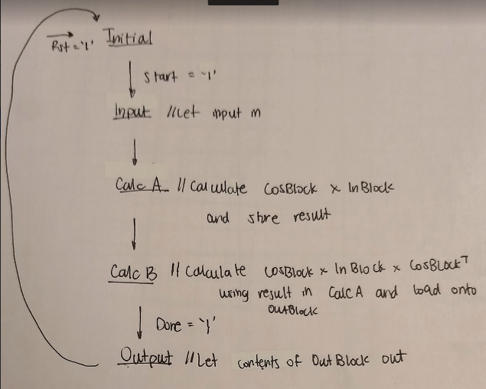

Lab 4 Computation Clock Cycles
Total clock cycles to perform “computation” portion of circuit (Figure 2): 128
Give a brief overview of what happens in each clock cycle.
For the first 64 cycles, COSBlock x InBlock is calculated by multiplying the corresponding “slots” on each matrix using the current values of the two for-loops and each is stored in a slot in the TempBlock. In the next 64, the values stored in TempBlock is multiplied by the values from the COSBlockT matrix which is the transpose of the COSBlock matrix. Similar to the first process, each slot of OutBlock is filled in with COSBlock x InBlock x COSBlockT in each clock cycle.

Lab 4 Behavioral Simulation Graph
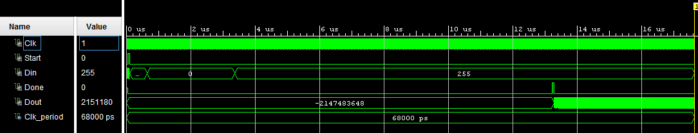
Here are some results outputted after Done is ‘1’
