Lab 3 Behavioral Report
Student Name: Richard Magdaluyo
Student ID: 45993793
Date Completed: 02/13/2018
Time Spent: Reviewing Digital Design Material: 15mins
Design/Preparation Work: 1hr
VHDL Coding & Debugging: 4hrs

Behavioral Overview
Replace this text w/ the % you feel you completed the lab. Be sure to list your general procedure of how you completed this lab & material (if any) you reviewed to help you complete this lab. Regardless of % stated, provide any details of difficulties (if any) you encountered during this lab. A few sentences are sufficient.
I feel that I’ve completed 100% of the behavioral portion of the lab since my code runs perfectly fine and produces the expected output for location. I started off with designing the FSM as shown in the lab, though I did not create one that would work for the structural since the behavioral doesn’t need as many states to perform operations. I then decided to simply use four states in the behavioral: Initial (start state), CountA (calculating 1/2at²), CountB (calculating the total for Loc) and Final (setting Loc to the total stored in regArray, letting the output through, and setting Done equal to ‘1’). In test bench, I had 3 test cases, one for when Start is0 (seeing if the CurrState stays at the Initial state as designed), one where Start = ‘1’ and letting the program run through the whole FSM, and finally one where Rst = ‘1’ some time while the program is processing the FSM.

Lab 3 FSMD
Show your FSMD for Lab 3 here. You can use Visio, another UML Diagramming tool, or attach a picture of your FSM as long as it is legible. Be sure to show what computations you want to complete in each step of your FSMD for your behavior.
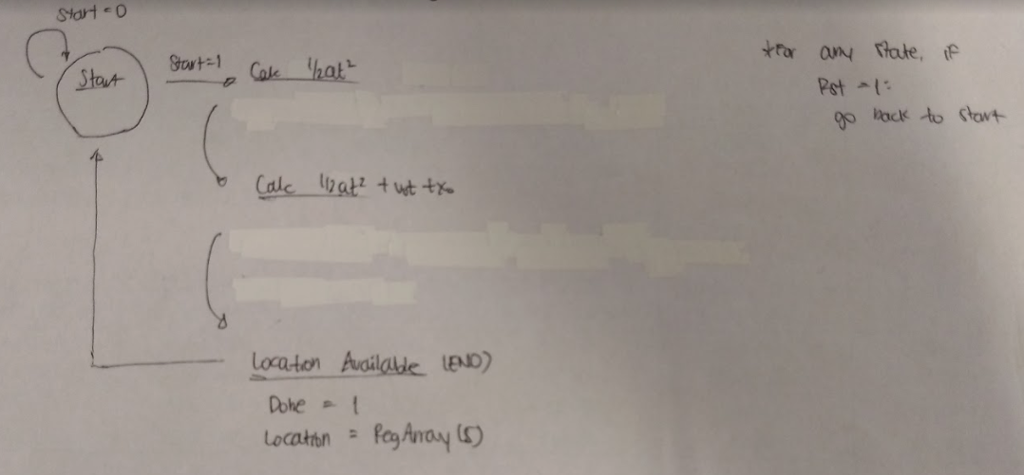

Lab 3 Behavioral Simulation Graph
Show a screenshot of your final graph here. You should crop it to the appropriate size so that it is legible.
