Lab 3 Structural Report
Academic Integrity (more info @ https://aisc.uci.edu/): You are encouraged to discuss the labs at a high level, but the code/equations/simulations you come up with should be your own. By typing “yes” at the end of this question and filling in your name, you certify that the work you are turning in is your own work. Is the work you are turning in your own? ___
If you worked on any portion of your report or vhdl code with other students (discussion at high level & debugging; if more, please describe), please list their names here: ____
Student Name: Richard Magdaluyo
Student ID: 45993793
Date Completed: Date you finished this portion of the lab
Time Spent: Reviewing Digital Design Material:
Design/Preparation Work:
VHDL Coding & Debugging:

Structural Overview
Replace this text w/ the % you feel you completed the lab. Be sure to list your general procedure of how you completed this lab & material (if any) you reviewed to help you complete this lab. Regardless of % stated, provide any details of difficulties (if any) you encountered during this lab. A few sentences are sufficient.
I feel that I have completed 95% of the lab since my code runs perfectly fine and produces the correct output at the right times (in accordance with the statements in the testbench). One thing

Lab 3 FSMD & Control Word Table
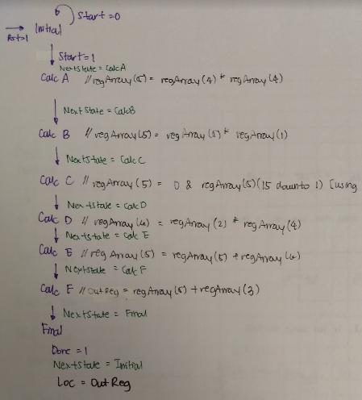
Compared to the FSMD I used for behavioral, this FSMD has more states since we are working with a datapath that has clocked components that can only perform certain operations per clock cycle, particularly the ALU. For example, in behavioral is was possible to add three things at once, however here the ALU only has two inputs therefore adding the three terms requires at least two clock cycles.
Show your control word table for your design here.
State Name/Operation | RegFile |  |  |  |  |  | ALU | Shifter | Selector | OutReg |  | TriStateBuff | Done
State Name/Operation | Rst | R_en | R_Addr1 | R_Addr2 | W_en | W_Addr | Sel | Sel | Sel | Rst | Ld | Oe | Done
Initial | 0 | 0 | 000 | 000 | 0 | 000 | 0 | 0 | 0 | 0 | 0 | 0 | 0
Calc A (t²⁾ | 0 | 1 | 100 | 100 | 1 | 101 | 1 | x | 1 | 0 | 0 | 0 | 0
Calc B (at²) | 0 | 1 | 001 | 101 | 1 | 101 | 1 | x | 1 | 0 | 0 | 0 | 0
Calc C (1/2at²) | 0 | 1 | 000 | 101 | 1 | 101 | 0 | 0 | 0 | 0 | 0 | 0 | 0
Calc D (v₀t) | 0 | 1 | 010 | 100 | 1 | 110 | 1 | x | 1 | 0 | 0 | 0 | 0
Calc E (1/2at² + v₀t) | 0 | 1 | 101 | 110 | 1 | 101 | 0 | x | 1 | 0 | 0 | 0 | 0
Calc F (1/2at² + v₀t + x₀₎ | 0 | 1 | 101 | 000 | 0 | xxx | 0 | x | 1 | 0 | 1 | 0 | 0
Final | x | x | x | x | x | x | x | x | x | x | x | 1 | 1

Lab 3 Minimum Clock Cycle
Minimum clock cyle: 37ns
Calculating the longest clock-to-clock path:
StateReg (4ns) → CombLogic (11ns) → RegFile[Read] (6ns) → ALU (12ns) → Selector (3ns) → OutReg (+1ns for setup time) = 37ns.

Lab 3 Structural Simulation Graph
Show a screenshot of your final graph here. You should crop it to the appropriate size so that it is legible.
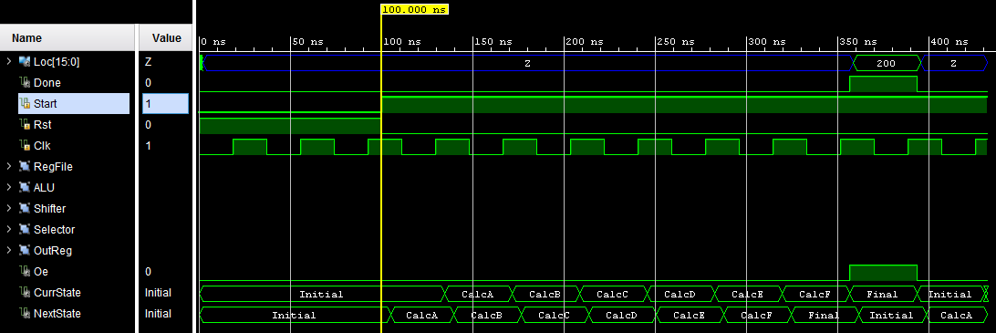

Lab 3 Structural and Behavioral Simulation Graph Comparisons
Compare your behavioral & structural graphs here. If there are any differences (delays, outputs, etc.), be sure to explain them here.
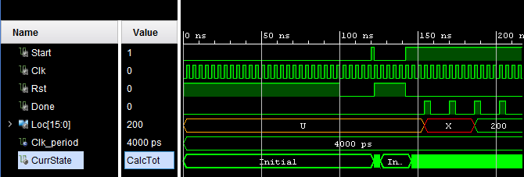
The waveform for my structural is very different from the waveform for my final. One of the major differences is the fact that I arbitrarily set my clock cycle to 4ns in the code for my behavioral since there were no components with delays in that program.

