Lab 1 Behavioral Report
Academic Integrity (more info @ https://aisc.uci.edu/): You are encouraged to discuss the labs at a high level, but the code/equations/simulations you come up with should be your own. By typing “yes” at the end of this question and filling in your name, you certify that the work you are turning in is your own work. Is the work you are turning in your own? ___
If you worked on any portion of your report or vhdl code with other students (discussion at high level & debugging; if more, please describe), please list their names here: Kevin Zhu, Alexis Moreno, Taleen Sarkissian, Travis Ao
Student Name: Richard Magdaluyo
Student ID: 45993793
Date Completed: 12 Jan, 2018
Time Spent: Reviewing Digital Design Material:
Design/Preparation Work:
VHDL Coding & Debugging:

Behavioral Overview
Replace this text w/ the % you feel you completed the lab. Be sure to list your general procedure of how you completed this lab & material (if any) you reviewed to help you complete this lab. Regardless of % stated, provide any details of difficulties (if any) you encountered during this lab. A few sentences are sufficient.

Lab 1 Truth Table
Provide your truth table for Lab 1 here. You can create a table in Word, Excel, or attach a picture of your truth table as long as it is legible.
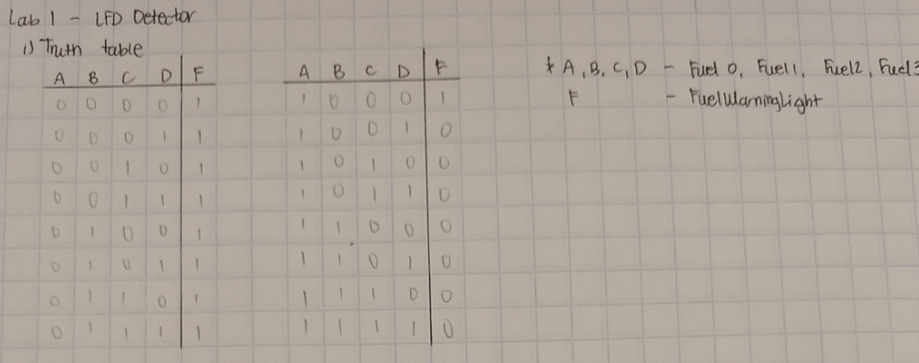

Lab 1 Minimized Equation
Show the work you did to go from the truth table to your minimized equation here. Don’t show your NAND/NOR/etc. conversions here, just the minimized Boolean equation that satisfies the requirements of the lab.
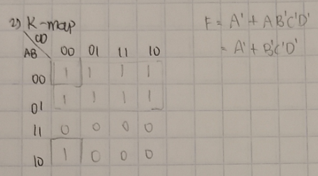

Lab 1 Estimated Delay
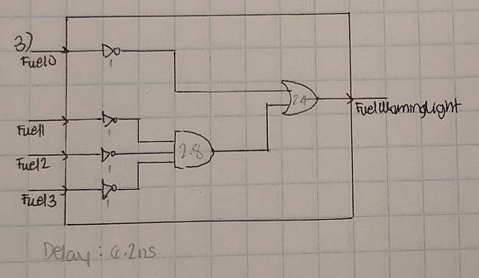
List your estimated delay here (you are not required to add the delay to the actual VHDL code for behavioral): 6.2 ns
- On paper, most significant bit was Fuel0.

Lab 1 Behavioral Simulation Graph
Show a screenshot of your final graph here. You should crop it to the appropriate size so that it is legible.
