Lab 2 Structural Report
Academic Integrity (more info @ https://aisc.uci.edu/): You are encouraged to discuss the labs at a high level, but the code/equations/simulations you come up with should be your own. By typing “yes” at the end of this question and filling in your name, you certify that the work you are turning in is your own work. Is the work you are turning in your own? ___
If you worked on any portion of your report or vhdl code with other students (discussion at high level & debugging; if more, please describe), please list their names here: Alexis Romero
Student Name: Richard Magdaluyo
Student ID: 45993793
Date Completed: Date you finished this portion of the lab
Time Spent: Reviewing Digital Design Material: 30mins
Design/Preparation Work: 5 hours
VHDL Coding & Debugging: 4 hours

Structural Overview
Replace this text w/ the % you feel you completed the lab. Be sure to list your general procedure of how you completed this lab & material (if any) you reviewed to help you complete this lab. Regardless of % stated, provide any details of difficulties (if any) you encountered during this lab. A few sentences are sufficient.
I feel that I’ve completed 80% of the lab since I was able to correctly encode all the states in my FSM and create a logical truth table for all the possible next states for each current state, as well as the corresponding outputs for each state. I attempted to use one-hot encoding for each state such that some of the state encodings only change by one bit when going from one state to the next (this is true for the transitions from RCV states to their corresponding Total states). I began the lab with ensuring that my behavioral program works and rewriting my FSM as necessary to fit the changes made in the code. From there, I created a truth table, using 4 bits to encode the 10 states in the FSM. For each state, I listed all the possible next states based on the FSM, the outputs for that state, and the necessary Inputs to go to each listed next state. I didn’t/couldn’t reduce the number of states I had since each one had unique next states for each input and no two states produced the same output and next state given the same input. Since the next state equations for each bit had 7 variables, I did not use a 128-box K-map to attempt an optimization, I simply coded them into Vivado. For The outputs, Permit and RetunChange, I was able to do simple Boolean algebra to reduce them into one minterm each. I used the same test cases as the one in behavioral, only changing the delay times to account for the changes in how the data is processed in this program. Finally, I attempted to make some adjustments to account for the wrong waveform when testing the code (fixing/modifying the delays), however it seems that my problem could be beyond simply ensuring that the delays are accurate, and I couldn’t successfully check the insanely long next state equations for errors.

Lab 2 Truth Table(s)

CurrState |  | Input  (I2|I1|I0) | NextState |  | Output  (Permit|ReturnChange)
Name | Q3Q2Q1Q0 | Input  (I2|I1|I0) | Name | Q3Q2Q1Q0 | Output  (Permit|ReturnChange)
Start | 0000 | 001 | FiveRCV | 0001 | 00
Start | 0000 | 010 | TenRCV | 0010 | 00
Start | 0000 | 100 | TwentyTotal | 0100 | 00
Start | 0000 | 000 | Start | 0000 | 00
FiveRCV | 0001 | 000 | FiveTotal | 0011 | 00
FiveRCV | 0001 | 001 | FiveRCV | 0001 | 00
FiveRCV | 0001 | 010 | FiveRCV | 0001 | 00
FiveRCV | 0001 | 100 | FiveRCV | 0001 | 00
FiveRCV | 0001 | 111 | FiveRCV | 0001 | 00
FiveTotal | 0011 | 000 | FiveTotal | 0011 | 00
FiveTotal | 0011 | 001 | TenRCV | 0010 | 00
FiveTotal | 0011 | 010 | FifteenRCV | 0111 | 00
FiveTotal | 0011 | 100 | OverTwentyTotal | 1100 | 00
FiveTotal | 0011 | 111 | Cancel | 1101 | 00
TenRCV | 0010 | 000 | TenTotal | 0110 | 00
TenRCV | 0010 | 001 | TenRCV | 0010 | 00
TenRCV | 0010 | 010 | TenRCV | 0010 | 00
TenRCV | 0010 | 100 | TenRCV | 0010 | 00
TenRCV | 0010 | 111 | TenRCV | 0010 | 00
TenTotal | 0110 | 000 | TenTotal | 0110 | 00
TenTotal | 0110 | 001 | FifteenRCV | 0111 | 00
TenTotal | 0110 | 010 | TwentyTotal | 0100 | 00
TenTotal | 0110 | 100 | OverTwentyTotal | 1100 | 00
TenTotal | 0110 | 111 | Cancel | 1101 | 00
FifteenRCV | 0111 | 000 | FifteenTotal |  | 00
FifteenRCV | 0111 | 001 | FifteenRCV | 0111 | 00
FifteenRCV | 0111 | 010 | FifteenRCV | 0111 | 00
FifteenRCV | 0111 | 100 | FifteenRCV | 0111 | 00
FifteenRCV | 0111 | 111 | FifteenRCV | 0111 | 00
FifteenTotal | 0101 | 000 | FifteenTotal | 0101 | 00
FifteenTotal | 0101 | 001 | TwentyTotal | 0100 | 00
FifteenTotal | 0101 | 010 | OverTwentyTotal | 1100 | 00
FifteenTotal | 0101 | 100 | OverTwentyTotal | 1100 | 00
FifteenTotal | 0101 | 111 | Cancel | 1101 | 00
TwentyTotal | 0100 | xxx | Start | 0000 | 10
OverTwentyTotal | 1100 | xxx | Start | 0000 | 11
Cancel | 1101 | xxx | Start | 0000 | 01

Lab 2 Final Equations
Permit = Q2Q1’Q0’
ReturnChange = Q3Q2Q1’
NextState3 = Q3‘Q2’Q1Q0I2I1’I0’ + Q3‘Q2’Q1Q0I2I1I0 + Q3‘Q2Q1Q0’I2I1’I0’ + Q3‘Q2Q1Q0’I2I1I0 + Q3’Q2Q1’Q0I2’I1I0’ + Q3’Q2Q1’Q0I2I1’I0’ + Q3‘Q2Q1’Q0I2I1I0
NextState2 = Q3’Q2’Q1’Q0’I2I1’I0’ + Q3’Q2’Q1Q0I2’I1I0’ + Q3’Q2’Q1Q0I2I1’I0’ + Q3’Q2’Q1Q0I2I1I0 + Q3’Q2’Q1Q0’I2’I1’I0’ + Q3’Q2Q1Q0’I2’I1’I0’ + Q3’Q2Q1Q0’I2’I1’I0 + Q3’Q2Q1Q0’I2’I1I0’ + Q3’Q2Q1Q0’I2I1’I0’ + Q3’Q2Q1Q0’I2I1I0 + Q3’Q2Q1Q0I2’I1’I0’ + Q3’Q2Q1Q0I2’I1’I0 + Q3’Q2Q1Q0I2’I1I0’ + Q3’Q2Q1Q0I2I1’I0’ + Q3’Q2Q1Q0I2I1I0 + Q3’Q2Q1’Q0I2’I1’I0’ + Q3’Q2Q1’Q0I2’I1’I0 + Q3’Q2Q1’Q0I2’I1I0’ + Q3’Q2Q1’Q0I2I1’I0’ + Q3’Q2Q1’Q0I2I1I0
NextState1 = Q3’Q2’Q1’Q0’I2’I1I0’ + Q3’Q2’Q1’Q0I2’I1’I0’ + Q3’Q2’Q1Q0I2’I1’I0’ + Q3’Q2’Q1Q0I2’I1’I0 + Q3’Q2’Q1Q0I2’I1I0’ + Q3’Q2’Q1Q0’I2’I1’I0’ + Q3’Q2’Q1Q0’I2’I1’I0 + Q3’Q2’Q1Q0’I2’I1I0’ + Q3’Q2’Q1Q0’I2I1’I0’ + Q3’Q2’Q1Q0’I2I1I0 + Q3’Q2Q1Q0’I2’I1’I0’ + Q3’Q2Q1Q0’I2’I1’I0 + Q3’Q2Q1Q0I2’I1’I0’ + Q3’Q2Q1Q0I2’I1I0’ + Q3’Q2Q1Q0I2I1’I0’ + Q3’Q2Q1Q0I2I1I0
NextState0 = Q3’Q2’Q1’Q0’I2’I1’I0 + Q3’Q2’Q1’Q0I2’I1’I0’ + Q3’Q2’Q1’Q0I2’I1’I0 + Q3’Q2’Q1’Q0I2’I1I0’ + Q3’Q2’Q1’Q0I2I1’I0’ + Q3’Q2’Q1’Q0I2I1I0 + Q3’Q2’Q1Q0I2’I1’I0’ + Q3’Q2’Q1Q0I2’I1I0’ + Q3’Q2’Q1Q0I2I1I0 + Q3’Q2Q1Q0’I2’I1’I0 + Q3’Q2Q1Q0’I2I1I0 + Q3’Q2Q1Q0I2’I1’I0’ + Q3’Q2Q1Q0I2’I1’I0 + Q3’Q2Q1Q0I2’I1I0’ + Q3’Q2Q1Q0I2I1’I0’ + Q3’Q2Q1Q0I2I1I0 + Q3’Q2Q1’Q0I2’I1’I0’ + Q3’Q2Q1’Q0I2I1I0
Explain any optimizations you may have made to your equations here.
For Permit: Q3’Q2Q1’Q0’ + Q3Q2Q1’Q0’ = (Q2Q1’Q0’)(Q3’ + Q3) = Q2Q1’Q0’(1) = Q2Q1’Q0’.
Similarly, for ReturnChange: Q3Q2Q1’Q0’ + Q3Q2Q1’Q0 = (Q3Q2Q1’)(Q0’ + Q0) = Q3Q2Q1’(1) = Q3Q2Q1’.

Lab 2 Minimum Clock Cycle
Minimum clock cyle: 10.6ns
The minimum clock cycle is the minimum amount of time required for a signal to go from a clocked component (i.e. a flip/flop) to another clocked component (i.e. another flip/flop), which is the CombLogic process: 5.6ns, plus the StateReg process and its set up time 4ns + 1ns = 10.6ns in total.

Lab 2 Structural Simulation Graph
Show a screenshot of your final graph here. You should crop it to the appropriate size so that it is legible.
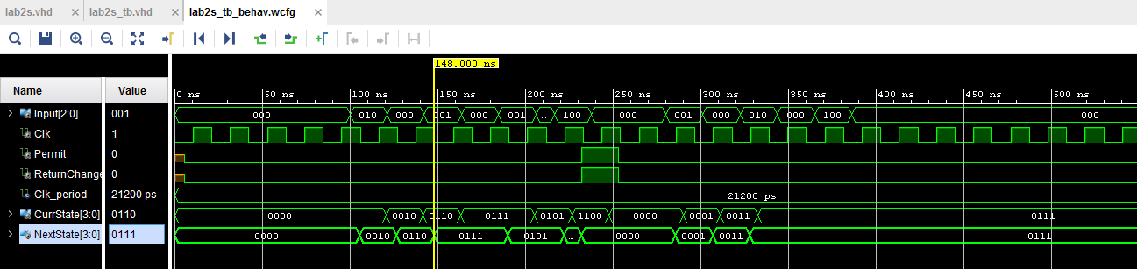

Lab 2 Structural and Behavioral Simulation Graph Comparisons
Compare your behavioral & structural graphs here. If there are any differences (delays, outputs, etc.), be sure to explain them here.
After fixing the behavioral code:
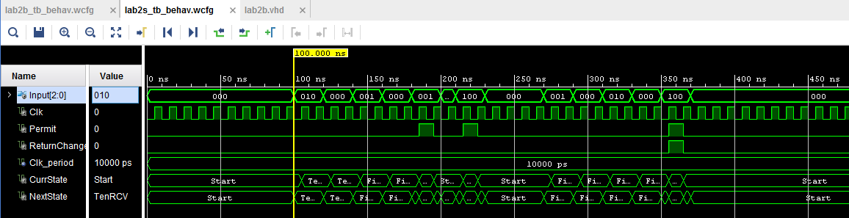
The behavioral code runs perfectly fine, however there seems to be an issue with delays/updates in the structural code. For some reason, 0111 (FifteenRCV) is held long enough that the next state, 0101 (FifteenTotal) doesn’t read the Input (001, $5), so it simply reads 000 until it reads 100 ($20) and instead goes to 1100 (OverTwentyTotal). The NextState and CurrState graphs should be similar for both, but instead of names, they’re encoded with bits controlled by next state equations in the structural CombLogic process.

