Lab 2 Behavioral Report
Academic Integrity (more info @ https://aisc.uci.edu/): You are encouraged to discuss the labs at a high level, but the code/equations/simulations you come up with should be your own. By typing “yes” at the end of this question and filling in your name, you certify that the work you are turning in is your own work. Is the work you are turning in your own? Yes
If you worked on any portion of your report or vhdl code with other students (discussion at high level & debugging; if more, please describe), please list their names here: ____
Student Name: Richard Magdaluyo
Student ID: 45993793
Date Completed: Date you finished this portion of the lab
Time Spent: Reviewing Digital Design Material: 10
Design/Preparation Work: 30 mins
VHDL Coding & Debugging:

Behavioral Overview
Replace this text w/ the % you feel you completed the lab. Be sure to list your general procedure of how you completed this lab & material (if any) you reviewed to help you complete this lab. Regardless of % stated, provide any details of difficulties (if any) you encountered during this lab. A few sentences are sufficient.

Lab 2 FSM
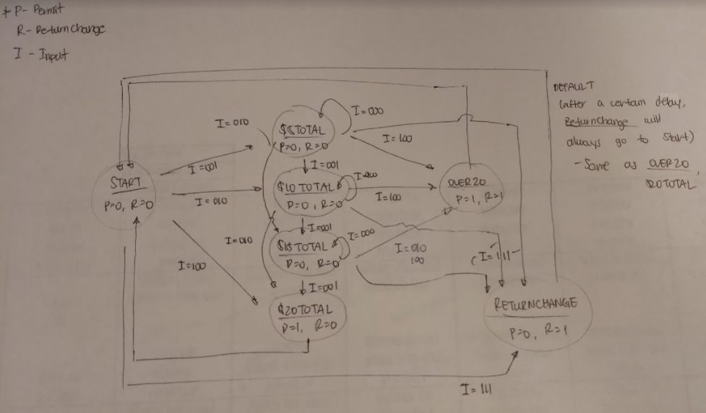

Lab 2 Behavioral Simulation Graph
Show a screenshot of your final graph here. You should crop it to the appropriate size so that it is legible.

