Assignment 4

Solutions

**Your section #: 01**

Students must abide by [UVic academic regulations](https://www.uvic.ca/calendar/undergrad/index.php#/policy/Sk_0xsM_V?bc=true&bcCurrent=08%20-%20Policy%20on%20Academic%20Integrity&bcGroup=Undergraduate%20Academic%20Regulations&bcItemType=policies) and observe standards of scholarly integrity (i.e. no plagiarism or cheating). Therefore, this assignment must be taken individually and not with a friend, classmate, or group. You are also prohibited from sharing any information about the assignment with others. I affirm that I will not give or receive any aid on this assignment and that all work will be my own. **name here**

Many aspects of the environment are public goods. Public goods are nonrivalrous and nonexcludable. Nonrivalrous means that you deriving benefit from the good does not diminish the amount of the good available for others. Nonexcludable means that there is no way to prevent people from deriving benefits from the good. Examples of environmental public goods include obvious things like the ozone layer, but can also be more subtle like the absence of litter in a park. Recall that in experiment 4 you decided how to allocate your personal endowment of 10 dollars between a private account, and a public good. Each dollar allocated to your private account yielded a marginal payoff of $1 to you alone. The value of the public good was 1.5 times the average contribution in your group, but **all** members of your group benefited equally from the public good.

Your payoff was the sum of your private consumption and the value of the public good. For example, individual 1’s profit was:

$π_{1}=10−g_{1}+1.5×\frac{g_{1}+...+g_{n}}{n}$

The treatments determined how subjects were rematched between rounds. In the not treatment subjects played all 20 rounds with the same group. In the randomly treatment subjects were randomly rematched for each round. Finally in the assortatively treatment subjects played each round with players who had made similar contributions in the previous round. Higher payoffs can be sustained in a public goods game if behaviour can be coordinated (each member of the group contributing a similar amount.) These treatments were designed to influence how easy it would be to coordinate behaviour.

# 1 (10 marks)

**If I gave you an extra dollar and you used it for private consumption, how much would your payoff increase? If instead you put that dollar into the public good, by how much would your payoff increase (assume 3 people in your group)? If a player is maximizing their own profit how much should they contribute to the public good? Does your answer depend on group size? Does your answer depend on round number? Does your answer depend on the contributions of others?**

# 2 (10 marks)

**Suppose that each group had a “government”, which could tax each group member (equally) and then invest (without loss) the proceeds in the public good. Would government taxation and provision of the public good increase player payoffs? What would the optimal tax *rate* be?**

# 3 (0 marks)

**Use boxplots to visualize how contributions differ by treatment.**

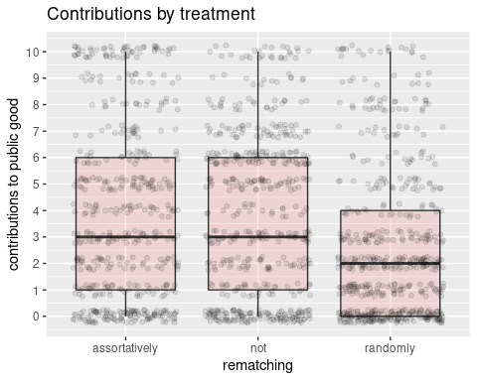

# 4 (10 marks)

**What do you observe in the above plot? Why do you think this is the case?**

# 5 (10 marks)

**Use boxplots to visualize how contributions differ by round.**

# 6 (10 marks)

**What do you observe in the above plot? Why do you think this is the case?**

# 7 (0 marks)

**Create a scatterplot with aesthetics x=round,y=choice,colour=rematching. Use transparency and jitter to avoid overplotting. Add in the best linear approximation for each treatment.**

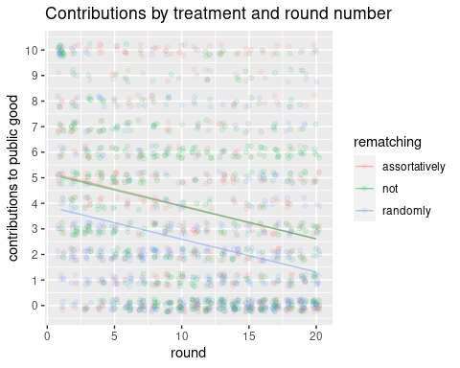

# 8 (10 marks)

**Create a scatterplot with aesthetics x=contribution, y=profit, colour=rematching. Use transparency and jitter to avoid overplotting. Add in the best linear approximation for each treatment.**

# 9 (10 marks)

**What do you see in the above plot? Why do you think this is the case?**

# 10 (10 marks)

**Create a new dataframe called within_group_variability by first taking dataframe mydf THEN grouping it by whichgroup,round,rematching THEN summarise each group by creating a variable variability_contributions which is equal to the standard deviation of the variable choice.**

# 11 (10 marks)

**Create a scatterplot using dataframe within_group_variability with aesthetics x=round, y=variability_contributions, colour=rematching. Add in the best linear approximation for each treatment.**

# 12 (10 marks)

**What do you see in the above plot? Why do you think this is the case?**