Homework: BME8730

Fall 2019

Due Monday 30th.

Please plan to discuss and ask questions Monday and/or Wednesday in class next week.

Code provided is outline only and is not working. You need to make it work. Feel free to adapt or re-write from scratch.

You may collaborate but must acknowledge.

100 points total.

1. Frequency dependent attenuation.

Gaussian function generation in the frequency domain.

Create functions corresponding to 20%, 50% and 80% -6dB fraction bandwidth.

(We did this as part of the beam plot exercise in class)

Create functions at 2 MHz center frequency and 10 MHz center frequency

Consider imaging depths of 1 cm and 3 cm

Apply frequency dependent attenuation at the rate of 0.5 dB/cm/MHz – and account for the fact that we are dealing with two way propagation. (multiply by 2)

For this question, multiply the attenuation rate by the imaging depth and then make it frequency dependent – i.e. at each frequency increment in your code, recalculate the dB attenuation which at that point accounts for both frequency and depth. Attenuation is a multiplier /scaling effect. Since this is in the dB domain, it is additive / subtractive. In effect, in the dB domain, attenuation appears as a low pass filter with a straight line (versus frequency) downward pattern.

For each permutation of center frequency, bandwidth and imaging depth, plot

The original spectrum (magnitude) and the attenuated version.

Measure off from the plot the reduction in amplitude at the peak level (in spectrum) and the attenuated versus original center frequency.

Calculate the center frequency from the midpoint between the -6dB upper and lower cutoff frequencies.

High frequencies experience more absolute attenuation.

Higher bandwidth pulses experience greater frequency downshift. (12)

2. Using the code approximately developed in class, review and make sure that it is doing the following:

Create a frequency axis – to at least 8x center frequency and a well sampled frequency interval – e.g. 512 frequency samples

Create the Gaussian function – i.e. 10 MHz, 30% -6dB BW

Set up the field sampling points – either along a azimuthal oriented line at a fixed range or at a 2D matrix of points in both azimuth and range

Calculate desired focusing delays – i.e. “inverted” time delay from all elements to the focal point

Step through field points.

Step through the array element locations

Calculated propagation delays to field point from the element location to the field point

Calculated the net delayed response at the field point taking account of the propagation delay and the applied focal delay (noting that when at the focal point the propagation delay and applied focal delay will cancel – hence the “inverted” focal delay)

Sum the contributions from all elements at the field point

Take the IFFT of the summed value

Find the peak amplitude of the envelope of the IFFT waveform. Use the magnitude of the Hilbert transform.

Record the peak amplitude value for that field point location

Determine and apply any normalization

(Typically, values are normalized at each range increment when doing a beam plot through azimuth and depth. This is because in a real imaging system, depth (or focus) dependent variations in peak amplitude are compensated out to produce a more even image intensity.)

Perform the interim steps suggested in the comments in the template code – i.e. changing the frequency axis sampling and extent to verify the expected impositions made on the time and frequency representations as you execute FFT and IFFT. Make plots of all results and use your own judgment as to whether to overplot lines or use separate figures. Differentiate and label lines as necessary. (9)

Observing the sampling frequency at fc/32, fc/64, and fc/128:

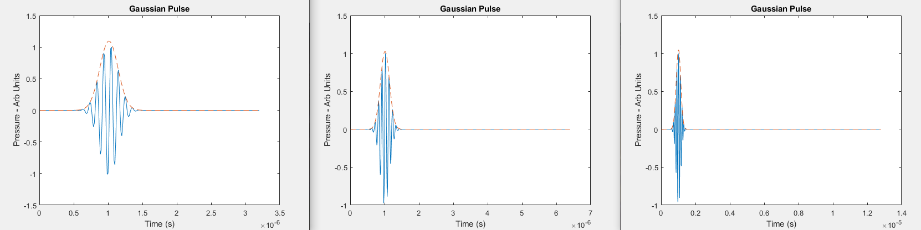

We see as the sampling frequency becomes smaller, the function repeats over a smaller time domain, but stays under the Gaussian pulse regardless of how the sampling frequency is changed.

When defining the frequency range, the maximum frequency was changed to 4, 8, and 16 times the center frequency as shown below.

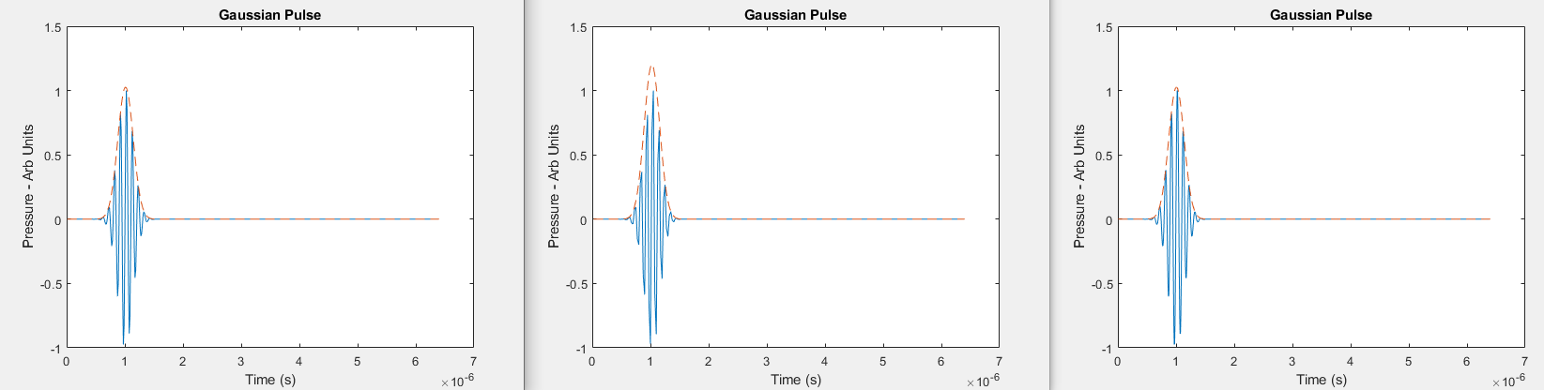

As the maximum frequency is increased, the pulse continues to a larger maximum pressure at a later time.

2A. Simulate a beamplot (i.e. magnitude of waveform, in dB, at a range of X- offsets around X,Z=(0,50) (i.e. at Z=50mm)) for a 10 MHz, 30% BW transducer array of 128 elements and wavelength spacing focused at a point straight ahead at range 50 mm. Simulate for the case of no apodization (weighting = all 1’s) and for Hann weighting. Verify the impact of apodization on main beam width and on presence of sidelobes. (Use your judgment to extend the range of the scale in both X direction (x-axis) and numbers of dBs (y-axis) in the plot to show this)

Use a narrow beam sampling so as to capture the main lobe and at least the first sidelobe. You may need to experiment with sampling. If the sampling is too coarse, you will not resolve the main beam and side lobes properly. +/- 2 mm is approximately sufficient for this question.

Your code should be able to create maps over 2D space (varying X and Z) over 1D space (varying X at a fixed Z – to get a beam cross-section although conventionally simply called a “beamplot”)

For this question and questions 3 and 4, you want to zoom in on the main lobe – plot over a range of approximate X = -2, + 2mm. These questions relate to main lone width and the presence of sidelobes so you need to resolve the main lobe properly.

The code normalizes the responses at each range. Leave that as is. In an imaging system, brightness is also normalized to de-emphasize the effect of focusing causing a bright spot at a specific depth.

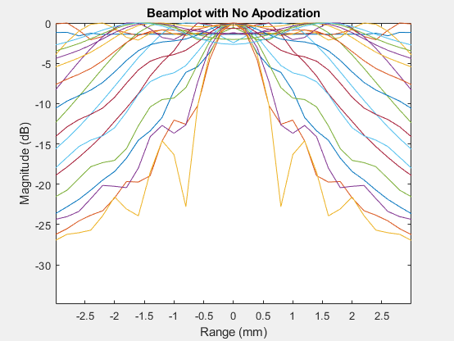

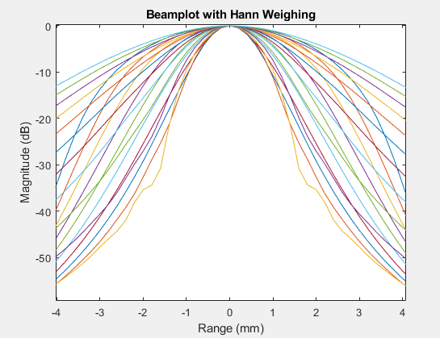

For the no apodization case, the sidelobes are shown with every beamplot. These sidelobes are resolved with less weight applied to the sidelobes in the second plot.

2B. Form a beamplot with a focus close in – X,Z=(0,25)mm. Verify that the apparent depth of focus is shorter. “Depth of focus” means the range in depth over which the beamwidth is still very narrow – e.g. <=200% of beam width at the true minimum.

Just place annotation on your plot indicating this effect. Estimate the approx range (by extracting data or by measurement from plot) the range of depths around the focus for which the -6 dB width is no more than 200% that at the actual focus. i.e. if -6dB width (X dimension) is 1.0 mm at focus, over what range (Z) is the -6dB width less than 2.0 mm.

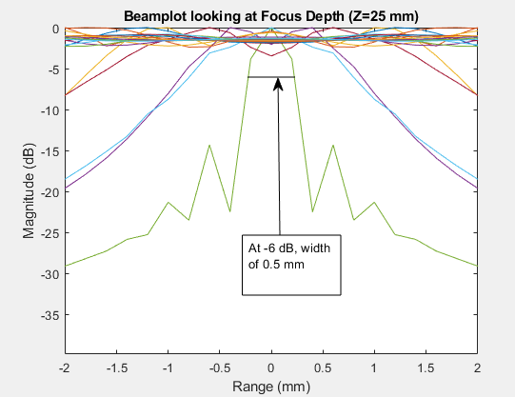

For Focus depth of Z = 25 mm, only the focus depth had a mainlobe less than 1 mm in width, as found after iteratively plotting the beamplots of the various depths.

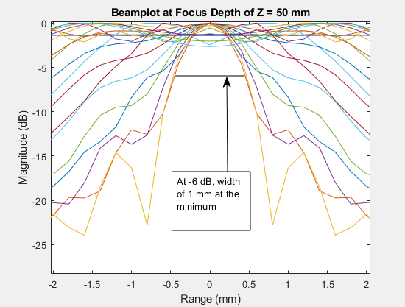

At a focus depth of 50 mm, the width at -6 dB is 1 mm. The depths that are within 200% of this width at -6 dB is 45 – 65 mm. This range of depths was found through iteratively plotting beamplots of the various depths and recording which iterations had a main lobe that matched these criteria. These depths corresponded to iterations of z_pts 9-13 for iterations of 5 mm.

At a focus depth of 50 mm, the width of the minimum main lobe at -6 dB is double that of the beamplot with focus depth of 25 mm.

(6)

3. Repeat 2 (no apodization) but with half wavelength spacing. i.e. shorter aperture. Verify that main lobe (at -6dB level) is doubled in width. (4) 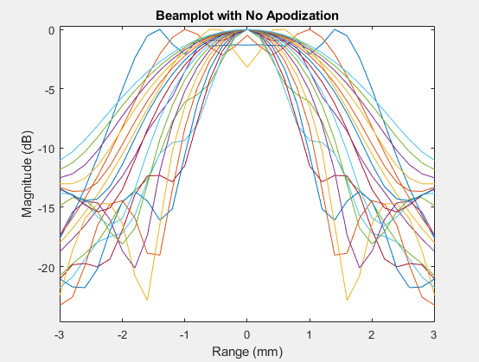

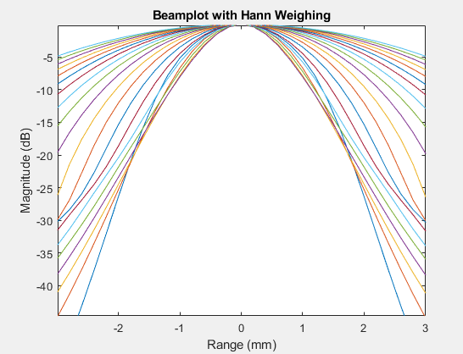

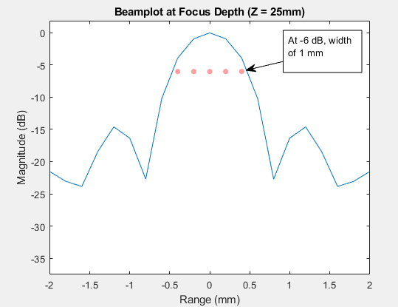

4. Repeat 2 (no apodization) with one wavelength spacing but the center frequency is now 5 MHz. Verify that main lobe (at -6dB level) is the same as in 2. Why isn’t the main lobe wider because we are using a lower frequency? (4)

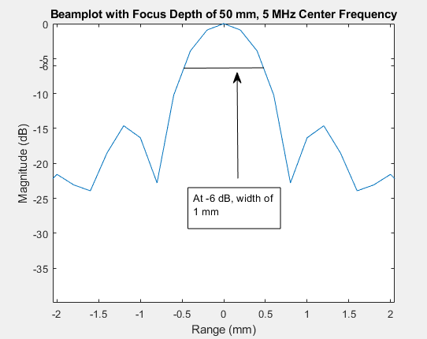

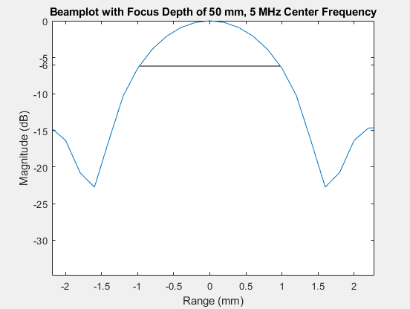

With a center frequency of 5 Mhz, the main lobe width for -6 dB is observed to be the same as a center frequency of 10 Mhz.

5. Measure from the pulse plot the code produces the -20dB (i.e. first crossing of amplitude over 0.1 of max value to last crossing of amplitude over 0.1 of max value) pulse duration for both the 10 MHz and 5 MHz pulses with 30% bandwidth. Convert these to axial resolution using speed of sound and factor of two for two way propagation. (6)

5 MHz: 4.5e-7 to 1.6e-6 = 1.15 e-06

10 MHz: 7.25e-7 to 1.3e-6 = 5.75e-07

6. Steer the beam by 45 degrees. Plot an entire beam pattern using the contour plot option. Use 10 MHz, 30% BW, 50 mm focusing in front of the transducer, no apodization, and then superimpose the 45 degree steering. Do this for wavelength and half wavelength spacing and verify that you can see grating lobes (an artifactual sidelobe that is related to spatial undersampling – akin to sub-Nyquist sampling) at the opposite angle to the intended main beam for the wavelength spacing case. You should find that as you steer the beam to 45 degrees the apparent range to focus moves closer to the beam origin. Can you explain? It has to do with effective element spacing. (8)

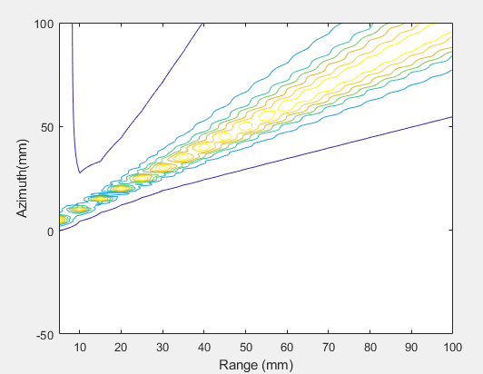

7. Extend the program to simulate a 2D array with elements populating a 32 x 32 matrix of X,Y locations. Assume 10 MHz, 30% BW, wavelength spacing. Focus at Z=50 mm directly in front. Create a field plot over X (+/-5mm) and Y (+/-5mm) for range (Z) = 50 mm. You may use ¼ or 1/8 symmetry in the field to reduce the total calculation time. You may also change the sampling in the frequency domain or use any other method you like to speed up the calculation so long as your approaches do not measurably impact the quality of the result. (16)

(You can use symmetry anywhere in solving these problems – but it clearly doesn’t help much when steering off axis)

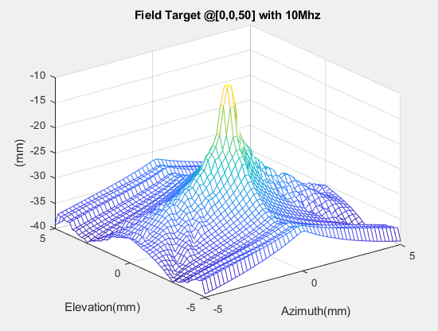

8. Single planar sources – model these as a finely sampled set of sources are simultaneous excited by a common function (use sampling frequency > ~50 fc

Sum( Wij * (1/rij) * f(t-tp)

In this question, assume no attenuation effects.

Planar

Define a 2D array of Huygen’s sources spaced at 30 micron intervals

5 MHz

Assume a 1cm diameter flat piston transducer

Set 2D array source weights to all zeros

Define a mask of array weights equal one within the circular area of the transducer – i.e. R< 0.5 cm = 1.0

In at least one of the following examples, include a factor for spherical spreading – i.e. the energy from a point source is spread across the surface of a sphere as it propagates outward in all directions. Thus, it is spread over pi r^2. Therefore, your contribution for each source can be divided by the distance used in “prop_del” ^2.

Create a meshplot (in dB domain) +/- 10 mm in azimuth (x) and 2-60 mm in range (Z) for each of:

1. Gaussian pulse 30% -6dB fractional BW (10)
2. CW at 5 MHz – per in class discussion. Evaluate at single frequency.
   1. For this case, also produce a finely sampled plot along the central axis (X=Y=0) to Z=80 mm (5)
3. Repeat a) and b) after imposing a Hann apodization function across the aperture with circular symmetry. Very the reduction in sidelobe activity. (10)
4. Experiment with increasing source spacing (i.e > 30 microns). Verify that source spacing is more critical in near field. (10)