BME 8730

Fall 2019

Due October 14th 2019 (Extendable)

Implementing Time Domain Diffraction Equations

Implement equations for velocity potential impulse response for both circular and rectangular sources. I suggest you start from the Lockwood paper and refer to the other diffraction papers to the extent that they help you. These papers are in “Resources”. The code should also include convolution with source waveform function and differentiation post convolution to obtain pressure (10,20)

Comment your code properly.

Produce a sketch (hand drawn if you prefer) denoting the geometries being used and the variable names in your matlab code. For example, show the arcs and angles for the various permutations of field point locations and shapes.

When dealing with rectangular apertures, your code should, ideally, be able handle all possible orientations – i.e. field points in all possible positions and account for the different order of critical time points depending on BOTH field point location (projected on to transducer plane) and the different permutations of long versus short sides of a rectangular source.

You code, if it doesn’t address all geometries, still needs to address those required to answer other questions listed here (see below)

Use your code to replicate the following figures:

Lockwood

Figure 3, 6, 7, 8 and 13 (10,10,10,10,10)

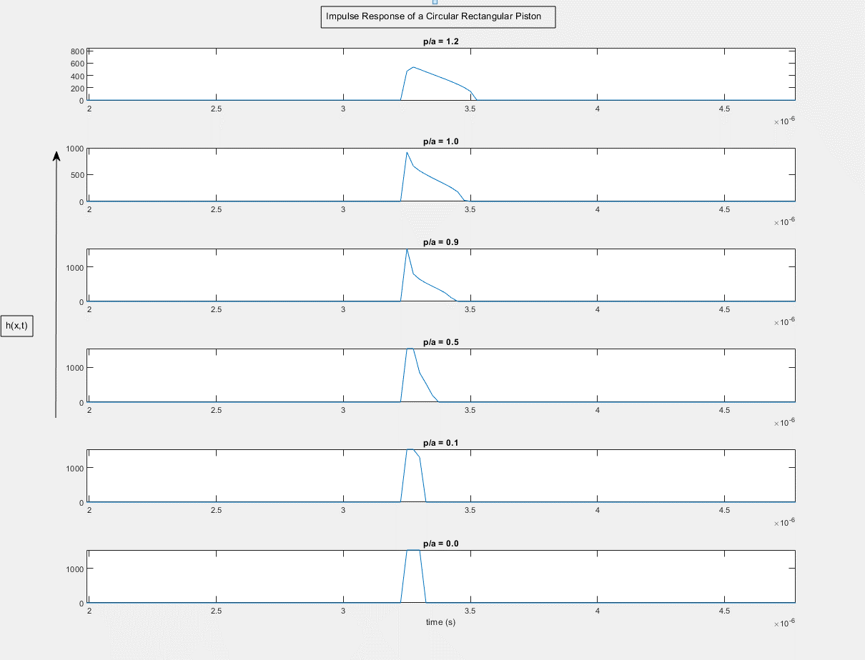

For the CW beamplots, you should consider convolving with a long sinusoidal pulse and detecting the peak to peak amplitude near the center of the pulse (to avoid transient effects near the beginning and end) or use an FFT of the impulse response and extract the correct Fourier component. (If one doesn’t work, try the other.) Be sure to use fine time sampling – at least 100 MHz and probably significantly higher. Notice that you need to define a and  to make your code work. It isn’t critical what actual values you use so long as they are consistent and produce the right results.

It is fine to discuss progress or questions in class. We have time for that.

Please try to do as much of the coding yourself but work together to debug (and acknowledge). If coding is proving to be a real challenge, pair up. However, if you do this please try to learn the operation of the code equally.

Submit, paper or PDF/word doc, figures and code – at least the core code doing the trigonometry.

Papers:

Stephanishen (circular), Lockwood and Willette (rectangular), Oberhettinger (circular) – theory and implementation of transient radiation. My conference paper (1993), has a solution for all zones that is easy to copy / implement. Whatever solution you use, please sketch the geometry so you know which angles are being calculated and why.

Please note that the primary purpose of this exercise is to arrive at exact solutions for transient radiation. We will then consider approximations that form the basis of the widely used FIELD II program that I hope you are able to master as an output of the class.