Saudi Arabia Country Analysis: Business Software

***Moon Macrosystems***

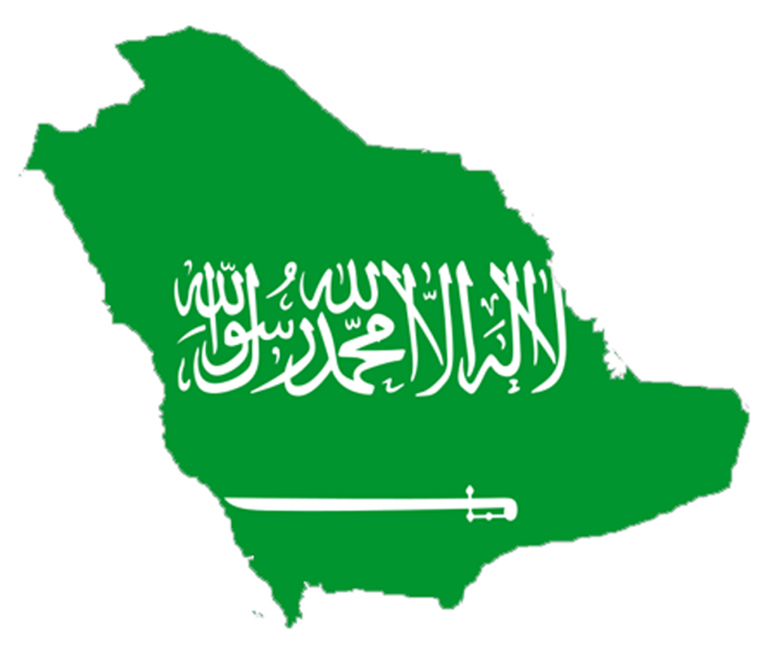

Business D270 International Business

Section: 29582 M/W 9:30 - 10:45 Eric Benjamin [Eranbenj@umail.iu.edu](mailto:Eranbenj@umail.iu.edu)

Professor Roberto Garcia Pak Tung Chen [Pakchen@umail.iu.edu](mailto:Pakchen@umail.iu.edu)

Friday, October 11, 2013 Robert Mulligan [Rpmullig@umail.iu.ed](mailto:Rpmullig@umail.iu.edu)

**Part I.**

**Setting The Stage**

Moon Macrosystems works with businesses to provide effective software computer integration exclusively within the US. The company creates software for internal accounting systems, schedules, emailing systems and other business software needs in addition to normal information technology services. It is an up and coming firm within the technology industry and is looking to reap the benefits from expanding its operations to an overseas location. Some of the Moon Macrosystems competitors like Microsoft and Sun Microsystems have already created a strong presence outside the US. The company executives feel inclined to take a similar course of action in order to keep up with the market competition. By going abroad, the company will be exposed to a much greater consumer base than the status quo of staying within the US, and therefore is presented with the opportunity to capture a greater profit. Another benefit of a move of this nature, would is the reduction of risk for the firm. When operating internationally, the company diversifies its risk by conducting business in a nation with different business cycles than the US.

**Why Saudi Arabia?**

The geological location of Saudi Arabia creates value for multinational companies to invest in. As you can see in the figure 1.1, Saudi Arabia is a country that physically connects Asia and Africa. This factor is important because a company that is located in Saudi Arabia can expand easily into the markets of two of the largest continents (Asia is the biggest and Africa is second) in the world relatively easier than companies located in other countries further away.

***Software Market***

The Market potential in Saudi Arabia is also very promising. The Software industry is a relative new market force in global economy, and also has a strong growth rate worldwide. The forecasted growth rate in global software industry is 5.7% from 2012 to 2013, while the growth rate of Saudi Arabia software market is 6.2% (7.8% in IT Services Sales).[1][2] This indicates a strong potential for profitability in the Saudi Arabia business software market.

(See figure 3.3 for more in-depth analysis of the Saudi market)

***The Report***

However, besides the *Economic* factors of Saudi Arabia, Moon Macrosystems should evaluate the non-market factors of the country, when deciding whether to partake in foreign direct investment in Saudi Arabia. The additional, non-market factors that should be considered are *Culture and Sociological*, *Political and Legal*,as well as *Technological and Infrastructure.* In this report, we are going to analyze all of these factors as they pertain to Saudi Arabia in order to provide a clear and objective outlook of the software industry in Saudi Arabia.

**Part II.**

**Economic Factors**

***Overview of Economy***

Saudi Arabia’s entire economy is defined by a single product: oil. Saudi Arabia has access to the largest amount of oil reserves of any country in the world. Oil alone accounts for roughly 90% of national exports and 80% of the government’s revenues.[2] Rising oil prices have fueled Saudi Arabia’s economic growth at a rate of 3.5% for each of the last five years.[2] Figure 2.1 illustrates this growth and also provides context on the annual GDP growth for the past forty years. The large increase was created from the founding of the oil industry. Indicators such as inflation show that the economy is relatively stable at the moment but encountered radical change with the discovery of oil. (See figure 2.2)

***National Income and Distribution of Wealth***

Saudi Arabia’s overall GDP is about $683 billion, and is $24,237 per capita.[3] Even with increasing demands for oil driving prices up, Saudi Arabia’s apparent wealth isn’t as attractive for foreign investment as it may seem as there is a wide gap between the rich and the poor of the nation. Saudi Arabia’s population has significantly increased--about 6 million in 1970 to over 28 million today(See Figure 2.3)--but welfare and job programs launched by the government have failed to keep up with this population surge.[4] Private estimates and investigations reported by *The Guardian* showed that between two and four million individuals live on less than $17 per day. The Saudi Arabian government attempts to repress data of this nature from being published. Despite the clear need to decrease the amount of individuals living beneath the poverty line, corruption is preventing the Saudi Arabians from making any improvements. The royal family continues to get richer as a result of nepotism and corrupt activities like confiscating and reselling land at unreasonably higher prices.[3] Without any changes from the authorities in power, the rich will continue to get richer and the poor will get poorer.

***Business Freedom Compared to World***

For new businesses, Saudi Arabia was about on par with the “Rest of World” averages for business freedom in 2013. Some factors that contribute to this variable are related to the cost and time associated with startup, obtaining licenses, and shutdown. According to *Doing Business 2013*, Saudi Arabia ranked twenty two out of one hundred and eighty five countries measured in terms of their business freedom ranking.[5] (See Figure 2.4) Protecting property rights and intellectual property are legitimate concerns too because of the court systems in Saudi Arabia, which are often subject to influence by royal family members and other rulers.

***Conclusion***

Oil truly defines the economy of Saudi Arabia as it is the majority of exports and sources of revenue for the government. Despite its economic growth in the past few years and relatively high wealth, there is a significant disparity in their distribution of wealth. A high percentage live well below the poverty line and corruption is inhibiting any motions towards solving these key issues. Saudi Arabia is about average in terms of the ease of conducting business when looking at the rest of the world, but protecting both the products and services of Moon Macrosystems may be more difficult in a country like Saudi Arabia when compared to other countries. Both segments of their “rule of law” rating (property rights and freedom from corruption) went down in their 2013 rating and this may continue in the future if there is no reform.[3]

**Culture and Sociological Factors**

***Overview of Culture***

To decipher the culture of Saudi Arabia, the company must look at their religion and customs. Saudi Arabia is highly uniformed by the Islamic religion and Arabic is its official language.[6] The country contains holy cities sacred to the Islamic religion. Because of all these factors, Saudi Arabia and its people tend to look to religion when making decisions.

***Religion and Customs***

The theocracy of Saudi Arabia creates unique laws, which differ from the US lawmaking perspective. Saudi Arabian citizens follow religious traditions such as praying 5 times daily, abstaining from alcohol and certain foods, wearing special clothing, and fasting on religious holidays. The government and majority of the citizens typically oppose anything they *perceive* as against the Islamic religion. Managers must recognize these differences and realize that they must adapt in order to work with them.

***People***

Saudi Arabia has a population of 28,082,541 that is growing 1.51% annually.[6] Figure 2.3 illustrates that population growth for Saudi Arabia is in times of economic boom. Currently, the growth has flattened. The Median age is relatively young at 26 years old, a positive for Moon Macrosystems integrating new technology.[6] 87.2% of the population can read, however women tend to be slightly less literate because of religious customs.[6] The majority of people live in an urban setting, with 16.7% of the population choosing to tackle the harsh, hot and dry desert climate as rural citizens[6]. Figure 2.4 depicts that that Saudi Arabia may pose an issue for piracy of intellectual property that Moon Macrosystems creates. This widespread disregard of property rights may result from the disparity of wealth and a rule of man perspective.

***Cultural Behaviors[7][8]***

Saudis tend to act indirectly and have a stronger *interdependence* and *collectivist* views than people from the US (See figure 2.5) . Most managers will find that employees may not speak out in public meetings, but work better in a private setting. This due to a *restraint*, *status* oriented, and *indirect* cultural behavior that the society favors. Managers should also note that Saudis are more *relationship* and *interdependent* oriented. Moving quickly to accomplish a task sale will not work as effectively, as having a long conversation about non-business topics and connecting on a personal level. Managers should focus on employees and know that they will look upon them as the key decision makers with their belief that *status* is very important.

***Conclusion***

Most Saudi business have been family owned and operated.[9] Business managers typically fill job positions with members of their own family. Working with Saudi businesses will take some time to gain trust, but after this occurs many doors will open because of interdependence. According to Figure 2.6, Saudi Arabia economy is still largely comprised of many imported goods and services, which means there remains a good chance that a foreign firm like Moon Macrosystems will be accepted as a foreign direct investment in Saudi Arabia.

**Political and Legal Policies**

***Overview of Systems***

Saudi Arabia’s governing body is centered on a hereditary monarchy system with Abdulaziz bin Abd al-Rahman Al Saud serving as king. This position is passed down from generation to generation to members within the royal family, and because of this no elections are held. A Crown Prince works directly with the king in order to help accomplish his tasks. This position is both appointed by the king and heir to the throne. In addition to the Crown Prince, the king also appoints individuals to help govern the state. These ministers specialize in a certain area within the government, and the majority are related to the king.[15]

***Legislature***

Their legislative body consists of a Consultative Council which provides additional advice to the king on issues regarding the nation as well as the process of amending and proposing laws. Like the cabinet, these one hundred and fifty members are appointed by the king. Their terms last four years, but are renewable. The personal experiences of each member dictate what subcommittee they will belong to. The nation is also divided into thirteen provinces each with their own governor, deputy, and council of at least ten citizens. These officials act in the best interest of their individual province.[16]

***Legal System***

Islamic Law sets the foundation for the judicial system of Saudi Arabia. The court system is divided into three parts: the Shari’ah, Board of Grievances, and the Supreme Council of Justice. The Shari’ah hears the majority of cases and is the largest of the three courts. The Board of Grievances supplements the Shari’ah and hears cases related to government. The highest of the three courts is the Supreme Council, which is composed of twelve senior jurists appointed by the king with input from members of the Supreme Judicial Council. The king is at the top of the judicial system with both the ability to administer pardons and acts as the final court of appeal.[16]

***Political Stability and Corruption***

As illustrated in the last section, the king possesses significant control in all three facets of the nation’s branches of government. Opposing political parties are banned and this in turn has led to many dissident groups forming. Even with an increasing demand for political reform, public opposition and suggestions for reform often yield repercussions like facing jail time. Despite these factors, Saudi Arabia has been able to keeps its current monarchical regime for over fifty years. According to a report by The Center for Strategic & International Studies, the Saudi Arabian Government has pumped over $36 Billion into projects designed to gain popularity for the regime some of which included real estate development, pay increases for state employees, programs to aid the needy.[10]

***Difficulties***

Corruption also exists in both the government and legal systems. According to the 2013 Index of Economic Freedom, Saudi Arabia’s “Freedom from Corruption Rating” was a contributing factor in their overall economic freedom score for 2013 (figure 2.7).[3] Court systems are regarded as inefficient due to long delays in the process. Delays can be so long that they can be seen as a deterrence from using the court system. Other branches of government’s influence is seen as a negative factor in the judicial system as well, and clearly the executive branch has a significant impact in the judicial process.

***Conclusion***

Saudi Arabia’s policies clearly illustrate the concept of “the rule of man”. One higher authority rules the country with his set of advisors and has significant authority in all three branches of government. This particular style of ruling isn’t necessarily a deterrent from conducting business in Saudi Arabia, but the present legal system certainly raises a red flag. The courts are not only weak and face interference from authorities in power, but intellectual and property rights aren’t strictly enforced. A country that practices the rule of law may be a better fit for a technology service like Moon Macrosystems, who would benefit more from a court system more focused on protecting these rights.

**Technology, Geography, and Infrastructure**

***Background***

Technology and infrastructure of a country can vitally affect the feasibility and profitability of doing business in that respective country. For example, Moon Macrosystem would conduct business in a country that has no internet services or has only a handful of computer owners. The infrastructure aspect affects many fundamental functions like transportation and communication. Saudi Arabia possess advantages and disadvantages related to its technology and infrastructure. Some include advantages are modernized transportation and adequate natural resources; disadvantages are poor climate, weak trade union involvement, and limitations on internet usage.

***Advantages of Saudi Arabia Technology and Infrastructure***

***Modernized Transportation***

The advanced transportation infrastructure in Saudi Arabia makes it attractive to entrepreneurs of multinational companies because it allows for a mobile labor force and easily transportable products which can increase efficiency and lower cost structure of businesses.

Saudi Arabia has 214 airports, ranking 26th in the world for 2013,which indicates a strong transportation infrastructure in Saudi Arabia.[6] Beside air transportation, the road transportation system in Saudi Arabia also adequately meets businesses needs. There are over 22,1372 kilometers of roadway available for ground transportation, ranking 22 worldwide.[6] The majority of these highways are well maintained, and many of these roads have been “constructed to resist the consistently high temperatures and do not reflect the strong sunshine”[11] because of the extreme climate of Saudi Arabia. The government continues to maintain, improve, and build new roadways throughout the country.

***Adequate Natural Resources***

Being the largest exporter of crude oil[6], Saudi Arabia local businesses face few risks from radical currency exchange rate changes. Figure 2.2 shows a stable currency value, suggesting stability in utilities, taxes, government contracts, and purchasing power. The abundance of crude oil in Saudi Arabia also indicates that it is unlikely to experience any energy shortages and low vehicular transportation costs. After researching the advantages in Saudi Arabia technology and infrastructure, the report moves on to consider Saudi Arabia’s disadvantages.

D***isadvantages of Saudi Arabia Technology and Infrastructure***

***Poor Climate***

The climate in Saudi Arabia is described as harsh, dry desert with great temperature extremes indicating an unfavorable natural environment.[6] (See figure 2.8) Moon Macrosystem needs to take this factor into account since the staff members and managers from the US may experience difficulties when living in such an extreme climate (high temperature in the daytime and low temperature in the nighttime) that Saudi Arabia has.

***Weak Trade Union Involvement***

A report published in 2012 indicates that “Saudi Arabia is in violation of all core labour standards” by banning the local trade union.[12] The trade unions in Saudi Arabia are not active because of governmental prohibition, and because of this local workers can only form “workers committees” which have to include government and employer participation. This act makes the trade union lack of development and prevent companies in Saudi Arabia from effectively motivating employees and increasing efficiency. Weak workers rights results in a low employee loyalty and a lack of communication between employees and managers. Lack of communication makes the cultural difference difficult to navigate around for managers.

***Limitation on Internet Access***

Another downside of infrastructure in Saudi Arabia is its restriction on internet usage. Wide-spread internet usage in Saudi Arabia starts stated later than 2001, when the rest of the world was already online. A major reason is the government’s fear of internet, an open outlet for non-Islamic ideals. Even now, the uses of internet is still not common in the country because of the government makes internet service costly for the Saudi Arabian people.[13] Local businesses would usually experience difficulty when accessing internet services and may need to pay hefty fees in order to do so.

***Conclusion***

The Saudi Arabian technology and infrastructure carry both advantages and disadvantages to a multinational company. If Moon Macrosystem’s executives decide that the advantages (transportation systems and adequate resources) outweigh the disadvantages(climate, weak trade union, and limited internet access), the company can conduct business in that country. In this instance, a company within the technology industry would be more impacted by the disadvantages because of the extent of government intervention.

**Part III.**

**Concluding Recommendation**

***Country At A Glance***

Moon Macrosystems should take into account all of the documented factors. Figure 3.1 illustrates the key driving forces behind each section of this report. Summing up all these factors results in both high monetary and time costs for Moon Macrosystems. Saudi Arabia’s weak economic freedom will prove to be detrimental in paying for corruption and slowing business process down. Dealing with a culture that will cost time to gain trust and support and may disregard Moon Macrosystem's intellectual property rights raises concern. Confronting high corruption and a poorly constructed legal system will prove cumbersome. Islamic Law preventing internet usage would not support Moon Macrosystem’s overall business model.

***Entry Mode***

The analysis suggest to proceed with caution, as figure 3.2 and figure 3.3 breaks down the factors into driving forces for a decision that Moon Macrosystems should avoid a quick, large-scale physical expansion into Saudi Arabia.This report recommends that Moon Macrosystems enters Saudi Arabia offering information technology support for firms instead of forming a costly physical presence with a full emersion of software. Only offering information technology services protects the software from piracy and still creates a brand recognition to compete against competitors.[14] The emerging Arabian software and information technology industry grows rapidly, though a great deal smaller than the US market. Possible future entry remains viable after forming connections with businesses and governmental leaders that could cut non-market costs incurred such as, corruption and the time cost of gaining a customer base.

**Appendix**

***Geographical Location of Saudi Arabia* (figure 1.1)[17]**

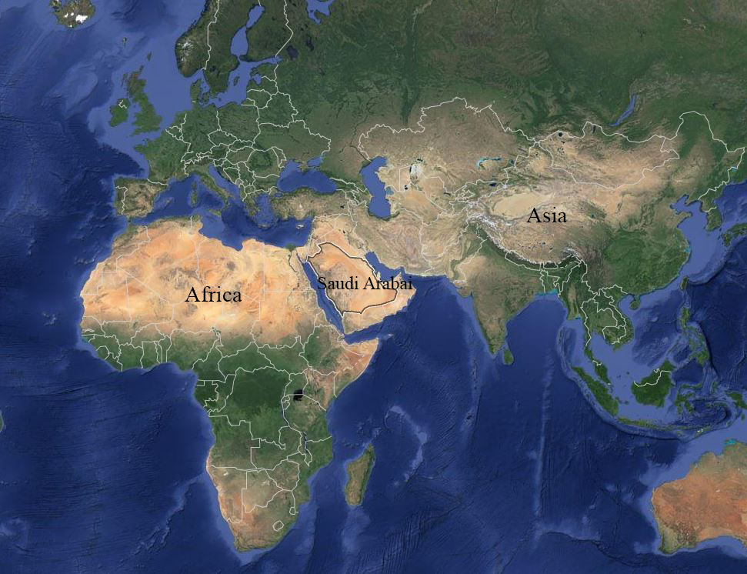

***World Bank: Annual GDP Growth % since 1969* (Figure 2.1)[18]**

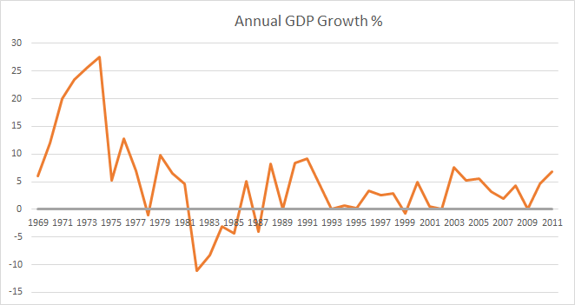

***World Bank: Inflation* (Figure 2.2)[18]**

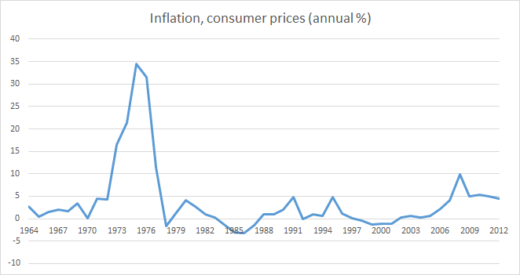

***Population Growth* (Figure 2.3)[18]**

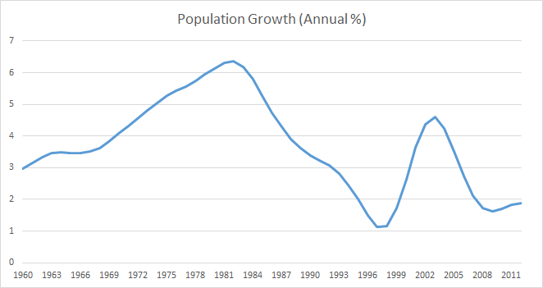

***International Property Rights Index* (Figure 2.4)[19]**

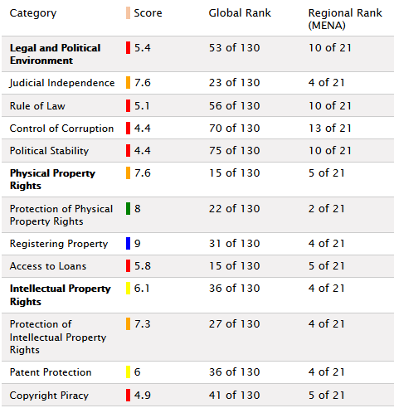

***Globe Smart Indicator: Saudi Arabia Comparison to United States* (Figure 2.5)[8]**

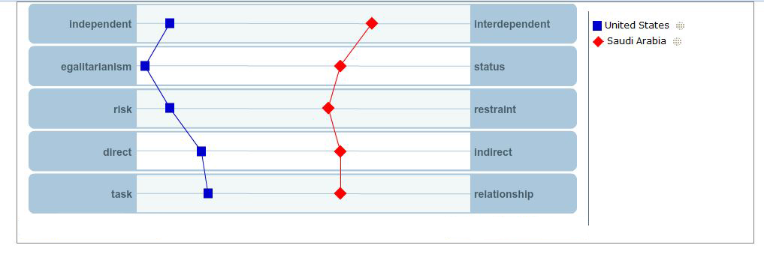

***World Bank: Imports of goods and Services (% of GDP)* (Figure 2.6)[18]**

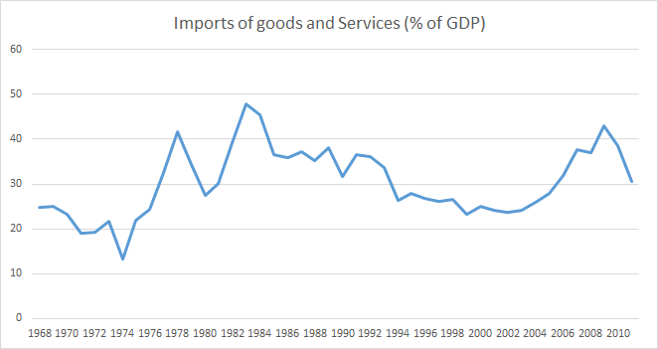

***Saudi Arabia: Economic Freedom Index* (Figure 2.7)[3]** 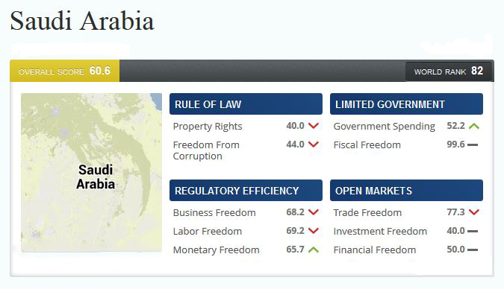

***Sand Storm*****(figure 2.8)**

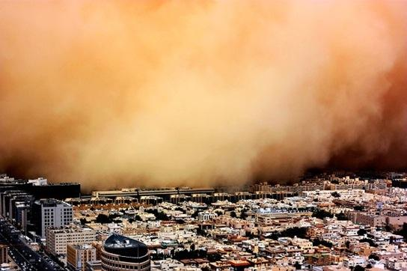

***Country at a glance* (Figure 3.1)**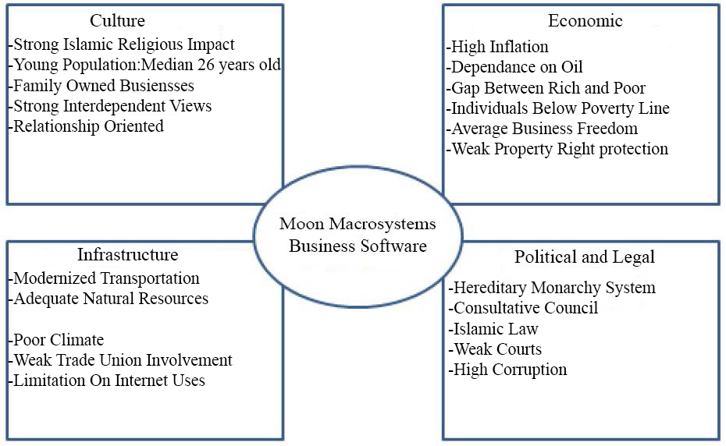

***SWOT ANALYSIS* (Figure 3.2)**

|  |  |
| --- | --- |
| **Strengths** | **Weaknesses** |
| Modernized Transportation  Adequate Natural resources  Young population  High Income Society | Time Consuming To Gain Trust of Business  Limitation on Internet Users  Weak Property Rights (Intellectual)  Poor Climate |
| **Opportunities** | **Threats** |
| Acceptance of FDIs and Growth  Connection Between Asia and Africa  Market Potential | Weak Property Rights and Court System  High Corruption  Limitation of Internet Users |

***Costly Indications: Key Index differences between US and Saudi Arabia* (Figure 3.3)[20]**

|  |  |  |  |  |  |  |
| --- | --- | --- | --- | --- | --- | --- |
|  | **Previous year**  **Market Growth**  **(USD $Total)** | **Market**  **Potential**  **Index** | **Economic**  **Freedom Index** | **Corruption**  **Perception**  **Index** | **Property Rights**  **Index** | **Intellectual**  **Property**  **(broken down from previous)** |
| **Saudi Arabia** | **10.6%**  **(6.1billion)** | **19** | **60.6**  **(82nd)** | **44/100** | **6.4** | **6.1** |
| **United**  **States** | **0.3%**  **(101.3 Billion)** | **(not considered an emerging market)** | **76.0**  **(10th)** | **73/100** | **7.6** | **8.3** |

**Bibliography**

1. “Worldwide Software Market Forecast to Continue on Modest Growth Trajectory Through 2017.”, IDC. IDC Corporate USA, 23 May 2013. Web. 07 Oct. 2013.

2. “Saudi Arabia Information Technology Report.” Business Monitor Store. Business Monitor International, 10 July 2013. Web. 07 Oct. 2013.

3. "Saudi Arabia." Economy: Population, GDP, Inflation, Business, Trade, FDI, Corruption. The Heritage Foundation, 2013. Web. 07 Oct. 2013.

4. Sullivan, Kevin. "Saudi Arabia's Riches Conceal a Growing Problem of Poverty." The Guardian. Washington Post, 1 Jan. 2013. Web. 07 Oct. 2013.

5. IFC. "Doing Business in Saudi Arabia - World Bank Group." *Doing Business in Saudi Arabia - World Bank Group*. International Finance Corporation, 2013. Web. 07 Oct. 2013.

6. Central Intelligence Agency. The World Factbook. 2013; Available from:http://www.cia.gov/library/publications/the-world-factbook/index.html.

7. Garcia, Roberto. "Professor Garcia." D270: International Business. Kelley School Of Business, Bloomington. 7 Oct. 2013. Lecture.

8. Aperian Global. "Globesmart." Chart. *GlobeSmart Assesment Profile*. N.p.: Aperian Global, n.d. N. pag.

9. Radebaugh, Lee H., and Daniel P. Sullivan. "Shifting Sands of Saudi Arabia Society." International Business: Environments & Operations. By John D. Daniales. 4th ed. Indianapolis: Prentice Hall, 2013. 47-50. Print.

10. “Understanding Saudi Stability and Instability: A Very Different Nation." Center for Strategic and International Studies, 26 Feb. 2011. Web. 07 Oct. 2013.

11. “Transport in Saudi Arabia.” Wikipedia. Wikipedia Foundatio*n,* 18 Sep. 2013. Web. 07 Oct. 2013.

12. ITUC. "Saudi Arabia Bans Trade Unions and Violates All International Labour Standards." *- International Trade Union Confederation*. International Trade Union Confederation, 25 Jan. 2012. Web. 07 Oct. 2013.

13. “The internet in Saudi Arabia.” Arab IP Centre. [www.arabipcentre.com](http://www.arabipcentre.com), n.d. Web. 07 Oct. 2013.

14. Passport. "Visual Data Basics." *Euromonitor International*. Euromonitor International, 7 Oct. 2013. Web. 07 Oct. 2013.

15. "About Saudi Arabia." The Royal Embassy of Saudi Arabia, 9 Oct. 2013Web. 07 Oct. 2013.

16. "The Political System of Saudi Arabia." The Political System of Saudi Arabia. Helen Zeigler & Associates, 2013. Web. 07 Oct. 2013.

17. Google. "Google Maps." *Google Maps*. Google Inc., 09 Oct. 2013. Web. 09 Oct. 2013.

18. World Bank Organization. "Saudi Arabia." Data. World Bank Organization, 1 Jan. 2013. Web. 06 Oct. 2013.

19. Braynard Group, Inc. "Saudi Arabia: International Property Rights Index." *International Property Rights Index*. Braynard Group, Inc., 1 Mar. 2013. Web. 09 Oct. 2013.

20. *Euromonitor International. "Visual Data." Euromonitor International. Euromonitor International, 3 Mar. 2013. Web. 09 Oct. 2013.*

**Works Consulted**

Garcia, Roberto. "Professor Garcia." D270: International Business. Kelley School Of Business, Bloomington. 7 Oct. 2013. Lecture.

Sanders, Chris. "Transparency International Says Saudi Arabia's Steps toward Anti-corruption Treaty a Good First Move." Transparency International, 31 Jan. 2013. Web. 07 Oct. 2013.

"Saudi Arabia Profile." BBC News, Middle East. BBC News, 31 July 2012. Web.