**without your resume, we will NOT be able to assign you to any company** as this is a required document for any job application, including internship.

**Online Training on Effective Resume Writing**

You can download the slideshow from sharepoint here: [<< Internship Online Training on Effective Resume Writing>>](http://intranet.rp.edu.sg/soi/students/Pages/Internship.aspx) *\*\* VPN required to access \*\**

**ACTION REQUIRED: Submission of New Improved Resume AFTER training**

Please **use new improved resume template attached** (This is the only acceptable template. **Other format will NOT be accepted**). Also improve on your resume write-up based on what you have learnt from the online training.

Points to Note

* Contact Details
  + **Use RP email only** – It will make your resume more professional. Do NOT include personal email in your contact details.
  + **Include the link to your LinkedIn profile** as well. If you don’t have one, watch the slides on how to create one. LinkedIn is used by professionals around the world to connect with each other. It is not too early to start having one now.
  + **Include your Skype ID** to facilitate online interview. If you don’t have one, please create one. Use your actual name as your ID rather than a nickname.
* Internship Objective. This is a new section. It should clearly highlight what skills you possess and how you can use them to contribute during the internship. Keep this section short
* For the rest of the sections, please go through the slides. These should highlight your skills, education and experiences and achievements that will **differentiate you from other applicants**. Remember that the employers are also looking at candidates from other polytechnics as well.  Use this section to convince the employers why they should choose you. Write in **reverse chronological order starting from the most recent first**
  + For **Summary of Key Skills**, think through what you have acquired during your 3 years in RP. Employers are interested in your skills. Be prepared to explain them during the interview.
  + For **Education**, you need NOT include primary school. It should list all your education from RP all the way back to your secondary school.
  + For **Work Experience**, you can use the SAR format (watch the slides to understand more about the SAR format) to highlight the results you have achieved in your past work assignments (if any). Employers are interested in your achievements in your part-time jobs.
  + For **Volunteer and Leadership Experience**, these can include your various CCA activities.
  + For **Achievement and Awards**, highlight any awards you received for good performance or Director’s Roll of Honour
  + For **References** section, you can **leave it as “Available upon request”**. References are people e.g. lecturers or your part time employers who know you well whom the company can contact. You do not need to fill in their details in your resume. The company will contact you if they require any references. However do make sure you obtain the consent of your referees before informing the company.

Submit your new improved resume at   >>> [C L I C K  H E R E](http://intranet.rp.edu.sg/soi/students/Lists/Register%20for%20IIP%20AY2020%20Semester%202/AllItems.aspx)  to access your earlier submission to replace <<< Complete by  26 May 2020 23:59 (Compulsory for all students)

Click on the … and then click on “Edit Item” to re-upload your new resume

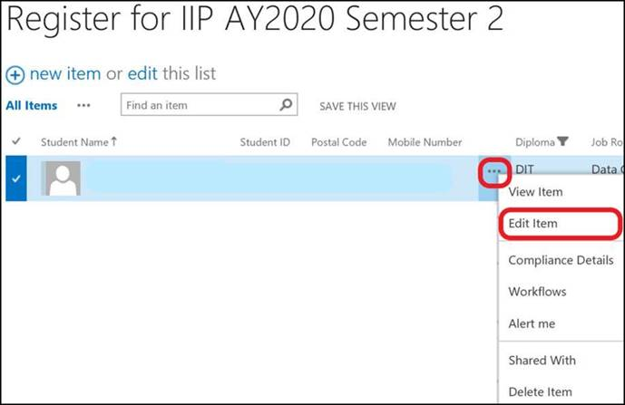

Click on  to remove your previous resume, and attached your new improved resume.

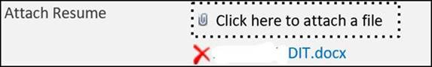

**Additional Resources for Career Guidance and Job Search Support**

We are pleased to share with you that the revamped ECG portal is now live and can be accessed via <go.gov.sg/ecgguide>. The portal contains information on ECG services and job search support for graduates including the RPJobsNet which can be directly accessed via <https://myrp.sharepoint.com/sites/findjobs/>. These will be useful when you are looking for full job employment nearing your graduation next year.

Thank you.

SOI IIP Management Team | School of Infocomm | Republic Polytechnic

9 Woodlands Avenue 9, Singapore 738964

DID 6369-8094 | General Enquiries 6510-3000 | Fax 6415-1310 | Website [www.rp.edu.sg](http://www.rp.edu.sg)

***Students who are placed on Stay-Home-Notice (SHN) or Quarantine Orders (Qhe lO) or Leave of Absence (LOA) should comply with the SHN, QO or LOA and Should NOT leave their home to attend any event mentioned in this email, if any, regardless the instructions****.* ***If you have any queries, please check with the staff-in-charge. Thank you.***