https://medium.com/@ausaf.cs/a-complete-guide-to-angular-pipes-f44670baccfc
A Complete Guide to Angular Pipes
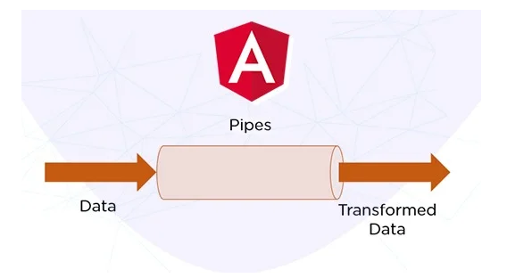
What Are Angular Pipes?
Angular Pipes allow you to transform and format data directly in templates without modifying the underlying data. They are great for:
✅ Formatting dates, numbers, currencies, and text
✅ Filtering lists
✅ Creating custom data transformations
Instead of writing extra code in your TypeScript files, you can apply transformations inline using pipes.
🔹 Using Built-in Pipes
Angular provides several built-in pipes that help format and transform data in templates:
DatePipe — Formats dates into different formats.
Example: {{ today | date:'fullDate' }}
Output: Monday, February 10, 2025
CurrencyPipe — Converts numbers into currency format.
Example: {{ price | currency:'USD' }}
Output: $100.00
UpperCasePipe — Converts text to uppercase.
Example: {{ 'angular' | uppercase }}
Output: ANGULAR
LowerCasePipe — Converts text to lowercase.
Example: {{ 'Angular' | lowercase }}
Output: angular
Get Ausaf Ahmad’s stories in your inbox
Join Medium for free to get updates from this writer.
DecimalPipe — Formats numbers with decimal precision.
Example: {{ 1234.56 | number:'1.1-2' }}
Output: 1,234.56

Pure vs. Impure Pipes in Angular
1️.Pure Pipes (Default)
- Executes only when the input value changes.
- Improves performance by avoiding unnecessary recalculations.
- Used for static data transformations.
Example:
@Pipe({
name: 'purePipeExample'
})
export class PurePipeExample implements PipeTransform {
transform(value: string): string {
console.log('Pure Pipe Executed');
return value.toUpperCase();
}
}
If the input value remains the same, this pipe won’t re-run, making it highly efficient.
2. Impure Pipes
- Executes on every change detection cycle, even if the input hasn’t changed.
- Can be used for dynamic transformations, such as filtering an array.
- Less performant because it runs more frequently.
Example:
@Pipe({
name: 'impurePipeExample',
pure: false
})
export class ImpurePipeExample implements PipeTransform {
transform(values: any[]): any[] {
console.log('Impure Pipe Executed');
return values.filter(item => item.active);
}
}
Even if the input array reference remains the same, this pipe recalculates on every change detection cycle.
🔹 Custom Pipes in Angular
Sometimes, built-in pipes aren’t enough. That’s when custom pipes come in handy!
Step 1: Generate a Custom Pipe
ng generate pipe reverseText
Step 2: Define Pipe Logic
Modify reverse-text.pipe.ts:
import { Pipe, PipeTransform } from '@angular/core';
@Pipe({
name: 'reverseText'
})
export class ReverseTextPipe implements PipeTransform {
transform(value: string): string {
return value.split('').reverse().join('');
}
}
Step 3: Use the Custom Pipe in a Template
<p>{{ 'Angular' | reverseText }}</p>
Output: ralugnA
🔹 When to Use Pipes vs. Component Logic?
🚀 Use Pipes When:
✔ You need simple formatting (dates, currency, uppercase, lowercase).
✔ You want to keep templates clean and readable.
⚡ Use Component Logic When:
✔ You need complex business logic.
✔ Performance is critical (pipes run every change detection cycle).

🔹 Conclusion
Angular Pipes are a powerful way to transform data without writing extra code in your components.
🔹 Use built-in pipes for common tasks like date formatting, currency, and text transformations.
🔹 Create custom pipes for specific use cases.
🔹 Be mindful of performance — use pure pipes when possible and impure pipes only when necessary.

