What Are Angular Standalone Components?
https://dev.to/nicholajones075/angular-standalone-components-vs-traditional-modules-an-ultimate-guide-1923
Angular standalone components were introduced with the release of Angular v14. They were designed to operate independently without the need to be declared in an Angular module. These components simplify the development process by minimizing boilerplate code and making dependency management more efficient. You can hire Angular developer to utilize these features to build robust and scalable applications effectively.
Key Features:
You should know the following are some of the key features of Standalone components in Angular.
- Self-contained: They can function without being part of NgModule.
- Import dependencies directly: Use import statements in the component itself.
- Enhanced flexibility: Ideal for micro frontends or standalone applications.
Benefits of Using Standalone Components
Let’s discuss some of the benefits of leveraging standalone components in your Angular project.
- Reduced Boilerplate: Standalone components remove the requirement for NgModule declarations, simplifying the setup process.
- Improved Flexibility: They are excellent for microservices or micro-frontend architectures where components must work independently.
- Simplified Dependency Management: Dependencies can be directly imported into the component without worrying about module imports.
import { Component } from '@angular/core';
import { CommonModule } from '@angular/common';

@Component({
selector: 'app-standalone',
standalone: true,
imports: [CommonModule],
template: `<h1>Standalone Component</h1>`
})
export class StandaloneComponent {}

What Are Traditional Modules in Angular?
The traditional modules have been a core part of Angular since its inception. An Angular module (NgMogule) is a class marked with the @NgModule decorator. It organizes an application into cohesive functionality blocks, making managing and scaling larger projects easier.
Key Features:
The following are some of the features of traditional modules in Angular:
- Structure hierarchy: Organizes components, directives, and pipes within modules.
- Reusability: Modules can be imported and exported across the application.
- Coordination: Strongly coupled with dependency injection.

Benefits of Using Traditional Modules:
Let’s discuss some of the best advantages of using traditional modules.
- Structured Organization: Modules offer a well-defined structure, making it easier to manage large applications.
- Reusability: Encapsulating features within modules allows them to be reused throughout the application, minimizing code duplication.
- Community Familiarity: Most Angular developers are accustomed to the module-based approach, which makes it easier for teams to collaborate.

import { NgModule } from '@angular/core';
import { CommonModule } from '@angular/common';
import { TraditionalComponent } from './traditional.component';

@NgModule({
declarations: [TraditionalComponent],
imports: [CommonModule],
exports: [TraditionalComponent]
})
export class TraditionalModule {}

Standalone Components vs. Traditional Modules: A Comparison
The below mentioned is the table of comparison of Standalone components vs. traditional modules.
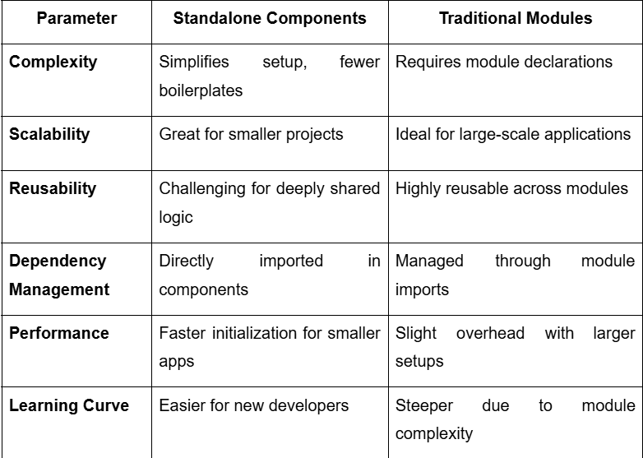
When to Use Which One?
Here are some common use cases for Angular standalone components.
- Small Projects: For smaller applications or POCs, standalone components offer simplicity and speed.
- Micro Frontends: Standalone components can produce better results when building modular applications where each feature must function independently.
- Testing and Prototyping: If you want to experiment with Angular without setting up full-fledged modules, you can use standalone components.
Now, let’s explore some of the use cases for traditional modules.
- Large-Scale Applications: For enterprise-level projects, modules provide a structured and scalable foundation.
- Shared Features: Traditional NgModules are useful when you reuse components, directives, or services across multiple application parts.
- Legacy Projects: If you are working on an existing application built using modules, it is advisable to continue using NgModules.

Conclusion:
In this article, we have compared Angular standalone components vs. traditional modules, and each has its strengths and weaknesses. While standalone components are ideal for simplifying development and promoting flexibility, traditional NgModules excel in maintaining structure and scalability for larger projects. The decision ultimately depends on the structure and scalability requirements of larger projects. The ideal approach will depend on how complex your project is, how large it is, and how you plan to maintain it over time. However, if you want any guidance or want to build an Angular application with Standalone components or NgModules, you can get in touch with an Angular development company. They will help you make informed decisions that align with your development needs and ensure the success of your application.

Angular Modules vs. Standalone Components: A Detailed Comparison
https://medium.com/@ausaf.cs/angular-modules-vs-standalone-components-a-detailed-comparison-7b28c803cdd2
When Angular introduced standalone components in version 14, it opened up a new way of building applications. But how do they compare to traditional modules? In this post, we’ll dive into the differences, benefits, and scenarios where each approach shines.

What Are Angular Modules?
Modules are the backbone of Angular applications. They group related components, directives, pipes, and services into cohesive units.
Key Characteristics:
- Declarative: Lists components, directives, and pipes it owns.
- Organizational Tool: Helps manage large codebases.
- Lazy Loading: Optimizes app performance.
Example:
@NgModule({
declarations: [ComponentA, ComponentB],
imports: [CommonModule],
exports: [ComponentA]
})
export class FeatureModule {}

What Are Standalone Components?
Introduced in Angular 14, standalone components allow you to build components without relying on a module.
Key Characteristics:
- Self-Contained: Can import required dependencies directly.
- Simplifies Small Apps: Ideal for lightweight applications.
- Streamlined Structure: Reduces boilerplate.
Example:
@Component({
selector: 'app-standalone',
standalone: true,
imports: [CommonModule],
template: `<h1>Hello Standalone!</h1>`
})
export class StandaloneComponent {}
Key Differences Between Angular Modules and Standalone Components
Introduced In:
- Angular Modules: Available since Angular 2.
- Standalone Components: Introduced in Angular 14.
Use Case:
- Angular Modules: Best for large, structured applications.
- Standalone Components: Suitable for small, modular, or isolated components.
Dependency Management:
- Angular Modules: Dependencies are managed centrally through @NgModule.
- Standalone Components: Dependencies are imported directly within the component.
Lazy Loading:
- Angular Modules: Fully supports lazy loading of feature modules.
- Standalone Components: Requires a custom setup or Router-based lazy loading.
Boilerplate Code:
- Angular Modules: Involves more setup and boilerplate.
- Standalone Components: Reduces boilerplate and simplifies structure.
When to Use Each
Use Angular Modules When:
- Building large-scale, enterprise-level applications.
- Managing complex dependencies.
- Using lazy-loaded feature modules.
Use Standalone Components When:
- Developing small, focused applications or micro-frontends.
- Creating isolated components for libraries or testing.
- Experimenting with modern Angular features.
Real-World Scenario
Imagine you’re building an e-commerce site:
- Use modules for grouping features like ProductModule, CartModule, and OrderModule.
- Use standalone components for isolated utilities like a custom button or modal.
Quick Exercise
Try converting one of your existing components into a standalone component. Observe the differences in structure and dependency imports.
Conclusion
Angular Modules and Standalone Components each have their strengths. Choosing the right approach depends on your application’s size, complexity, and goals.

https://blog.angular-university.io/angular-standalone-components/
Angular Standalone Components: Complete Guide
A complete guide to Angular standalone components. Learn why they are way better than regular components, and how to easily upgrade to them.
The main benefit of standalone components in Angular is probably not what you think it is.
In this guide we are going to learn everything about standalone components, and how they are better than NgModule-based components.
We are going to lay out in our next sections all the advantages of standalone components, an explain why some of their perceived disadvantages aren't that big of a problem after all.
We are also going to learn how standalone components can help make your application much faster, with minimal refactoring.
We will also look at how you can easily migrate your application to standalone components, and start reaping all these benefits.
Table of Contents
- What are standalone components?
- Using standard directives in standalone components
- Why Standalone Components?
- So what is the main practical benefit of standalone components?
- Standalone Pipes
- Standalone Directives
- Using standalone components in NgModule-based components
- Using NgModule-based components in standalone components
- Lazy loading with standalone components
- Application bootstrapping with standalone components
- Easily migrating to standalone components
- Summary

