Types of Functional Interfaces in Java
A functional interface in Java is an interface that has only one abstract method, making it suitable for use with lambda expressions and method references (introduced in Java 8).
- Use @FunctionalInterface to ensure only one abstract method (annotation is optional).
- Enable clean, concise code using lambdas and method references.

Java 8 introduced four main functional interface types under the package java.util.function. These are widely used in Stream API, collections and lambda-based operations.
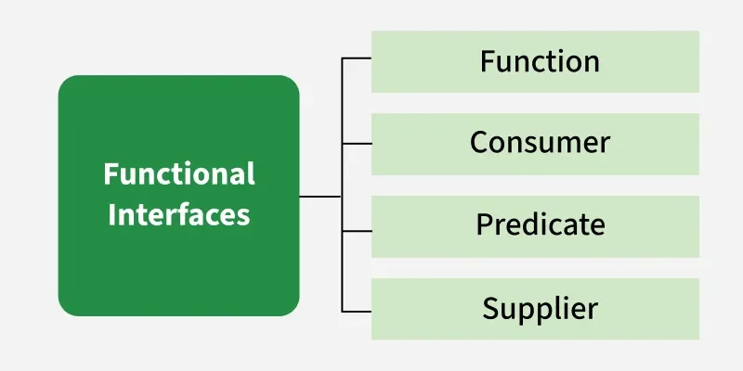

1. Consumer
Consumer interface of the functional interface is the one that accepts only one argument. It is used for performing an action, such as printing or logging. There are also functional variants of the Consumer DoubleConsumer, IntConsumer and LongConsumer.
Syntax:
Consumer<Integer> consumer = (value) -> System.out.println(value);

Example:
// Consumer to multiply 2 to every integer of a list
Consumer<List<Integer> > modify = list -> {
for (int i = 0; i < list.size(); i++) {
list.set(i, 2 * list.get(i));
}
};
// Implement modify using accept()
dispList.accept(list); // 4 2 6

// Consumer to multiply 2 to every integer of a list
Consumer<List<Integer> > modify = list -> {
for (int i = 0; i < list.size(); i++)
list.set(i, 2 * list.get(i));
};

// Consumer to display a list of integers
Consumer<List<Integer>> dispList = list -> list.stream().forEach(a -> System.out.print(a + " "));

List<Integer> list = new ArrayList<Integer>();
list.add(2);
list.add(1);
list.add(3);
modify.andThen(dispList).accept(list); // 4 2 6

2. Predicate
Predicate interface represents a boolean-valued function of one argument. It is commonly used for filtering operations in streams. There are also functional variants of the Predicate IntPredicate, DoublePredicate and LongPredicate.
In Java 8, Predicate is a functional interface, which accepts an argument and returns a boolean. Usually, it used to apply in a filter for a collection of objects.
Syntax:
public interface Predicate<T> {
boolean test(T t);
}
The Java predicate functional interface can also be implemented using Lambda expressions.
Predicate<Integer> predicate = (value) -> value != null;
Example:
// Creating predicate
Predicate<Integer> lesserthan = i -> (i < 18);

// Calling Predicate method
System.out.println(lesserthan.test(10));

Predicate<Integer> greaterThanTen = (i) -> i > 10;
Predicate<Integer> lowerThanTwenty = (i) -> i < 20;
boolean result = greaterThanTen.and(lowerThanTwenty).test(15);
System.out.println(result); // true

3. Function
The function interface takes one argument and returns a result. It is commonly used for transforming data. Several variations exist:
In Java 8, Function is a functional interface; it takes an argument (object of type T) and returns an object (object of type R). The argument and output can be a different type.
Function.java
@FunctionalInterface
public interface Function<T, R> {
R apply(T t);
}
- T – Type of the input to the function.
- R – Type of the result of the function.

Syntax:
Function<Integer, Integer> function = (value) -> value * value;

Example:
// Function which takes in a number and returns half of it
Function<Integer, Double> half = a -> a / 2.0;

// Applying the function to get the result
System.out.println(half.apply(10));

// Function which takes in a number and returns half of it
Function<Integer, Double> half = a -> a / 2.0;

// Triple the value given to half function
half = half.compose(a -> 3 * a);

// Applying the function to get the result
System.out.println(half.apply(5)); // 7.5

4. Supplier
Supplier functional interface is also a type of functional interface that does not take any input or argument and yet returns a single output. The different extensions of the Supplier functional interface hold many other suppliers functions like BooleanSupplier, DoubleSupplier, LongSupplier and IntSupplier.
Syntax:
Supplier<String> supplier = () -> "Hello, World!";
Example:
// This function returns a random value.
Supplier<Double> randomValue = () -> Math.random();

// Print the random value using get()
System.out.println(randomValue.get());
Functional Interfaces Table
Functional Interfaces | Description | Method
Runnable | It represents a task that can be executed by a thread. | void run()
Comparable | It compares two objects for ordering. | int compareTo(T o)
ActionListener | It handles an action event in event-driven programming. | void actionPerformed(ActionEvent e)
Callable | It represents a task that can return a result or throw an exception. | V call() throws Exception
Consumer | It accepts a single input argument and returns no result. | void accept(T t)
Predicate | It accepts a single argument and returns a boolean result. | boolean test(T t)
Function | It accepts a single argument and returns a result. | R apply(T t)
Supplier | It does not take any arguments but provides a result. | T get()
BiConsumer | It accepts two arguments and returns no result. | void accept(T t, U u)
BiPredicate | It accepts two arguments and returns a boolean result. | boolean test(T t, U u)
BiFunction | It accepts two arguments and returns a result. | R apply(T t, U u)
UnaryOperator | This is a special case of Function, where input and output types are the same. | T apply(T t)
BinaryOperator | This is a special case of BiFunction, where input and output types are the same. | T apply(T t1, T t2)

