Java Servlet
Servlet je program napsaný v jazyce Java, který je nástrojem pro tvorbu webových aplikací. Funguje na principu zpracování HTTP požadavků a generování HTML stránek. Tvoří vrstvu mezi HTTP požadavkem od webového klienta a databází nebo aplikací na jiném serveru. Servletem je každá Java třída, která implementuje interface javax.servlet.Servlet. Protože ale z praktického hlediska má smysl uvažovat pouze servlety obsluhující protokol HTTP, je důležitější vědět, že HTTP servletem je každá třída, která je potomkem třídy javax.servlet.http.HttpServlet.
Servlet is a Java program that runs on a Java-enabled web server or application server. It handles client requests, processes them and generates responses dynamically. Servlets are the backbone of many server-side Java applications due to their efficiency and scalability.
Životní cyklus servletu
zahrnuje vytváření, inicializaci, zpracování požadavků a zničení, to vše spravované kontejnerem, jako je Tomcat nebo WebLogic. Tento řízený životní cyklus zajišťuje efektivní zpracování požadavků tím, že používá jednu instanci k obsluze více požadavků, na rozdíl od CGI, které spouští nové procesy pro každý požadavek.
Kroky životního cyklu servletu
- Načítání a vytváření instancí u kontejneru.
- Inicializace přes init() metoda.
- Zpracování požadavku použitím service() si doGet() or doPost().
- Zničení přes destroy() metoda.

Výhody oproti CGI
Servlet | CGI
Založené na vláknech → vysoký výkon | Procesní → pomalejší
Lepší efektivita paměti | Vysoká spotřeba zdrojů
Integrovaný Java ekosystém | Závislé na jazyce

Features of Java Servlets
- Work on the server-side.
- Efficiently handle complex client requests.
- Generate dynamic responses.
- Provide better performance compared to older technologies like CGI.
- Highly scalable in enterprise-level web applications.

Java Servlets Architecture
Java servlets container play a very important role. It is responsible for handling important tasks like load balancing, session management and resource allocation, it make sure that all the requests are process efficiently under high traffic. The container distribute requests accross multiple instances, which helps improve the system performance.
Servlet Architecture can be depicted from the image itself as provided below as follows:
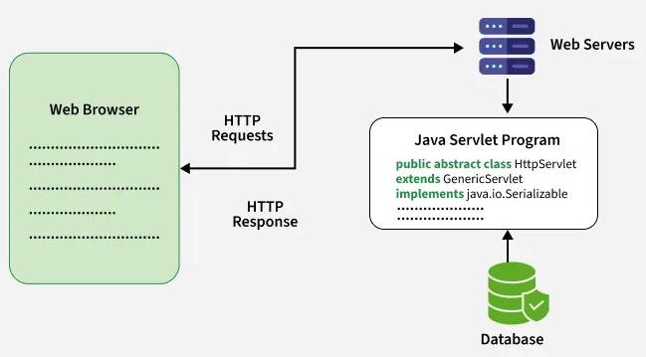
Servlet Architecture Workflow:
Execution of Servlets basically involves Six basic steps:
- The Clients send the request to the Web Server.
- The Web Server receives the request.
- The Web Server passes the request to the corresponding servlet.
- The Servlet processes the request and generates the response in the form of output.
- The Servlet sends the response back to the webserver.
- The Web Server sends the response back to the client and the client browser displays it on the screen.

Need of Server-Side Extensions
- Server-side extensions allow dynamic web page generation by running programs on the server.
- Web servers provide APIs to help developers build these applications.
- Java Servlets (part of Jakarta EE) are a key API for Java-based web development.

Servlet Container
Servlet container, also known as Servlet engine, is an integrated set of objects that provide a run time environment for Java Servlet components. It is a system that manages Java Servlet components on top of the Web server to handle the Web client requests.

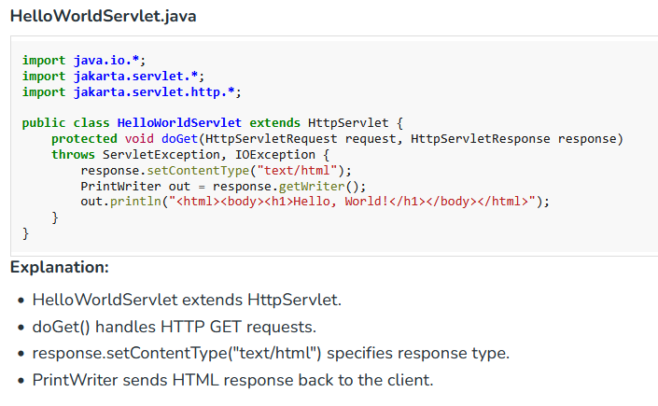
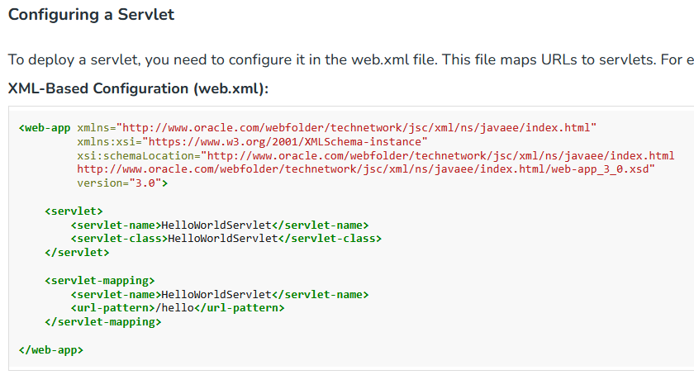
Explanation:
This is a web.xml file used for mapping URLs to servlets. So, when you visit http://localhost:8080/yourApp/hello, the servlet runs and shows "Hello, World!" in the browser.

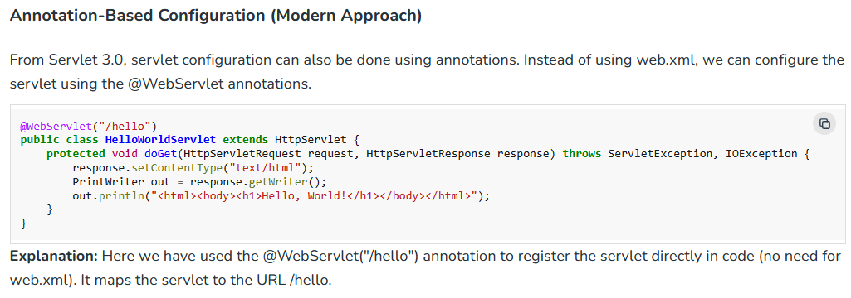

A Java Web Server
is a specialized software that handles HTTP requests and responses, facilitating the deployment and management of Java-based web applications. It serves as the intermediary between the client (often a web browser) and the server-side components, such as servlets and JSPs (JavaServer Pages)
A web server is a machine program that receives the request from the user’s browser for a particular web page. It finds the correct information and sends it back. Thus, this web server and client request and response happens in the background every time a user opens your webpage.
For example, the user sends a request for a form, then a web server will give that form. When he clicks on submit, it will process and return the result. This way, it keeps on responding to all the user steps.
some of the best Java servers:
Apache Tomcat
Tomcat is the most used Java Web Server in the world. It supports servlets and JSP. Well, it is lightweight, easy to configure, and works well for most projects, so developers prefer it. Also, it is open-source.
Jetty
Jetty is a flexible and small Java server that works fast and is often used with Spring Boot. You can get more control over server behaviour. Also, it is good for embedded systems.
GlassFish
GlassFish supports full Java EE or Jakarta EE features. You can run advanced enterprise applications with it. For example, Government and corporate systems use it for its complete support of enterprise-level components.
WildFly
Red Hat developed WildFly, which supports enterprise Java features. It is useful when you need strong performance and advanced options. You can scale your applications and manage them easily.

Which Java Web Server to Use?
Server | Best For | Special Feature
Tomcat | General purpose web apps | Simple and reliable
Jetty | Lightweight and embedded use | Fast and flexible
GlassFish | Full enterprise applications | Complete Java EE support
WildFly | High-performance enterprise | Scalable and robust

