Grid system
Use our powerful mobile-first flexbox grid to build layouts of all shapes and sizes thanks to a twelve column system, six default responsive tiers, Sass variables and mixins, and dozens of predefined classes.
Grid options
Bootstrap’s grid system can adapt across all six default breakpoints, and any breakpoints you customize. The six default grid tiers are as follows:
- Extra small (xs)
- Small (sm)
- Medium (md)
- Large (lg)
- Extra large (xl)
- Extra extra large (xxl)
As noted above, each of these breakpoints have their own container, unique class prefix, and modifiers. Here’s how the grid changes across these breakpoints:
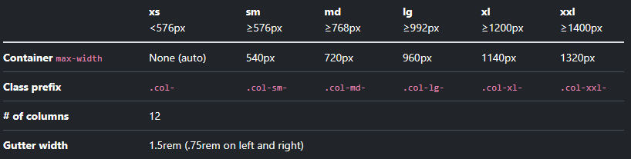


<div class="container text-center">
<div class="row">
<div class="col">1 of 2</div>
<div class="col">2 of 2</div>
</div> <div class="row">
<div class="col">1 of 3</div>
<div class="col">2 of 3</div>
<div class="col">3 of 3</div>
</div>
</div>

Setting one column width
Auto-layout for flexbox grid columns also means you can set the width of one column and have the sibling columns automatically resize around it. You may use predefined grid classes (as shown below), grid mixins, or inline widths. Note that the other columns will resize no matter the width of the center column.


<div class="container text-center">
<div class="row">
<div class="col">1 of 3</div>
<div class="col-6">2 of 3 (wider) </div>
<div class="col">3 of 3</div>
</div>
<div class="row">
<div class="col">1 of 3</div>
<div class="col-5">2 of 3 (wider) </div>
<div class="col">3 of 3</div>
</div>
</div>

Variable width content
Use col-{breakpoint}-auto classes to size columns based on the natural width of their content.

<div class="container text-center">
<div class="row justify-content-md-center">
<div class="col col-lg-2">1 of 3</div>
<div class="col-md-auto">Variable width content</div>
<div class="col col-lg-2">3 of 3</div>
</div>
<div class="row">
<div class="col">1 of 3</div>
<div class="col-md-auto">Variable width content</div>
<div class="col col-lg-2">3 of 3</div>
</div>
</div>
Columns
- Columns build on the grid’s flexbox architecture. Flexbox means we have options for changing individual columns and modifying groups of columns at the row level. You choose how columns grow, shrink, or otherwise change.
- When building grid layouts, all content goes in columns. The hierarchy of Bootstrap’s grid goes from container to row to column to your content. On rare occasions, you may combine content and column, but be aware there can be unintended consequences.
- Bootstrap includes predefined classes for creating fast, responsive layouts. With six breakpoints and a dozen columns at each grid tier, we have dozens of classes already built for you to create your desired layouts. This can be disabled via Sass if you wish.

Alignment
Use flexbox alignment utilities to vertically and horizontally align columns.
Vertical alignment
Change the vertical alignment with any of the responsive align-items-* classes.

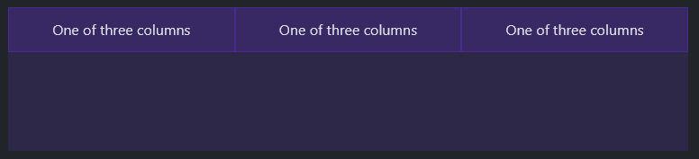
<div class="container text-center">
<div class="row align-items-start">
<div class="col">One of three columns</div>
<div class="col">One of three columns</div>
<div class="col">One of three columns</div>
</div>
</div>


<div class="container text-center">
<div class="row align-items-center">
<div class="col">One of three columns</div>
…


<div class="container text-center">
<div class="row align-items-end">
<div class="col">One of three columns</div>
…


<div class="container text-center">
<div class="row">
<div class="col align-self-start">One of three columns</div>
<div class="col align-self-center">One of three columns</div>
<div class="col align-self-end">One of three columns</div>
</div>
</div>

Horizontal alignment
Change the horizontal alignment with any of the responsive justify-content-* classes.
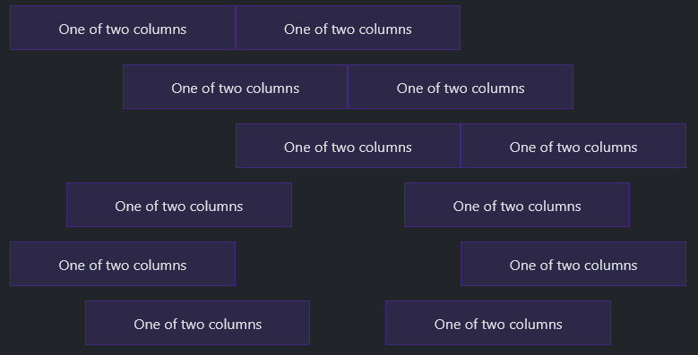
<div class="container text-center">
<div class="row justify-content-start">
<div class="col-4">One of two columns</div>
<div class="col-4">One of two columns</div>
</div>
<div class="row justify-content-center">
<div class="col-4">One of two columns</div>
<div class="col-4">One of two columns</div>
</div>
<div class="row justify-content-end">
<div class="col-4">One of two columns</div>
<div class="col-4">One of two columns</div>
</div>
<div class="row justify-content-around">
<div class="col-4">One of two columns</div>
<div class="col-4">One of two columns</div>
</div>
<div class="row justify-content-between">
<div class="col-4">One of two columns</div>
<div class="col-4">One of two columns</div>
</div>
<div class="row justify-content-evenly">
<div class="col-4">One of two columns</div>
<div class="col-4">One of two columns</div>
</div>
</div>

Column wrapping
If more than 12 columns are placed within a single row, each group of extra columns will, as one unit, wrap onto a new line.
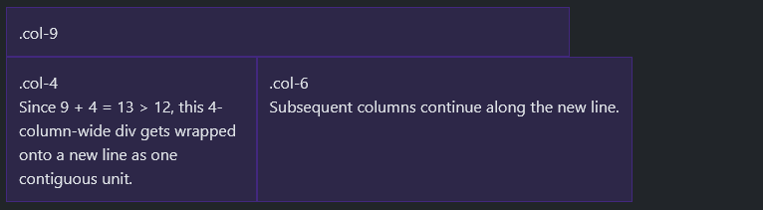
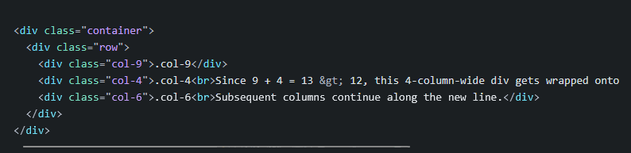
Column breaks
Breaking columns to a new line in flexbox requires a small hack: add an element with width: 100% wherever you want to wrap your columns to a new line. Normally this is accomplished with multiple .rows, but not every implementation method can account for this.
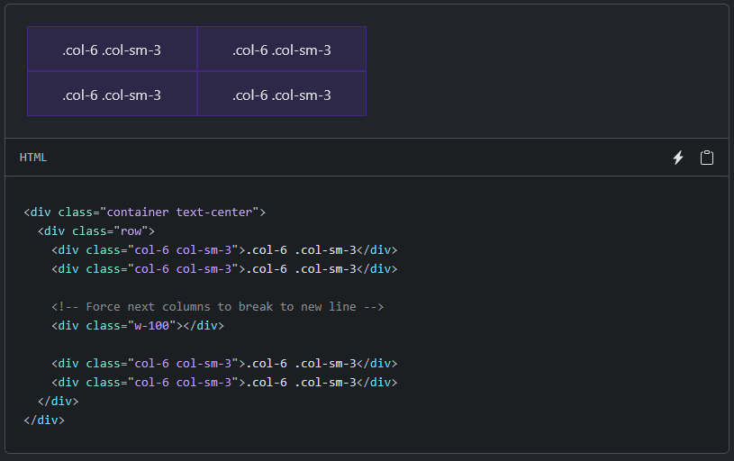

Offsetting columns
You can offset grid columns in two ways: our responsive .offset- grid classes and our margin utilities. Grid classes are sized to match columns while margins are more useful for quick layouts where the width of the offset is variable.
Offset classes
Move columns to the right using .offset-md-* classes. These classes increase the left margin of a column by * columns. For example, .offset-md-4 moves .col-md-4 over four columns.
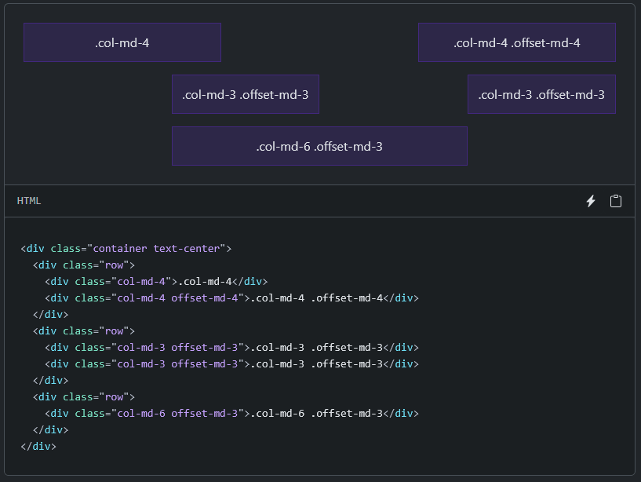
In addition to column clearing at responsive breakpoints, you may need to reset offsets. See this in action in the grid example.

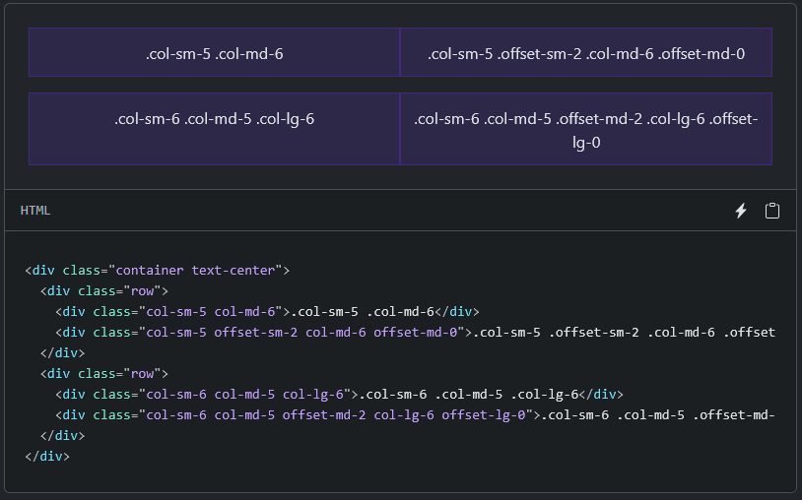

Margin utilities
With the move to flexbox in v4, you can use margin utilities like .me-auto to force sibling columns away from one another.
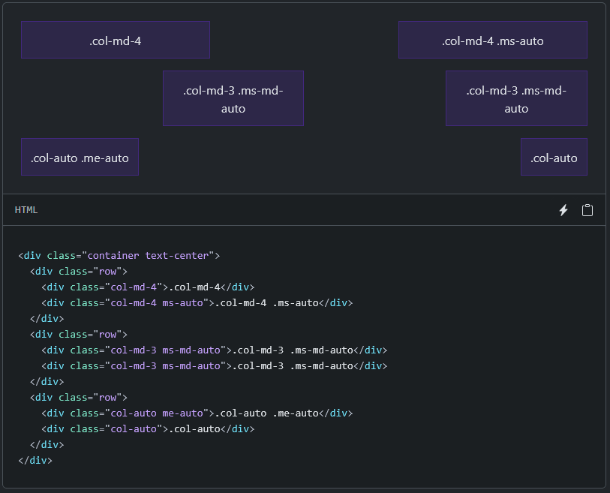

Gutters
Gutters are the padding between your columns, used to responsively space and align content in the Bootstrap grid system.

How they work
- Gutters are the gaps between column content, created by horizontal padding. We set padding-right and padding-left on each column, and use negative margin to offset that at the start and end of each row to align content.
- Gutters start at 1.5rem (24px) wide. This allows us to match our grid to the padding and margin spacers scale.
- Gutters can be responsively adjusted. Use breakpoint-specific gutter classes to modify horizontal gutters, vertical gutters, and all gutters.

Horizontal gutters
.gx-* classes can be used to control the horizontal gutter widths. The .container or .container-fluid parent may need to be adjusted if larger gutters are used too to avoid unwanted overflow, using a matching padding utility. For example, in the following example we’ve increased the padding with .px-4:

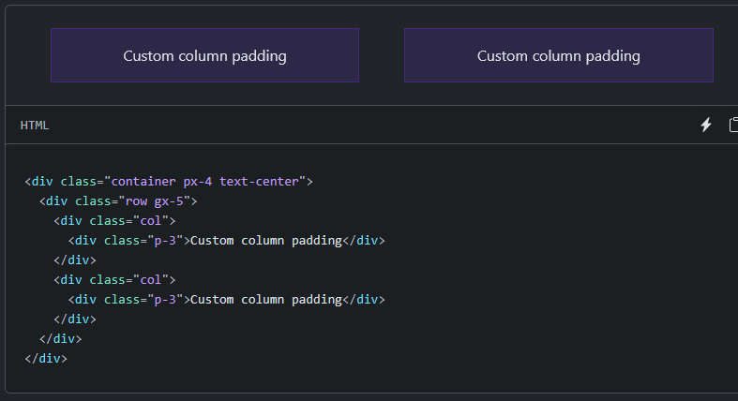

An alternative solution is to add a wrapper around the .row with the .overflow-hidden class:
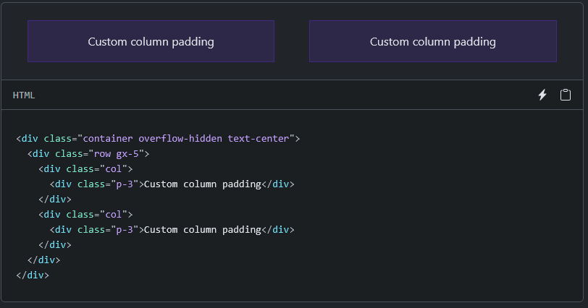

Vertical gutters
.gy-* classes can be used to control the vertical gutter widths within a row when columns wrap to new lines. Like the horizontal gutters, the vertical gutters can cause some overflow below the .row at the end of a page. If this occurs, you add a wrapper around .row with the .overflow-hidden class:

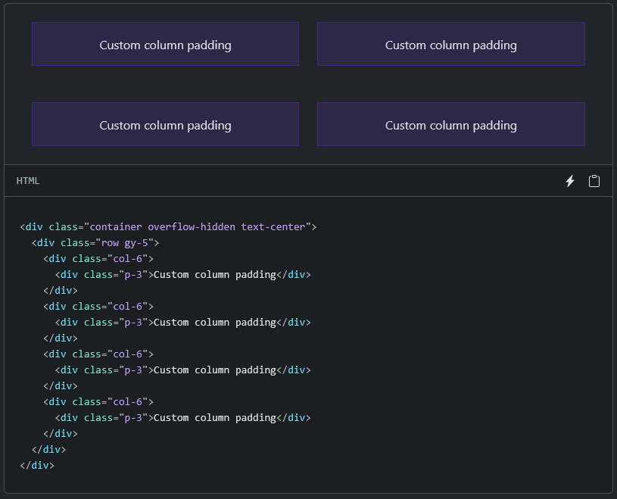

Horizontal & vertical gutters
Use .g-* classes to control the horizontal and vertical grid gutters. In the example below, we use a smaller gutter width, so there isn’t a need for the .overflow-hidden wrapper class.
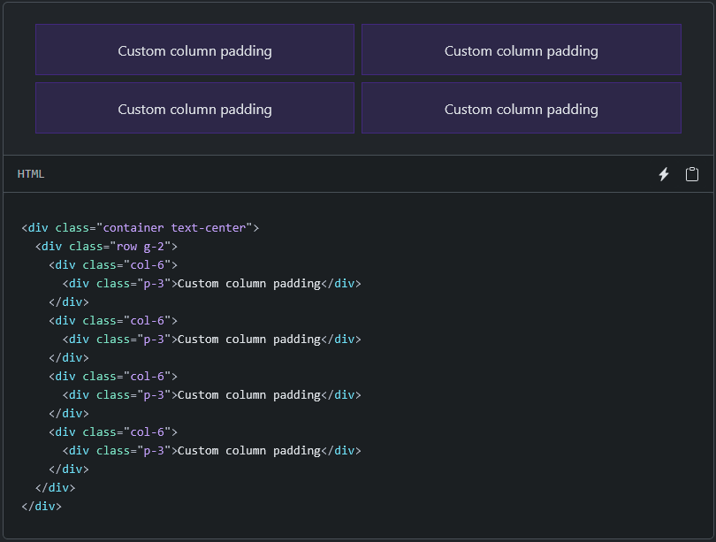

Row columns gutters
Gutter classes can also be added to row columns. In the following example, we use responsive row columns and responsive gutter classes.
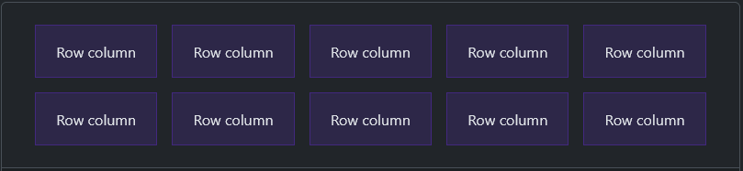
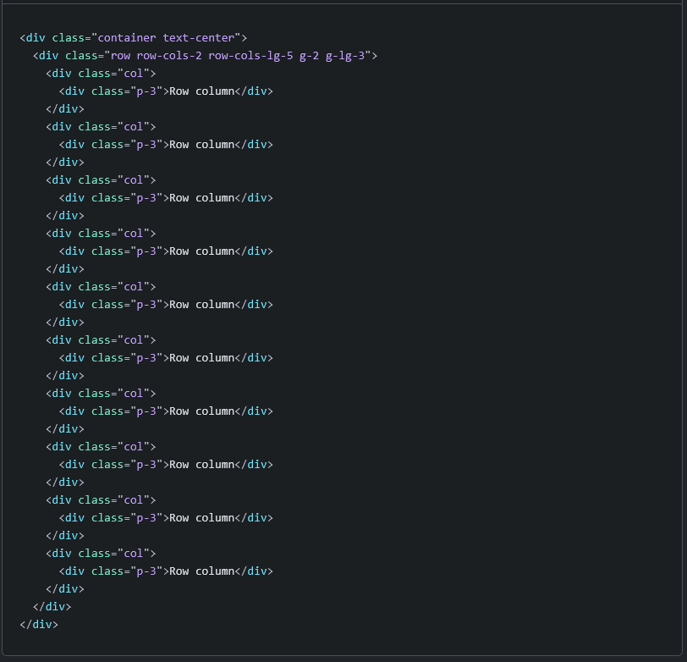

No gutters
The gutters between columns in our predefined grid classes can be removed with .g-0. This removes the negative margins from .row and the horizontal padding from all immediate children columns.
Need an edge-to-edge design? Drop the parent .container or .container-fluid and add .mx-0 to the .row to prevent overflow.
In practice, here’s how it looks. Note that you can continue to use this with all other predefined grid classes (including column widths, responsive tiers, reorders, and more).
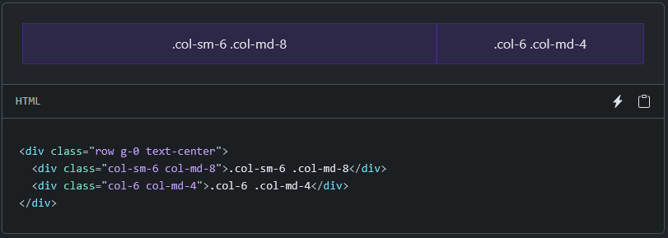

Sizing
Easily make an element as wide or as tall with our width and height utilities.

Relative to the parent
Width and height utilities are generated from the utility API in _utilities.scss. Includes support for 25%, 50%, 75%, 100%, and auto by default. Modify those values as you need to generate different utilities here.
