Kotlin
is a modern but already mature programming language designed to make developers happier. It's concise, safe, interoperable with Java and other languages, and provides many ways to reuse code between multiple platforms for productive programming.
Kotlin is used for:
- Mobile applications (specially Android apps)
- Web development
- Server side applications
- Data science
- And much, much more!

Why Use Kotlin?
- Kotlin is fully compatible with Java
- Kotlin works on different platforms (Windows, Mac, Linux, Raspberry Pi, etc.)
- Kotlin is concise and safe
- Kotlin is easy to learn, especially if you already know Java
- Kotlin is free to use
- Big community/support

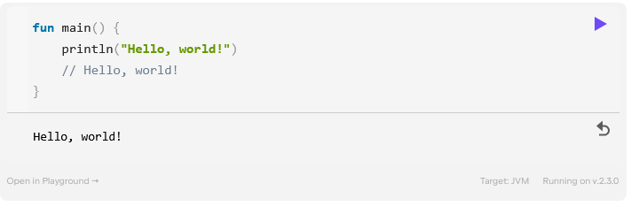
In Kotlin:
- fun is used to declare a function
- The main() function is where your program starts from
- The body of a function is written within curly braces {}
- println() and print() functions print their arguments to standard output

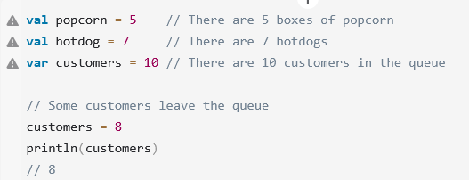

https://www.like-it.sk/cz/n/260/jak-zacit-s-kotlin-navod-pro-zacatecniky.html

