Microservices Architecture with NodeJS
Microservices architecture allows us to break down complex applications into smaller, independently deployable services. Node.js, with its non-blocking I/O and event-driven nature, is an excellent choice for building microservices.
How to Build a Microservices Architecture with NodeJS?
Microservices architecture can involve designing the application as a collection of loosely coupled services. Each service is independent, deployable, and communicates over the network. This article will guide you through creating a microservices architecture using NodeJS.
https://www.apriorit.com/dev-blog/how-to-build-microservices-with-node-js
Microservices is an architectural pattern in which an application consists of a collection of loosely coupled, independently deployable services, each designed to perform a specific business function. Because these services operate independently, they enhance the application’s overall scalability and flexibility.
This architectural style allows for improved scalability, maintainability, and flexibility of modern software applications. The ability to independently deploy and scale services makes it easier to manage large codebases, implement new features, fix bugs, and manage user roles, effectively meeting the diverse needs of your clients.
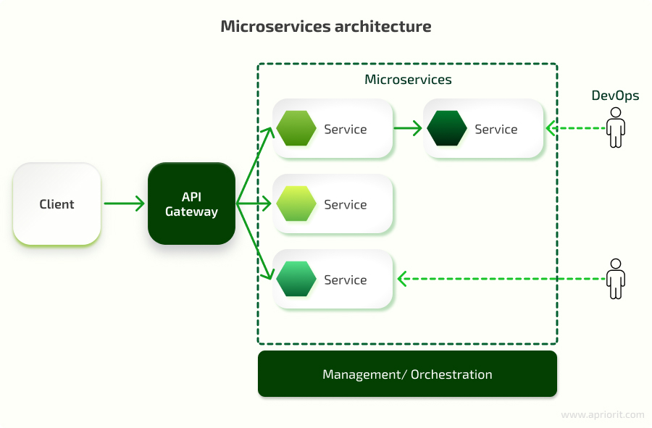
Node.js, a powerful tool for creating server-side cross-platform applications, has emerged as a popular choice for building microservices. Because of its event-driven design, which allows the system to respond to actions as they happen rather than waiting for tasks to complete, Node.js is perfect for handling lots of data at once. It is also well-suited for developing not only traditional websites and backend API services but also scalable and efficient microservices.
The compatibility of Node.js with advanced technologies like gRPC, TypeScript, and serverless architectures allows developers to build modern and adaptable services. The thriving Node.js community also provides extensive resources and frameworks, streamlining the microservices development process.
Why choose Node.js for your microservices architecture?
Adopting Node.js for microservices offers significant business advantages, driving both operational efficiency and market competitiveness for your business. Here are key benefits that you can leverage by implementing Node.js microservices:
