What is Next.js?
Next.js is a lightweight open-source React framework for creating fast-loading and SEO-friendly websites and applications. It was created by Vercel and released in 2016.
Next.js powers over 1.3 million websites, including those of brands like Loom, Target, TikTok, and The Washington Post. Next.js builds upon the foundation of React and adds features like route handlers, Server-Side Rendering (SSR), Static-Site Generation (SSG), and file-based routing that elevate the developer experience.
Benefits of Next.js?
- Active community: As a popular frontend framework, Next.js has a vibrant community of developers that regularly contribute third-party tools, learning resources, and templates to its ever-growing ecosystem.
- Provides built-in optimization features: Next.js further improves performance optimization by providing built-in optimization for images, fonts, and third-party scripts. This improves page speed and results in a better developer experience.
- Code Splitting: Next.js helps in splitting our code into smaller parts. This means that browsers only download the code they need, leading to faster loading website pages.
- SEO-friendly: Next.js SSR support allows search engines to crawl and index website content effectively. This makes it a great choice for websites that need high SEO rankings.
Build a Next.js Site with SEO Super Powers
Explore this practical guide to learn how to build an SEO-friendly website with Next.js and Prismic.
- Great developer experience: Next.js provides several built-in features like routing, different rendering methods, SSR, and code splitting, which improve productivity and shorten development time.

Tailwind
Tailwind is a CSS framework that speeds up the development process by allowing you to quickly write utility classes directly in your React code.
In Tailwind, you style elements by adding class names. For example, adding "text-blue-500" will turn the <h1> text blue:
https://tailwindcss.com/
Rapidly build modern websites without ever leaving your HTML

Next.js is a flexible React framework that gives you building blocks to create fast, full-stack web applications.
But what exactly do we mean by this? Let's spend some time expanding on what React and Next.js are and how they can help you build web applications.
Building blocks of a web application
There are a few things you need to consider when building modern applications. Such as:
- User Interface - how users will consume and interact with your application.
- Routing - how users navigate between different parts of your application.
- Data Fetching - where your data lives and how to get it.
- Rendering - when and where you render static or dynamic content.
- Integrations - what third-party services you use (for CMS, auth, payments, etc.) and how you connect to them.
- Infrastructure - where you deploy, store, and run your application code (serverless, CDN, edge, etc.).
- Performance - how to optimize your application for end-users.
- Scalability - how your application adapts as your team, data, and traffic grow.
- Developer Experience - your team's experience building and maintaining your application.
For each part of your application, you will need to decide whether you will build a solution yourself or use other tools, such as packages, libraries, and frameworks.
What is React?
React is a JavaScript library for building interactive user interfaces.
By user interfaces (UI), we mean the elements that users see and interact with on-screen.
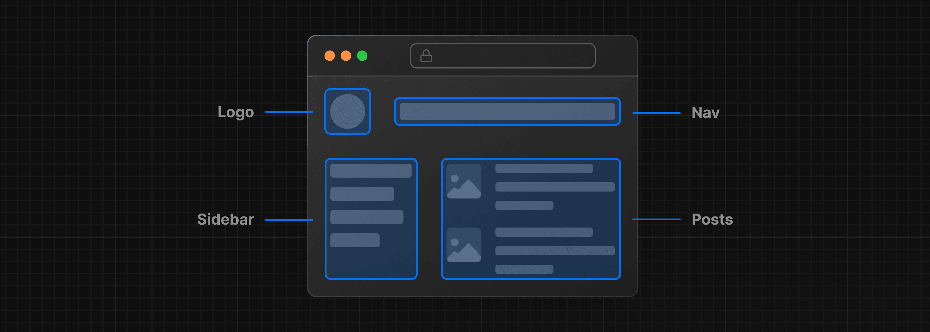
By library, we mean React provides helpful functions (APIs) to build UI, but leaves it up to the developer where to use those functions in their application.
Part of React's success is that it is relatively unopinionated about the other aspects of building applications. This has resulted in a flourishing ecosystem of third-party tools and solutions, including Next.js.
It also means, however, that building a complete React application from the ground up requires some effort. Developers need to spend time configuring tools and reinventing solutions for common application requirements.
What is Next.js?
Next.js is a React framework that gives you building blocks to create web applications.
By framework, we mean Next.js handles the tooling and configuration needed for React, and provides additional structure, features, and optimizations for your application.
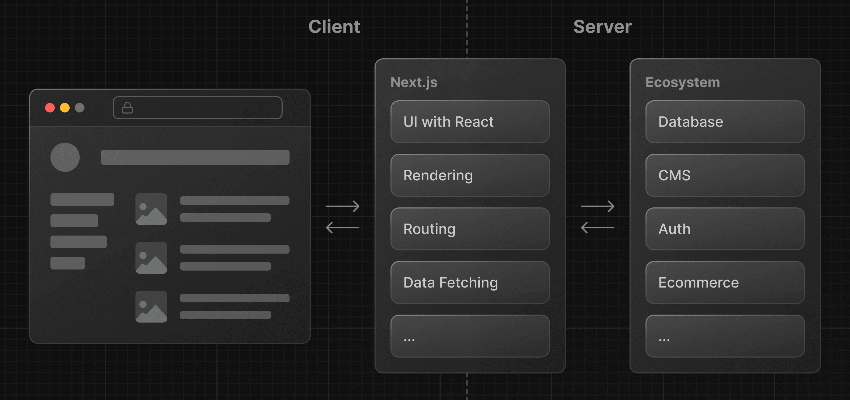
You can use React to build your UI, then incrementally adopt Next.js features to solve common application requirements such as routing, data fetching, and caching - all while improving the developer and end-user experience.
Whether you're an individual developer or part of a larger team, you can use React and Next.js to build fully interactive, highly dynamic, and performant web applications.

Next.js or Vite.js: Which Framework is Better, and When?
They’re both popular, both fast, and both backed by strong communities. But they take very different approaches to building modern websites.
Next.js is a React framework specialized in server-side rendering (SSR), static site generation (SSG), and hybrid applications. It provides features like file-based routing and image optimization, making it particularly suited for projects where SEO and fast initial load times are priorities.
Vite.js, in contrast, is a lightweight build tool that supports various frameworks including React, Vue, and Svelte. It focuses on client-side rendering, offering lightning-fast development startup and hot module replacement (HMR). Vite is ideal for projects where rapid iteration and reduced server complexity are key.
Both tools are evolving quickly — with major performance and DX upgrades in the latest releases — so let’s dive into what makes each one shine, where they differ, and how to choose the right fit for your next project.

What makes Next.js remarkable (pozoruhodný)?
Next.js offers many features that enhance the development experience and the performance of web apps, such as:
- File-System Routing: Next.js automatically creates routes based on the files in the pages (or new app) directory. This convention means you get intuitive, built-in routing without extra configuration.
- Image Optimization: Next.js provides a built-in <Image> component that automatically optimizes images for faster loading. It supports lazy loading, resizing, and quality adjustment out of the box.
- Internationalization (i18n): Next.js supports built-in internationalization and localization, allowing you to create multilingual web apps with ease using domain or subpath routing for locales.
- API Routes (Full-Stack Capabilities): You can create API endpoints in the pages/api directory. These serverless functions let you handle backend logic (like form submissions, database queries, etc.) within the same project, eliminating the need for a separate server.
- Incremental Static Regeneration (ISR): Next.js can update or regenerate specific static pages after the site has been built, without requiring a full rebuild. This means you can serve static content and still refresh it at runtime (e.g. after a certain interval or on demand), blending the benefits of static sites and dynamic content.
- Modern Performance Features: Recent Next.js versions (13 and above) have introduced a new App Router that leverages React Server Components and streaming. Next.js also began adopting a Rust-based bundler called Turbopack for development, which dramatically speeds up local server start and Fast Refresh times.

