Úvod do React
Zdroj: https://www.itnetwork.cz/javascript/react/zaklady/uvod-do-react
React je open-source javascriptová knihovna pro tvorbu uživatelského rozhraní (anglicky UI jako User Interface). Vyvinula ji společnost Meta (dříve Facebook).
Určitě jste si již zkusili, že manuální obsluha formulářů v JavaScriptu, jejich validace nebo třeba obnovování různých částí stránky novými daty, nejsou úplně triviální úlohy. Právě s tímto vším nám React pomůže a ve výsledku budeme mít aplikaci vytvořenou rychleji a kvalitněji. Důležité je také rozdělení aplikace do komunikujících komponent, čímž se zjednoduší.
Webová API
Uživatelská rozhraní v React typicky komunikují s nějakým webovým API serverem, ze kterého získávají data, případně mu data posílají. Díky tomu můžeme React aplikaci používat snadno na více zařízeních a máme stále aktuální data, protože jsou uložena na serveru. Tato serverová část aplikace může být napsaná také v JavaScriptu, např. v prostředí Node.js. React se nicméně používá prakticky s jakýmkoli dalším programovacím jazykem běžícím s databází na serveru (Java, C#, PHP, ...).
React je knihovna, ne komplexní framework
Na rozdíl od různých kompletních frameworků (např. Angular) se React soustředí na jednu specifickou oblast - UI. Pokud jste seznámeni s konceptem MVC architektury, React tvoří právě a pouze view, tedy pohledovou vrstvu aplikace, která prezentuje data uživateli. React se z tohoto důvodu s oblibou používá s dalšími knihovnami a existuje kolem něj celý ekosystém. Ten je potom předmětem navazujících kurzů. Pro účely tohoto kurzu si nicméně vystačíme s téměř čistým Reactem.
React je v současné době na trhu práce jednou z nejoblíbenějších a nejžádanějších technologií. Určitě je tedy skvělou volbou jako další znalost webového programátora, kterou lze využít na front-end většiny běžných aplikací.
Jak React aplikace fungují
React komponenty
Základní stavební kameny React aplikací tvoří tzv. komponenty (components). To jsou různé znovupoužitelné HTML elementy se zapouzdřenou funkcionalitou, jejichž skládáním vzniká komplexní UI aplikace. Komponentou může být např. přihlašovací formulář nebo hvězdičkové hodnocení produktu. Rozdělením aplikace na menší celky je aplikace přehlednější a vývoj jednodušší.
React komponenty pak mají své:
- vstupní vlastnosti (props) a
- svůj vnitřní stav (state).
React dokáže automaticky reagovat na změnu stavů a překreslovat aplikaci jen kdy a kde je to potřeba. Způsob práce v React je tzv. deklarativní. To znamená, že definujeme stavy a prvky rozhraní a neřešíme např. jak se má překreslovat při změně. Právě to je jedním z důvodů, proč je tato knihovna tak populární.
Komponenty lze v React vytvářet buď jako funkce nebo jako třídy (class). Pro tvorbu UI má funkcionální způsob hned několik výhod a proto převládá nad objektovým.
React hooks
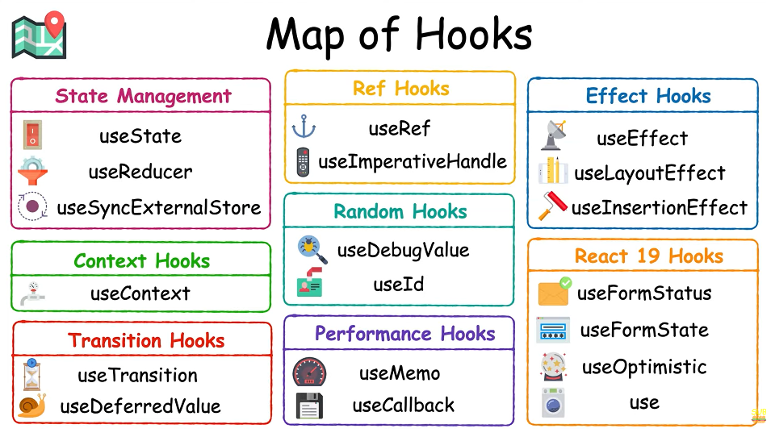
React nám pro funkcionální komponenty poskytuje tzv. React hooks. To jsou jednoduché funkce, jejichž voláním můžeme pokrýt veškerou funkcionalitu tříd a objekty tak vůbec nemusíme používat. Zbavení se objektů možná může znít nestandardně, ale připomeňme si, že pracujeme s UI částí aplikace, jejíž kód obsahuje HTML, a proto by měl být minimalistický. Současně hooks poskytují větší flexibilitu při extrakci, testování a znovupoužití kódu.
Starší syntaxi komponent pomocí klíčového slova class si rovněž ukážeme.
JSX - HTML kód v JavaScriptu
Aby byla tvorba React aplikací ještě jednodušší, kromě funkcionálního paradigma se nejčastěji používá také JSX. To je zkratkou JavaScript + XML a umožňuje psát HTML kód přímo do JavaScriptu. A to ne jako klasický string, ale opravdu jako HTML elementy. React si s ním opět hezky rozumí a celkově se nám tak zjednoduší vytváření HTML elementů i samotných komponent.
Použití JSX může vypadat např. takto:
return <h1>Ukázka JSX</h1>;
Nepoužili jsme žádné uvozovky, protože výsledkem není text, ale opravdu nový element.
Samozřejmě takováto kombinace nebude jen tak fungovat přímo v prohlížeči a kód se musí prvně přeložit potřebnými nástroji. To za nás udělají aplikace z ekosystému React (konkrétně Babel, který již budeme mít po založení React projektu nakonfigurovaný). Používání JSX není při psaní kódu v Reactu povinné, rozhodně se ale vyplatí a je k Reactu oficiálně doporučované. Proto jej i my budeme používat.

Nástroj Vite
Vite je nástroj pro vývoj a následné sestavení frontendových webových aplikací. Jeho hlavní předností je především vysoká rychlost načítání provedených změn v aplikaci během vývoje, čímž zvyšuje naši celkovou produktivitu. Dosahuje toho použitím nejnovějších postupů, webových technologií a standardů.
Vite podporuje řadu populárních frontendových knihoven, mezi nimiž samozřejmě nechybí ani React. K vygenerování React projektu pomocí Vite využijeme příkaz create vite.
Dříve se ke generování React projektů používal příkaz a nástroj Create React App, který se však již nevyvíjí.
Create vite project : npm create vite@latest
npm create vite@latest vite-project-js-1 -- --template react-ts ... create tsx
npm create vite@latest vite-project-js-1 -- --template react ... create jsx

https://react.dev/learn/creating-a-react-app
Creating a React App
If you want to build a new app or website with React, we recommend starting with a framework.
If your app has constraints not well-served by existing frameworks, you prefer to build your own framework, or you just want to learn the basics of a React app, you can build a React app from scratch.
Full-stack frameworks
These recommended frameworks support all the features you need to deploy and scale your app in production. They have integrated the latest React features and take advantage of React’s architecture.
Note
Full-stack frameworks do not require a server.
All the frameworks on this page support client-side rendering (CSR), single-page apps (SPA), and static-site generation (SSG). These apps can be deployed to a CDN or static hosting service without a server. Additionally, these frameworks allow you to add server-side rendering on a per-route basis, when it makes sense for your use case.
This allows you to start with a client-only app, and if your needs change later, you can opt-in to using server features on individual routes without rewriting your app. See your framework’s documentation for configuring the rendering strategy.

Next.js (App Router)
Next.js’s App Router is a React framework that takes full advantage of React’s architecture to enable full-stack React apps.
npx create-next-app@latest
Next.js is maintained by Vercel. You can deploy a Next.js app to any hosting provider that supports Node.js or Docker containers, or to your own server. Next.js also supports static export which doesn’t require a server.

React Router (v7)
React Router is the most popular routing library for React and can be paired with Vite to create a full-stack React framework. It emphasizes standard Web APIs and has several ready to deploy templates for various JavaScript runtimes and platforms.
To create a new React Router framework project, run:
npx create-react-router@latest
React Router is maintained by Shopify.

Expo (for native apps)
Expo is a React framework that lets you create universal Android, iOS, and web apps with truly native UIs. It provides an SDK for React Native that makes the native parts easier to use. To create a new Expo project, run:
npx create-expo-app@latest
If you’re new to Expo, check out the Expo tutorial.
Expo is maintained by Expo (the company). Building apps with Expo is free, and you can submit them to the Google and Apple app stores without restrictions. Expo additionally provides opt-in paid cloud services.

Features
- React - A JavaScript library for building user interfaces.
- Vite - A fast, opinionated frontend build tool.
- TypeScript - A typed superset of JavaScript that compiles to plain JavaScript.
- Tailwind CSS - A utility-first CSS framework. (v4)
- Tailwind Prettier Plugin - A Prettier plugin for formatting Tailwind CSS classes.
- ESLint - A pluggable linting utility for JavaScript and TypeScript.

TypeScript with React
https://blog.logrocket.com/how-to-use-typescript-react-tutorial-examples/
The benefits of using TypeScript in React
Combining Typescript with React helps developers improve the quality of their codebase (or code output) and also streamlines the development process. Below are a few ways TypeScript is beneficial with React:
Static typing
TypeScript provides static typing to JavaScript, which allows developers to define types for states and variables. This helps catch any errors during development, making the code more readable and easy to maintain.
Code consistency and scalability
When working with React, TypeScript enforces a consistent code style and organization with features such as interface, generics, and enums, which allows developers to build more scalable React applications.
Early error detection
When using TypeScript with React, errors are caught at the development stage before the code is compiled and executed. This prevents runtime errors and reduces debugging time.
Variable and bug checks
TypeScript offers variable checks by checking the data type assigned to statically-defined variables. This reduces the possibility of assigning the wrong types to our variables.
TypeScript also runs compilation time checks that help flag errors such as wrong parameter assignments and syntax errors. This reduces the likelihood of calling the wrong function or accidentally skipping a variable declaration.
Interfaces
TypeScript allows you to define complex type definitions in the form of interfaces. This is helpful when you have a complex type that you want to use in your application, such as an object that contains other properties. Statically typing interfaces results in strict checks, which reduce the number of possible bugs you may produce without using interfaces in TypeScript.
Better support for JSX
Using TypeScript with React provides better IntelliSense and code completion for JSX (JavaScript XML), which allows us to write HTML code directly in our React project.
IDE support
TypeScript is also helpful when using IDEs like Visual Studio, Visual Studio Code, Webstorm, Eclipse, etc. These provide better autocompletion and snippet generation, making development faster. Read more about TypeScript IDEs here.
Support for existing React projects
TypeScript allows you to gradually adapt its usage in your existing projects. You can also configure the TypeScript compiler for this use case. Find a list of TypeScript compilers in the official TypeScript documentation.
Community
Finally, TypeScript is an open source language backed by Microsoft. It’s widely loved and used by millions of developers worldwide. Because it’s so widely used, it’s easy to find support and answers to your questions if you get stuck while learning or using it.
Understanding .tsx files in TypeScript
The introduction of .tsx in TypeScript came several releases after TypeScript v1.0. According to the release notes for TypeScript v1.6 where .tsx extension was introduced, the new extension was designed to enable JSX inside of TypeScript files, and make the new as operator the default way to cast.

The introduction of .tsx also resulted in three additional things:
- JavaScript bundlers like webpack, esbuild, and others can run different plugins for .tsx files
- Test runners like Jest can run a different test environment only for .tsx files
- New language support by code editors

Difference between .ts and .tsx in TypeScript
With the introduction of the .tsx file extension, many developers wanted to know the difference between the new file extension and the existing .ts.
The .ts file extension is used when you are creating functions, classes, reducers, etc., that do not require the use of JSX syntax and elements, whereas the .tsx file extension is used when you create a React component and use JSX elements and syntax.

ReactJS Interview Question
It includes questions such as:
- What is React?
- The history behind React evolution
React, (also known as ReactJS or React.js) is a popular free and open-source front end Javascript library that is used for building UI components and user interfaces. It was created by Facebook and is still maintained by them along with an ever growing community of companies and individual developers. React is commonly used as the code base for SPA’s (Single Page Applications). It is currently listed at or near the top of many industry rankings for popularity, developer satisfaction, and most wanted industry tools.
Major features of React
React can be used to develop single-page, mobile, or server-rendered applications with frameworks like Next.js and React Router. Because React is only concerned with the user interface and rendering components to the DOM, React applications often rely on libraries for routing and other client-side functionality.[11][12] A key advantage of React is that it only re-renders those parts of the page that have changed, avoiding unnecessary re-rendering of unchanged DOM elements.
https://en.wikipedia.org/wiki/React_(software)

https://www.mygreatlearning.com/react-js/tutorials/benefits-of-react-js
Here are some benefits of using React:
- Declarative: Declarative components aid in building interactive UIs. You can describe how the UI should like, and React will take care of the rendering.
- Reusable components: With React, you can build reusable components that can be used in multiple places in your application. This makes it easier to develop and maintain your app over time.
- Fast rendering: React uses a virtual DOM (Document Object Model) to optimize updates to the actual DOM. This means that when your application's state changes, React can efficiently update the DOM to reflect those changes, resulting in faster rendering.
- JSX: React introduces the concept of JSX, which is a syntax extension for JavaScript that allows you to write HTML-like code in your JavaScript files. This can make it easier to build and understand your UI.
- Server-side rendering: React can be used to render content on the server side, providing a faster initial load time for your app and improving the performance of your app for search engines.
- Strong developer community: React has a large and active developer community, which means that you can find a wealth of resources and support when you need it.

Main Features of React JS
- Virtual DOM
- JSX
- Component-Based Structure
- One-way Data Binding
- Performance and Simplicity
https://medium.com/@ojebiyifulness/5-main-features-of-react-js-that-developers-must-know-759e222d3699
What are the features of ReactJS ?
https://www.geeksforgeeks.org/reactjs/what-are-the-features-of-reactjs/
Created by Facebook, ReactJS is a JavaScript library designed for crafting dynamic and interactive applications, elevating UI/UX for web and mobile platforms. Operating as an open-source, component-based front-end library, React is dedicated to UI design and streamlines code debugging by employing a component-oriented approach.
- JSX(JavaScript Syntax Extension):
- Virtual DOM:
- One-way Data Binding:
- Performance:
- Extension:
- Conditional Statements:
- Components:
- Simplicity:

- JSX
JSX stands for JavaScript XML.
JSX allows us to write HTML in React.
JSX makes it easier to write and add HTML in React.
- Difference between Element and Component
An Element is an object that represents a DOM node it is a part of DOM structure, while a component is a reusable block of code that contains logic, states, and also returns the Element.
The element contains the information to be rendered on the UI and the Components are composed of the elements.

React Element
It is the basic building block in a react application, it is an object representation of a virtual DOM node. React Element contains both type and property. It may contain other Elements in its props. React Element does not have any methods, making it light and faster to render than components.
React Component
It is independent and reusable. It returns the virtual DOM of the element. One may or may not pass any parameter while creating a component. A component can be further described into functional components and class components.
Note: Always start the components name with the capital letter, react consider the lowercase component name as HTML tags so it will not show the component.
Element | Component
An element is always gets returned by a component. | A component can be functional or a class that optionally takes input and returns an element.
The element does not have any methods. | Each component has its life cycle methods.
A React element is an object representation of a DOM node. | A component encapsulates a DOM tree.
Elements are immutable i,e once created cannot be changed. | The state in a component is mutable.
An element can be created using React.createElement( ) with type property. | A component can be declared in different ways like it can be an element class with render() method or can be defined as a function.
We cannot use React Hooks with elements as elements are immutable. | React hooks can be used with only functional components
Elements are light, stateless and hence it is faster. | It is comparatively slower than elements.

Conclusion
A React element represents a dom node and it is a plain JavaScript Object. On the other hand a component is the logical structure of reusable code containting state and other useful information that returns or creates element.

- Creating components in React
This example creates a component named Welcome with props that can be reused multiple time to create elements.
import React from 'react';
import ReactDOM from 'react-dom';

function Welcome(user) {
return <div>
<h3>Welcome {user.name}</h3>
</div>
}
const ele = <Welcome name="Geek" />
ReactDOM.render(ele, document.getElementById("root"));

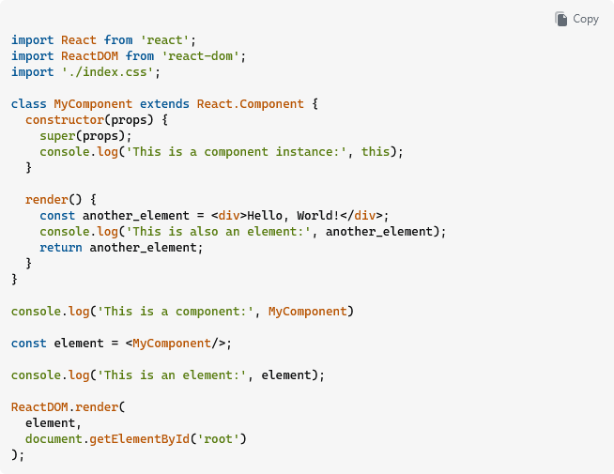
In the code above:
- MyComponent (the class itself) is a Component
- element is an Element. It's not an instance of MyComponent; rather, it's simply a description of the component instance to be created. It's an object with key, props, ref and type properties. Here, key and ref are null, props is an empty object, and type is MyComponent.
- An instance of MyComponent gets created (and, in the example above, logs itself from its constructor) when element gets rendered.
- another_element is also an element, and has key, ref, props and type properties just like element does - but this time the value of type is the string "div".

https://legacy.reactjs.org/blog/2015/12/18/react-components-elements-and-instances.html
An element is a plain object describing what you want to appear on the screen in terms of the DOM nodes or other components. Elements can contain other elements in their props. Creating a React element is cheap. Once an element is created, it is never mutated.
A component can be declared in several different ways. It can be a class with a render() method. Alternatively, in simple cases, it can be defined as a function. In either case, it takes props as an input, and returns an element tree as the output.
When a component receives some props as an input, it is because a particular parent component returned an element with its type and these props. This is why people say that the props flows one way in React: from parents to children.
An instance is what you refer to as this in the component class you write. It is useful for storing local state and reacting to the lifecycle events.
Function components don’t have instances at all. Class components have instances, but you never need to create a component instance directly—React takes care of this.
Finally, to create elements, use React.createElement(), JSX, or an element factory helper. Don’t write elements as plain objects in the real code—just know that they are plain objects under the hood.

- When to use a Class Component over a Function Component
https://www.freecodecamp.org/news/function-component-vs-class-component-in-react/
In React, there are two primary ways to create components: function and class components. Each has its own syntax and use cases, although with the introduction of React Hooks, the gap between them has narrowed significantly. But the selection of appropriate component types is still very crucial for building efficient and maintainable React applications.
What are React Components?
In React, components are the building blocks of a user interface. They are reusable, self-contained pieces of code that represent a part of the UI. React allows you to break down your UI into smaller components, which makes it easier to manage and maintain your codebase.
You can think of components as custom HTML elements that encapsulate their own logic and UI structure. They can accept inputs called props (short for properties) and return React elements describing what should appear on the screen.
There are two main types of components in React:
Function Components: These are simple JavaScript functions that take props as input and return JSX elements. They are often used for presentational or stateless components.
Class Components: These are ES6 classes that extend from React.Component or React.PureComponent. They have a render() method where you define the structure of your component's UI using JSX. Class components are used for components that need to manage state or have lifecycle methods.
Conclusion
In summary, React Hooks have made a big impact on how we build components in React. Function components have become really popular because they're simpler and more flexible than class components.
With Hooks, we can easily manage state, handle side effects, and control how components behave. This has made React development more straightforward and efficient.
Looking forward, function components with Hooks are likely to become the standard way of building React applications. They're easier to use and offer better performance, making them a favorite among developers.
While class components still have their place, especially in older projects, the trend is moving towards function components with Hooks. They provide a modern and efficient approach to building user interfaces, making React development more enjoyable for everyone involved.

https://www.geeksforgeeks.org/reactjs/when-to-use-a-class-component-over-a-function-component-in-reactjs/
ReactJS provides two main ways to create components: Class Components and Function Components. With the introduction of React Hooks in version 16.8, Function Components became more powerful and are now commonly preferred. However, there are still scenarios where Class Components might be a better choice or necessary.
What Are Class Components?
Class Components are ES6 classes that extend the React.Component base class. They allow you to use lifecycle methods and manage state without additional libraries or hooks.
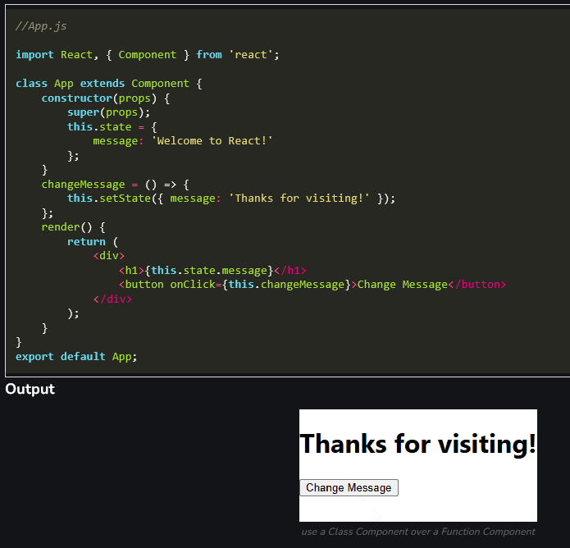

What Are Function Components?
Function Components are simpler JavaScript functions that take props as an argument and return JSX. With React Hooks, they can now manage state and side effects.
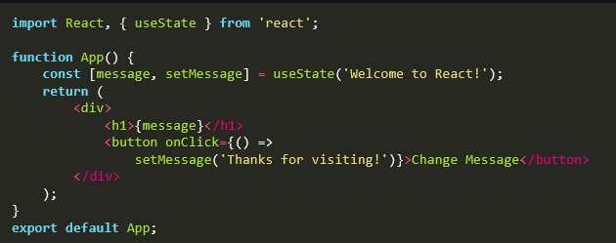
It will give the same output as give by class component.
Difference Between Class and Function Components
Feature | Class Components | Function Components
State Management | Uses this.state and this.setState | Uses useState hook
Lifecycle Methods | Explicit lifecycle methods (e.g., componentDidMount) | Uses useEffect hook
Syntax | Requires ES6 classes | Simpler, function-based syntax
Performance | Slightly slower (before React 18 optimizations) | Faster and lighter in structure
Readability | Can be difficult | More concise and easier to read
When to Use Class Components?
Although Function Components are now more popular, Class Components may still be relevant in the following cases:
- Legacy Codebases: In older React projects, you might encounter Class Components extensively. When making updates or maintaining these projects, it’s easier to stick with the existing pattern rather than refactoring everything to Function Components.
- Strict Lifecycle Control: If your component relies heavily on lifecycle methods like shouldComponentUpdate, componentDidCatch, or getDerivedStateFromProps, Class Components are a natural fit since these methods are not available in Function Components.
- Complex State Logic: While useReducer can handle complex state logic in Function Components, Class Components provide a built-in way to manage such logic without introducing additional hooks.
- Third-Party Libraries Without Hook Support: Some older libraries or tools are built with the assumption that you’re using Class Components. Integrating these libraries might require Class Components.
- Error Boundaries: As of now, Error Boundaries can only be implemented using Class Components. Error Boundaries are used to catch JavaScript errors in a component tree and display fallback UI.
When to Use Function Components?
Function Components are preferred in most modern React applications for their simplicity and flexibility. Use them when:
- Building New Projects: Start with Function Components to use React’s latest features.
- Using Hooks: They allow powerful features like useState, useEffect, and custom hooks.
- Performance Optimization: Function Components are typically more lightweight and easier to optimize.
- Readability and Maintenance: The concise syntax makes them easier to understand and maintain.
Conclusion
Class Components are becoming less common with the rise of Hooks, but they still have valid use cases in legacy systems, complex lifecycle management, and specific scenarios like Error Boundaries. For most new React applications, Function Components are the recommended choice due to their simplicity, modern features, and better performance.

Tailwind
is a CSS framework that speeds up the development process by allowing you to quickly write utility classes directly in your React code.
In Tailwind, you style elements by adding class names. For example, adding "text-blue-500" will turn the <h1> text blue:
<h1 className="text-blue-500">I'm blue!</h1>

Using the clsx library to toggle class names
There may be cases where you may need to conditionally style an element based on state or some other condition.
clsx is a library that lets you toggle class names easily. We recommend taking a look at documentation for more details, but here's the basic usage:
- Suppose that you want to create an InvoiceStatus component which accepts status. The status can be 'pending' or 'paid'.
- If it's 'paid', you want the color to be green. If it's 'pending', you want the color to be gray.
You can use clsx to conditionally apply the classes, like this:
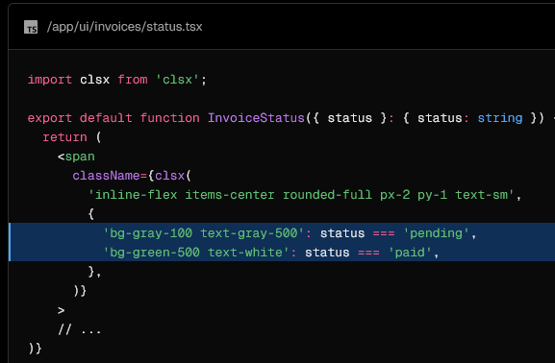

‘use client’
The 'use client' directive declares an entry point for the components to be rendered on the client side and should be used when creating interactive user interfaces (UI) that require client-side JavaScript capabilities, such as state management, event handling, and access to browser APIs. This is a React feature.
Good to know:
You do not need to add the 'use client' directive to every file that contains Client Components. You only need to add it to the files whose components you want to render directly within Server Components. The 'use client' directive defines the client-server boundary, and the components exported from such a file serve as entry points to the client.
Usage
To declare an entry point for the Client Components, add the 'use client' directive at the top of the file, before any imports:
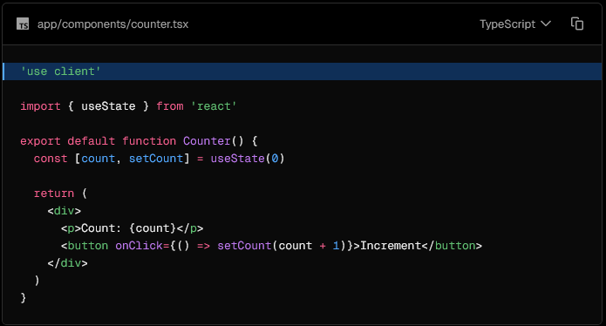
Nesting Client Components within Server Components
Combining Server and Client Components allows you to build applications that are both performant and interactive:
- Server Components: Use for static content, data fetching, and SEO-friendly elements.
- Client Components: Use for interactive elements that require state, effects, or browser APIs.
- Component composition: Nest Client Components within Server Components as needed for a clear separation of server and client logic.

In the following example:
- Header is a Server Component handling static content.
- Counter is a Client Component enabling interactivity within the page.
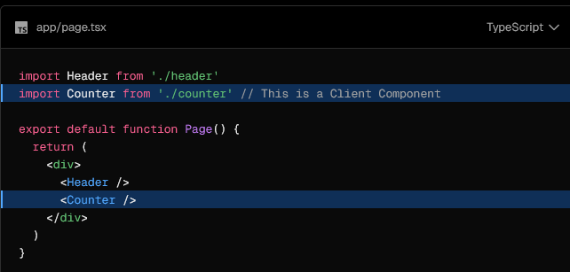

‘use server’
The use server directive designates a function or file to be executed on the server side. It can be used at the top of a file to indicate that all functions in the file are server-side, or inline at the top of a function to mark the function as a Server Function. This is a React feature.
Using use server at the top of a file
The following example shows a file with a use server directive at the top. All functions in the file are executed on the server.
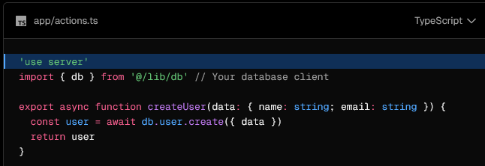
Using Server Functions in a Client Component
To use Server Functions in Client Components you need to create your Server Functions in a dedicated file using the use server directive at the top of the file. These Server Functions can then be imported into Client and Server Components and executed.
Assuming you have a fetchUsers Server Function in actions.ts:
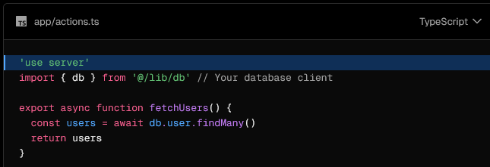
Then you can import the fetchUsers Server Function into a Client Component and execute it on the client-side.
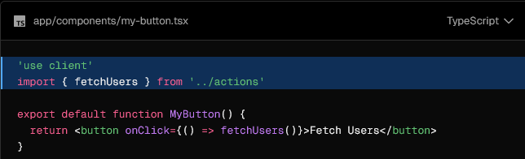

Using use server inline
In the following example, use server is used inline at the top of a function to mark it as a Server Function:
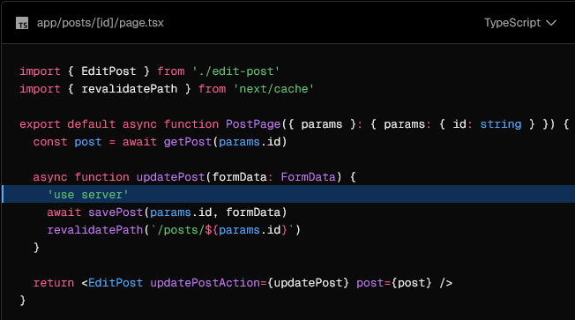
Security considerations
When using the use server directive, it's important to ensure that all server-side logic is secure and that sensitive data remains protected.
Authentication and authorization
Always authenticate and authorize users before performing sensitive server-side operations.
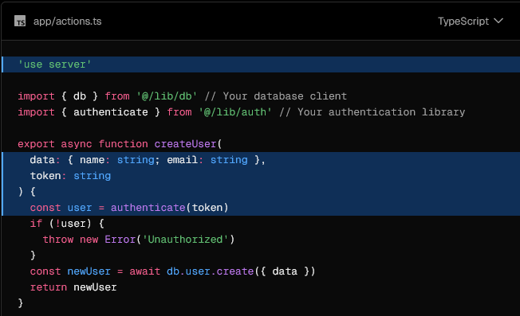
‘use cache’
The use cache directive allows you to mark a route, React component, or a function as cacheable. It can be used at the top of a file to indicate that all exports in the file should be cached, or inline at the top of function or component to cache the return value.
Good to know:
- To use cookies or headers, read them outside cached scopes and pass values as arguments. This is the preferred pattern.
- If the in-memory cache isn't sufficient for runtime data, 'use cache: remote' allows platforms to provide a dedicated cache handler, though it requires a network roundtrip to check the cache and typically incurs platform fees.
- For compliance requirements or when you can't refactor to pass runtime data as arguments to a use cache scope, see 'use cache: private'.

Usage
use cache is a Cache Components feature. To enable it, add the cacheComponents option to your next.config.ts file:
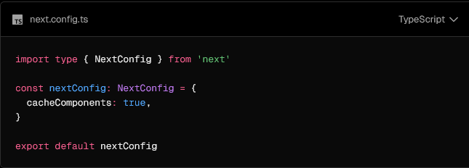
Then, add use cache at the file, component, or function level:
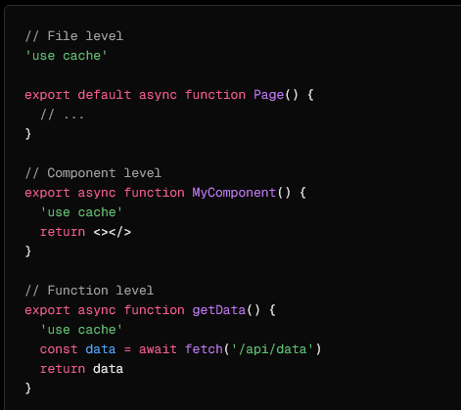
Good to know: When used at file level, all function exports must be async functions.

ReactJS Hooks (hák)
introduced in React 16.8, are among the most impactful updates to the library, with over 80% of modern React projects adopting them for state and lifecycle management. They let developers use state, side effects, and other React features without writing class components. Hooks streamline code, improve readability, and promote a functional programming style, making functional components as powerful—if not more—than their class-based counterparts.
Hooks allow functions to have access to state and other React features without using classes.
Hooks are functions that let you "hook into" React state and lifecycle features from functional components.

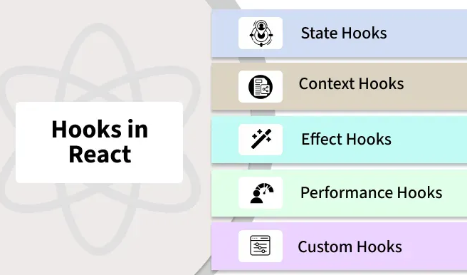
https://www.geeksforgeeks.org/reactjs/reactjs-hooks/
Hook Rules
There are 3 rules for hooks:
- Hooks can only be called inside React function components.
- Hooks can only be called at the top level of a component.
- Hooks cannot be conditional
Note: Hooks will not work in React class components.

Yarn
is an established open-source package manager used to manage dependencies in JavaScript projects. It assists with the process of installing, updating, configuring, and removing packages dependencies, eventually helping you reach your objectives faster with fewer distractions.
Its areas of focus are speed, correctness, security, and developer experience, which we improve along every axis by leveraging a suite of innovative features such as workspaces, offline caching, parallel installs, hardened mode, interactive commands, and more.
Given its robust features and stellar track record, Yarn proves to be an indispensable asset to the JavaScript ecosystem, driving efficiency, security, and positive developer experience in projects of any size.

What is Bun?
https://bun.com/docs
https://blog.logrocket.com/getting-started-bun-react/#what-bun
Bun is a lightweight JavaScript runtime that includes a native bundler, transpiler, task runner, and native npm client. It allows you to bundle, transpile, install, and run JavaScript and TypeScript projects.
Bun is the new kid on the block. It was created by Jared Sumner, released to the public in 2021, and is currently in version v1.0.15.
Bun is all about speed and efficiency and is a strong contender for the top JavaScript runtime spot, claiming to be faster and more feature-rich than Node.js and Deno.
Bun comes with many useful features:
- Includes web APIs such as Fetch, WebSocket, and ReadableStream
- Transpiles every file, so both TypeScript and JSX work seamlessly
- Implements the Node.js module resolution algorithm, meaning npm packages may be used
- Includes a lightning-fast SQLite3 client
- Implements the majority of the Node.js API, meaning that many native Node modules work
What can I do with Bun?
Bun’s website refers to it as a “fast all-in-one JavaScript runtime.” So what else can we do with Bun? Let’s take a look.

https://bun.com/docs/guides/ecosystem/react
Build a React app with Bun
Bun supports .jsx and .tsx files out of the box. React just works with Bun.
Create a new React app with bun init --react. This gives you a template with a simple React app and a simple API server together in one full-stack app.
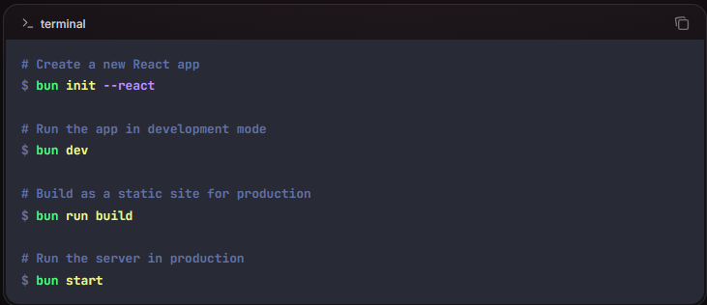

Axios
is a promise-based HTTP Client for node.js and the browser. It is isomorphic (= it can run in the browser and node.js with the same codebase). On the server-side it uses the native node.js http module, while on the client (browser) it uses XMLHttpRequest.
Features
- Make XMLHttpRequest from the browser
- Make http requests from node.js
- Supports the Promise API
- Intercept request and response
- Transform request and response data
- Cancel requests
- Timeouts
- Query parameters serialization with support for nested entries
- Automatic request body serialization to:
  - JSON (application/json)
  - Multipart / FormData (multipart/form-data)
  - URL encoded form (application/x-www-form-urlencoded)
- Posting HTML forms as JSON
- Automatic JSON data handling in response
- Progress capturing for browsers and node.js with extra info (speed rate, remaining time)
- Setting bandwidth limits for node.js
- Compatible with spec-compliant FormData and Blob (including node.js)

What is Axios?
Axios is a promise-based HTTP client for JavaScript, which is used to make HTTP requests to fetch or send data to a server. It simplifies the process of handling requests by providing a cleaner API, better error handling, and support for features like request/response interceptors, cancellation, and more. It is also fully compatible with modern browsers and can be used in both the browser and NodeJS environments.
Key Features of Axios
- Promise-based API.
- Works in both NodeJS and browsers.
- Automatically transforms JSON data.
- Supports request and response interceptors.
- Allows easy handling of timeouts and cancellation of requests.
- Supports making GET, POST, PUT, DELETE, and other HTTP requests.
https://www.geeksforgeeks.org/reactjs/axios-in-react-a-guide-for-beginners/
https://axios-http.com/docs/example

