JavaFX Tutorial
https://www.geeksforgeeks.org/java/javafx-tutorial/
https://openjfx.io/openjfx-docs/

JavaFX is a Java library and GUI toolkit for developing Rich Internet Applications (RIA), web applications and desktop applications. The framework emphasizes cross-platform compatibility across Windows, Linux, iOS, Android, desktops, web platforms, TVs and tablets.
Key Features
- Rich GUI: Supports advanced UI controls, charts, tables and 3D graphics.
- FXML: XML-based markup for declarative UI design.
- Scene Builder: Visual drag-and-drop UI design tool.
- Platform-independent: Runs on Windows, macOS, Linux and mobile platforms.
- CSS Styling: UI components can be styled using CSS.
- Multimedia Support: Handles audio, video and animation.
- Hardware-accelerated Graphics: Uses GPU for better performance.
- Integration: Works with Java libraries, multithreading, generics and lambda expressions.
Architecture of JavaFX
JavaFX employs a layered design supporting rich, cross-platform GUI and web applications. Each layer provides a distinct set of services that together deliver the full JavaFX platform.
- JavaFX API: Top layer providing classes and packages for animations, UI controls, CSS styling, scene graph, events, media and application lifecycle.
- Scene Graph: Core of the GUI; a hierarchical tree of nodes (root, branch, leaf) representing visual components.
- Quantum Toolkit: Connects Prism (graphics engine) and Glass (windowing toolkit) to the API.
- Prism: Hardware-accelerated 2D/3D graphics engine; falls back to software rendering if GPU is unavailable.
- Glass Windowing Toolkit: Platform-dependent layer managing windows, events and OS surfaces.
- WebView: Embeds web content (HTML5, CSS, JavaScript) and allows Java-JavaScript interaction.
- Media Engine: High-performance multimedia pipeline (GStreamer) for audio and video playback.
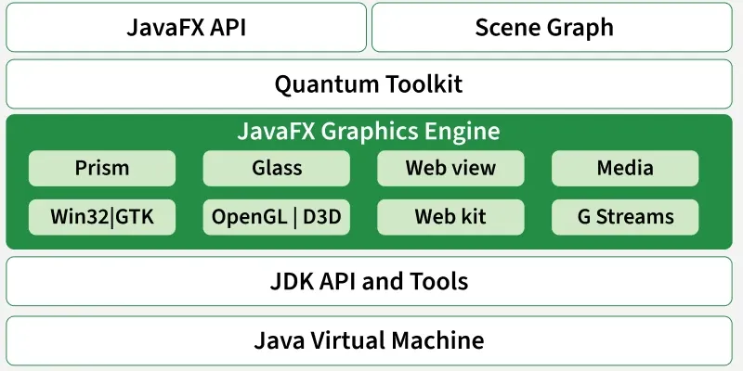
Lifecycle of a JavaFX Application
A JavaFX application goes through four main phases, managed by the javafx.application.Application class.
- init(): Runs first on a non-GUI thread; used for initialization (e.g., loading resources).
- start(Stage primaryStage): Main entry point — create scenes, UI, event handlers and show the stage.
- Running: Application event loop handles user interactions and animations.
- stop(): Called on exit; used for cleanup and resource release.
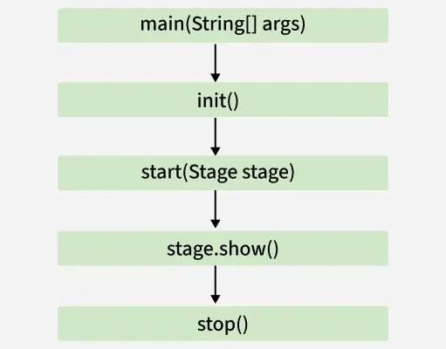
JavaFX 2D Shapes
2D shapes are geometrical figures represented on the X-Y plane (e.g., line, circle, rectangle, ellipse). These shapes reside in the javafx.scene.shape package, with the Shape class as their root.
Steps to Create a 2D Shape
- Instantiate the shape class:
Line line = new Line();

- Set properties using setters:
line.setStartX(0);
line.setEndX(100);

- Add to Group and display:
root.getChildren().add(line);

Common 2D Shape Classes
- Line: Connects two points.
- Rectangle: Four sides with right angles.
- Ellipse: Curve with two focal points.
- Circle: Special ellipse with coinciding foci.
- Arc: Portion of a circle or ellipse.
- Polygon: Shape formed by connecting line segments.
- CubicCurve: Degree-3 Bezier curve.
- QuadCurve: Degree-2 Bezier curve.
JavaFX 3D Shapes
3D shapes are solid geometrical figures represented using X, Y, Z coordinates. Unlike 2D shapes these require a Z coordinate. Support comes via the javafx.scene.shape package, with Shape3D as the base class.
Types of 3D Shapes
Predefined 3D Shapes — built-in classes:
- Sphere: Perfectly round object.
- Box: Rectangular prism with height, width and depth.
- Cylinder: Solid with circular bases.
User-defined 3D Shapes — using TriangleMesh to define custom points, faces and textures.
Steps to Create a 3D Shape
- Instantiate the shape class:
Box box = new Box();

- Set properties:
box.setHeight(100);
box.setWidth(60);
box.setDepth(80);

- Set camera:
PerspectiveCamera cam = new PerspectiveCamera();
scene.setCamera(cam);

- Add to scene graph and display:
Group root = new Group();
root.getChildren().add(box);
Scene scene = new Scene(root, 500, 500);
primaryStage.setScene(scene);
primaryStage.show();

JavaFX Effects
Effects in JavaFX enhance the visual appearance of nodes. They are part of the javafx.scene.effect package, with Effect as the root class. Effects are applied using the setEffect() method.
Steps to Apply an Effect
- Create the node (e.g., ImageView).
- Instantiate the effect: e.g., Glow glow = new Glow();
- Set effect properties: e.g., glow.setLevel(0.9);
- Apply to the node: imgView.setEffect(glow);
Common JavaFX Effects
- Blend: Combines pixels of two inputs using a blending mode.
- Glow: Brightens pixels to create a glowing effect.
- Bloom: Similar to Glow; highlights bright areas of the node.
- Shadow: Creates a blurred duplicate behind the node.
- Reflection: Adds a reflection beneath the node.
- ColorAdjust: Alters hue, brightness, saturation and contrast.
- SepiaTone: Applies a reddish-brown vintage filter.
- Lighting: Simulates light sources — point, spot or distant.
- InnerShadow: Creates a shadow inside the node edges.
JavaFX Texts
Text in JavaFX is represented by the Text class (javafx.scene.text), which also extends the Shape class. This allows both text-specific and shape-level properties to be applied.
Steps to Create Text
- Instantiate: Text txt = new Text();
- Set properties: txt.setText("Hello"); txt.setX(50); txt.setY(50);
- Add to group: root.getChildren().add(txt);
Key Text Properties
- Font: setFont(Font value)
- Line Spacing: setLineSpacing(double)
- Text Content: setText(String)
- Underline: setUnderline(boolean)
- Coordinates: setX(double), setY(double)
JavaFX Animations
Animations in JavaFX simulate motion by applying sequential transformations to nodes. All animation classes extend javafx.animation.Animation and are in the javafx.animation package.
Steps to Apply an Animation
- Create the node: e.g., Rectangle rect = new Rectangle(100, 100, 100, 100);
- Instantiate the animation: e.g., RotateTransition rotate = new RotateTransition();
- Set animation properties: duration, axis, cycle count, auto-reverse, etc.
- Attach the target node: rotate.setNode(rect);
- Play the animation: rotate.play();
Common Animation Classes
- ScaleTransition: Animates the scaling of a node.
- TranslateTransition: Moves a node from one location to another.
- RotateTransition: Rotates a node around a specified axis.
- FadeTransition: Animates node opacity over time.
- StrokeTransition: Animates the node stroke color between two values.
- FillTransition: Animates the node fill color between two values.
- PathTransition: Moves a node along a specified path.
- ParallelTransition: Runs multiple animations on a node simultaneously.
JavaFX Transformations
Transformations modify the appearance or position of nodes — translation, rotation, scaling and shearing. All transformation classes belong to javafx.scene.transform.
- Rotate: Rotates a node by a specific angle.
- Translate: Moves a node in X, Y or Z directions.
- Scale: Changes the size of a node.
- Shear: Slants the node along X or Y axes.
JavaFX UI Controls
JavaFX provides a rich set of UI controls for building interactive applications. All controls are part of the javafx.scene.control package and extend the Control class.
- Button: Clickable button for user actions.
- Label: Displays text or images.
- TextField: Single-line text input.
- TextArea: Multi-line text input.
- CheckBox: Selectable boolean toggle.
- RadioButton: Selectable option within a group.
- ComboBox: Drop-down list selector.
- ListView: Displays a scrollable list of items.
- TableView: Displays data in a tabular format.
- Slider: Selects a numeric value from a range.
- ProgressBar / ProgressIndicator: Shows task progress.
JavaFX Charts
Charts represent data visually and are part of the javafx.scene.chart package.
PieChart
A circular chart showing proportions of categories.
XYChart
Plots data on X and Y axes. Two axis types are available:
- CategoryAxis: Represents string categories.
- NumberAxis: Represents numeric ranges.
Common Chart Classes
- BarChart: Rectangular bars representing data values.
- LineChart: Data points connected by lines.
- AreaChart: Plots areas between data points and the axis.
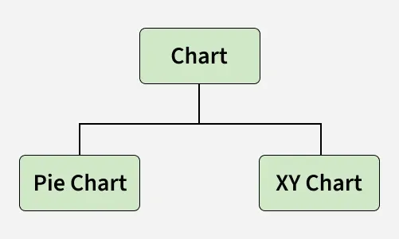
JavaFX Layouts
Layouts in JavaFX are top-level container classes that manage the arrangement of UI elements. All layout classes belong to the javafx.scene.layout package, with Pane as the root class.
Steps to Create a Layout
- Instantiate the layout:
HBox root = new HBox();

- Set layout properties:
root.setSpacing(20);

- Add nodes to the layout:
root.getChildren().addAll(node1, node2);

Common JavaFX Layouts
- HBox: Arranges nodes horizontally (javafx.scene.layout.HBox).
- VBox: Arranges nodes vertically (javafx.scene.layout.VBox).
- BorderPane: Arranges nodes in top, bottom, left, right and center zones.
- GridPane: Arranges nodes in a grid of rows and columns — ideal for forms.
- FlowPane: Arranges nodes in a flow, wrapping horizontally or vertically.
- StackPane: Arranges nodes on top of each other like a stack.
JavaFX Event Handling
JavaFX allows user interaction through events — notifications that something has happened (e.g., mouse click, key press, scroll). All events are instances of javafx.event.Event or its subclasses.
Processing Events
- Events inform the application about user actions.
- All events are instances of javafx.event.Event or its subclasses.
- Common classes include MouseEvent, KeyEvent, ScrollEvent, DragEvent.
- Custom events can be created by extending Event.
Types of Events
- Foreground Events: Triggered by direct user interaction — clicks, key presses, selections, scrolling.
- Background Events: Triggered without user action — OS interrupts, operation completion.
Common Event Classes
- KeyEvent: Keyboard actions (KEY_PRESSED, KEY_RELEASED, KEY_TYPED).
- MouseEvent: Mouse actions (MOUSE_CLICKED, MOUSE_PRESSED, MOUSE_MOVED, MOUSE_ENTERED, MOUSE_EXITED).
- WindowEvent: Window lifecycle (WINDOW_SHOWING, WINDOW_SHOWN, WINDOW_HIDING, WINDOW_HIDDEN).
- DragEvent: Drag-and-drop (DRAG_ENTERED, DRAG_DROPPED, DRAG_OVER, DRAG_EXITED).

JavaFX vs Java Swing
Both JavaFX and Swing are GUI toolkits in Java, but they differ in design approach, capabilities and modernization level.
Aspect | Java Swing | JavaFX
Introduction | Legacy GUI framework introduced in 1997. | Modern framework introduced in 2008 for rich desktop and web applications.
UI Components | Large set of mature and pluggable UI components. | Supports CSS styling, FXML and hardware-accelerated UI components.
Graphics & Animation | Limited graphics; no built-in animation support. | Includes built-in animation, 2D/3D graphics and visual effects.
Architecture | Partial MVC pattern support. | Strong and consistent MVC architecture.
Event & Device Support | Less consistent event handling; no touch gesture support. | Uniform event model; supports modern touch and gesture devices.

Real-world Applications Made Using JavaFX
JavaFX is used across multiple domains including healthcare, aviation, finance and research.
- Curator / Caliop: Used in hospitals to manage and record surgery data.
- Navigator Lynden: Helps dispatch managers monitor flight operations.
- Atlas Trader: Commodity trading platform for assets like gold and oil.
- Template Editor IAV: Analyzes and configures vehicle fleet data.
- FORUM (Carl Zeiss Meditec AG): Clinical data management system combining Swing and JavaFX.
- NEOS (EBU): Manages TV and radio transmission operations.
- Deep Space Trajectory Explorer (NASA): Designs and visualizes interplanetary trajectories.
History of JavaFX
JavaFX was initially developed by Chris Oliver at See Beyond Technology Corporation as Form Follows Functions (F3).
- 2005: Sun Microsystems acquires F3.
- 2007: JavaFX officially announced at the JavaOne conference.
- 2008: NetBeans integration; JavaFX SDK 1.0 released.
- 2009: JavaFX 1.2 released; JavaFX Mobile support added; Oracle acquires Sun Microsystems.
- 2010: JavaFX 1.3 released.
- 2011: JavaFX 2.0 released.
- 2012: Mac OS desktop support introduced.

