Week 11

Raj, Ponnam

March 5th, 2022

# a. Plot the data from each dataset using a scatter plot.

library('ggplot2')  
library('class')

## Warning: package 'class' was built under R version 4.0.3

# working directory path to access binary-classifier-data.CSV file from local drive  
setwd("/Users/rajponnam/Documents/ds_course/dsc520/data")  
  
# Read the files `binary-classifier-data.csv` and trinary-classifier-data.csv to `binary_df` and 'trinary_df'  
binary_df <- read.csv("binary-classifier-data.csv")  
trinary_df <- read.csv("trinary-classifier-data.csv")  
  
temp_binary_df <- binary_df  
temp_binary_df$label <- as.factor(temp_binary_df$label)  
temp_trinary_df <- trinary_df  
temp_trinary_df$label <- as.factor(temp_trinary_df$label)  
  
# Plot the data dataset using a scatter plot for both files  
ggplot(temp_binary_df, aes(x=x, y=y, color=label)) + geom_point()

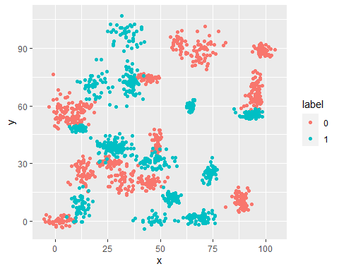

ggplot(temp_trinary_df, aes(x=x, y=y, color=label)) + geom_point()

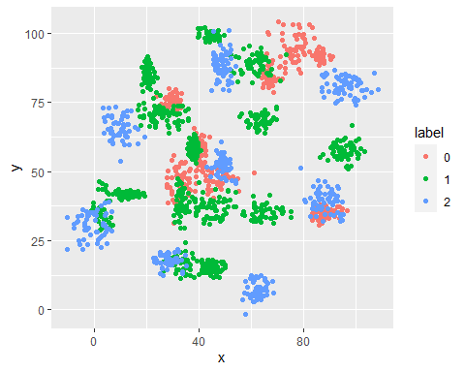

# b.In this problem, you will determine which points are nearest by calculating the Euclidean distance between two points.

library ('TSdist')

## Warning: package 'TSdist' was built under R version 4.0.3

## Loading required package: proxy

## Warning: package 'proxy' was built under R version 4.0.3

##   
## Attaching package: 'proxy'

## The following objects are masked from 'package:stats':  
##   
## as.dist, dist

## The following object is masked from 'package:base':  
##   
## as.matrix

## Registered S3 method overwritten by 'quantmod':  
## method from  
## as.zoo.data.frame zoo

## Loaded TSdist v3.7. See ?TSdist for help, citation("TSdist") for use in publication.

EuclideanDistance(binary_df$x,binary_df$y)

## [1] 1411.959

EuclideanDistance(trinary_df$x,trinary_df$y)

## [1] 1357.734

# Fit a k nearest neighbors model for each dataset for k=3, k=5, k=10, k=15, k=20, and k=25. Compute the accuracy of the resulting models for each value of k. Plot the results in a graph where the x-axis is the different values of k and the y-axis is the accuracy of the model.

knn for binary

# Split data to use 80% of data to train the model and 20% of data to test the model  
data_split_binary <- sample(1:nrow(binary_df), 0.8 * nrow(binary_df))  
train_binary <- binary_df[data_split_binary,]  
test_binary <- binary_df[-data_split_binary,]  
  
binary_glm <- glm(label ~ x + y, data=binary_df, family = binomial)  
  
# extract 1st column of train dataset because it will be used as 'cl' argument in knn function.  
target_category <- binary_df[data_split_binary,1]  
  
# extract 1st column if test dataset to measure the accuracy  
test_category <- binary_df[-data_split_binary,1]  
  
k_values<- c(3, 5, 10, 15, 20, 25)  
Accuracy <- NULL  
for (i in 1:length(k_values))  
{  
 test_pred <- knn(train_binary,test_binary,cl=target_category,k=k_values[i])  
 confmatrix <- table(test_category,test_pred)  
 accuracy <- (confmatrix[[1,1]] + confmatrix[[2,2]]) / sum(confmatrix)  
 Accuracy <- c(Accuracy, round((accuracy * 100), digits=2))  
}  
binary_results_df <- data.frame(k_values, Accuracy)  
binary_results_df

## k_values Accuracy  
## 1 3 97.00  
## 2 5 97.00  
## 3 10 97.67  
## 4 15 97.00  
## 5 20 97.00  
## 6 25 96.00

ggplot(binary_results_df, aes(x=k_values, y=Accuracy)) + geom_point() + geom_line(colour="red")

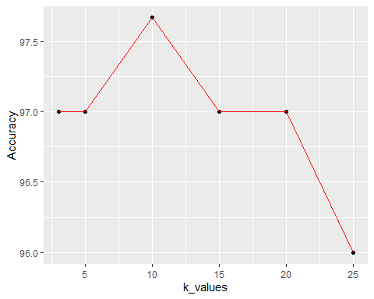 knn for trinary

# Split data to use 80% of data to train the model and 20% of data to test the model  
data_split_trinary <- sample(1:nrow(trinary_df), 0.8 * nrow(trinary_df))  
train_trinary <- trinary_df[data_split_trinary,]  
test_trinary <- trinary_df[-data_split_trinary,]  
  
trinary_glm <- glm(label ~ x + y, data=trinary_df, family = poisson)  
  
# extract 1st column of train dataset because it will be used as 'cl' argument in knn function.  
target_category <- trinary_df[data_split_trinary,1]  
  
# extract 1st column if test dataset to measure the accuracy  
test_category <- trinary_df[-data_split_trinary,1]  
  
k_values<- c(3, 5, 10, 15, 20, 25)  
Accuracy <- NULL  
for (i in 1:length(k_values))  
{  
 test_pred <- knn(train_trinary,test_trinary,cl=target_category,k=k_values[i])  
 confmatrix <- table(test_category,test_pred)  
 accuracy <- (confmatrix[[1,1]] + confmatrix[[2,2]]) / sum(confmatrix)  
 Accuracy <- c(Accuracy, round((accuracy * 100), digits=2))  
}  
trinary_results_df <- data.frame(k_values, Accuracy)  
trinary_results_df

## k_values Accuracy  
## 1 3 68.79  
## 2 5 68.79  
## 3 10 66.56  
## 4 15 66.56  
## 5 20 65.29  
## 6 25 64.97

ggplot(trinary_results_df, aes(x=k_values, y=Accuracy)) + geom_point() + geom_line(colour="red")

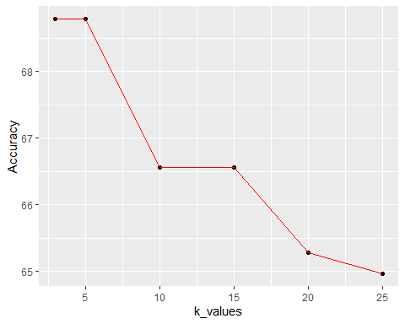

# C. Looking back at the plots of the data, do you think a linear classifier would work well on these datasets?

Linear classifier will not work for both binary and trinary datasets because data points are not grouped around a line. Data points are spread all over the graph.