**Week1: Assignment**

Rajendra Prasad Ponnam

Data Presentation & Visualization, Bellevue University

DSC640-T301: Week1 Assignment

Professor Catherine Williams Catie

December 04, 2022

**Bar chart:**

I have imported the hotdog-contest-winners excel file into tableau application to plot the below bar chart. I have taken Dogs eaten and winners columns to understand the bar chart.

**Stacked bar chart:**

I have taken the Obama-approval rating data set to draw the below stacked bar chart. The below chart helped me to understand the stacked bar chart and its usage in the data visualization. By using stacked bar chart, I have visualized and compared the relation between approvals and disapprovals.

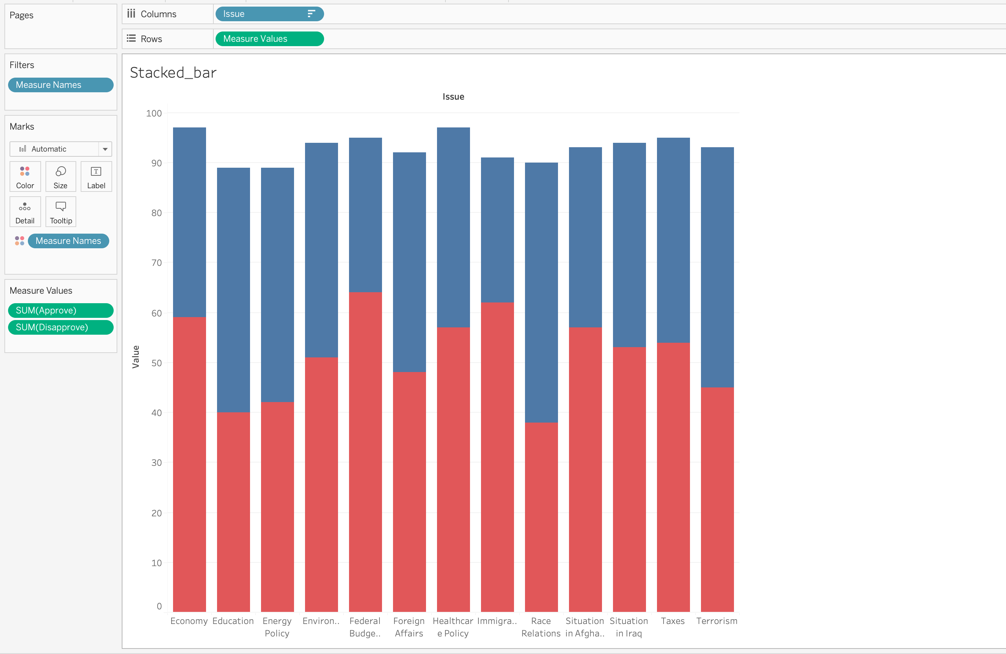

**Pie chart:**

I have chosen the hotdog-contest-winners dataset to draw below pie chart. I want to show the multiple categories of data with comparisons, so I have used pie chart to visualize the data.

