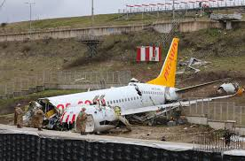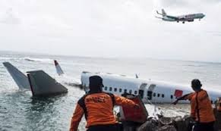

**Airline Fatal accidents:**

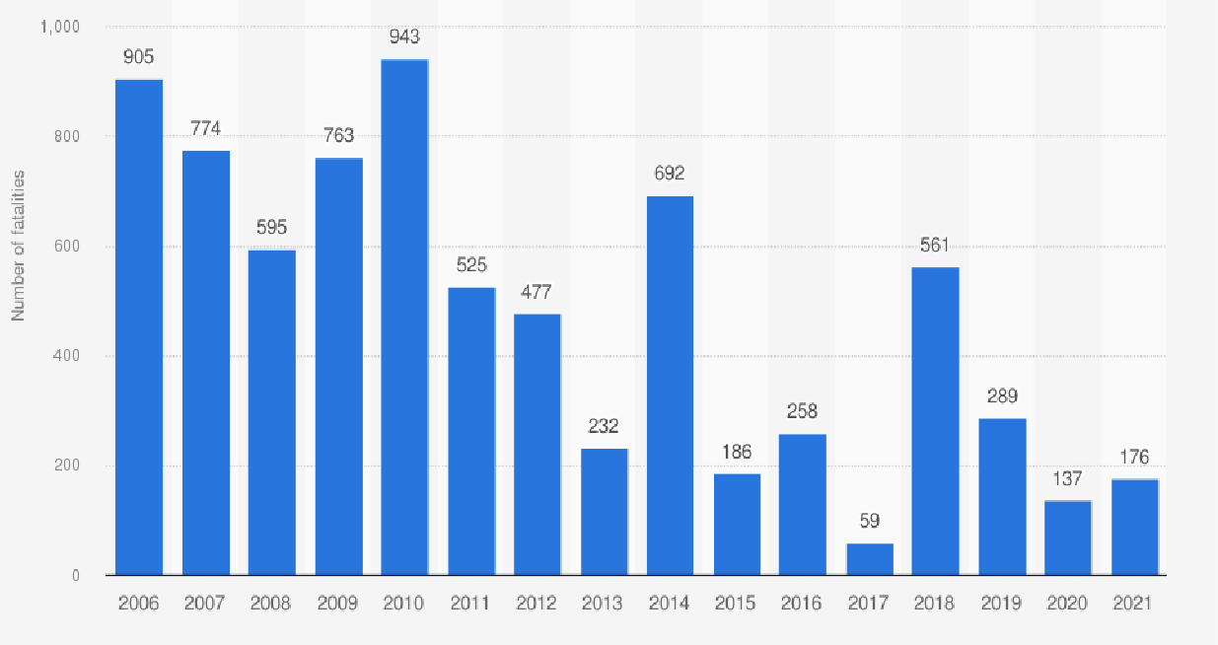 50% Decrease rate in air accidents worldwide