ReadMe file for evaluation project: **Cozy n Chic**

My project is based on fashion-based products, let it be clothes, accessories and trendy essentials. For demo part and time being constraint, there are product **with size and color based variants** for categories: clothes and accessories. I will be working on other categories as well it intrigued my interest how process flow can be managed in STS so easily.

As instructed, react is used for front end and Spring boot is used for backend.

I have uploaded the front end and backend code in separate directories. I used STS for spring boot and Visual Studio Code for react development. For avoiding confusion, I have stored STS based project in directory named as Back-end and react based project is stored in directory named : Front-end.

To start react development server:

1. Traverse to the directory where react project is located(in my case: Cozy n Chic) as displayed below.In my case it was located in Documents>reactApps>Cozy n Chic. **Make sure npm in installed.**

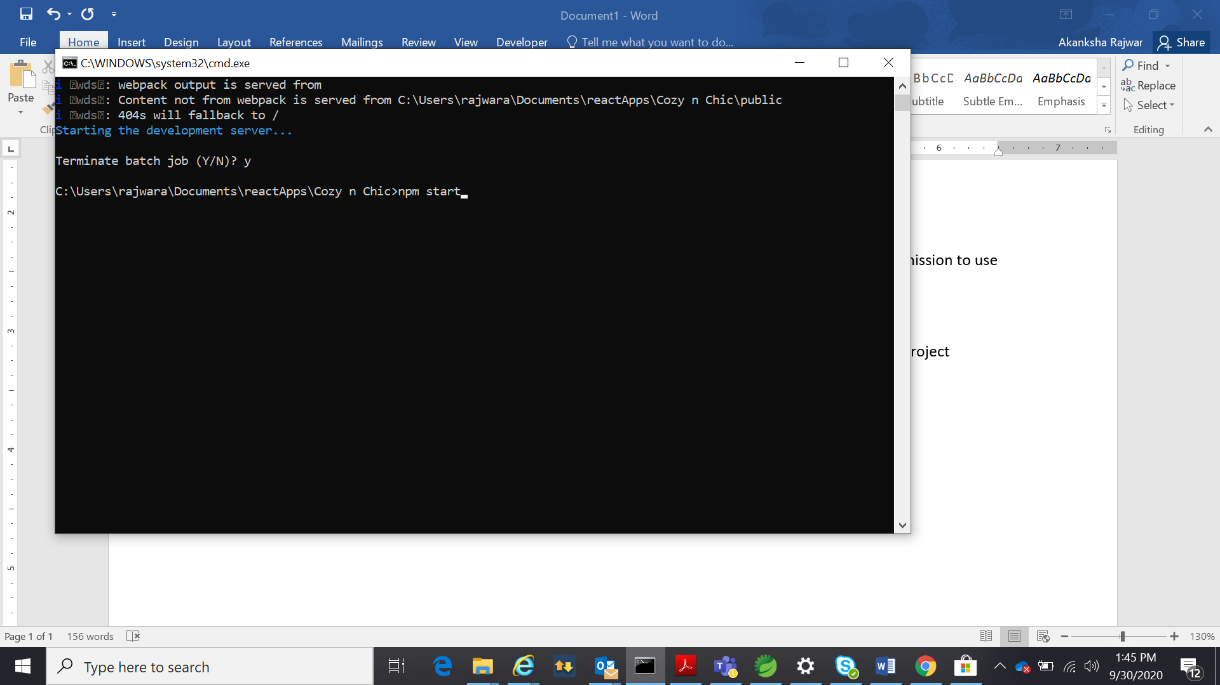

1. Run command: npm start (It will run on port:3000 if its available otherwise it will ask for permission to use another port). Please open it in Chrome : <http://localhost:3000/>

It will open like this.

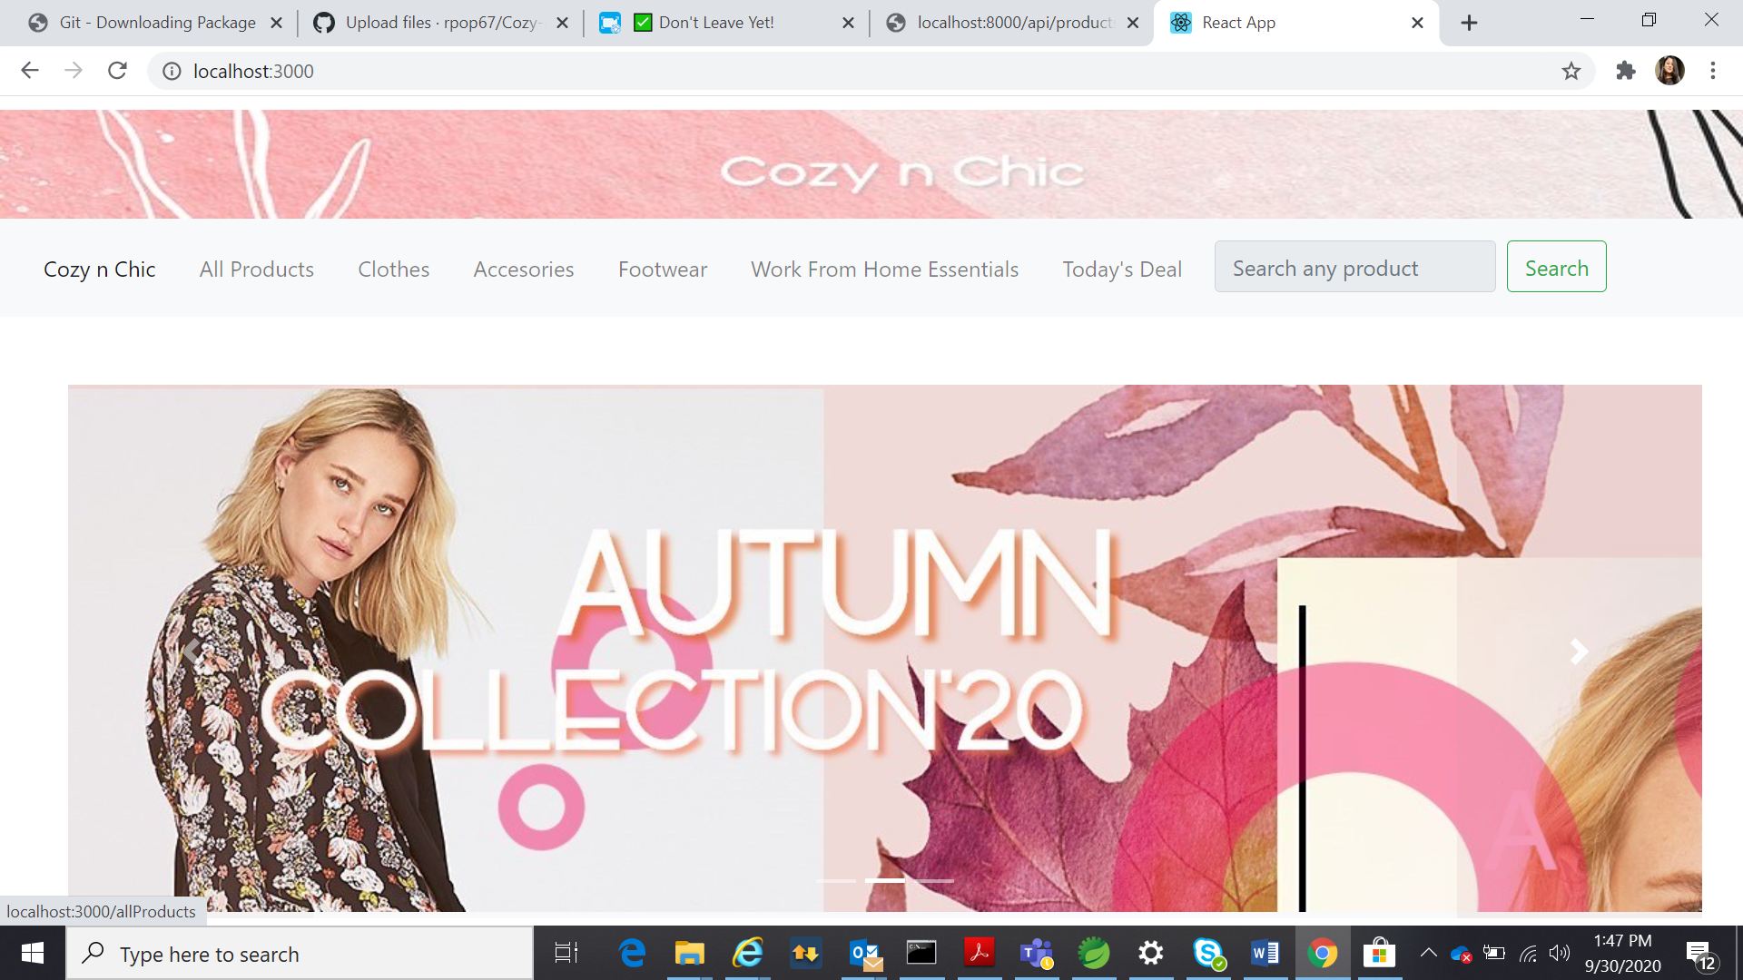

To start Spring boot server to handle API requests

1. STS project is created by the name of : evaluation_proj, open it in framework .Right click on project director> run as> Spring Boot App.
2. It will run on 8000 port number, if that port is not available port number can be changed in application.properties file, which is located in src/main/resources.

Console of STS will look like this… As it can be observed in highlighted part , that server has started running on port 8000.

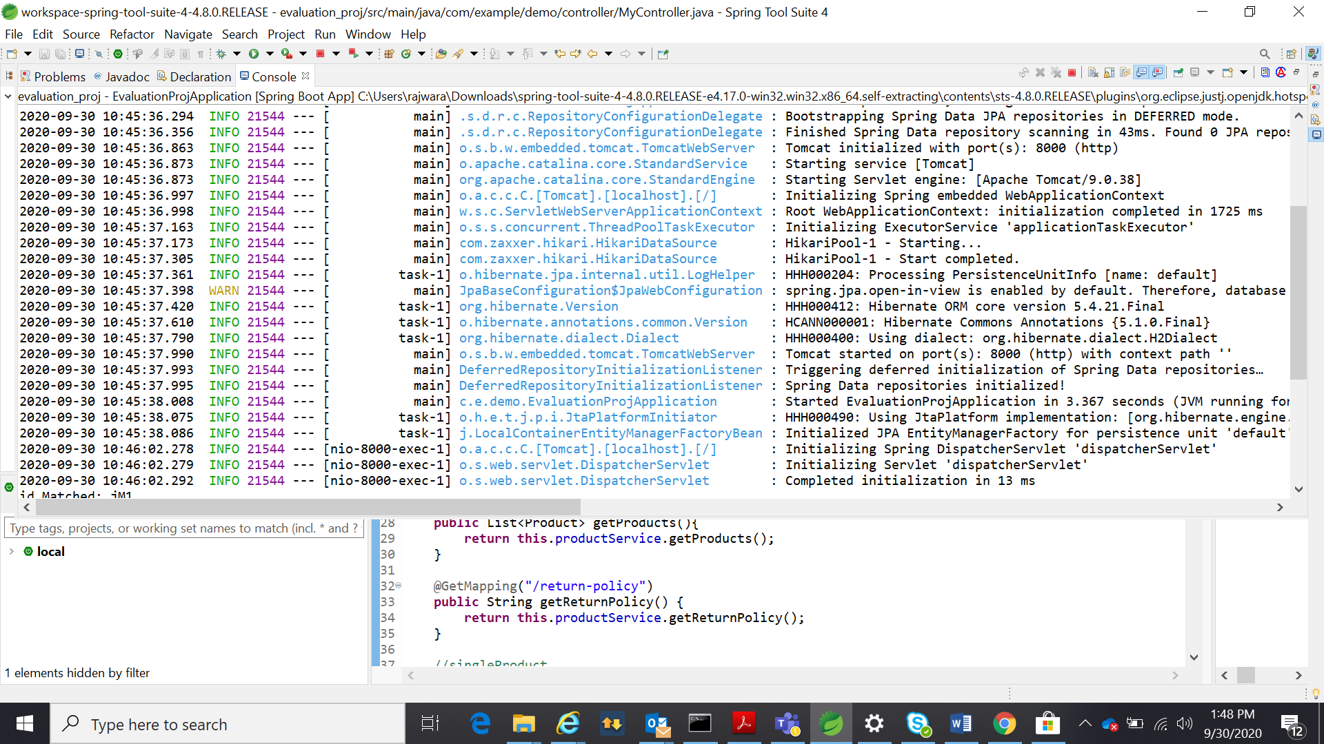

Now, you are good to go. You can explore my evaluation project. I have also recorded the demo of my project which can be found in zipped folder that I have attached or here: <http://10.196.19.105:15871/cgi-bin/blockpage.cgi?ws-session=18446744071941682118/>

To stop it, just press ctrl+c in terminal where react app was started.It will ask to terminate the process.

For STS, click on stop button (which is located between run and re-launch).

Structure for data goes like this:

**Product**(id,title,**Description**,rating,List of **Color**,List of **Variant**,sizesAvailable)

**Color(**color ,colorcode)

**Variant**(vId,color,size,quantity,price)

**Description(**header, material, specifications[])

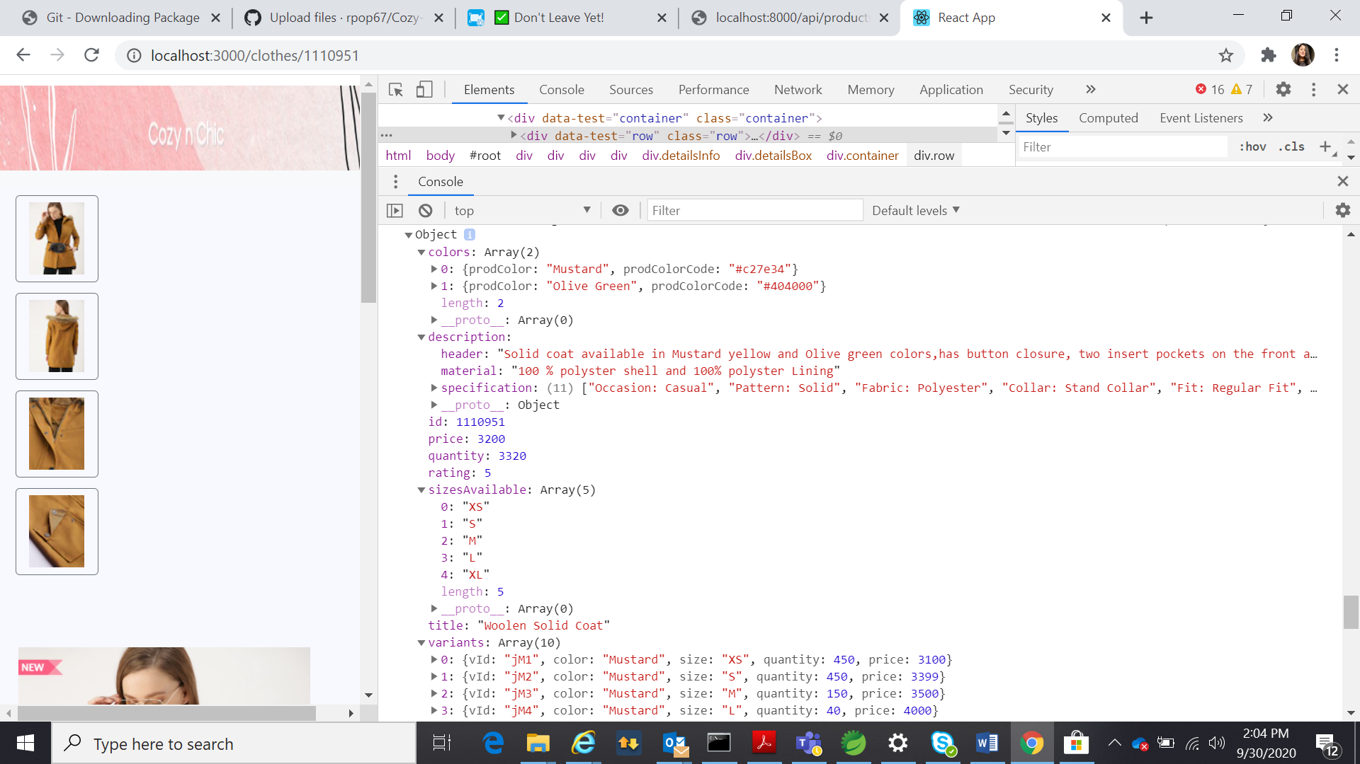

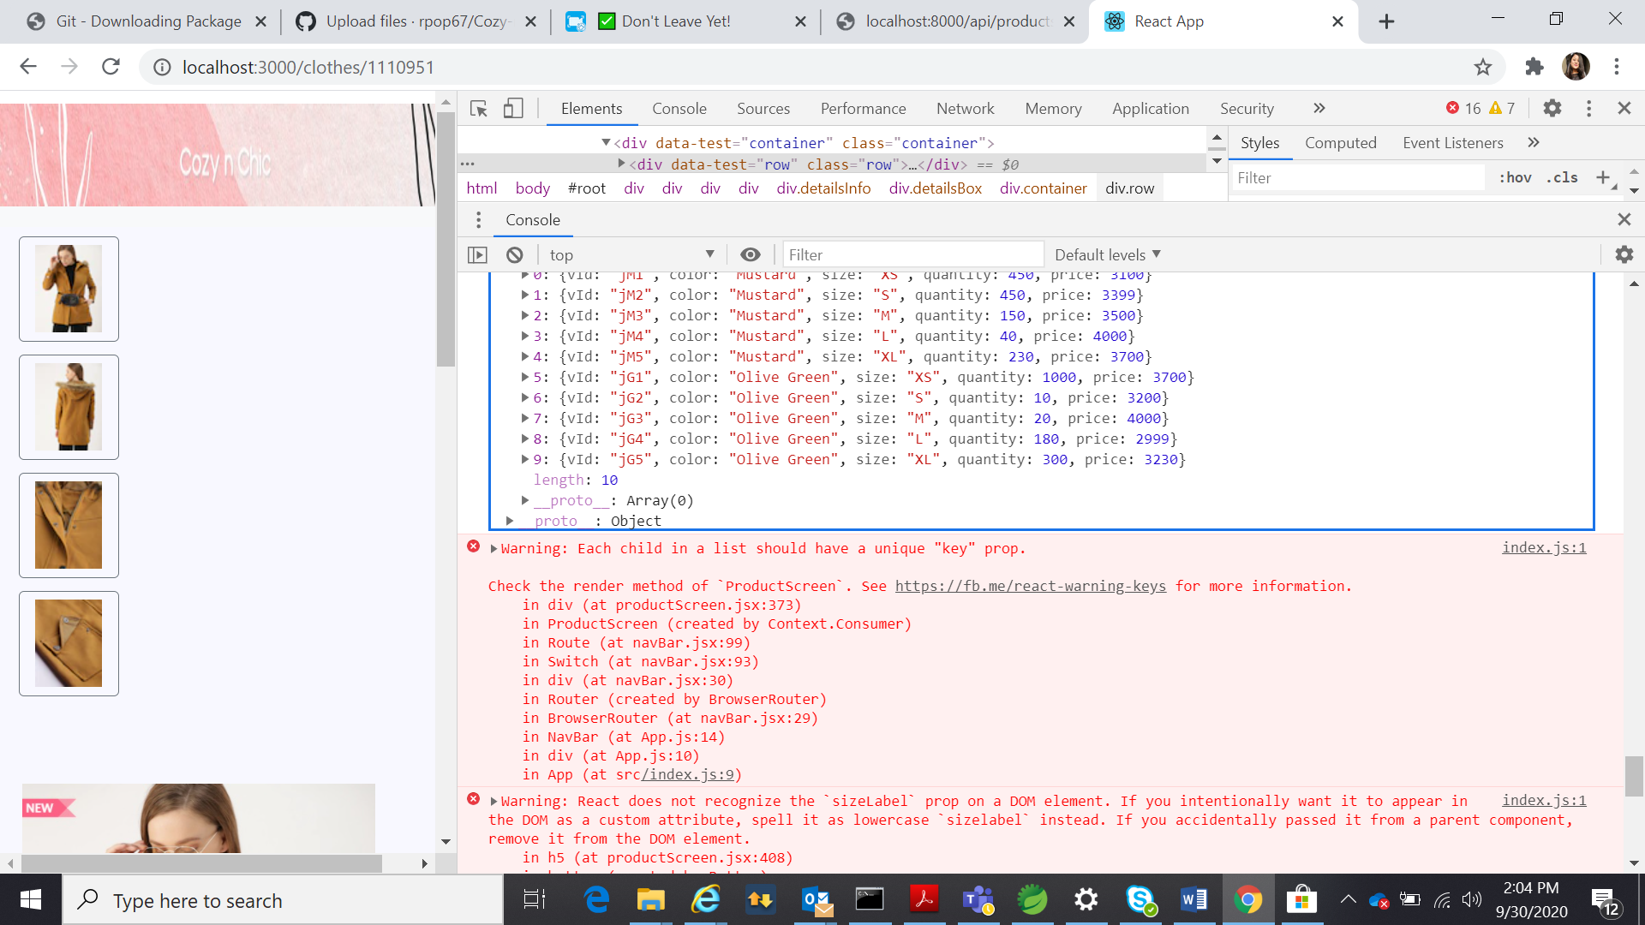

Submitted by-Akanksha Rajwar

Employee ID: 172662