Questionnaire on the relevance of DBPedia predicates for role representation of unstructured, contextualized values

L.Int.Ar – University of Milano-Bicocca

We are running a research aimed at recovering the semantics of sets of unstructured values, given the context where they occur. The values usually occur in tables or lists over the Web. We want to reconcile these unstructured data with respect to an ontology. More precisely, given a context (e.g., books) we want to infer that the role of values such as J.R.R. Tolkien, J.K. Rowling or Isaac Asimov is author.

The basic idea behind our approach is that we infer which ontology predicate is the most likely to be the role of all the values for a given context. For our experiments we choose the DBPedia Ontology. In order to evaluate our approach we need to compare its results with relevance judgments given by domain experts with some experience in Semantic Web and ontology design.

The file questionnaire.xlsx contains 39 sets of values with a corresponding context, along with a set of DBPedia predicates that possibly represent the role of the values within the given context. You are asked to judge how well each predicate represent the role of the values. For each predicate that you will judge, you are asked to provide a relevance judgment between 0 and 2, with the following interpretation:

0 – not relevant. The predicate does clearly not represent the role of the specified set of values within the provided context.

1 – somehow relevant. The predicate can to some extent be used to represent the role of the specified set of values within the provided context.

2 – definitely relevant. The predicate rightly represents the role the specified set of values within the provided context.

The evaluation questionnaire that you will provided with looks like this:

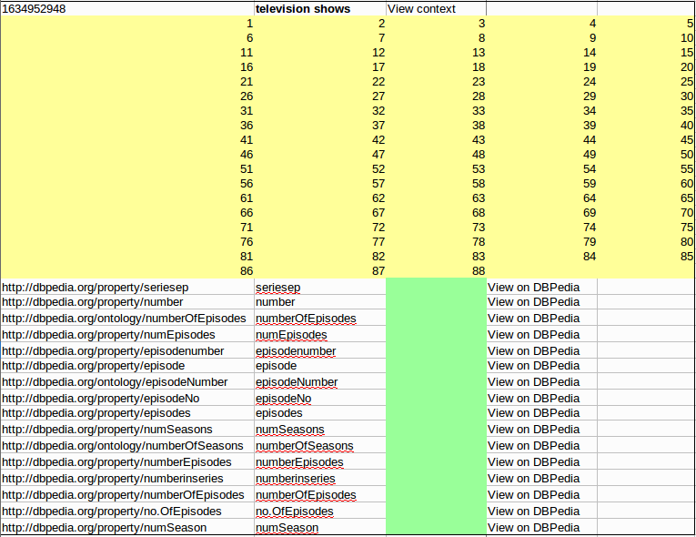
context
values
DBPedia predicate
Predicate's short name
Put your relevance judgments here
Click here to access a more
detailed view of the context
Click here if you want to see some triples involving the specific predicate

The questionnaire will take you about 1 hour to complete. Once you completed it, please email it to riccardo.porrini@disco.unimib.it.

Thank you very much for your collaboration.

See e.g., the Wikipedia Page on the episodes of the tv show “How I met your mother”

