Designing a Visualization for Your Manager

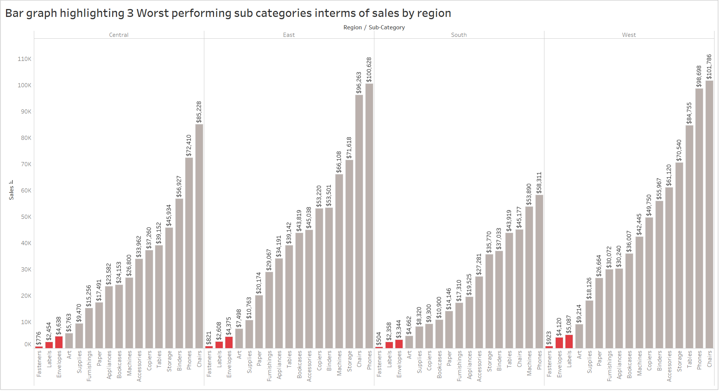

URL for the above visualization in Tableau: <t.ly/pbj1>

* How does your visualization leverage at least one “pop-out effect” or “pre-attentive attribute?” Which one(s) was (were) chosen and why?

A: Above visualization leverages pre-attentive attributes like Color. The bars representing three worst performing sub-categories by region in terms of sales were highlighted with color ‘Red’.

* How does your visualization utilize at least one Gestalt principle? Which principle(s) is (are) being reflected, and how?

A: Above visualization utilizes Gestalt principle like Proximity, Similarity. By sorting the sub categories based on sales, we have grouped worst three sub-categories together, this reflects Proximity. And by coloring the worst sub categories with ‘Red’, this reflects Similarity.

* How does your design reflect an understanding of cognitive load and clutter?

A: Visualization is designed with the intention of making it visually usable and clear to understand. Unnecessary grid lines, labels, multiple colors are removed and two colors with mark labels are used to reflect the understanding of cognitive load and clutter.

* Is your visualization static or interactive? Why did you choose that format?

A: This visualization is a Static visualization. Static format was picked as the Manager/VP of sales can not afford to spend more time on visualization and is also not good with numbers. As user interaction and knowledge is limited (almost 0), static format had been picked.

* What need does this visualization address that words or numbers alone cannot fill?

A: The key purpose of this visualization is to answer the questions audience have. Within the limited time the manager had, words or numbers alone cannot fill the answers unless there is some visualization to directly fetch the answer.