Sample cytotoxicity values were calculated for each sample at each time point using the following formula:

(Abs490-Abs680)-LDH/(Max LDH-LDH)

A scatter/line plot was constructed of the cytotoxicity values which allowed the identification of an anomalous datapoint in one sample, so that datapoint was imputed based on the mean of the five corresponding values for that treatment and time point.

At each time point, ANOVA was performed to determine whether differences exist between the cytotoxicity levels of different treatments, and in all cases these differences were significant. Furthermore, Tukey’s HSD test was performed between all samples. An additional “Null” group was added to the Tukey’s analysis to determine if the values significantly differ from zero. All groups were significantly different with the following exceptions:

ATP vs. Null : Timepoints 2,4,12

MSU vs. Nigericin: Timepoint 21

FIGURES

Before:

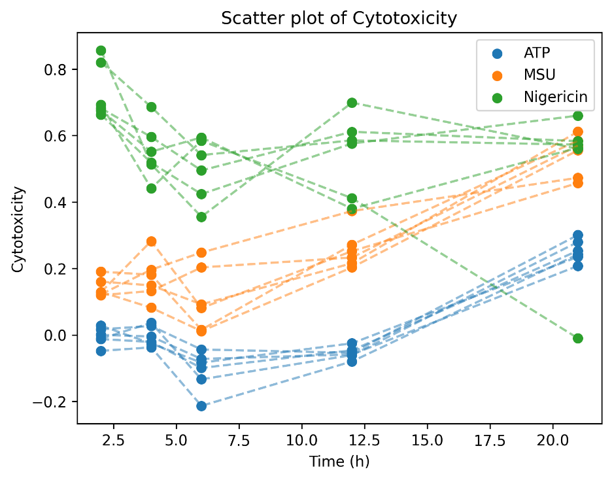

After:

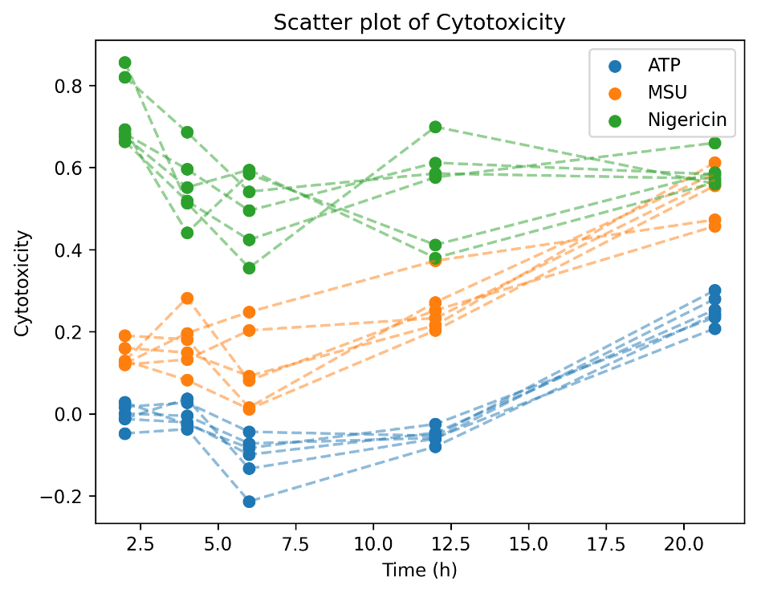

Bar chart showing percentage cytotoxicity between treatment groups. Error bars depict standard error.