Methods:

In order to analyze speck count data, the mean values of the technical replicates were initially combined. Owing to an experimental discrepancy, the first experimental replicate from each of the MCC950 groups was excluded from the analysis. Datasets for both speck count data and cytokine data were normalized with respect to the baseline values at time zero for each experimental replicate. Subsequently, the rate of change was computed for each time point in relation to the preceding one, based on the normalized values. For both normalized values and maximum rate of change, the peak values along with the corresponding time points were identified for each replicate. Additionally, the ratios of IL-1β to IL-18 were calculated utilizing the raw values for each replicate across the various time points.

Peak normalized measurements, the timing of peak measurements, the highest rate of change, and the timing of peak rate of change were juxtaposed between the MCC950 and non-MCC950 samples within the speck dataset (Table 1). In light of the small sample size and the nonparametric nature of our data, we employed the Nonparametric bootstrap t-test as it is known for its efficacy with such datasets (Dwivedi et al., 2017). We modelled our implementation of this test after Dwivedi et al.’s framework using Python instead of R. Additionally, for each sample, at each time point, the mean value was compared against the baseline value to ascertain if there was a statistically significant deviation among all the replicates from the initial value (see appendix: TS_Cyto_significant_times, TS_Speck_significant_times).

Results / Discussion:

The study unveiled that post-treatment, there was a substantial upswing in both the speck count and interleukin measurements across all variations (see appendix: summary_table). Cells subjected to nigericin displayed the highest values in all metrics, while those exposed to ATP recorded the lowest. Intriguingly, in the ATP-treated samples, the application of MCC950 led to a decrease in speck counts below the levels recorded before the treatment commenced (see Figure X, inflammasome speck count MCC950 + ATP).

Upon comparing the impact of MCC950 on speck count samples, within the normalized measurements, only the Nigericin-treated samples exhibited a significant difference (P=0.002) in peak measurement values. However, a noteworthy shift in peak time was observed across all three treatments (P<0.0001), with the ATP samples demonstrating the most pronounced change. In the case of the MSU samples, the effects on maximum measurement are somewhat indeterminate due to the extreme variability in our samples. The rate of change in the MSU and Nigericin samples was substantially curtailed, whereas ATP displayed no significant alteration. Moreover, the time at which the peak rate of change was observed for ATP and MSU was considerably deferred, while no such effect was evident in the Nigericin samples.

Table 1 - Effects of MCC950 modification by treatment

|  |  |  |  |
| --- | --- | --- | --- |
| **Treatment** | **ATP** | **MSU** | **Nigericin** |
| **Modifier** | **MCC950** | **MCC950** | **MCC950** |
| **base peak Normalized Measurement** | 2.329 | 23.269 | 66.301 |
| **mod peak Normalized Measurement** | 1.721 | 2.999 | 4.268 |
| **peak Normalized Measurement p** | 0.102 | 0.139 | 0.002 |
| **peak Normalized Measurement ci** | (-0.091, 1.085) | (-2.208, 24.55) | (11.426, 54.521) |
| **base peak Normalized Measurement time** | 3 | 5.9 | 1.9 |
| **mod peak Normalized Measurement time** | 21 | 20.7 | 4.5 |
| **peak Normalized Measurement time p** | <0.0001 | <0.0001 | <0.0001 |
| **peak Normalized Measurement time ci** | (5.3, 15.7) | (7.125, 14.208) | (1.15, 2.25) |
| **base peak Change Rate** | 32.5 | 191.8 | 803.4 |
| **mod peak Change Rate** | 37.8 | 46 | 169.2 |
| **peak Change Rate p** | 0.659 | <0.0001 | 0.003 |
| **peak Change Rate ci** | (23.45, 43.6) | (80.248, 175.833) | (258.899, 688.352) |
| **base peak Change Rate time** | 0.5 | 1.5 | 0.9 |
| **mod peak Change Rate time** | 18.7 | 14.9 | 0.9 |
| **peak Change Rate time p** | <0.0001 | 0.001 | 0.453 |
| **peak Change Rate time ci** | (2.75, 13.35) | (1.208, 9.458) | (-0.95, -0.25) |

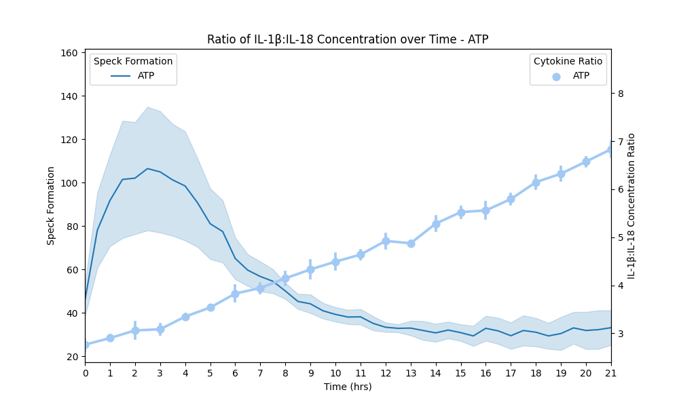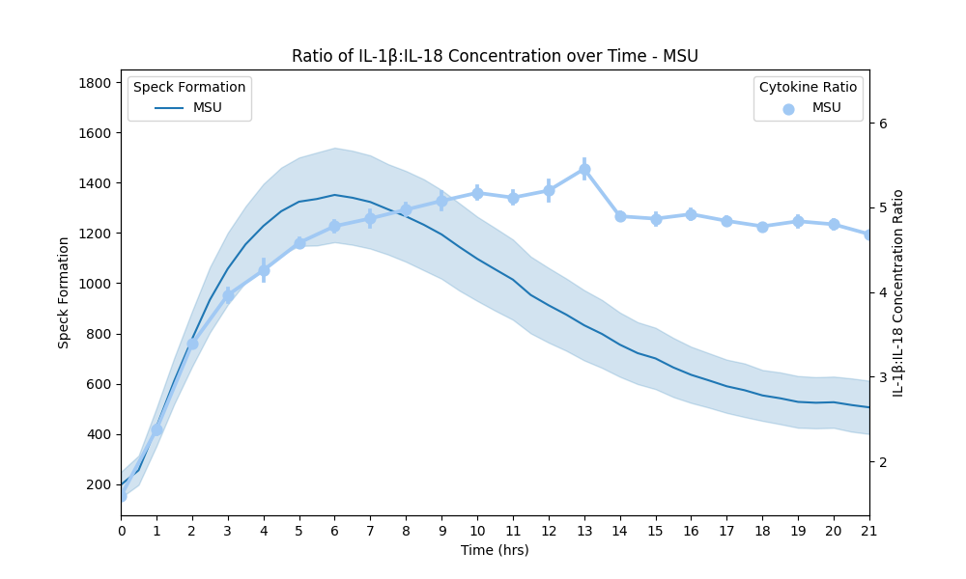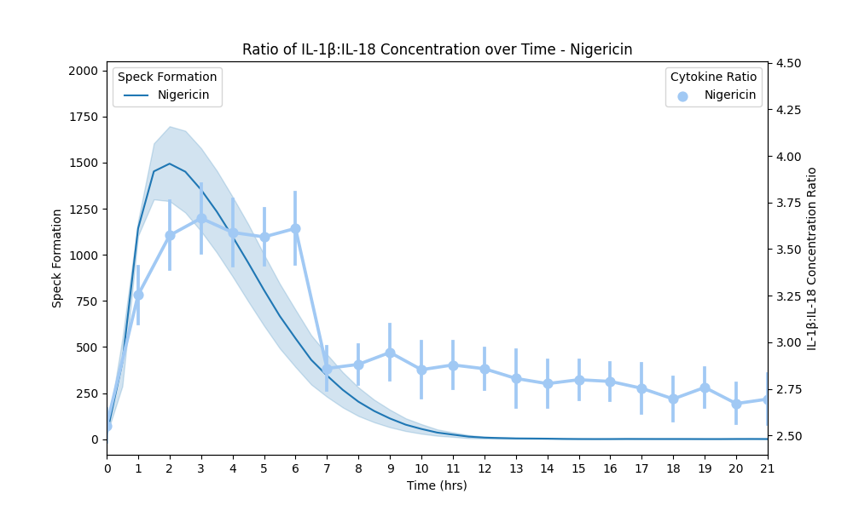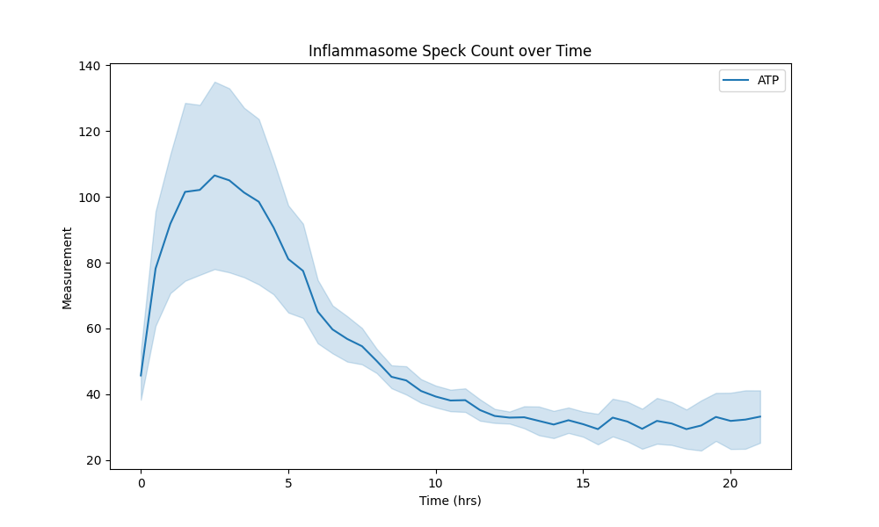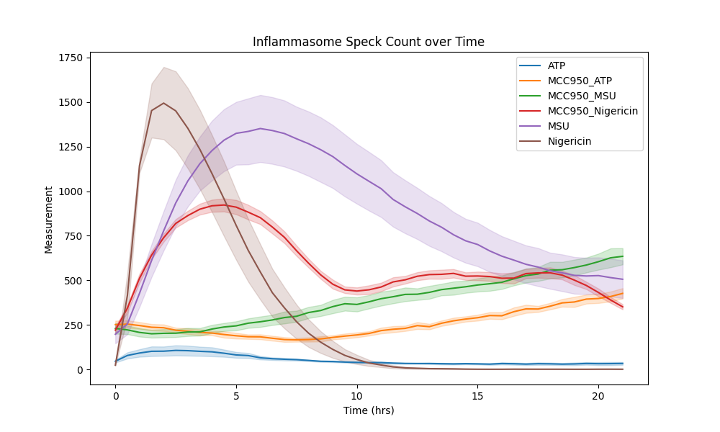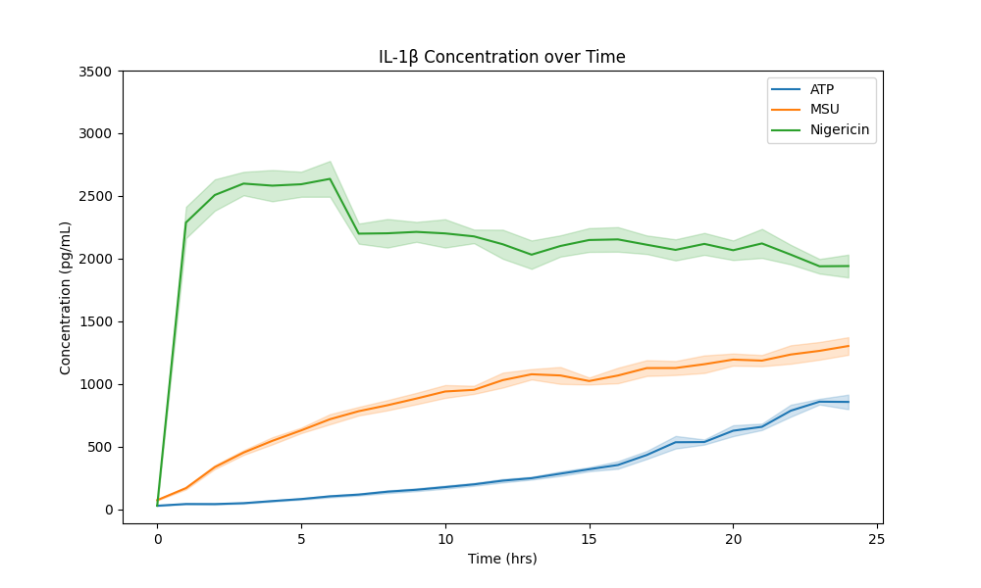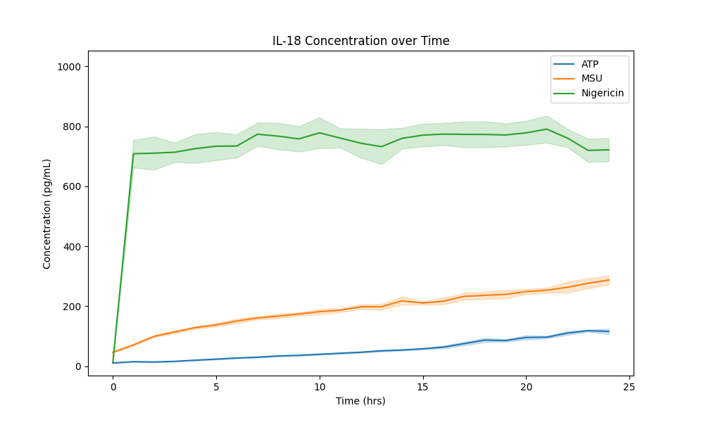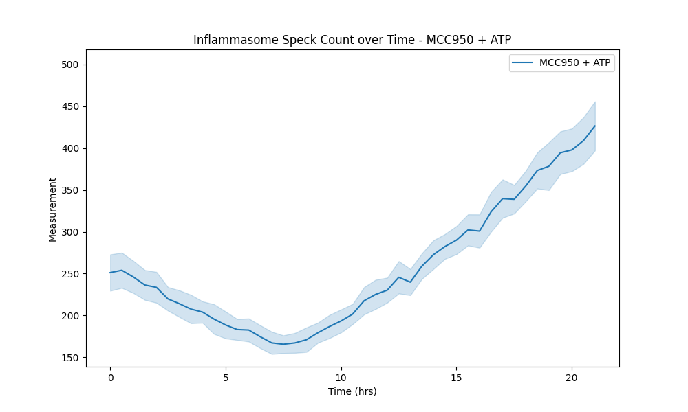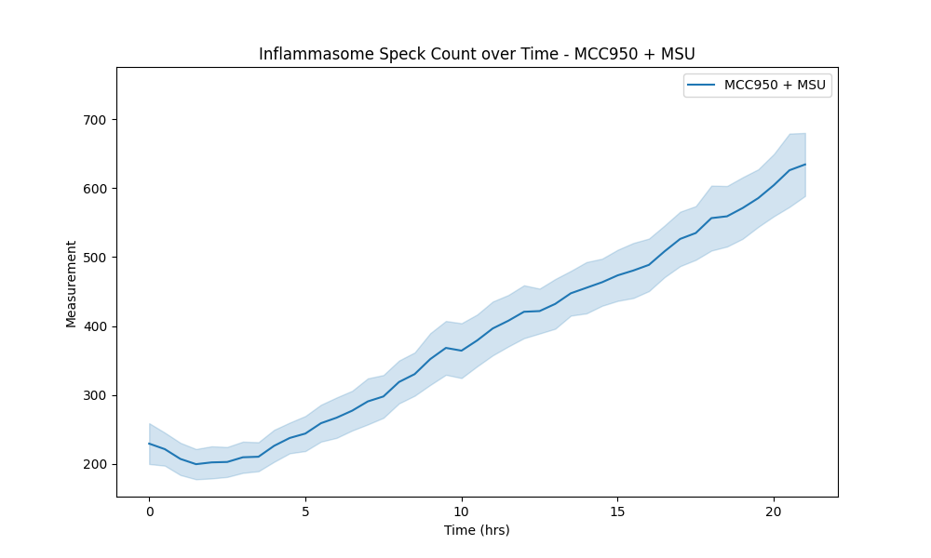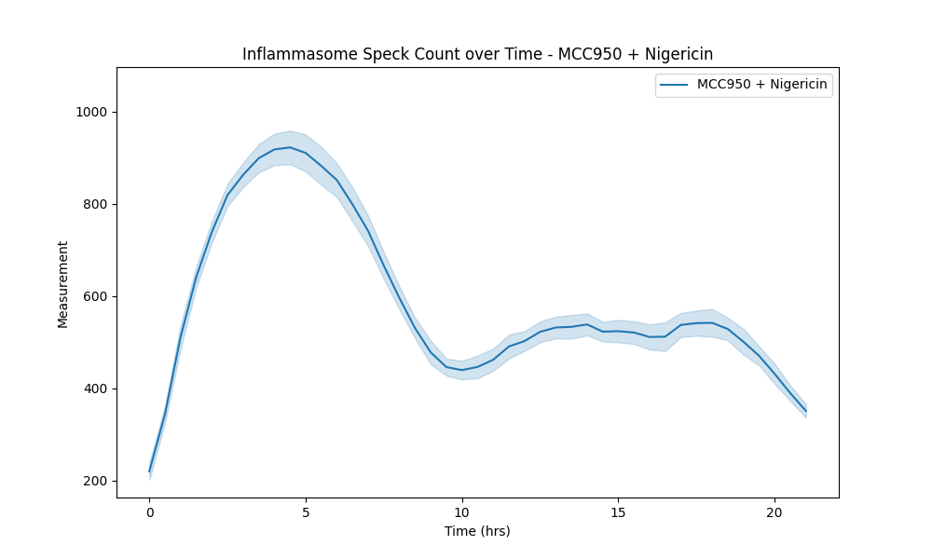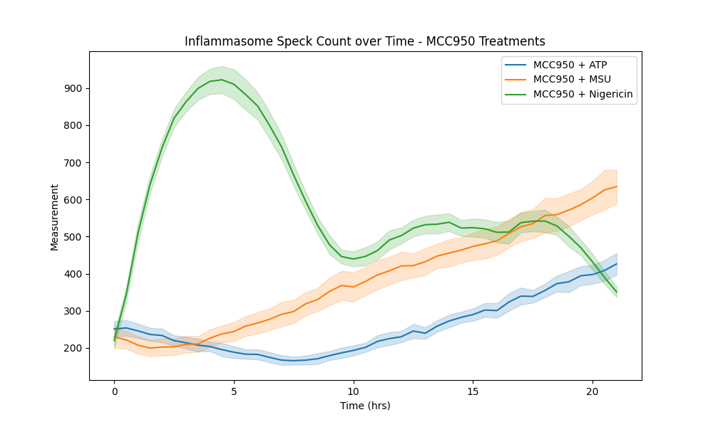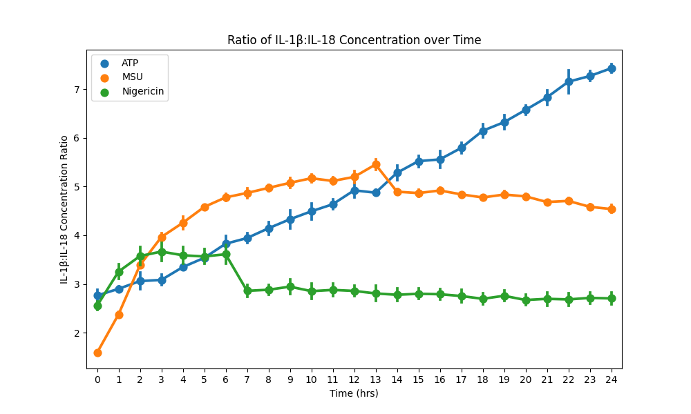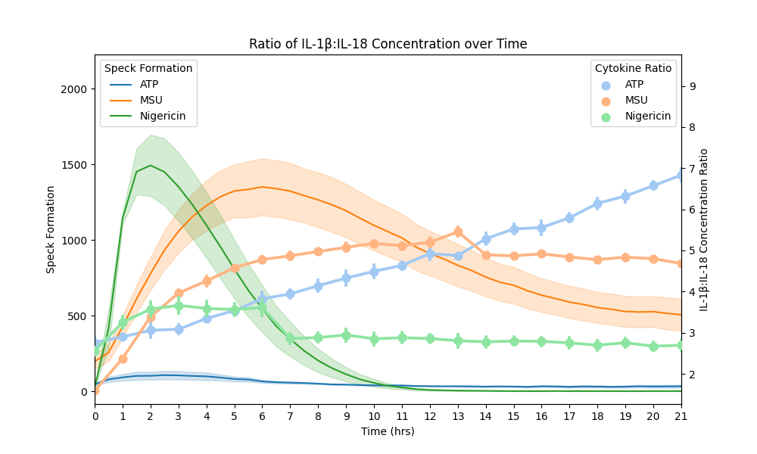

Code Segment (Bootstrap T-Test)

def bootstrap_t_test(array1, array2, n_bootstrap=1000):

*# Combine the two arrays*

    val = np.concatenate((array1, array2))

    grp = np.array([1] * len(array1) + [2] * len(array2))

*# Calculate the observed t statistic*

*## The t-statistic is calculated as the difference between the group means divided by the standard error of the difference.*

    observed_t_stat = stats.ttest_ind(

        val[grp == 1], val[grp == 2], equal_var=True

    ).statistic

*# Perform bootstrapping*

    t_values = np.zeros(n_bootstrap)

    n1 = len(array1)

    n2 = len(array2)

    for j in **range**(n_bootstrap):

        sample = np.random.choice(val, size=n1 + n2, replace=True)

        group1 = sample[:n1]

        group2 = sample[n1 : n1 + n2]

        if np.std(group1) == 0 or np.std(group2) == 0:

            t_values[j] = np.nan

        else:

            t_values[j] = stats.ttest_ind(group1, group2, equal_var=True).statistic

*# Calculate p-value*

    p_value = np.nanmean(np.abs(t_values) >= np.abs(observed_t_stat))

*# Confidence interval info*

    dfcol1 = val

    dfcol2 = grp

    diffs = []

    for i in **range**(n_bootstrap):

        dfcol1, dfcol2 = equalize_series_lengths(dfcol1, dfcol2)

        diff = np.array(dfcol1) - np.array(dfcol2)

        diffs.append((diff))

    diffs_mean = np.mean(diffs, axis=0)

    bs_result = bs.bootstrap(diffs_mean, stat_func=bs_stats.mean)

    confidence_interval = (

        round(bs_result.lower_bound, 3),

        round(bs_result.upper_bound, 3),

    )

    return p_value, confidence_interval

Sources

Dwivedi, A. K., Mallawaarachchi, I., and Alvarado, L. A. (2017) Analysis of small sample size studies using nonparametric bootstrap test with pooled resampling method. *Statist. Med.*, 36: 2187– 2205. doi: [10.1002/sim.7263](https://doi.org/10.1002/sim.7263).