SRM缓存启用

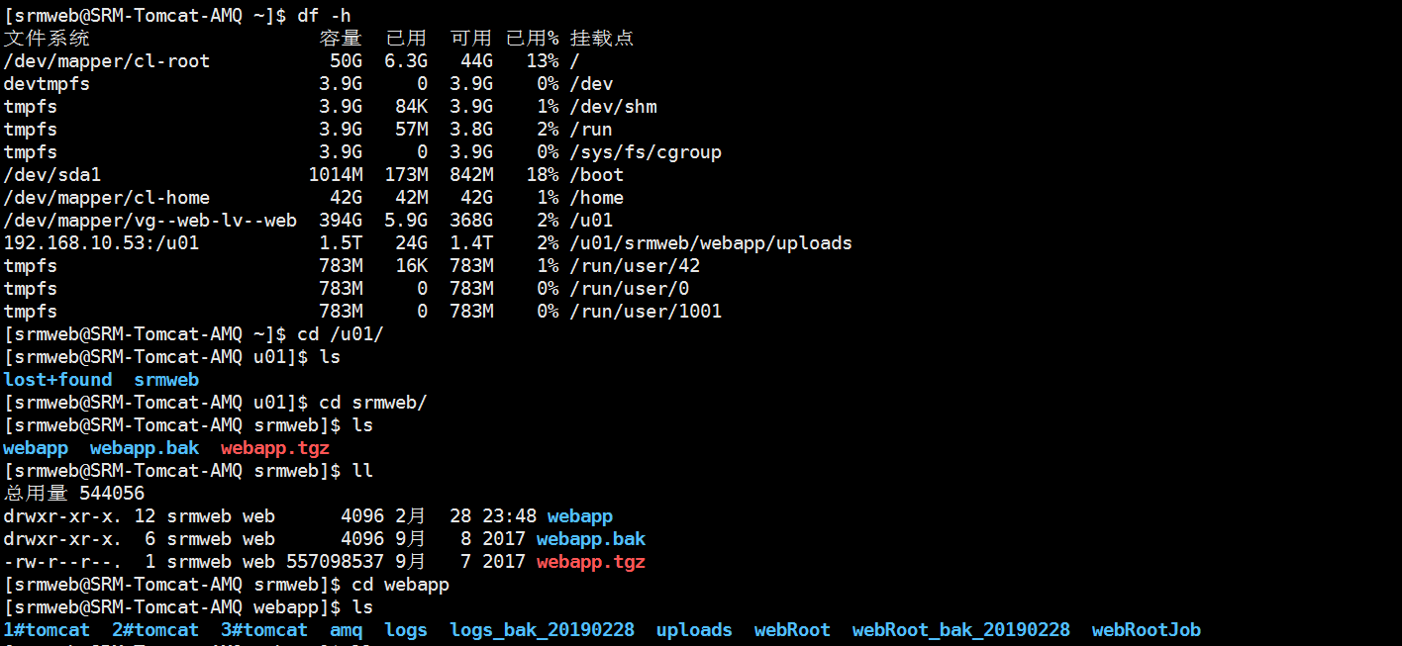

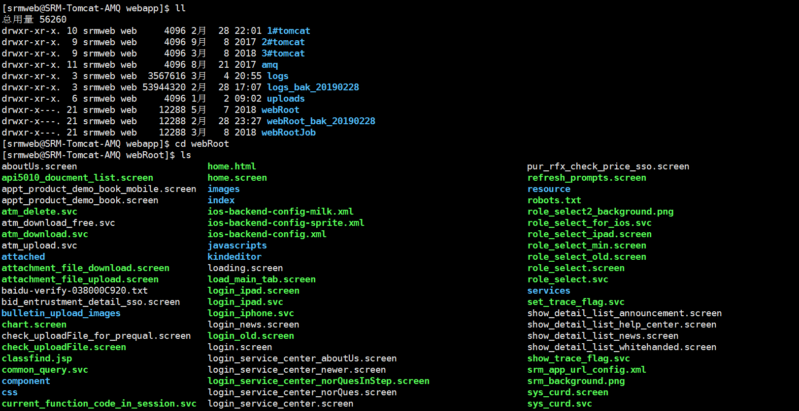

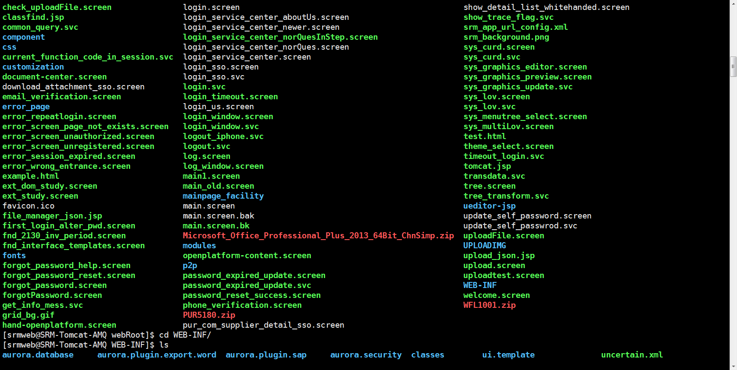

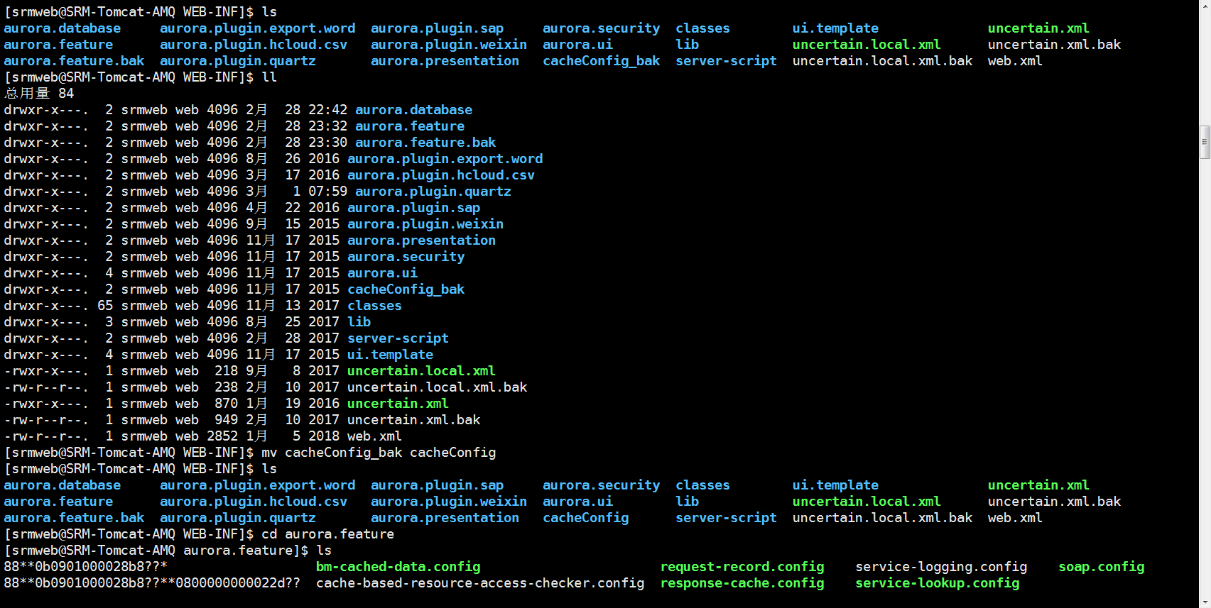

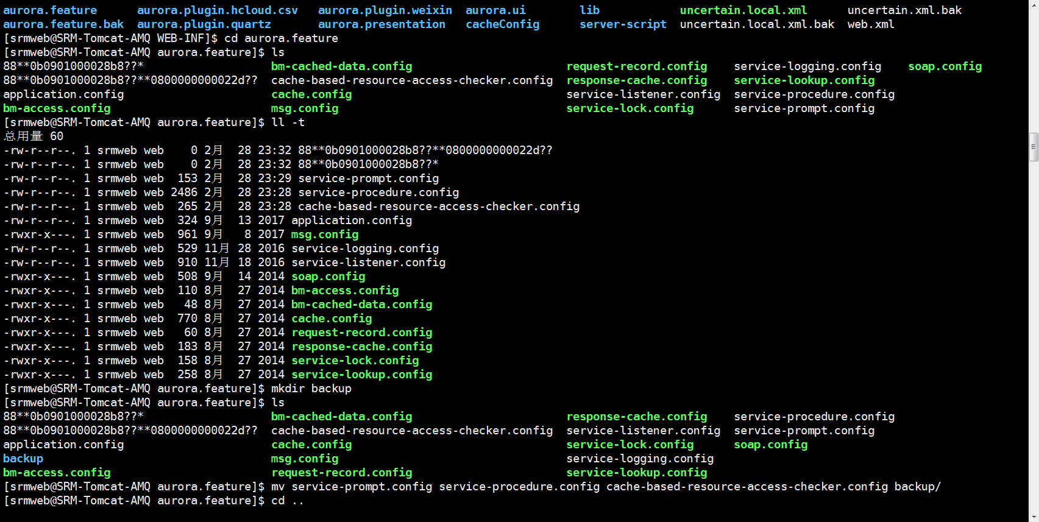

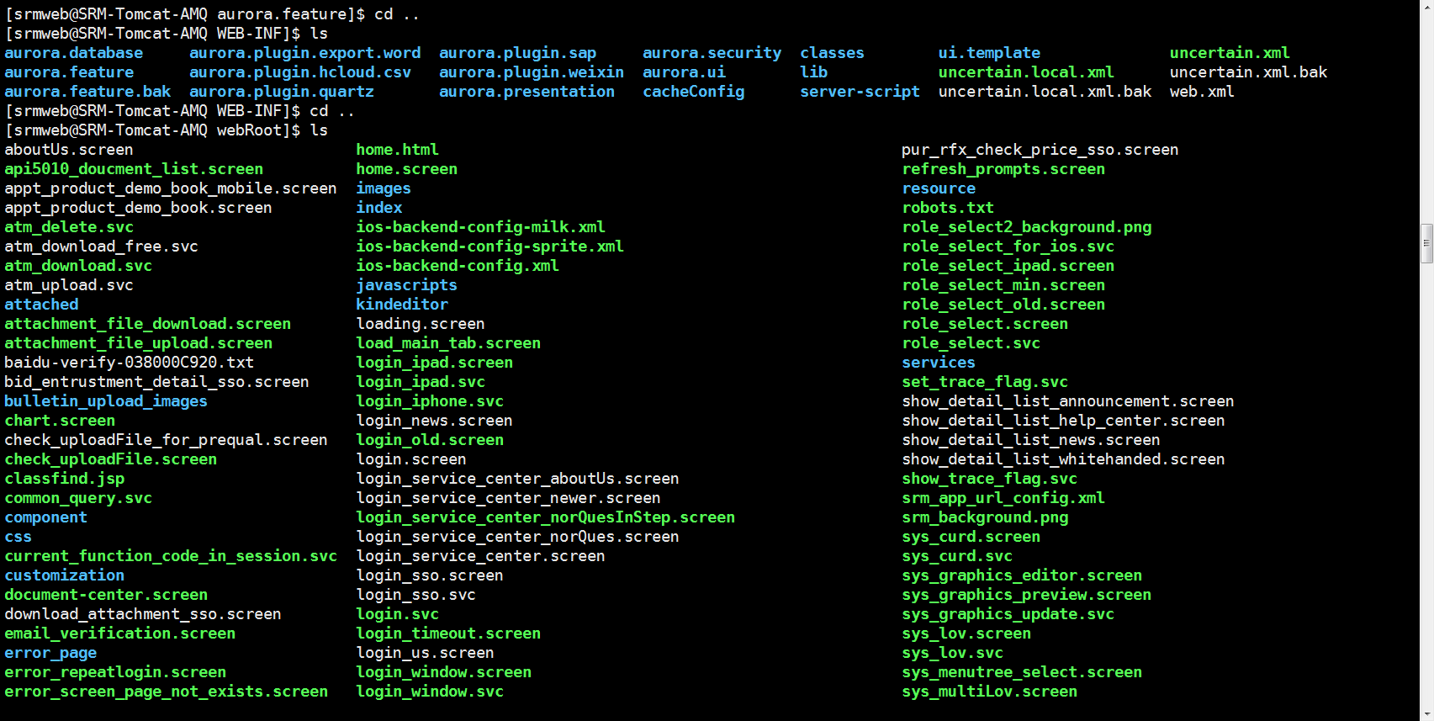

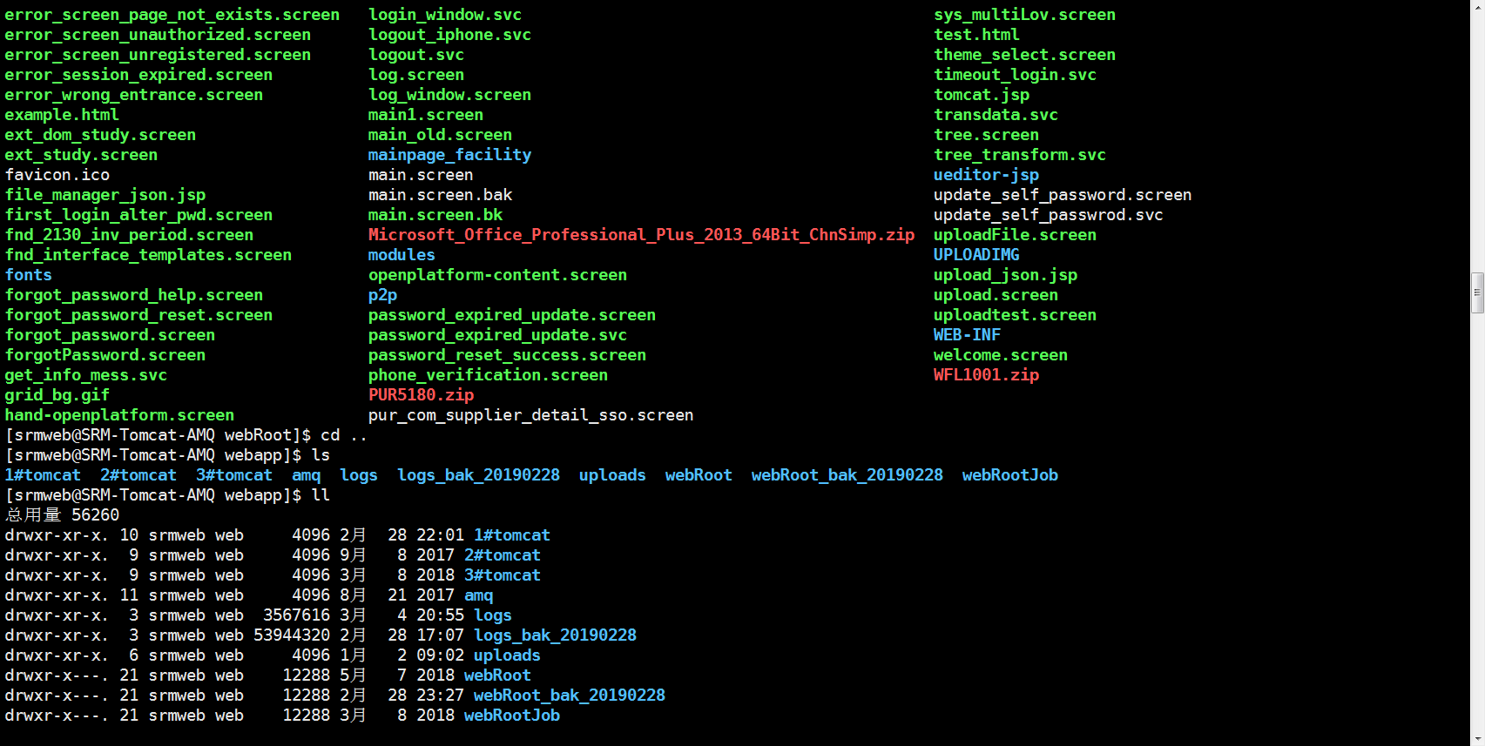

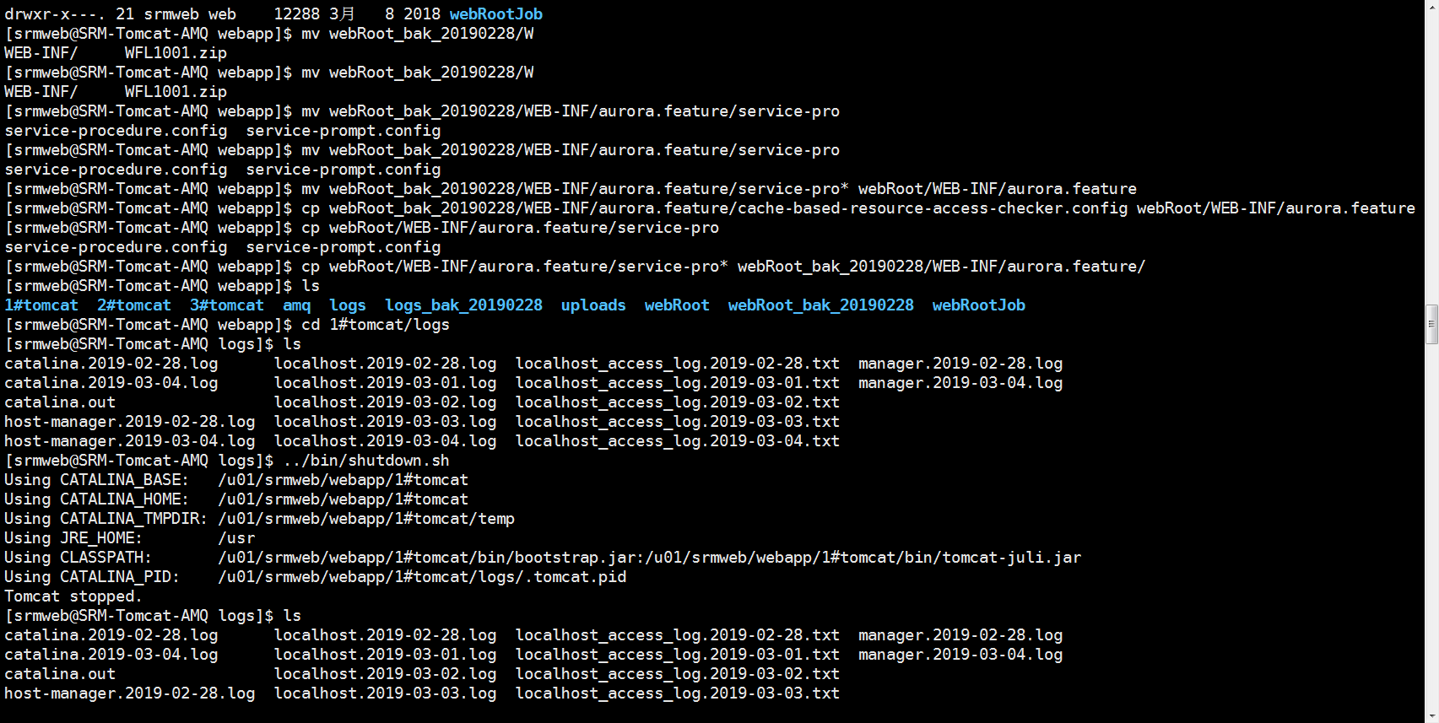

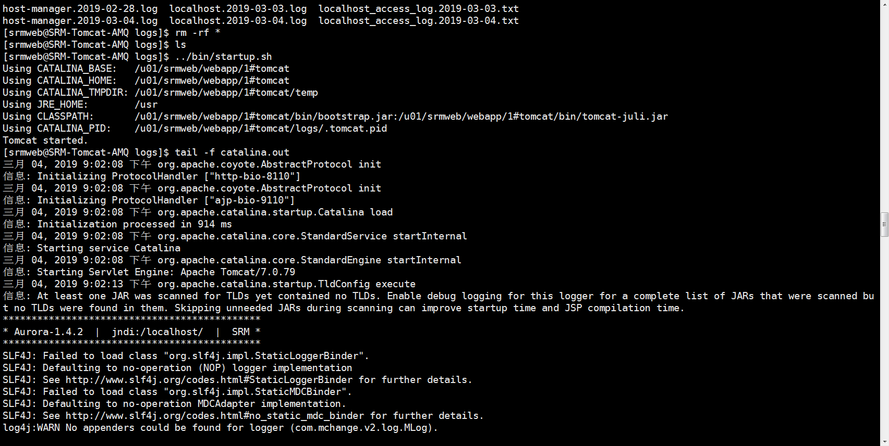

[srmweb@SRM-Tomcat-AMQ ~]$ ll

总用量 0

drwxr-xr-x. 2 srmweb web 6 7月 29 2018 公共

drwxr-xr-x. 2 srmweb web 6 7月 29 2018 模板

drwxr-xr-x. 2 srmweb web 6 7月 29 2018 视频

drwxr-xr-x. 2 srmweb web 6 7月 29 2018 图片

drwxr-xr-x. 2 srmweb web 6 7月 29 2018 文档

drwxr-xr-x. 2 srmweb web 6 7月 29 2018 下载

drwxr-xr-x. 2 srmweb web 6 7月 29 2018 音乐

drwxr-xr-x. 2 srmweb web 6 7月 29 2018 桌面

[srmweb@SRM-Tomcat-AMQ ~]$ df -h

文件系统 容量 已用 可用 已用% 挂载点

/dev/mapper/cl-root 50G 6.3G 44G 13% /

devtmpfs 3.9G 0 3.9G 0% /dev

tmpfs 3.9G 84K 3.9G 1% /dev/shm

tmpfs 3.9G 57M 3.8G 2% /run

tmpfs 3.9G 0 3.9G 0% /sys/fs/cgroup

/dev/sda1 1014M 173M 842M 18% /boot

/dev/mapper/cl-home 42G 42M 42G 1% /home

/dev/mapper/vg--web-lv--web 394G 5.9G 368G 2% /u01

192.168.10.53:/u01 1.5T 24G 1.4T 2% /u01/srmweb/webapp/uploads

tmpfs 783M 16K 783M 1% /run/user/42

tmpfs 783M 0 783M 0% /run/user/0

tmpfs 783M 0 783M 0% /run/user/1001

[srmweb@SRM-Tomcat-AMQ ~]$ cd /u01/

[srmweb@SRM-Tomcat-AMQ u01]$ ls

lost+found srmweb

[srmweb@SRM-Tomcat-AMQ u01]$ cd srmweb/

[srmweb@SRM-Tomcat-AMQ srmweb]$ ls

webapp webapp.bak webapp.tgz

[srmweb@SRM-Tomcat-AMQ srmweb]$ ll

总用量 544056

drwxr-xr-x. 12 srmweb web 4096 2月 28 23:48 webapp

drwxr-xr-x. 6 srmweb web 4096 9月 8 2017 webapp.bak

-rw-r--r--. 1 srmweb web 557098537 9月 7 2017 webapp.tgz

[srmweb@SRM-Tomcat-AMQ srmweb]$ cd webapp

[srmweb@SRM-Tomcat-AMQ webapp]$ ls

1#tomcat 2#tomcat 3#tomcat amq logs logs_bak_20190228 uploads webRoot webRoot_bak_20190228 webRootJob

[srmweb@SRM-Tomcat-AMQ webapp]$ ll

总用量 56260

drwxr-xr-x. 10 srmweb web 4096 2月 28 22:01 1#tomcat

drwxr-xr-x. 9 srmweb web 4096 9月 8 2017 2#tomcat

drwxr-xr-x. 9 srmweb web 4096 3月 8 2018 3#tomcat

drwxr-xr-x. 11 srmweb web 4096 8月 21 2017 amq

drwxr-xr-x. 3 srmweb web 3567616 3月 4 20:55 logs

drwxr-xr-x. 3 srmweb web 53944320 2月 28 17:07 logs_bak_20190228

drwxr-xr-x. 6 srmweb web 4096 1月 2 09:02 uploads

drwxr-x---. 21 srmweb web 12288 5月 7 2018 webRoot

drwxr-x---. 21 srmweb web 12288 2月 28 23:27 webRoot_bak_20190228

drwxr-x---. 21 srmweb web 12288 3月 8 2018 webRootJob

[srmweb@SRM-Tomcat-AMQ webapp]$ cd webRoot

[srmweb@SRM-Tomcat-AMQ webRoot]$ ls

aboutUs.screen home.html pur_rfx_check_price_sso.screen

api5010_doucment_list.screen home.screen refresh_prompts.screen

appt_product_demo_book_mobile.screen images resource

appt_product_demo_book.screen index robots.txt

atm_delete.svc ios-backend-config-milk.xml role_select2_background.png

atm_download_free.svc ios-backend-config-sprite.xml role_select_for_ios.svc

atm_download.svc ios-backend-config.xml role_select_ipad.screen

atm_upload.svc javascripts role_select_min.screen

attached kindeditor role_select_old.screen

attachment_file_download.screen loading.screen role_select.screen

attachment_file_upload.screen load_main_tab.screen role_select.svc

baidu-verify-038000C920.txt login_ipad.screen services

bid_entrustment_detail_sso.screen login_ipad.svc set_trace_flag.svc

bulletin_upload_images login_iphone.svc show_detail_list_announcement.screen

chart.screen login_news.screen show_detail_list_help_center.screen

check_uploadFile_for_prequal.screen login_old.screen show_detail_list_news.screen

check_uploadFile.screen login.screen show_detail_list_whitehanded.screen

classfind.jsp login_service_center_aboutUs.screen show_trace_flag.svc

common_query.svc login_service_center_newer.screen srm_app_url_config.xml

component login_service_center_norQuesInStep.screen srm_background.png

css login_service_center_norQues.screen sys_curd.screen

current_function_code_in_session.svc login_service_center.screen sys_curd.svc

customization login_sso.screen sys_graphics_editor.screen

document-center.screen login_sso.svc sys_graphics_preview.screen

download_attachment_sso.screen login.svc sys_graphics_update.svc

email_verification.screen login_timeout.screen sys_lov.screen

error_page login_us.screen sys_lov.svc

error_repeatlogin.screen login_window.screen sys_menutree_select.screen

error_screen_page_not_exists.screen login_window.svc sys_multiLov.screen

error_screen_unauthorized.screen logout_iphone.svc test.html

error_screen_unregistered.screen logout.svc theme_select.screen

error_session_expired.screen log.screen timeout_login.svc

error_wrong_entrance.screen log_window.screen tomcat.jsp

example.html main1.screen transdata.svc

ext_dom_study.screen main_old.screen tree.screen

ext_study.screen mainpage_facility tree_transform.svc

favicon.ico main.screen ueditor-jsp

file_manager_json.jsp main.screen.bak update_self_password.screen

first_login_alter_pwd.screen main.screen.bk update_self_passwrod.svc

fnd_2130_inv_period.screen Microsoft_Office_Professional_Plus_2013_64Bit_ChnSimp.zip uploadFile.screen

fnd_interface_templates.screen modules UPLOADIMG

fonts openplatform-content.screen upload_json.jsp

forgot_password_help.screen p2p upload.screen

forgot_password_reset.screen password_expired_update.screen uploadtest.screen

forgot_password.screen password_expired_update.svc WEB-INF

forgotPassword.screen password_reset_success.screen welcome.screen

get_info_mess.svc phone_verification.screen WFL1001.zip

grid_bg.gif PUR5180.zip

hand-openplatform.screen pur_com_supplier_detail_sso.screen

[srmweb@SRM-Tomcat-AMQ webRoot]$ cd WEB-INF/

[srmweb@SRM-Tomcat-AMQ WEB-INF]$ ls

aurora.database aurora.plugin.export.word aurora.plugin.sap aurora.security classes ui.template uncertain.xml

aurora.feature aurora.plugin.hcloud.csv aurora.plugin.weixin aurora.ui lib uncertain.local.xml uncertain.xml.bak

aurora.feature.bak aurora.plugin.quartz aurora.presentation cacheConfig_bak server-script uncertain.local.xml.bak web.xml

[srmweb@SRM-Tomcat-AMQ WEB-INF]$ ll

总用量 84

drwxr-x---. 2 srmweb web 4096 2月 28 22:42 aurora.database

drwxr-x---. 2 srmweb web 4096 2月 28 23:32 aurora.feature

drwxr-x---. 2 srmweb web 4096 2月 28 23:30 aurora.feature.bak

drwxr-x---. 2 srmweb web 4096 8月 26 2016 aurora.plugin.export.word

drwxr-x---. 2 srmweb web 4096 3月 17 2016 aurora.plugin.hcloud.csv

drwxr-x---. 2 srmweb web 4096 3月 1 07:59 aurora.plugin.quartz

drwxr-x---. 2 srmweb web 4096 4月 22 2016 aurora.plugin.sap

drwxr-x---. 2 srmweb web 4096 9月 15 2015 aurora.plugin.weixin

drwxr-x---. 2 srmweb web 4096 11月 17 2015 aurora.presentation

drwxr-x---. 2 srmweb web 4096 11月 17 2015 aurora.security

drwxr-x---. 4 srmweb web 4096 11月 17 2015 aurora.ui

drwxr-x---. 2 srmweb web 4096 11月 17 2015 cacheConfig_bak

drwxr-x---. 65 srmweb web 4096 11月 13 2017 classes

drwxr-x---. 3 srmweb web 4096 8月 25 2017 lib

drwxr-x---. 2 srmweb web 4096 2月 28 2017 server-script

drwxr-x---. 4 srmweb web 4096 11月 17 2015 ui.template

-rwxr-x---. 1 srmweb web 218 9月 8 2017 uncertain.local.xml

-rw-r--r--. 1 srmweb web 238 2月 10 2017 uncertain.local.xml.bak

-rwxr-x---. 1 srmweb web 870 1月 19 2016 uncertain.xml

-rw-r--r--. 1 srmweb web 949 2月 10 2017 uncertain.xml.bak

-rw-r--r--. 1 srmweb web 2852 1月 5 2018 web.xml

[srmweb@SRM-Tomcat-AMQ WEB-INF]$ mv cacheConfig_bak cacheConfig

[srmweb@SRM-Tomcat-AMQ WEB-INF]$ ls

aurora.database aurora.plugin.export.word aurora.plugin.sap aurora.security classes ui.template uncertain.xml

aurora.feature aurora.plugin.hcloud.csv aurora.plugin.weixin aurora.ui lib uncertain.local.xml uncertain.xml.bak

aurora.feature.bak aurora.plugin.quartz aurora.presentation cacheConfig server-script uncertain.local.xml.bak web.xml

[srmweb@SRM-Tomcat-AMQ WEB-INF]$ cd aurora.feature

[srmweb@SRM-Tomcat-AMQ aurora.feature]$ ls

88**0b0901000028b8??* bm-cached-data.config request-record.config service-logging.config soap.config

88**0b0901000028b8??**0800000000022d?? cache-based-resource-access-checker.config response-cache.config service-lookup.config

application.config cache.config service-listener.config service-procedure.config

bm-access.config msg.config service-lock.config service-prompt.config

[srmweb@SRM-Tomcat-AMQ aurora.feature]$ ll -t

总用量 60

-rw-r--r--. 1 srmweb web 0 2月 28 23:32 88**0b0901000028b8??**0800000000022d??

-rw-r--r--. 1 srmweb web 0 2月 28 23:32 88**0b0901000028b8??*

-rw-r--r--. 1 srmweb web 153 2月 28 23:29 service-prompt.config

-rw-r--r--. 1 srmweb web 2486 2月 28 23:28 service-procedure.config

-rw-r--r--. 1 srmweb web 265 2月 28 23:28 cache-based-resource-access-checker.config

-rw-r--r--. 1 srmweb web 324 9月 13 2017 application.config

-rwxr-x---. 1 srmweb web 961 9月 8 2017 msg.config

-rw-r--r--. 1 srmweb web 529 11月 28 2016 service-logging.config

-rw-r--r--. 1 srmweb web 910 11月 18 2016 service-listener.config

-rwxr-x---. 1 srmweb web 508 9月 14 2014 soap.config

-rwxr-x---. 1 srmweb web 110 8月 27 2014 bm-access.config

-rwxr-x---. 1 srmweb web 48 8月 27 2014 bm-cached-data.config

-rwxr-x---. 1 srmweb web 770 8月 27 2014 cache.config

-rwxr-x---. 1 srmweb web 60 8月 27 2014 request-record.config

-rwxr-x---. 1 srmweb web 183 8月 27 2014 response-cache.config

-rwxr-x---. 1 srmweb web 158 8月 27 2014 service-lock.config

-rwxr-x---. 1 srmweb web 258 8月 27 2014 service-lookup.config

[srmweb@SRM-Tomcat-AMQ aurora.feature]$ mkdir backup

[srmweb@SRM-Tomcat-AMQ aurora.feature]$ ls

88**0b0901000028b8??* bm-cached-data.config response-cache.config service-procedure.config

88**0b0901000028b8??**0800000000022d?? cache-based-resource-access-checker.config service-listener.config service-prompt.config

application.config cache.config service-lock.config soap.config

backup msg.config service-logging.config

bm-access.config request-record.config service-lookup.config

[srmweb@SRM-Tomcat-AMQ aurora.feature]$ mv service-prompt.config service-procedure.config cache-based-resource-access-checker.config backup/

[srmweb@SRM-Tomcat-AMQ aurora.feature]$ cd ..

[srmweb@SRM-Tomcat-AMQ WEB-INF]$ ls

aurora.database aurora.plugin.export.word aurora.plugin.sap aurora.security classes ui.template uncertain.xml

aurora.feature aurora.plugin.hcloud.csv aurora.plugin.weixin aurora.ui lib uncertain.local.xml uncertain.xml.bak

aurora.feature.bak aurora.plugin.quartz aurora.presentation cacheConfig server-script uncertain.local.xml.bak web.xml

[srmweb@SRM-Tomcat-AMQ WEB-INF]$ cd ..

[srmweb@SRM-Tomcat-AMQ webRoot]$ ls

aboutUs.screen home.html pur_rfx_check_price_sso.screen

api5010_doucment_list.screen home.screen refresh_prompts.screen

appt_product_demo_book_mobile.screen images resource

appt_product_demo_book.screen index robots.txt

atm_delete.svc ios-backend-config-milk.xml role_select2_background.png

atm_download_free.svc ios-backend-config-sprite.xml role_select_for_ios.svc

atm_download.svc ios-backend-config.xml role_select_ipad.screen

atm_upload.svc javascripts role_select_min.screen

attached kindeditor role_select_old.screen

attachment_file_download.screen loading.screen role_select.screen

attachment_file_upload.screen load_main_tab.screen role_select.svc

baidu-verify-038000C920.txt login_ipad.screen services

bid_entrustment_detail_sso.screen login_ipad.svc set_trace_flag.svc

bulletin_upload_images login_iphone.svc show_detail_list_announcement.screen

chart.screen login_news.screen show_detail_list_help_center.screen

check_uploadFile_for_prequal.screen login_old.screen show_detail_list_news.screen

check_uploadFile.screen login.screen show_detail_list_whitehanded.screen

classfind.jsp login_service_center_aboutUs.screen show_trace_flag.svc

common_query.svc login_service_center_newer.screen srm_app_url_config.xml

component login_service_center_norQuesInStep.screen srm_background.png

css login_service_center_norQues.screen sys_curd.screen

current_function_code_in_session.svc login_service_center.screen sys_curd.svc

customization login_sso.screen sys_graphics_editor.screen

document-center.screen login_sso.svc sys_graphics_preview.screen

download_attachment_sso.screen login.svc sys_graphics_update.svc

email_verification.screen login_timeout.screen sys_lov.screen

error_page login_us.screen sys_lov.svc

error_repeatlogin.screen login_window.screen sys_menutree_select.screen

error_screen_page_not_exists.screen login_window.svc sys_multiLov.screen

error_screen_unauthorized.screen logout_iphone.svc test.html

error_screen_unregistered.screen logout.svc theme_select.screen

error_session_expired.screen log.screen timeout_login.svc

error_wrong_entrance.screen log_window.screen tomcat.jsp

example.html main1.screen transdata.svc

ext_dom_study.screen main_old.screen tree.screen

ext_study.screen mainpage_facility tree_transform.svc

favicon.ico main.screen ueditor-jsp

file_manager_json.jsp main.screen.bak update_self_password.screen

first_login_alter_pwd.screen main.screen.bk update_self_passwrod.svc

fnd_2130_inv_period.screen Microsoft_Office_Professional_Plus_2013_64Bit_ChnSimp.zip uploadFile.screen

fnd_interface_templates.screen modules UPLOADIMG

fonts openplatform-content.screen upload_json.jsp

forgot_password_help.screen p2p upload.screen

forgot_password_reset.screen password_expired_update.screen uploadtest.screen

forgot_password.screen password_expired_update.svc WEB-INF

forgotPassword.screen password_reset_success.screen welcome.screen

get_info_mess.svc phone_verification.screen WFL1001.zip

grid_bg.gif PUR5180.zip

hand-openplatform.screen pur_com_supplier_detail_sso.screen

[srmweb@SRM-Tomcat-AMQ webRoot]$ cd ..

[srmweb@SRM-Tomcat-AMQ webapp]$ ls

1#tomcat 2#tomcat 3#tomcat amq logs logs_bak_20190228 uploads webRoot webRoot_bak_20190228 webRootJob

[srmweb@SRM-Tomcat-AMQ webapp]$ ll

总用量 56260

drwxr-xr-x. 10 srmweb web 4096 2月 28 22:01 1#tomcat

drwxr-xr-x. 9 srmweb web 4096 9月 8 2017 2#tomcat

drwxr-xr-x. 9 srmweb web 4096 3月 8 2018 3#tomcat

drwxr-xr-x. 11 srmweb web 4096 8月 21 2017 amq

drwxr-xr-x. 3 srmweb web 3567616 3月 4 20:55 logs

drwxr-xr-x. 3 srmweb web 53944320 2月 28 17:07 logs_bak_20190228

drwxr-xr-x. 6 srmweb web 4096 1月 2 09:02 uploads

drwxr-x---. 21 srmweb web 12288 5月 7 2018 webRoot

drwxr-x---. 21 srmweb web 12288 2月 28 23:27 webRoot_bak_20190228

drwxr-x---. 21 srmweb web 12288 3月 8 2018 webRootJob

[srmweb@SRM-Tomcat-AMQ webapp]$ mv webRoot_bak_20190228/W

WEB-INF/ WFL1001.zip

[srmweb@SRM-Tomcat-AMQ webapp]$ mv webRoot_bak_20190228/W

WEB-INF/ WFL1001.zip

[srmweb@SRM-Tomcat-AMQ webapp]$ mv webRoot_bak_20190228/WEB-INF/aurora.feature/service-pro

service-procedure.config service-prompt.config

[srmweb@SRM-Tomcat-AMQ webapp]$ mv webRoot_bak_20190228/WEB-INF/aurora.feature/service-pro

service-procedure.config service-prompt.config

[srmweb@SRM-Tomcat-AMQ webapp]$ mv webRoot_bak_20190228/WEB-INF/aurora.feature/service-pro* webRoot/WEB-INF/aurora.feature

[srmweb@SRM-Tomcat-AMQ webapp]$ cp webRoot_bak_20190228/WEB-INF/aurora.feature/cache-based-resource-access-checker.config webRoot/WEB-INF/aurora.feature[srmweb@SRM-Tomcat-AMQ webapp]$ cp webRoot/WEB-INF/aurora.feature/service-pro

service-procedure.config service-prompt.config

[srmweb@SRM-Tomcat-AMQ webapp]$ cp webRoot/WEB-INF/aurora.feature/service-pro* webRoot_bak_20190228/WEB-INF/aurora.feature/

[srmweb@SRM-Tomcat-AMQ webapp]$ ls

1#tomcat 2#tomcat 3#tomcat amq logs logs_bak_20190228 uploads webRoot webRoot_bak_20190228 webRootJob

[srmweb@SRM-Tomcat-AMQ webapp]$ cd 1#tomcat/logs

[srmweb@SRM-Tomcat-AMQ logs]$ ls

catalina.2019-02-28.log localhost.2019-02-28.log localhost_access_log.2019-02-28.txt manager.2019-02-28.log

catalina.2019-03-04.log localhost.2019-03-01.log localhost_access_log.2019-03-01.txt manager.2019-03-04.log

catalina.out localhost.2019-03-02.log localhost_access_log.2019-03-02.txt

host-manager.2019-02-28.log localhost.2019-03-03.log localhost_access_log.2019-03-03.txt

host-manager.2019-03-04.log localhost.2019-03-04.log localhost_access_log.2019-03-04.txt

[srmweb@SRM-Tomcat-AMQ logs]$ ../bin/shutdown.sh

Using CATALINA_BASE: /u01/srmweb/webapp/1#tomcat

Using CATALINA_HOME: /u01/srmweb/webapp/1#tomcat

Using CATALINA_TMPDIR: /u01/srmweb/webapp/1#tomcat/temp

Using JRE_HOME: /usr

Using CLASSPATH: /u01/srmweb/webapp/1#tomcat/bin/bootstrap.jar:/u01/srmweb/webapp/1#tomcat/bin/tomcat-juli.jar

Using CATALINA_PID: /u01/srmweb/webapp/1#tomcat/logs/.tomcat.pid

Tomcat stopped.

[srmweb@SRM-Tomcat-AMQ logs]$ ls

catalina.2019-02-28.log localhost.2019-02-28.log localhost_access_log.2019-02-28.txt manager.2019-02-28.log

catalina.2019-03-04.log localhost.2019-03-01.log localhost_access_log.2019-03-01.txt manager.2019-03-04.log

catalina.out localhost.2019-03-02.log localhost_access_log.2019-03-02.txt

host-manager.2019-02-28.log localhost.2019-03-03.log localhost_access_log.2019-03-03.txt

host-manager.2019-03-04.log localhost.2019-03-04.log localhost_access_log.2019-03-04.txt

[srmweb@SRM-Tomcat-AMQ logs]$ rm -rf *

[srmweb@SRM-Tomcat-AMQ logs]$ ls

[srmweb@SRM-Tomcat-AMQ logs]$ ../bin/startup.sh

Using CATALINA_BASE: /u01/srmweb/webapp/1#tomcat

Using CATALINA_HOME: /u01/srmweb/webapp/1#tomcat

Using CATALINA_TMPDIR: /u01/srmweb/webapp/1#tomcat/temp

Using JRE_HOME: /usr

Using CLASSPATH: /u01/srmweb/webapp/1#tomcat/bin/bootstrap.jar:/u01/srmweb/webapp/1#tomcat/bin/tomcat-juli.jar

Using CATALINA_PID: /u01/srmweb/webapp/1#tomcat/logs/.tomcat.pid

Tomcat started.

[srmweb@SRM-Tomcat-AMQ logs]$ tail -f catalina.out

三月 04, 2019 9:02:08 下午 org.apache.coyote.AbstractProtocol init

信息: Initializing ProtocolHandler ["http-bio-8110"]

三月 04, 2019 9:02:08 下午 org.apache.coyote.AbstractProtocol init

信息: Initializing ProtocolHandler ["ajp-bio-9110"]

三月 04, 2019 9:02:08 下午 org.apache.catalina.startup.Catalina load

信息: Initialization processed in 914 ms

三月 04, 2019 9:02:08 下午 org.apache.catalina.core.StandardService startInternal

信息: Starting service Catalina

三月 04, 2019 9:02:08 下午 org.apache.catalina.core.StandardEngine startInternal

信息: Starting Servlet Engine: Apache Tomcat/7.0.79

三月 04, 2019 9:02:13 下午 org.apache.catalina.startup.TldConfig execute

信息: At least one JAR was scanned for TLDs yet contained no TLDs. Enable debug logging for this logger for a complete list of JARs that were scanned but no TLDs were found in them. Skipping unneeded JARs during scanning can improve startup time and JSP compilation time.

*********************************************

* Aurora-1.4.2 | jndi:/localhost/ | SRM *

*********************************************

SLF4J: Failed to load class "org.slf4j.impl.StaticLoggerBinder".

SLF4J: Defaulting to no-operation (NOP) logger implementation

SLF4J: See http://www.slf4j.org/codes.html#StaticLoggerBinder for further details.

SLF4J: Failed to load class "org.slf4j.impl.StaticMDCBinder".

SLF4J: Defaulting to no-operation MDCAdapter implementation.

SLF4J: See http://www.slf4j.org/codes.html#no_static_mdc_binder for further details.

log4j:WARN No appenders could be found for logger (com.mchange.v2.log.MLog).

log4j:WARN Please initialize the log4j system properly.

/usr/java/packages/lib/amd64:/usr/lib64:/lib64:/lib:/usr/lib:/u01/srmweb/webapp/webRoot/WEB-INF/lib

Added job JobDetail 'DEFAULT.rfx_to_erp': jobClass: 'aurora.plugin.quartz.AuroraStatefulJobRunner isStateful: true isVolatile: false isDurable: false requestsRecovers: false

Added job JobDetail 'DEFAULT.vendor_update_to_erp': jobClass: 'aurora.plugin.quartz.AuroraStatefulJobRunner isStateful: true isVolatile: false isDurable: false requestsRecovers: false

Added job JobDetail 'DEFAULT.downgrade_to_erp': jobClass: 'aurora.plugin.quartz.AuroraStatefulJobRunner isStateful: true isVolatile: false isDurable: false requestsRecovers: false

Added trigger Trigger 'DEFAULT.rfx_to_erp_st': triggerClass: 'org.quartz.SimpleTrigger isVolatile: false calendar: 'null' misfireInstruction: 0 nextFireTime: null

Added trigger Trigger 'DEFAULT.vendor_update_to_erp_st': triggerClass: 'org.quartz.SimpleTrigger isVolatile: false calendar: 'null' misfireInstruction: 0 nextFireTime: null

Added trigger Trigger 'DEFAULT.downgrade_to_erp_st': triggerClass: 'org.quartz.SimpleTrigger isVolatile: false calendar: 'null' misfireInstruction: 0 nextFireTime: null

三月 04, 2019 9:02:19 下午 org.apache.coyote.AbstractProtocol start

信息: Starting ProtocolHandler ["http-bio-8110"]

三月 04, 2019 9:02:19 下午 org.apache.coyote.AbstractProtocol start

信息: Starting ProtocolHandler ["ajp-bio-9110"]

三月 04, 2019 9:02:19 下午 org.apache.catalina.startup.Catalina start

信息: Server startup in 11345 ms

^C

[srmweb@SRM-Tomcat-AMQ logs]$ cd ../..

[srmweb@SRM-Tomcat-AMQ webapp]$ ls

1#tomcat 2#tomcat 3#tomcat amq logs logs_bak_20190228 uploads webRoot webRoot_bak_20190228 webRootJob

[srmweb@SRM-Tomcat-AMQ webapp]$ cd 2#tomcat/logs/

[srmweb@SRM-Tomcat-AMQ logs]$ ls

catalina.2019-02-28.log localhost.2019-02-28.log localhost_access_log.2019-02-28.txt localhost_access_log.2019-03-04.txt

catalina.2019-03-04.log localhost.2019-03-01.log localhost_access_log.2019-03-01.txt manager.2019-02-28.log

catalina.out localhost.2019-03-02.log localhost_access_log.2019-03-02.txt

host-manager.2019-02-28.log localhost.2019-03-04.log localhost_access_log.2019-03-03.txt

[srmweb@SRM-Tomcat-AMQ logs]$ ../bin/shutdown.sh

Using CATALINA_BASE: /u01/srmweb/webapp/2#tomcat

Using CATALINA_HOME: /u01/srmweb/webapp/2#tomcat

Using CATALINA_TMPDIR: /u01/srmweb/webapp/2#tomcat/temp

Using JRE_HOME: /usr

Using CLASSPATH: /u01/srmweb/webapp/2#tomcat/bin/bootstrap.jar:/u01/srmweb/webapp/2#tomcat/bin/tomcat-juli.jar

Using CATALINA_PID: /u01/srmweb/webapp/2#tomcat/logs/.tomcat.pid

Tomcat stopped.

[srmweb@SRM-Tomcat-AMQ logs]$ ../bin/startup.sh

Using CATALINA_BASE: /u01/srmweb/webapp/2#tomcat

Using CATALINA_HOME: /u01/srmweb/webapp/2#tomcat

Using CATALINA_TMPDIR: /u01/srmweb/webapp/2#tomcat/temp

Using JRE_HOME: /usr

Using CLASSPATH: /u01/srmweb/webapp/2#tomcat/bin/bootstrap.jar:/u01/srmweb/webapp/2#tomcat/bin/tomcat-juli.jar

Using CATALINA_PID: /u01/srmweb/webapp/2#tomcat/logs/.tomcat.pid

Tomcat started.

[srmweb@SRM-Tomcat-AMQ logs]$ tail -f catalina.out

三月 04, 2019 9:19:41 下午 org.apache.coyote.AbstractProtocol stop

信息: Stopping ProtocolHandler ["ajp-bio-9111"]

三月 04, 2019 9:19:41 下午 org.apache.coyote.AbstractProtocol destroy

信息: Destroying ProtocolHandler ["http-bio-8111"]

三月 04, 2019 9:19:41 下午 org.apache.coyote.AbstractProtocol destroy

信息: Destroying ProtocolHandler ["ajp-bio-9111"]

OpenJDK 64-Bit Server VM warning: ignoring option PermSize=64M; support was removed in 8.0

OpenJDK 64-Bit Server VM warning: ignoring option MaxPermSize=256M; support was removed in 8.0

Error occurred during initialization of VM

Initial heap size set to a larger value than the maximum heap size

^C

[srmweb@SRM-Tomcat-AMQ logs]$ vi ../bin/startup.sh

[srmweb@SRM-Tomcat-AMQ logs]$ ../bin/shutdown.sh

Using CATALINA_BASE: /u01/srmweb/webapp/2#tomcat

Using CATALINA_HOME: /u01/srmweb/webapp/2#tomcat

Using CATALINA_TMPDIR: /u01/srmweb/webapp/2#tomcat/temp

Using JRE_HOME: /usr

Using CLASSPATH: /u01/srmweb/webapp/2#tomcat/bin/bootstrap.jar:/u01/srmweb/webapp/2#tomcat/bin/tomcat-juli.jar

Using CATALINA_PID: /u01/srmweb/webapp/2#tomcat/logs/.tomcat.pid

PID file found but no matching process was found. Stop aborted.

[srmweb@SRM-Tomcat-AMQ logs]$ ls

catalina.2019-02-28.log localhost.2019-02-28.log localhost_access_log.2019-02-28.txt localhost_access_log.2019-03-04.txt

catalina.2019-03-04.log localhost.2019-03-01.log localhost_access_log.2019-03-01.txt manager.2019-02-28.log

catalina.out localhost.2019-03-02.log localhost_access_log.2019-03-02.txt

host-manager.2019-02-28.log localhost.2019-03-04.log localhost_access_log.2019-03-03.txt

[srmweb@SRM-Tomcat-AMQ logs]$ ps aux |grep srmweb |grep tomcat

srmweb 3145 7.2 22.1 6986292 1772972 pts/0 Sl 21:02 1:23 /usr/bin/java -Djava.util.logging.config.file=/u01/srmweb/webapp/1#tomcat/conf/logging.properties -Djava.util.logging.manager=org.apache.juli.ClassLoaderLogManager -Xmx3072m -Xms3072m -Djava.awt.headless=true -Dfile.encoding=UTF-8 -XX:PermSize=64M -XX:MaxPermSize=256M -Djdk.tls.ephemeralDHKeySize=2048 -Djava.endorsed.dirs=/u01/srmweb/webapp/1#tomcat/endorsed -classpath /u01/srmweb/webapp/1#tomcat/bin/bootstrap.jar:/u01/srmweb/webapp/1#tomcat/bin/tomcat-juli.jar -Dcatalina.base=/u01/srmweb/webapp/1#tomcat -Dcatalina.home=/u01/srmweb/webapp/1#tomcat -Djava.io.tmpdir=/u01/srmweb/webapp/1#tomcat/temp org.apache.catalina.startup.Bootstrap start

srmweb 3872 0.0 0.0 112664 972 pts/0 S+ 21:21 0:00 grep --color=auto tomcat

srmweb 19087 0.4 15.1 4768284 1215640 ? Sl 07:55 4:00 /usr/bin/java -Djava.util.logging.config.file=/u01/srmweb/webapp/3#tomcat/conf/logging.properties -Djava.util.logging.manager=org.apache.juli.ClassLoaderLogManager -Xmx1024m -Xms1024m -Djava.awt.headless=true -Dfile.encoding=UTF-8 -XX:PermSize=64M -XX:MaxPermSize=256M -Djdk.tls.ephemeralDHKeySize=2048 -Djava.endorsed.dirs=/u01/srmweb/webapp/3#tomcat/endorsed -classpath /u01/srmweb/webapp/3#tomcat/bin/bootstrap.jar:/u01/srmweb/webapp/3#tomcat/bin/tomcat-juli.jar -Dcatalina.base=/u01/srmweb/webapp/3#tomcat -Dcatalina.home=/u01/srmweb/webapp/3#tomcat -Djava.io.tmpdir=/u01/srmweb/webapp/3#tomcat/temp org.apache.catalina.startup.Bootstrap start

[srmweb@SRM-Tomcat-AMQ logs]$ ls

catalina.2019-02-28.log localhost.2019-02-28.log localhost_access_log.2019-02-28.txt localhost_access_log.2019-03-04.txt

catalina.2019-03-04.log localhost.2019-03-01.log localhost_access_log.2019-03-01.txt manager.2019-02-28.log

catalina.out localhost.2019-03-02.log localhost_access_log.2019-03-02.txt

host-manager.2019-02-28.log localhost.2019-03-04.log localhost_access_log.2019-03-03.txt

[srmweb@SRM-Tomcat-AMQ logs]$ rm *

[srmweb@SRM-Tomcat-AMQ logs]$ ls

[srmweb@SRM-Tomcat-AMQ logs]$ ../bin/startup.sh

Using CATALINA_BASE: /u01/srmweb/webapp/2#tomcat

Using CATALINA_HOME: /u01/srmweb/webapp/2#tomcat

Using CATALINA_TMPDIR: /u01/srmweb/webapp/2#tomcat/temp

Using JRE_HOME: /usr

Using CLASSPATH: /u01/srmweb/webapp/2#tomcat/bin/bootstrap.jar:/u01/srmweb/webapp/2#tomcat/bin/tomcat-juli.jar

Using CATALINA_PID: /u01/srmweb/webapp/2#tomcat/logs/.tomcat.pid

Existing PID file found during start.

Removing/clearing stale PID file.

Tomcat started.

[srmweb@SRM-Tomcat-AMQ logs]$ tail -f catalina.out

三月 04, 2019 9:21:42 下午 org.apache.coyote.AbstractProtocol init

信息: Initializing ProtocolHandler ["http-bio-8111"]

三月 04, 2019 9:21:42 下午 org.apache.coyote.AbstractProtocol init

信息: Initializing ProtocolHandler ["ajp-bio-9111"]

三月 04, 2019 9:21:42 下午 org.apache.catalina.startup.Catalina load

信息: Initialization processed in 531 ms

三月 04, 2019 9:21:42 下午 org.apache.catalina.core.StandardService startInternal

信息: Starting service Catalina

三月 04, 2019 9:21:42 下午 org.apache.catalina.core.StandardEngine startInternal

信息: Starting Servlet Engine: Apache Tomcat/7.0.79

三月 04, 2019 9:21:45 下午 org.apache.catalina.startup.TldConfig execute

信息: At least one JAR was scanned for TLDs yet contained no TLDs. Enable debug logging for this logger for a complete list of JARs that were scanned but no TLDs were found in them. Skipping unneeded JARs during scanning can improve startup time and JSP compilation time.

*********************************************

* Aurora-1.4.2 | jndi:/localhost/ | SRM *

*********************************************

SLF4J: Failed to load class "org.slf4j.impl.StaticLoggerBinder".

SLF4J: Defaulting to no-operation (NOP) logger implementation

SLF4J: See http://www.slf4j.org/codes.html#StaticLoggerBinder for further details.

SLF4J: Failed to load class "org.slf4j.impl.StaticMDCBinder".

SLF4J: Defaulting to no-operation MDCAdapter implementation.

SLF4J: See http://www.slf4j.org/codes.html#no_static_mdc_binder for further details.

log4j:WARN No appenders could be found for logger (com.mchange.v2.log.MLog).

log4j:WARN Please initialize the log4j system properly.

/usr/java/packages/lib/amd64:/usr/lib64:/lib64:/lib:/usr/lib:/u01/srmweb/webapp/webRoot/WEB-INF/lib

Added job JobDetail 'DEFAULT.rfx_to_erp': jobClass: 'aurora.plugin.quartz.AuroraStatefulJobRunner isStateful: true isVolatile: false isDurable: false requestsRecovers: false

Added job JobDetail 'DEFAULT.vendor_update_to_erp': jobClass: 'aurora.plugin.quartz.AuroraStatefulJobRunner isStateful: true isVolatile: false isDurable: false requestsRecovers: false

Added job JobDetail 'DEFAULT.downgrade_to_erp': jobClass: 'aurora.plugin.quartz.AuroraStatefulJobRunner isStateful: true isVolatile: false isDurable: false requestsRecovers: false

Added trigger Trigger 'DEFAULT.rfx_to_erp_st': triggerClass: 'org.quartz.SimpleTrigger isVolatile: false calendar: 'null' misfireInstruction: 0 nextFireTime: null

Added trigger Trigger 'DEFAULT.vendor_update_to_erp_st': triggerClass: 'org.quartz.SimpleTrigger isVolatile: false calendar: 'null' misfireInstruction: 0 nextFireTime: null

Added trigger Trigger 'DEFAULT.downgrade_to_erp_st': triggerClass: 'org.quartz.SimpleTrigger isVolatile: false calendar: 'null' misfireInstruction: 0 nextFireTime: null

三月 04, 2019 9:21:50 下午 org.apache.coyote.AbstractProtocol start

信息: Starting ProtocolHandler ["http-bio-8111"]

三月 04, 2019 9:21:50 下午 org.apache.coyote.AbstractProtocol start

信息: Starting ProtocolHandler ["ajp-bio-9111"]

三月 04, 2019 9:21:50 下午 org.apache.catalina.startup.Catalina start

信息: Server startup in 8195 ms

^C

[srmweb@SRM-Tomcat-AMQ logs]$ cd ../../3#tomcat/logs/

[srmweb@SRM-Tomcat-AMQ logs]$ ls

catalina.2018-03-08.log catalina.2019-03-04.log host-manager.2019-03-04.log localhost_access_log.2018-03-08.txt manager.2018-03-20.log

catalina.2018-03-20.log catalina.out localhost.2018-03-08.log localhost_access_log.2018-03-20.txt manager.2018-03-21.log

catalina.2018-03-21.log host-manager.2018-03-08.log localhost.2018-03-20.log localhost_access_log.2018-03-21.txt manager.2018-03-22.log

catalina.2018-03-22.log host-manager.2018-03-20.log localhost.2018-03-21.log localhost_access_log.2018-03-22.txt manager.2018-03-23.log

catalina.2018-03-23.log host-manager.2018-03-21.log localhost.2018-03-22.log localhost_access_log.2018-03-23.txt manager.2018-03-26.log

catalina.2018-03-26.log host-manager.2018-03-22.log localhost.2018-03-23.log localhost_access_log.2018-03-26.txt manager.2018-04-06.log

catalina.2018-04-06.log host-manager.2018-03-23.log localhost.2018-03-26.log localhost_access_log.2018-04-06.txt manager.2018-04-11.log

catalina.2018-04-11.log host-manager.2018-03-26.log localhost.2018-04-06.log localhost_access_log.2018-04-11.txt manager.2018-05-03.log

catalina.2018-04-30.log host-manager.2018-04-06.log localhost.2018-04-11.log localhost_access_log.2018-05-03.txt manager.2018-05-07.log

catalina.2018-05-03.log host-manager.2018-04-11.log localhost.2018-05-03.log localhost_access_log.2018-05-07.txt manager.2018-05-22.log

catalina.2018-05-07.log host-manager.2018-05-03.log localhost.2018-05-07.log localhost_access_log.2018-05-22.txt manager.2018-06-27.log

catalina.2018-05-22.log host-manager.2018-05-07.log localhost.2018-05-22.log localhost_access_log.2018-06-27.txt manager.2018-07-29.log

catalina.2018-06-27.log host-manager.2018-05-22.log localhost.2018-06-27.log localhost_access_log.2018-07-29.txt manager.2018-09-16.log

catalina.2018-07-28.log host-manager.2018-06-27.log localhost.2018-07-29.log localhost_access_log.2018-09-16.txt manager.2018-10-29.log

catalina.2018-07-29.log host-manager.2018-07-29.log localhost.2018-09-16.log localhost_access_log.2018-10-29.txt manager.2018-11-27.log

catalina.2018-09-16.log host-manager.2018-09-16.log localhost.2018-10-29.log localhost_access_log.2018-11-27.txt manager.2018-12-15.log

catalina.2018-10-29.log host-manager.2018-10-29.log localhost.2018-11-27.log localhost_access_log.2018-12-15.txt manager.2018-12-27.log

catalina.2018-11-27.log host-manager.2018-11-27.log localhost.2018-12-15.log localhost_access_log.2018-12-27.txt manager.2019-01-03.log

catalina.2018-12-15.log host-manager.2018-12-15.log localhost.2018-12-27.log localhost_access_log.2019-01-03.txt manager.2019-01-28.log

catalina.2018-12-27.log host-manager.2018-12-27.log localhost.2019-01-03.log localhost_access_log.2019-01-28.txt manager.2019-02-24.log

catalina.2019-01-03.log host-manager.2019-01-03.log localhost.2019-01-28.log localhost_access_log.2019-02-24.txt manager.2019-02-28.log

catalina.2019-01-28.log host-manager.2019-01-28.log localhost.2019-02-24.log localhost_access_log.2019-02-28.txt manager.2019-03-04.log

catalina.2019-02-24.log host-manager.2019-02-24.log localhost.2019-02-28.log localhost_access_log.2019-03-04.txt

catalina.2019-02-28.log host-manager.2019-02-28.log localhost.2019-03-04.log manager.2018-03-08.log

[srmweb@SRM-Tomcat-AMQ logs]$ ../bin/shutdown.sh

Using CATALINA_BASE: /u01/srmweb/webapp/3#tomcat

Using CATALINA_HOME: /u01/srmweb/webapp/3#tomcat

Using CATALINA_TMPDIR: /u01/srmweb/webapp/3#tomcat/temp

Using JRE_HOME: /usr

Using CLASSPATH: /u01/srmweb/webapp/3#tomcat/bin/bootstrap.jar:/u01/srmweb/webapp/3#tomcat/bin/tomcat-juli.jar

Using CATALINA_PID: /u01/srmweb/webapp/3#tomcat/logs/.tomcat.pid

Tomcat stopped.

[srmweb@SRM-Tomcat-AMQ logs]$ ls

catalina.2018-03-08.log catalina.2019-03-04.log host-manager.2019-03-04.log localhost_access_log.2018-03-08.txt manager.2018-03-20.log

catalina.2018-03-20.log catalina.out localhost.2018-03-08.log localhost_access_log.2018-03-20.txt manager.2018-03-21.log

catalina.2018-03-21.log host-manager.2018-03-08.log localhost.2018-03-20.log localhost_access_log.2018-03-21.txt manager.2018-03-22.log

catalina.2018-03-22.log host-manager.2018-03-20.log localhost.2018-03-21.log localhost_access_log.2018-03-22.txt manager.2018-03-23.log

catalina.2018-03-23.log host-manager.2018-03-21.log localhost.2018-03-22.log localhost_access_log.2018-03-23.txt manager.2018-03-26.log

catalina.2018-03-26.log host-manager.2018-03-22.log localhost.2018-03-23.log localhost_access_log.2018-03-26.txt manager.2018-04-06.log

catalina.2018-04-06.log host-manager.2018-03-23.log localhost.2018-03-26.log localhost_access_log.2018-04-06.txt manager.2018-04-11.log

catalina.2018-04-11.log host-manager.2018-03-26.log localhost.2018-04-06.log localhost_access_log.2018-04-11.txt manager.2018-05-03.log

catalina.2018-04-30.log host-manager.2018-04-06.log localhost.2018-04-11.log localhost_access_log.2018-05-03.txt manager.2018-05-07.log

catalina.2018-05-03.log host-manager.2018-04-11.log localhost.2018-05-03.log localhost_access_log.2018-05-07.txt manager.2018-05-22.log

catalina.2018-05-07.log host-manager.2018-05-03.log localhost.2018-05-07.log localhost_access_log.2018-05-22.txt manager.2018-06-27.log

catalina.2018-05-22.log host-manager.2018-05-07.log localhost.2018-05-22.log localhost_access_log.2018-06-27.txt manager.2018-07-29.log

catalina.2018-06-27.log host-manager.2018-05-22.log localhost.2018-06-27.log localhost_access_log.2018-07-29.txt manager.2018-09-16.log

catalina.2018-07-28.log host-manager.2018-06-27.log localhost.2018-07-29.log localhost_access_log.2018-09-16.txt manager.2018-10-29.log

catalina.2018-07-29.log host-manager.2018-07-29.log localhost.2018-09-16.log localhost_access_log.2018-10-29.txt manager.2018-11-27.log

catalina.2018-09-16.log host-manager.2018-09-16.log localhost.2018-10-29.log localhost_access_log.2018-11-27.txt manager.2018-12-15.log

catalina.2018-10-29.log host-manager.2018-10-29.log localhost.2018-11-27.log localhost_access_log.2018-12-15.txt manager.2018-12-27.log

catalina.2018-11-27.log host-manager.2018-11-27.log localhost.2018-12-15.log localhost_access_log.2018-12-27.txt manager.2019-01-03.log

catalina.2018-12-15.log host-manager.2018-12-15.log localhost.2018-12-27.log localhost_access_log.2019-01-03.txt manager.2019-01-28.log

catalina.2018-12-27.log host-manager.2018-12-27.log localhost.2019-01-03.log localhost_access_log.2019-01-28.txt manager.2019-02-24.log

catalina.2019-01-03.log host-manager.2019-01-03.log localhost.2019-01-28.log localhost_access_log.2019-02-24.txt manager.2019-02-28.log

catalina.2019-01-28.log host-manager.2019-01-28.log localhost.2019-02-24.log localhost_access_log.2019-02-28.txt manager.2019-03-04.log

catalina.2019-02-24.log host-manager.2019-02-24.log localhost.2019-02-28.log localhost_access_log.2019-03-04.txt

catalina.2019-02-28.log host-manager.2019-02-28.log localhost.2019-03-04.log manager.2018-03-08.log

[srmweb@SRM-Tomcat-AMQ logs]$ rm *

[srmweb@SRM-Tomcat-AMQ logs]$ ls

[srmweb@SRM-Tomcat-AMQ logs]$ ../bin/startup.sh

Using CATALINA_BASE: /u01/srmweb/webapp/3#tomcat

Using CATALINA_HOME: /u01/srmweb/webapp/3#tomcat

Using CATALINA_TMPDIR: /u01/srmweb/webapp/3#tomcat/temp

Using JRE_HOME: /usr

Using CLASSPATH: /u01/srmweb/webapp/3#tomcat/bin/bootstrap.jar:/u01/srmweb/webapp/3#tomcat/bin/tomcat-juli.jar

Using CATALINA_PID: /u01/srmweb/webapp/3#tomcat/logs/.tomcat.pid

Tomcat started.

[srmweb@SRM-Tomcat-AMQ logs]$ tail -f catalina.out

三月 04, 2019 9:22:06 下午 org.apache.coyote.AbstractProtocol init

信息: Initializing ProtocolHandler ["http-bio-8112"]

三月 04, 2019 9:22:06 下午 org.apache.coyote.AbstractProtocol init

信息: Initializing ProtocolHandler ["ajp-bio-9112"]

三月 04, 2019 9:22:06 下午 org.apache.catalina.startup.Catalina load

信息: Initialization processed in 439 ms

三月 04, 2019 9:22:06 下午 org.apache.catalina.core.StandardService startInternal

信息: Starting service Catalina

三月 04, 2019 9:22:06 下午 org.apache.catalina.core.StandardEngine startInternal

信息: Starting Servlet Engine: Apache Tomcat/7.0.79

三月 04, 2019 9:22:10 下午 org.apache.catalina.startup.TldConfig execute

信息: At least one JAR was scanned for TLDs yet contained no TLDs. Enable debug logging for this logger for a complete list of JARs that were scanned but no TLDs were found in them. Skipping unneeded JARs during scanning can improve startup time and JSP compilation time.

*********************************************

* Aurora-1.4.2 | jndi:/localhost/ | SRM *

*********************************************

SLF4J: Failed to load class "org.slf4j.impl.StaticLoggerBinder".

SLF4J: Defaulting to no-operation (NOP) logger implementation

SLF4J: See http://www.slf4j.org/codes.html#StaticLoggerBinder for further details.

SLF4J: Failed to load class "org.slf4j.impl.StaticMDCBinder".

SLF4J: Defaulting to no-operation MDCAdapter implementation.

SLF4J: See http://www.slf4j.org/codes.html#no_static_mdc_binder for further details.

log4j:WARN No appenders could be found for logger (com.mchange.v2.log.MLog).

log4j:WARN Please initialize the log4j system properly.

/usr/java/packages/lib/amd64:/usr/lib64:/lib64:/lib:/usr/lib:/u01/srmweb/webapp/webRootJob/WEB-INF/lib

Added job JobDetail 'DEFAULT.rfx_to_erp': jobClass: 'aurora.plugin.quartz.AuroraStatefulJobRunner isStateful: true isVolatile: false isDurable: false requestsRecovers: false

Added job JobDetail 'DEFAULT.vendor_update_to_erp': jobClass: 'aurora.plugin.quartz.AuroraStatefulJobRunner isStateful: true isVolatile: false isDurable: false requestsRecovers: false

Added job JobDetail 'DEFAULT.pur_po__to_erp_tiem': jobClass: 'aurora.plugin.quartz.AuroraStatefulJobRunner isStateful: true isVolatile: false isDurable: false requestsRecovers: false

Added job JobDetail 'DEFAULT.pur_po_to_erp_time_subsection': jobClass: 'aurora.plugin.quartz.AuroraStatefulJobRunner isStateful: true isVolatile: false isDurable: false requestsRecovers: false

Added trigger Trigger 'DEFAULT.rfx_to_erp_st': triggerClass: 'org.quartz.SimpleTrigger isVolatile: false calendar: 'null' misfireInstruction: 0 nextFireTime: null

Added trigger Trigger 'DEFAULT.vendor_update_to_erp_st': triggerClass: 'org.quartz.SimpleTrigger isVolatile: false calendar: 'null' misfireInstruction: 0 nextFireTime: null

Added trigger Trigger 'DEFAULT.pur_po__to_erp_tiem_st': triggerClass: 'org.quartz.SimpleTrigger isVolatile: false calendar: 'null' misfireInstruction: 0 nextFireTime: null

Added trigger Trigger 'DEFAULT.pur_po_to_erp_time_subsection_st': triggerClass: 'org.quartz.SimpleTrigger isVolatile: false calendar: 'null' misfireInstruction: 0 nextFireTime: null

三月 04, 2019 9:22:16 下午 org.apache.coyote.AbstractProtocol start

信息: Starting ProtocolHandler ["http-bio-8112"]

三月 04, 2019 9:22:16 下午 org.apache.coyote.AbstractProtocol start

信息: Starting ProtocolHandler ["ajp-bio-9112"]

三月 04, 2019 9:22:16 下午 org.apache.catalina.startup.Catalina start

信息: Server startup in 9939 ms