FIT3179 Data Visualisation

Semester 2, 2024

**Homework Assessment Week 10**

Name: Rahul P. Rajendran

Student ID: 32912617

Studio: 7, Friday 2p.m

Tutor: Dr Ting Chai Wen

Screen Capture of Task 1:

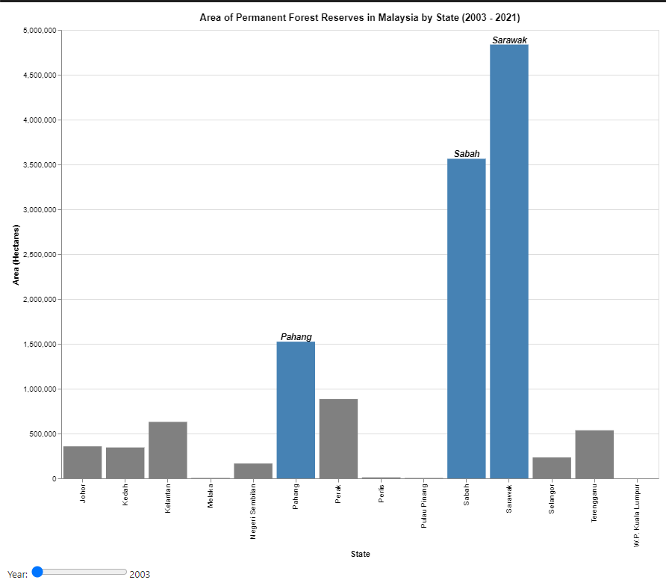

Public Url: <https://rpra-hul.github.io/FIT3179-Homework-Repo/>

Additional Information:

1. **Domain:** The visualisation focuses on the distribution and extent of permanent forest area reserves across states in Malaysia for the year 2021, providing insights into regional conservation efforts and forest management.
2. **Dataset:** Provided by the Government of Malaysia, with one ordinal attribute (date), one categorical attribute (states) and one quantitative attribute (area).
3. **Justification:** A proportional symbol map or dot map would not be suitable in this scenario because the dataset does not provide any latitude or longitude values to be able to plot on the map. Hence, a choropleth map is more suitable to represent the quantitative attribute.