**Exercise 3.1 - Logistic map**

%Prabavathy Rajasekaran(2130757

% Anjaly Kuriakose(2132537)

%r=2.7:0.002:4;

r=0:0.002:4;

x0=0:0.002:1;

N=2000;

tic

for lr=1:length(r)

xN=replogA(x0,N,r(lr));

plot(r(lr)*ones(size(xN)),xN,'k.','MarkerSize',1); hold on;

end

toc

xlabel('r');

ylabel('x');

**At r < 1 the map has one fixed point. What is its value? Is it stable?**

The value is 0 till r=1 and it is stable

**Write a function function xN = replog(x0, N, r) That applies the logistic map N times on the initial value x0, with parameter r.**

%Prabavathy Rajasekaran(2130757

% Anjaly Kuriakose(2132537)

function [XN] = replogA(x0, N, r)

for i=1:N

for j=1:length(x0)

x0(j)=r*x0(j)*(1-x0(j));

end

end

XN =x0;

end

Elapsed time is 18.029626 seconds.

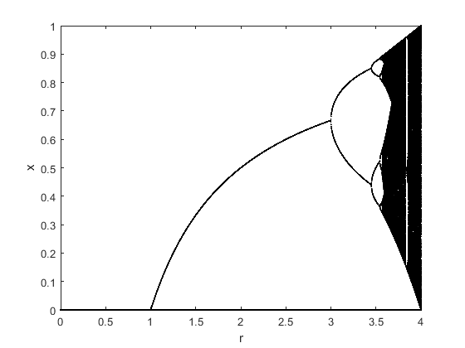

**% r=2.7:0.002:4 and Elapsed time is 3.581790 seconds.**

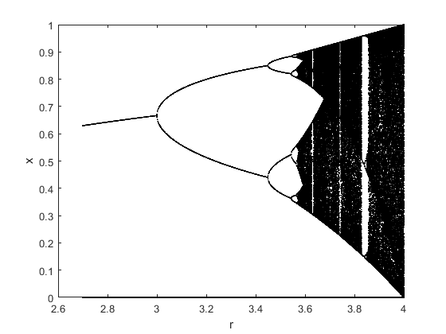

[*Published with MATLAB® R2021b*](https://www.mathworks.com/products/matlab/)

%Prabavathy Rajasekaran(2130757

% Anjaly Kuriakose(2132537)

%r=2.7:0.002:4;

r=0:0.002:4;

x0=0:0.002:1;

N=2000;

tic

for lr=1:length(r)

xN=replog(x0,N,r(lr));

plot(r(lr)*ones(size(xN)),xN,'k.','MarkerSize',1); hold on;

end

toc

xlabel('r');

ylabel('x');

%imagesc(xN);

**Write a variant without the for loop, using matlab’s vectorization capabilities.**

%Prabavathy Rajasekaran(2130757

% Anjaly Kuriakose(2132537)

function [XN] = replog(Y, N, r)

for i=0:N

Y= r.*Y.*(1-Y);

end

XN =Y;

end

Elapsed time is 8.429788 seconds.

**Compare the run-time of the two versions (hint: tic, toc)**

Run time for the variant with for loop for the different Initial values is ***18.029626*** seconds

Run time for the variant without the for loop using Matlab’s Vectorization is ***8.429788*** seconds

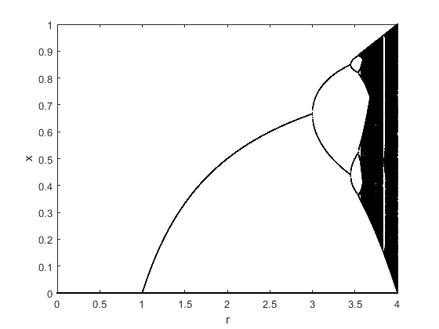

**% r=2.7:0.002:4 and Elapsed time is 2.255386 seconds.**

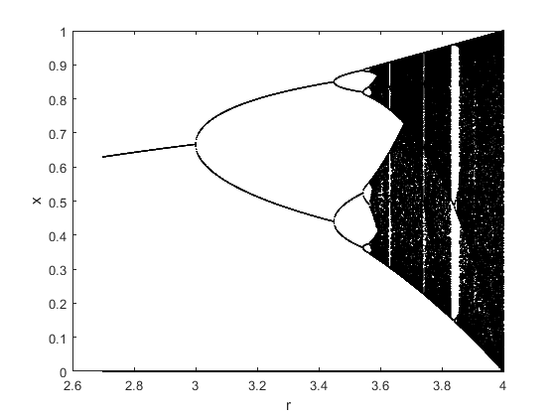

[*Published with MATLAB® R2021b*](https://www.mathworks.com/products/matlab/)

%Prabavathy Rajasekaran(2130757

% Anjaly Kuriakose(2132537)

r=3.7;

X0=0:0.001:1;

N=1000;

xN=replog(x0,N,r);

histogram(xN,20);

title('Histogram');

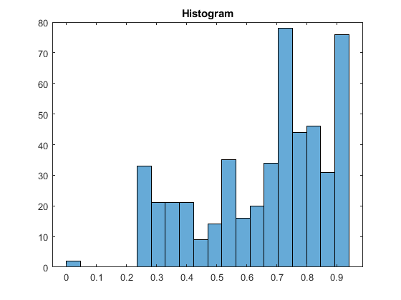

[*Published with MATLAB® R2021b*](https://www.mathworks.com/products/matlab/)

**At low values of r there are a few stable orbits. At r = 4 we have chaotic behavior. Study the transition by plotting x (N) as a function of r for high N. (You can use the script transition.m to plot your results.)**

%Prabavathy Rajasekaran(2130757

% Anjaly Kuriakose(2132537)

%r=2.7:0.002:4;

%r=0:0.002:4;

r=4;

x0=0:0.002:1;

N=2000;

tic

for lr=1:length(r)

[xN]=replog(x0,N,r(lr));

plot(xN); hold on;

end

toc

xlabel('r');

ylabel('x');

Elapsed time is 0.052668 seconds.

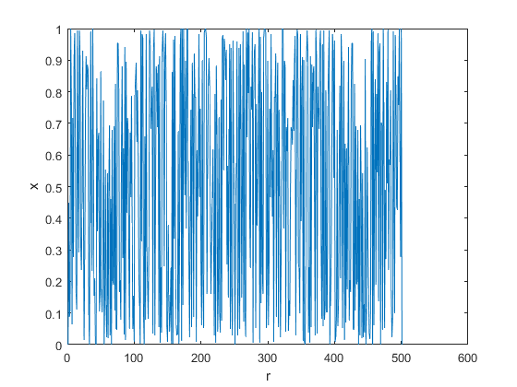

[*Published with MATLAB® R2021b*](https://www.mathworks.com/products/matlab/)

**Modify replog such that also an estimate of the Lyapunov exponent is computed and returned for each initial value. Plot the exponent, averaged over different x (0), as a function of r.**

%Prabavathy Rajasekaran(2130757

% Anjaly Kuriakose(2132537)

r=2.7:0.002:4;

x0=0:0.002:1;

N=2000;

for lr=1:length(r)

lP=lyapunov(x0,N,r(lr));

plot(r(lr)*ones(size(lP)),lP,'k.','MarkerSize',1); hold on;

end

xlabel('r');

ylabel('lN');

title('Lyapunov exponent')

%Prabavathy Rajasekaran(2130757

% Anjaly Kuriakose(2132537)

function [lP] = lyapunov(Z, N, r)

for i=0:N

Z=Z+log(abs(r*(1-(2*Z))));

end

lP=Z./N;

end

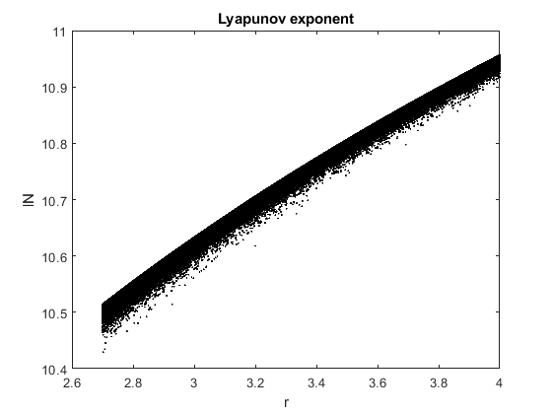

[*Published with MATLAB® R2021b*](https://www.mathworks.com/products/matlab/)

**Exercise 3.2 - Fancy plot At last we try improve the presentation of our results.**

Decide on an image (=matrix) size, e.g. 500 × 1000 pixels. Choose the number of different r values, to coincide with the number of columns in your image matrix.

Run your program for each r with N ≥ 2000 and length(x0) much larger than the number of rows. Each row in your matrix corresponds to an interval in x. Count for each row, how many values of xN fell into its interval. Store the result in the image matrix.

Use the command image to display your data. Read the documentation. You will need to normalize your matrix and/or adjust the color map.

%Prabavathy Rajasekaran(2130757

% Anjaly Kuriakose(2132537)

r=2.7:0.002:4;

%r=0:0.002:4;

x0=0:0.002:1;

N=2000;

figure(1);

im = imagesc(r);

%Creating an Image Matrix such that r values matches the column of image

%matrix

title('Image matrix creation');

tic

for lr=1:length(r)

xN=replogA(x0,N,r(lr));

figure(2);

plot(r(lr)*ones(size(xN)),xN,'k.','MarkerSize',1); hold on;

end

toc

xlabel('r');

ylabel('x');

title('Logistic map');

figure(3);

im=imagesc(xN);

title('Fancy Plot of xN(Logistic map)');

figure(4);

imshow(xN);

title('Normalized Image');

Elapsed time is 26.095200 seconds.

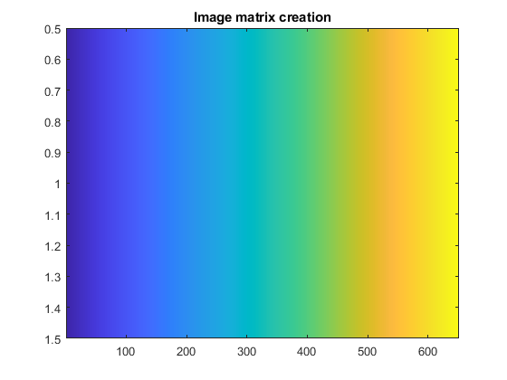 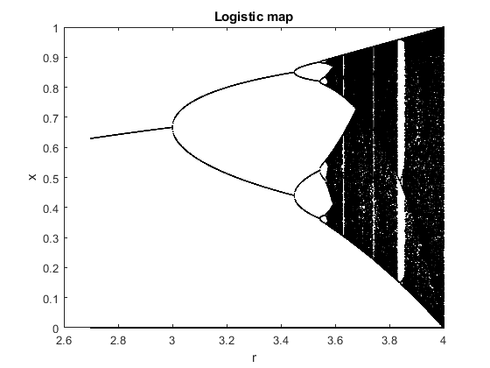 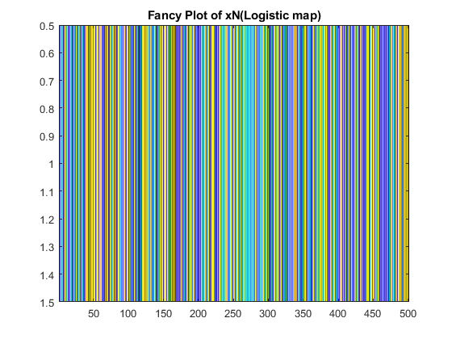 

[*Published with MATLAB® R2021b*](https://www.mathworks.com/products/matlab/)