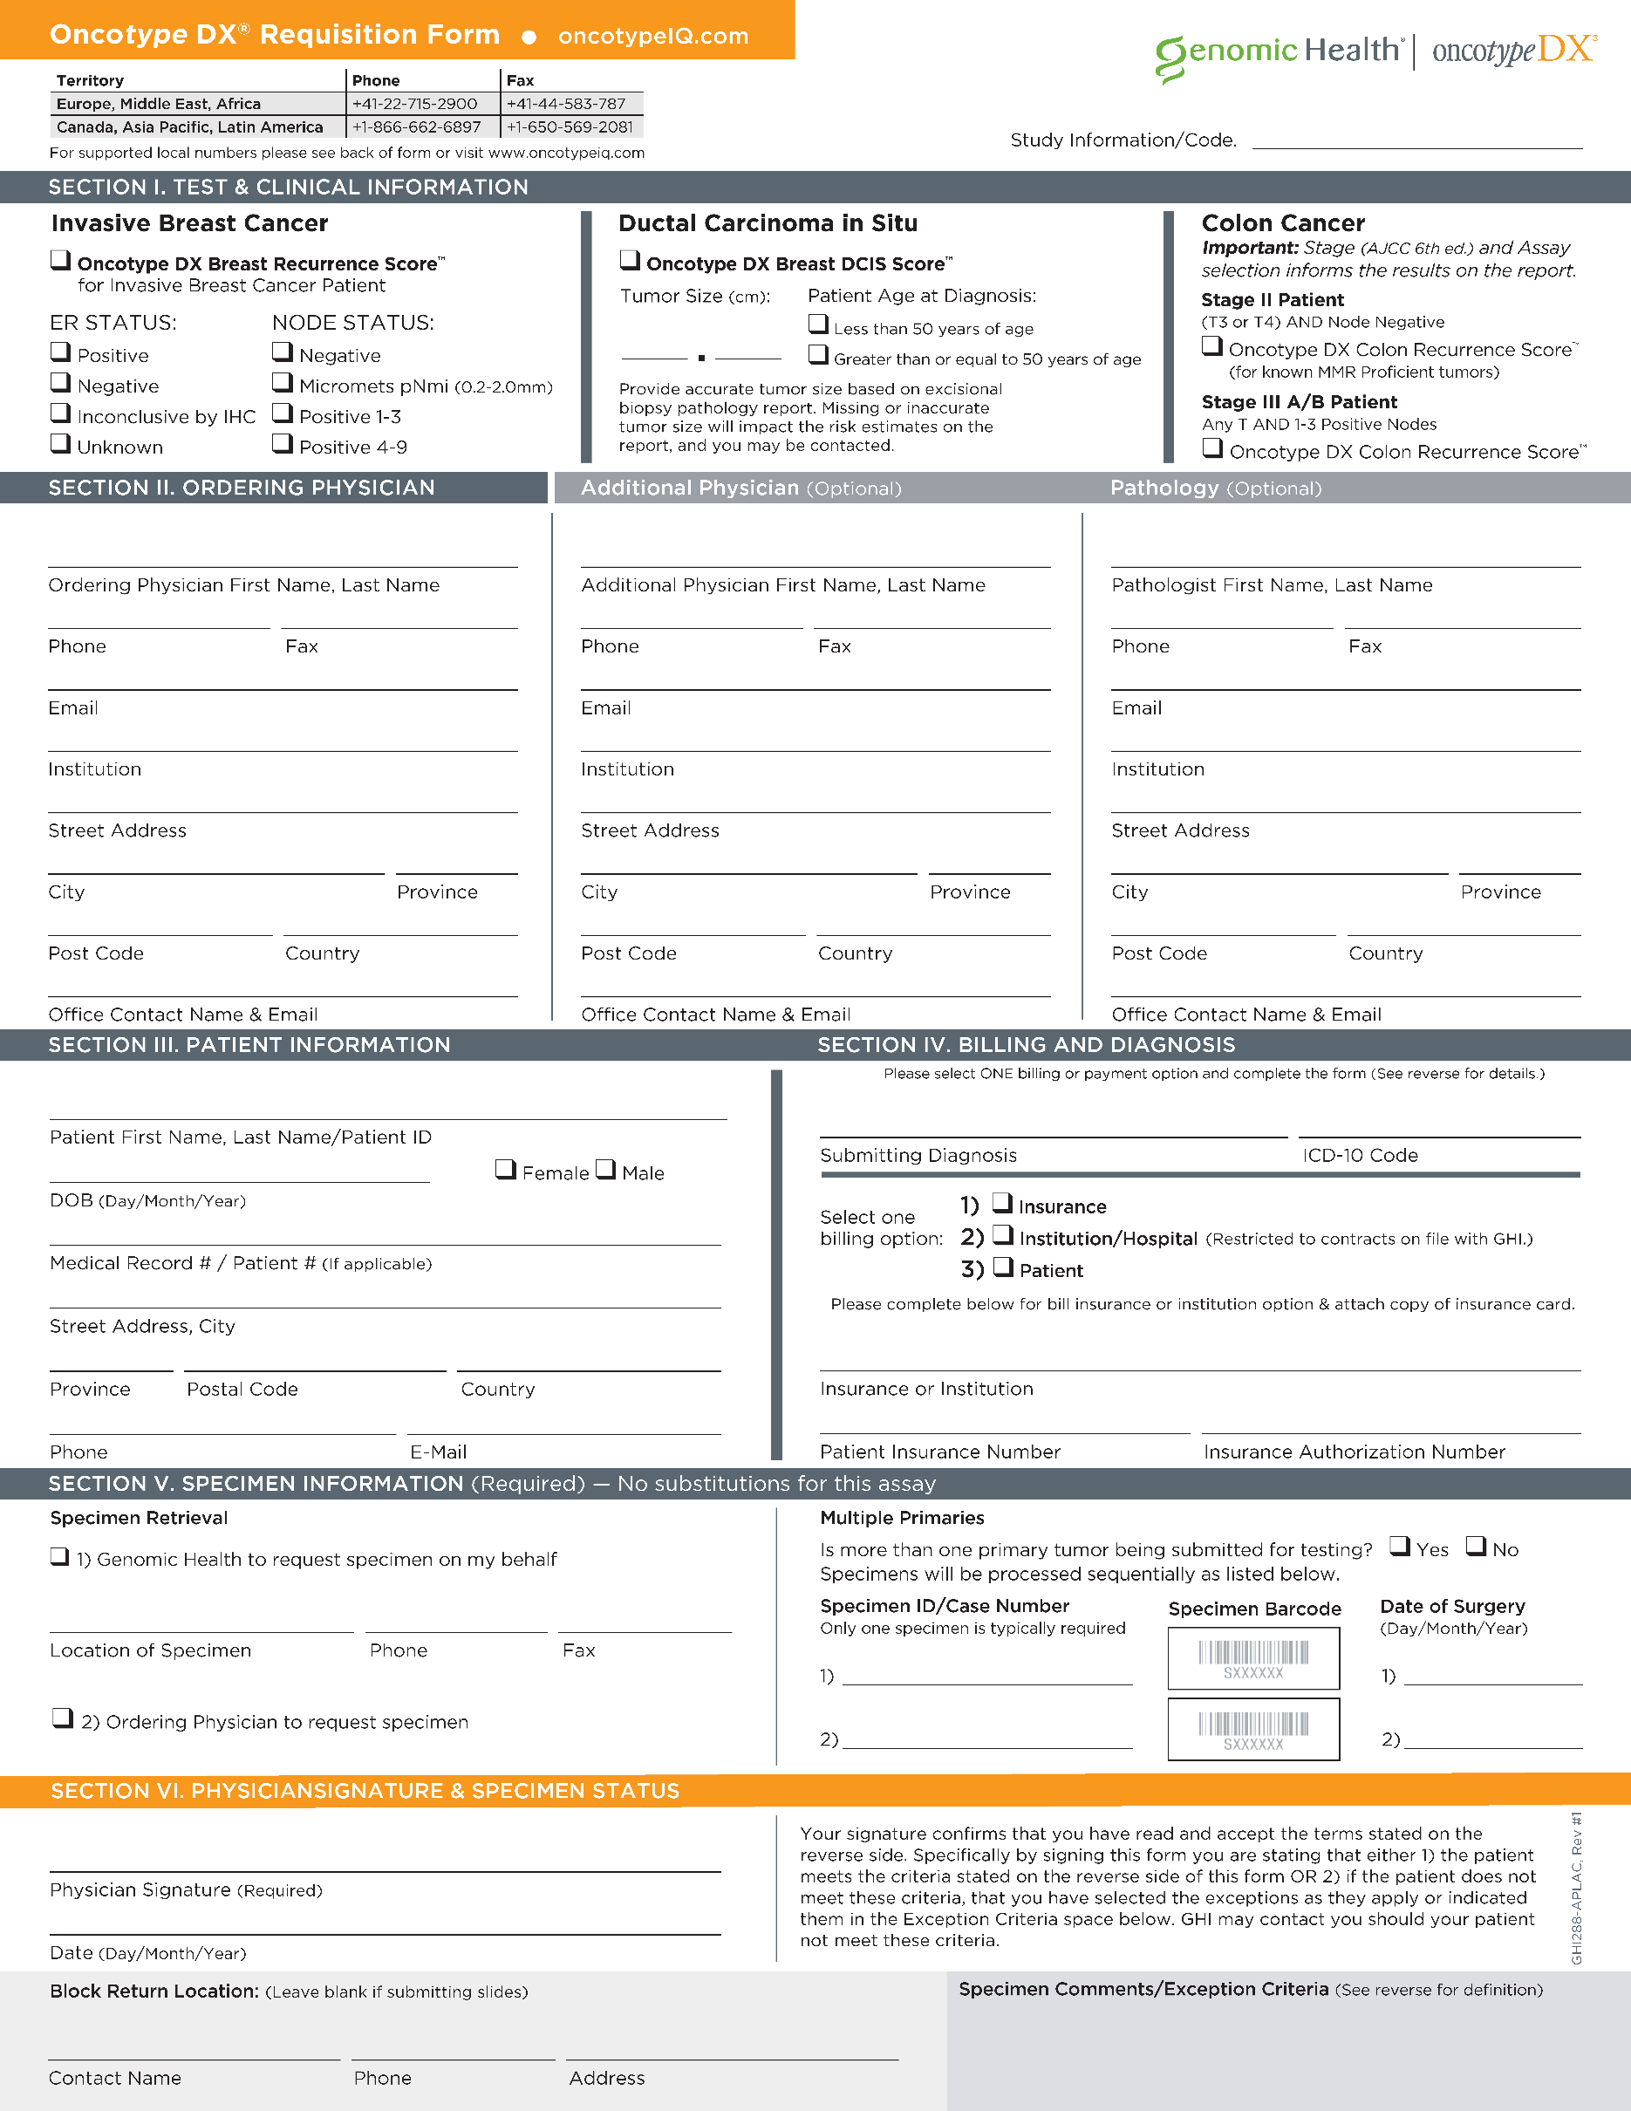

{{TableStart:SRCase}}{{CASE_OSM_MAIN_CASE_NUMBER}}{{TableEnd:SRCase}}

{{TableStart:Order}}{{ORDER_GHI_PORTAL_SECONDARY_SPECIMEN_ID}}{{TableEnd:Order}}

{{TableStart:Order}}{{ORDER_GHI_PORTAL_PRIMARY_SPECIMEN_ID}}{{TableEnd:Order}}

{{TableStart:OLI}}{{ORDERITEM_OSM_CONGA_ICD_FORMULA}}{{TableEnd:OLI}}

{{TableStart:OLI}}{{ORDERITEM_OSM_SUBMITTING_DIAGNOSIS}}{{TableEnd:OLI}}

{{TableStart:Ordering}}{{OSM_ORDER_ROLE_OSM_CONTACT_FULL_NAME}}{{TableEnd:Ordering}}

{{TableStart:Order}}{{ORDER_GHI_PORTAL_COMMENTS}}{{TableEnd:Order}}

{{TableStart:Order}}{{ORDER_OSM_PATIENT_FULL_NAME}}{{TableEnd:Order}}

{{TableStart:OLI}}{{ORDERITEM_OSM_EXCEPTION_CRITERIA}}{{TableEnd:OLI}}

**{{TableStart:OLI}}🗸«IF»{{TableEnd:OLI}}**

{{TableStart:Order}}{{ORDER_GHI_PORTAL_SECONDARY_DATE_OF_SURGERY\@ dd/MM/yyyy}}{{TableEnd:Order}}

{{TableStart:Order}}{{ORDER_OSM_DATE_OF_COLLECTION_SURGERY \@ dd/MM/yyyy}}{{TableEnd:Order}}

{{TableStart:SpecimenSubmittingOR}}{{OSM_ORDER_ROLE_OSM_ACCOUNT_FAX}}{{TableEnd:SpecimenSubmittingOR}}

{{TableStart:OLI}}{{ORDERITEM_OSM_SR_FORM_INSURANCE_ON_FILE}}{{TableEnd:OLI}}

{{TableStart:Order}}{{ORDER_GHI_POTAL_PATIENT_EMAIL}}{{TableEnd:Order}}

{{TableStart:Order}}{{ORDER_OSM_PATIENT_PHONE}}{{TableEnd:Order}}

{{TableStart:Order}}{{ORDER_OSM_PATIENT_COUNTRY}}{{TableEnd:Order}}

0

{{TableStart:Order}}{{ORDER_OSM_PATIENT_STREET}}{{TableEnd:Order }}, {{TableStart:Order}}{{ORDER_OSM_PATIENT_CITY}}{{TableEnd:Order}}

6

4

{{TableStart:Order}}{{ORDER_OSM_PATIENT_MRN}}{{TableEnd:Order}}

{{TableStart:Order}}{{ORDER_OSM_PATIENT_DOB \@ dd/MM/yyyy }}{{TableEnd:Order}}

{{TableStart:Ordering}}{{OSM_ACCOUNT_NAME}}{{TableEnd:Ordering}}

{{TableStart:Order}}{{ORDER_OSM_PATIENT_STATE}}{{TableEnd:Order}}

{{TableStart:Ordering}}{{OSM_ACCOUNT_OSM_MAIN_ACCOUNT_NUMBER}}{{TableEnd:Ordering}}

{{TableStart:Ordering}}{{IMAGE:OSM_ORDER_ROLE__COSM_ACCOUNT_OSM_DM_BARCODE_ACCOUNT:W=40}}{{TableEnd:Ordering}}

{{TableStart:MaterialReturn}}{{OSM_ORDER_ROLE_OSM_ACCOUNT_PHONE}}{{TableEnd:MaterialReturn}}

{{TableStart:MaterialReturn}}{{OSM_ORDER_ROLE_OSM_CONTACT_FULL_NAME}}{{TableEnd:MaterialReturn}}

{{TableStart:AdtlReportRec}}{{OSM_ORDER_ROLE_OSM_CITY }}{{TableEnd:AdtlReportRec}}

{{TableStart:Additional}}{{OSM_ORDER_ROLE_OSM_CITY }}{{TableEnd:Additional}}

{{TableStart:Ordering}}{{OSM_ORDER_ROLE_OSM_CITY }}{{TableEnd:Ordering}}

{{TableStart:Additional}}{{OSM_ORDER_ROLE_OSM_ACCOUNT_STATE}}{{TableEnd:Additional}}

{{TableStart:Ordering}}{{OSM_ORDER_ROLE_OSM_ACCOUNT_POSTAL_ADDRESS}}{{TableEnd:Ordering}}

**{{TableStart:Order}}🗸«IF»{{TableEnd:Order}}**

**🗸«IF»**

{{TableStart:AdtlReportRec}}{{OSM_ORDER_ROLE_OFFICE_CONTACT}}{{TableEnd:AdtlReportRec}}

{{TableStart:AdtlReportRec}}{{OSM_ACCOUNT_NAME}}{{TableEnd:AdtlReportRec}}

{{TableStart:AdtlReportRec}}{{OSM_ORDER_ROLE_OSM_PORTAL_EMAIL}}{{TableEnd:AdtlReportRec}}

{{TableStart:AdtlReportRec}}{{OSM_ORDER_ROLE_OSM_ACCOUNT_FAX}}{{TableEnd:AdtlReportRec}}

{{TableStart:AdtlReportRec}}{{OSM_ORDER_ROLE_OSM_ACCOUNT_PHONE}}{{TableEnd:AdtlReportRec}}

{{TableStart:AdtlReportRec}}{{OSM_ORDER_ROLE_OSM_CONTACT_FULL_NAME}}{{TableEnd:AdtlReportRec}}

{{TableStart:Ordering}}{{OSM_ORDER_ROLE_OFFICE_CONTACT}}{{TableEnd:Ordering}}

{{TableStart:Additional}}{{OSM_ORDER_ROLE_OSM_ACCOUNT_ADDRESS_LINE_1}}{{TableEnd:Additional}}

{{TableStart:Ordering}}{{OSM_ORDER_ROLE_OSM_PORTAL_EMAIL}}{{TableEnd:Ordering}}

{{TableStart:Ordering}}{{OSM_ORDER_ROLE_OSM_ACCOUNT_FAX}}{{TableEnd:Ordering}}

{{TableStart:Ordering}}{{OSM_ORDER_ROLE_OSM_ACCOUNT_PHONE}}{{TableEnd:Ordering}}

{{TableStart:Additional}}{{OSM_ACCOUNT_NAME}}{{TableEnd:Additional}}

{{TableStart:Additional}}{{OSM_ORDER_ROLE_OSM_PORTAL_EMAIL}}{{TableEnd:Additional}}

{{TableStart:Additional}}{{OSM_ORDER_ROLE_OSM_ACCOUNT_FAX}}{{TableEnd:Additional}}

{{TableStart:Additional}}{{OSM_ORDER_ROLE_OSM_ACCOUNT_PHONE}}{{TableEnd:Additional}}

{{TableStart:Additional}}{{OSM_ORDER_ROLE_OSM_CONTACT_FULL_NAME}}{{TableEnd:Additional}}

{{TableStart:Order}}{{ORDER_OSM_PATIENT_POSTAL_CODE}}{{TableEnd:Order}}

{{TableStart:SpecimenSubmittingOR}}{{OSM_ORDER_ROLE_OSM_ACCOUNT_PHONE}}{{TableEnd:SpecimenSubmittingOR}}

{{TableStart:SpecimenSubmittingOR}}{{OSM_ORDER_ROLE_OSM_ACCOUNT_NAME}}{{TableEnd:SpecimenSubmittingOR}}

{{TableStart:Order}}{{ORDER_OSM_SIGNATURE_DATE\@ dd/MM/yyyy}}{{TableEnd:Order}}

{{TableStart:Signature}}{{ORDER_OSM_SIGNATURE_VERIFIED_SR_FORM_FORMULA}}{{TableEnd:Signature}}

{{TableStart:Order}}{{ORDER_OSM_STUDY_ID}}{{TableEnd:Order}}

{{TableStart:AdtlReportRec}}{{IMAGE:OSM_ORDER_ROLE__COSM_ACCOUNT_OSM_DM_Barcode_Account:W=40}}{{TableEnd:AdtlReportRec}}

{{TableStart:Additional}}{{IMAGE:OSM_ORDER_ROLE__COSM_ACCOUNT_OSM_DM_Barcode_Account:W=40}}{{TableEnd:Additional}}

{{TableStart:SRCase}}{{IMAGE:CASE_OSM_DM_Barcode_Case:W=40 }}{{TableEnd:SRCase}}

{{TableStart:Order}}{{IMAGE:ORDER_OSM_DM_Barcode_Order:W=40}}{{TableEnd:Order}}

**{{TableStart:Order}}🗸«IF»{{TableEnd:Order}}**

**{{TableStart:Order}}🗸«IF»{{TableEnd:Order}}**

**🗸«IF»**

**{{TableStart:Order}}🗸«IF»{{TableEnd:Order}}**

**{{TableStart:Order}}🗸«IF»{{TableEnd:Order}}**

**🗸«IF»**

**{{TableStart:Order}}🗸«IF»{{TableEnd:Order}}**

**{{TableStart:Order}}🗸«IF»{{TableEnd:Order}}**

**{{TableStart:Order}}🗸«IF»{{TableEnd:Order}}**

**{{TableStart:Order}}🗸«IF»{{TableEnd:Order}}**

**🗸«IF»**

**{{TableStart:Order}}🗸«IF»{{TableEnd:Order}}**

**🗸«IF»**

**{{TableStart:Order}}🗸«IF»{{TableEnd:Order}}**

**🗸«IF»**

**{{TableStart:OLI}}🗸«IF»{{TableEnd:OLI}}**

**{{TableStart:OLI}}🗸«IF»{{TableEnd:OLI}}**

**{{TableStart:OLI}}🗸«IF»{{TableEnd:OLI}}**

**{{TableStart:Order}}🗸«IF»{{TableEnd:Order}}**

**{{TableStart:OLI}}🗸«IF»{{TableEnd:OLI}}**

**7**

**{{TableStart:OLI}}🗸«IF»{{TableEnd:OLI}}**

**{{TableStart:OLI}}🗸«IF»{{TableEnd:OLI}}**

**{{TableStart:OLI}}****🗸«IF»{{TableEnd:OLI}}**

**{{TableStart:OLI}}🗸«IF»{{TableEnd:OLI}}**

**{{TableStart:OLI}}🗸«IF»{{TableEnd:OLI}}**

**{{TableStart:OLI}}🗸«IF»{{TableEnd:OLI}}**

**{{TableStart:OLI}}🗸«IF»{{TableEnd:OLI}}**

{{TableStart:MaterialReturn}}{{OSM_ORDER_ROLE_OSM_ACCOUNT_POSTAL_ADDRESS}}{{TableEnd:MaterialReturn }}

{{TableStart:MaterialReturn}}{{OSM_ORDER_ROLE_OSM_ACCOUNT_COUNTRY}}{{TableEnd:MaterialReturn }}

{{TableStart:AdtlReportRec}}{{OSM_ACCOUNT_OSM_MAIN_ACCOUNT_NUMBER}}{{TableEnd:AdtlReportRec}}

{{TableStart:Additional}}{{OSM_ACCOUNT_OSM_MAIN_ACCOUNT_NUMBER}}{{TableEnd:Additional}}

{{TableStart:Order}}{{ORDER_OSM_MAIN_ORDER_ID}}{{TableEnd:Order}}

{{TableStart:OLI}}{{ORDERITEM_DCIS_TUMOR_SIZE_CM_CONGA}}{{TableEnd:OLI}}

{{TableStart:MaterialReturn}}{{OSM_ORDER_ROLE_OSM_ACCOUNT_STATE}}{{TableEnd:MaterialReturn }}

{{TableStart:MaterialReturn}}{{OSM_ORDER_ROLE_OSM_ACCOUNT_ADDRESS_LINE_1}}{{TableEnd:MaterialReturn}}

{{TableStart:MaterialReturn}}{{OSM_ORDER_ROLE_OSM_ACCOUNT_NAME}}{{TableEnd:MaterialReturn}}

{{TableStart:Additional}}{{OSM_ORDER_ROLE_OSM_ACCOUNT_COUNTRY}}{{TableEnd:Additional}}

{{TableStart:Ordering}}{{OSM_ORDER_ROLE_OSM_ACCOUNT_COUNTRY}}{{TableEnd:Ordering}}

{{TableStart:Additional}}{{OSM_ORDER_ROLE_OFFICE_CONTACT}}{{TableEnd:Additional}}

{{TableStart:AdtlReportRec}}{{OSM_ORDER_ROLE_OSM_ACCOUNT_POSTAL_ADDRESS}}{{TableEnd:AdtlReportRec}}

{{TableStart:Additional}}{{OSM_ORDER_ROLE_OSM_ACCOUNT_POSTAL_ADDRESS}}{{TableEnd:Additional}}

{{TableStart:AdtlReportRec}}{{OSM_ORDER_ROLE_OSM_ACCOUNT_COUNTRY}}{{TableEnd:AdtlReportRec}}

{{TableStart:Ordering}}{{OSM_ORDER_ROLE_OSM_ACCOUNT_STATE}}{{TableEnd:Ordering}}

{{TableStart:Ordering}}{{OSM_ORDER_ROLE_OSM_ACCOUNT_ADDRESS_LINE_1}}{{TableEnd:Ordering}}

{{TableStart:MaterialReturn}}{{OSM_ORDER_ROLE_OSM_CITY }}{{TableEnd:MaterialReturn}}

{{TableStart:AdtlReportRec}}{{OSM_ORDER_ROLE_OSM_ACCOUNT_STATE}}{{TableEnd:AdtlReportRec}}

{{TableStart:AdtlReportRec}}{{OSM_ORDER_ROLE_OSM_ACCOUNT_ADDRESS_LINE_1}}{{TableEnd:AdtlReportRec}}

