MECH420 Lab #1

Ratthamnoon Prakitpong

#63205165

Part A:

1.

Use average(range) and stdev(range) commands.

Table A1: Average and standard deviation

2.

Figure A2: Sensor output vs linear position

3.

IR Sensor: y = -1.9235x + 11.9001

LED Sensor: y = 1.0485x + 1.2121

Eddy Current Sensor: y = -0.0358x + 10.6493

4.

Find position where difference between experimental and theoretical values is maximum. Use match(max(range), range, 0) command.

IR Sensor: x(950) = 8.2 mm

LED Sensor: x(2) = 6.2253 mm

Eddy Current Sensor: x(1203) = 1.5711 mm

Part B:

1.

Figure B1: Values over time

Range of Eddy current sensor seems to end at 4.24 mm, and range of LED sensor seems to start at 2.81 mm. Capacitive sensor behaves like a switch.

2.



Table B1: Sensor output and displacement values over time

Figure B2: Average sensor outputs vs displacement

V(x) for:

IR Sensor: V = 0.8506x – 0.4967

LED Sensor: V = -0.4672x + 7.9882

3.

Inversing LED Sensor’s V(x) equation, we get:

x = 2.1204V – 17.0980

4.

IR Sensor: Looks non-linear, consistent with output over distance plot at the end of datasheet.

Capacitive Sensor: Acts like a switch, consistent with datasheet.

Eddy Current Sensor: Placement of sensor may be too far/near to return noticeable voltage output.

LED Sensor: Range of +/-4 mm from datasheet, so there is bound to be cut-off when measuring our range of 10 mm if sensor is not placed very carefully such that all of wanted displacements is within sensor’s range.

5a. Use Eddy current sensor because object’s medium is subjected to fluctuating magnetic fields.

5b. Use LED sensor because light reflects off of opaque object.

Additional Exercises:

1.

|  |  |  |  |
| --- | --- | --- | --- |
| Type | ID | Price | Supplier |
| IR | OPB704 | 4.10CAD | https://www.digikey.ca/en/products/detail/tt-electronics-optek-technology/OPB704/498713 |
| LED | Z4W-V | 2271.90CAD | https://www.mouser.com/ProductDetail/Omron-Automation-and-Safety/Z4W-V25R?qs=NA0XKeglvRX6O%2FDjmCKY0Q%3D%3D |
| Eddy current | AK9-10-1H | NA (product retired) | https://www.automationdirect.com/adc/shopping/catalog/retired_products/sensors_-z-_encoders/ak9-10-1h |
| Capacitive | CT1-AN-1A | 77USD | https://www.automationdirect.com/adc/shopping/catalog/sensors_-z-_encoders/capacitive_proximity_sensors/30mm_round_industrial_automation/dc_powered_(30mm)/ct1-an-1a |

Table AE1: Sensor price and suppliers

2.

|  |  |  |  |
| --- | --- | --- | --- |
| Type | ID | Range | Datasheet |
| IR | OPB704 | Output over distance plot at the end of datasheet suggests 0.1-0.4 in range, which is about 10 mm, so it would work for our range. | https://www.ttelectronics.com/TTElectronics/media/ProductFiles/Optoelectronics/Datasheets/OPB703-70_70A-70F-B-704.pdf |
| LED | Z4W-V | Range of +/-4 mm from measurement point of 25 mm, so wouldn’t work for range of 0-10 mm. | https://www.mouser.ca/datasheet/2/307/z4w-v_e217-e1_3_1_csm1402-795225.pdf |
| Eddy current | AK9-10-1H | Sensing range is 0-10 mm, so it would just work with our wanted range. | https://cdn.automationdirect.com/static/specs/oldspec/prox18mmanalogak_02_13.pdf |
| Capacitive | CT1-AN-1A | Acts like a switch. | https://cdn.automationdirect.com/static/specs/proxctm30metal.pdf |

Table AE2: Sensor range and datasheets

3.

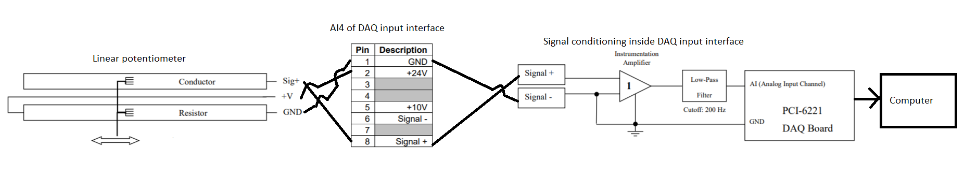Figure AE3: Linear potentiometer connections

4.

Nonlinearity may result from properties of sensor. For example:

* Magnetic saturation (transformers)
* Deformation or plasticity (mechanical)

There are a few ways to correct this. For example:

* Local linearization
* Rescaling (for example, use log scale)
* Nonlinear feedback