MECH420 Lab #4

Ratthamnoon Prakitpong

#63205165

A1.

From my lab 1 report, we can get formula of LED sensor output to displacement in mm:

x = 2.1204V – 17.0980

From lab 2 manual, we can know that each block of weights are 200 g, so we can say that gravitational force is 0.2*9.81 N per block.

We can use average LED sensor values for each number of weights to calculate string stiffness, and tabulate results like shown in the table below:

Table A1: Measured and calculated values for getting spring stiffness

We can use the average stiffness as our final calculated stiffness, which will be k = 5.05 N/mm.

A2.

For each constant voltage in, we have coil voltage and coil current readings. Coil current readings are in volts, measured across a 0.2 ohm resistor with a gain of 10, so we can use that resistance and gain to convert value in volts to correct amps. We can take average value of each readings, normalize it to 0V in, and use those to find average coil resistance. Results are tabulated below:

Table A2: Measured and calculated values for getting resistance

Again, we average valid resistances (for input voltages of 1~2.5V) to get average R of 0.0447 ohm.

A3.

Using same equation to convert LED sensor output to displacement and stiffness constant we found, we can solve for force. We will be using absolute value of displacement normalized to 0.5V input voltage since for calculating Bl, it doesn’t matter which direction it’s displaced to, just that it’s displaced from center. Processing displacement this way results in a nicer Bl value.

Fig A3: Coil current vs force

Looking at slope of the plot, we can say that 1/Bl = 0.28025 A/N, so Bl = 3.57 N/A.

B1.

To get impedance, we find peak-to-peak current by finding difference of minimum and maximum current in interval, and converting it from voltage reading to current using the same method as in A2. We divide 0.2 V peak-to-peak voltage by that value to get impedance.

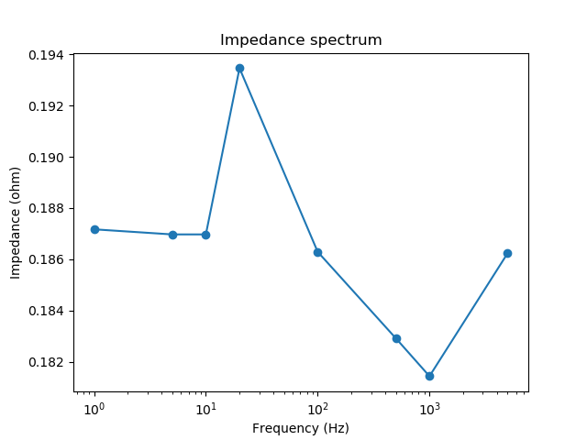Fig B1: Impedance spectrum

I plotted it on a log scale for easier viewing. We see a local maximum at ~40Hz (the point in this plot is 20Hz, closest point to 40Hz), which is consistent with explanation in lab manual.

B2.

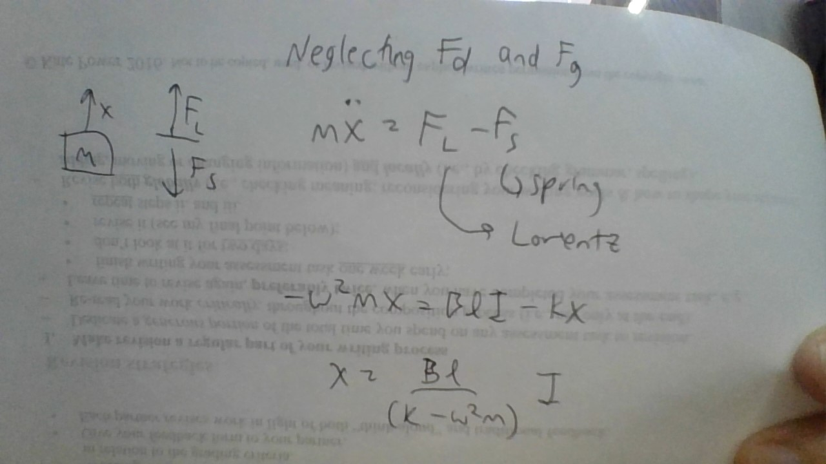

B3.

Since we’re given data at 48Hz, we can reasonably assume that our resonance is at 48Hz.

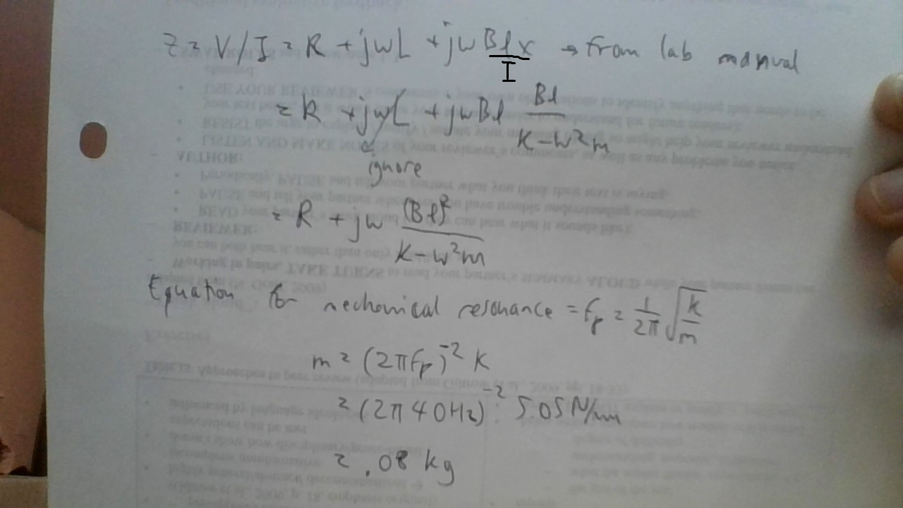

B4.

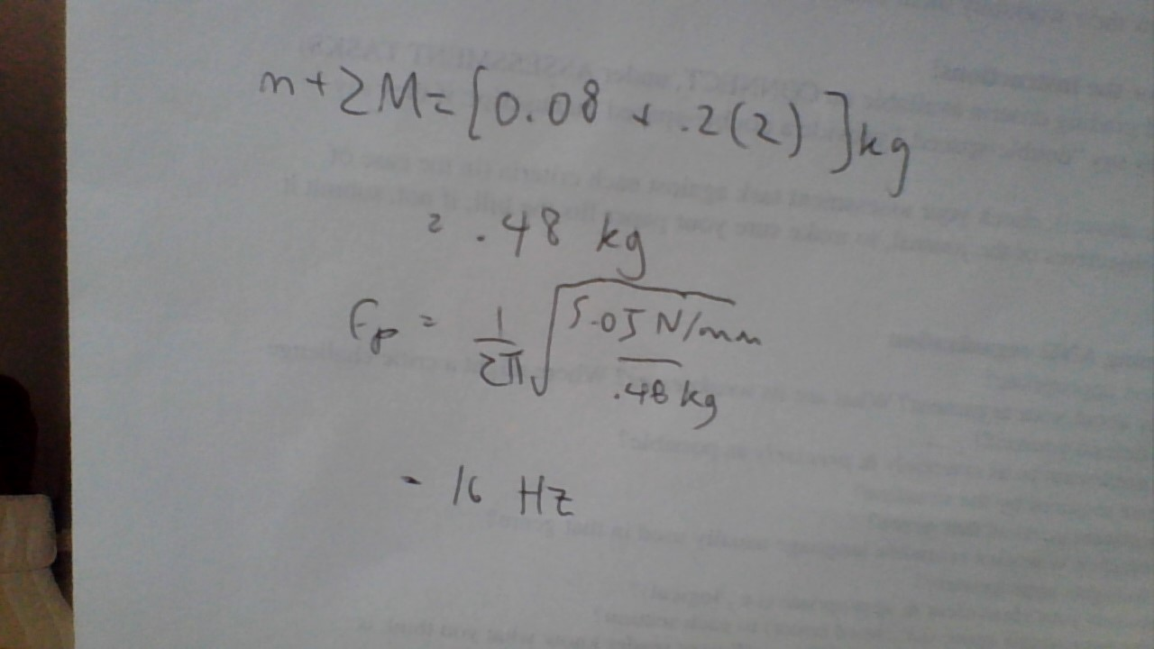

Looking at experimental data at 48Hz (close to 40Hz) and no weights, and 28Hz (close to 16Hz) and 2 weight blocks, we can say that a similar resonance happened at both points, confirming our calculations.

C1.

To get displacement, we use the same sensitivity as in A1. The equation becomes:

x = V_sensor*2.1204

To get velocity, we can use the fact that current is zero. Because current is zero, its derivative is also zero. Therefore, deriving from Faraday’s Law found in lab manual, we can say that:

V_coil = Blu

v = u = V_coil/Bl

We can use Bl value we found in A3 to solve for velocity.

To get acceleration, we can reference sensitivity from datasheet (as I’ve done in lab 3), which is 1/9.81 V/m/s^2. Our acceleration equation becomes:

a = V_sensor*9.81

All three are normalized to initial value (t = 0.005 s) to emphasize their change from initial conditions.

Fig C1: Displacement, velocity, and acceleration over time

Units are chosen arbitrarily so that all three plots are scaled such that they make visual sense when overlaid on the same chart.

C2.

We can see that velocity and displacement doesn’t make sense since they are just the negative of each other, which means that either one of these measurements has to be wrong. It is difficult to judge accuracy of acceleration data while uncertain about velocity data.

Fig C2: Analysis

I’m going to take absolute value of velocity, so that they become positive. We can plot acceleration that is calculated with time differential of velocity. We can see that that acceleration’s trend lines up fairly well with acceleration data. This leads me to believe that recorded acceleration data is in fact a differential of either recorded velocity or recorded displacement. If it is the recorded velocity that is correct, then there may have been small wiring error for velocity voltage, and displacement voltage coming from wrong source. If it is the recorded displacement that is correct, then there may have been an error in finding the right voltage source for both velocity and acceleration voltages. I believe that it is the recorded displacement value that is wrong, since it requires more things to have gone wrong to believe that recorded velocity value to go wrong.

5.1

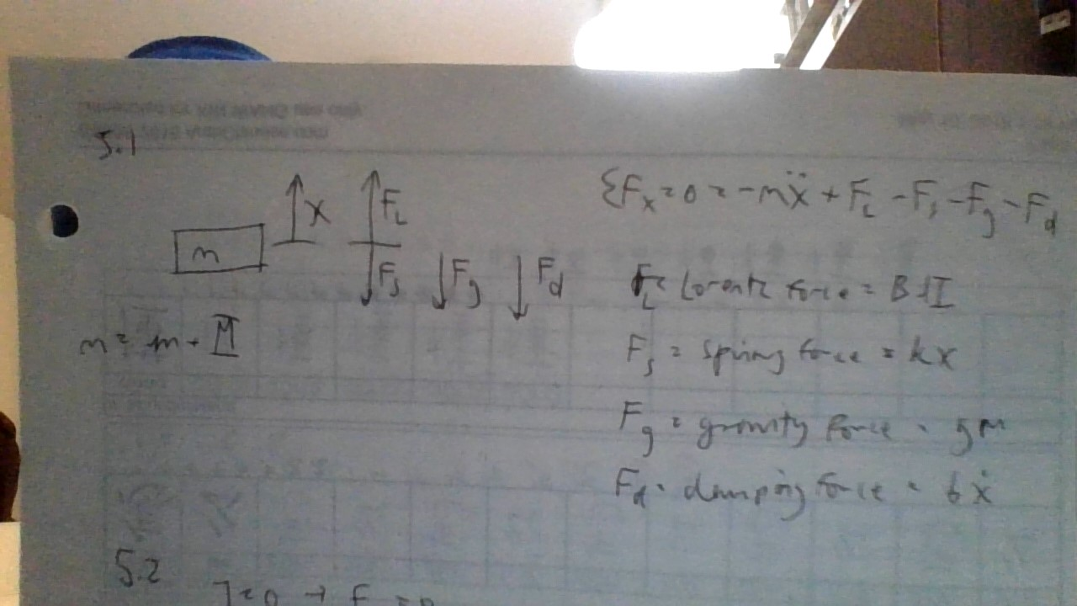

5.2

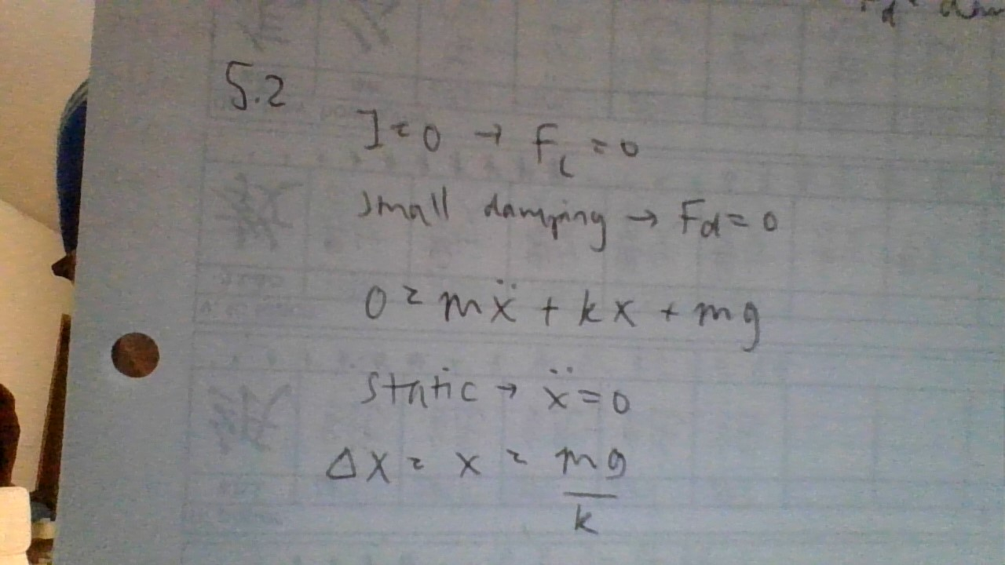

5.3

|  |  |
| --- | --- |
| Part | Datasheet |
| Linear DC actuator | https://resources.kitronik.co.uk/pdf/2595-linear-actuator-assembly-instructions.pdf |
| Microcontroller | https://www.farnell.com/datasheets/1682209.pdf |
| Actuator driver | https://media.digikey.com/pdf/Data%20Sheets/DFRobot%20PDFs/DRI0002_Web.pdf |
| Acceleration sensor | https://media.digikey.com/pdf/Data%20Sheets/Adafruit%20PDFs/3575_Web.pdf |
| Voice coil | http://www.hammondmfg.com/pdf/5c0039.pdf |

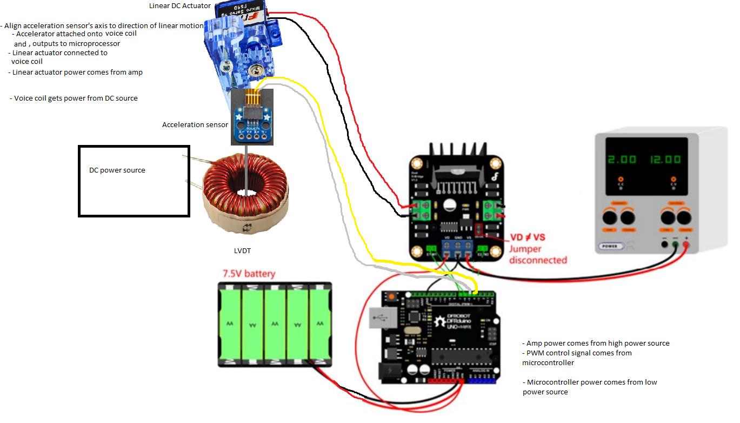Fig 5.3: Assembly diagram