MECH420 Lab 5 Report

Ratthamnoon Prakitpong

63205165

**C1:**

We are given an equation for linear calibration relation:

x = N * 9.05µm - 100.9 mm

Since we have position data, we can get velocity from position difference, which we can use to get flow rate according to the equation below:

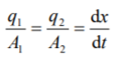

Diameters are D1 = 4.0”, D2 = 2.5”, and Ds = 0.5”. In this case, dt is always 1/20s, since we’re capturing sensor data at 20Hz.

To get QS, we can use a factor of (16GPM)/(10V) to convert sensor signal linearly, as per lab manual, and use another factor to convert GPM to (m^3)/s.

Figure C1: Flow rate over time

For some reason, the Q1 and Q2 are off from Qs by about a factor of 100. A sample calculation from at 2 sec is shown here:

Q1 = [dx/dt]*pi*[A1] = [(x_n - x_n-1)/dt]*pi*[A1]

8.73430845558294E-07 = [(6.0307-5.426)*0.00000905/(0.05) m/s]*3.1415*[(0.0508*0.0508-0.00635*0.00635)m^2]

Qs = Qs * [factor]

9.72792154586853E-05 = (0.9637 V)*[16/10 GPM/V]*(0.00378541178 m^3/G)*(1/60 min/s)

My suspicion is this may be due to some fault in my derivation of conversion equations. Another reason could be from an ambiguity in the given position equation; since we’re not given a voltage-to-count equation, I assumed that we’re supposed to use voltage directing as N, but there may be a missing equation that converts voltage to counts. The plot above is scaled so that they overlap at where are they supposed to overlap.

**C2:**

Theoretically, the pistons are lifting when Q1=Qs, and lowering when -Q2=Qs.

**C3:**

To get p1, we use bottom pressure, and convert it to psi using 2500/10 psi/V conversion factor, per sensor specification in lab manual. Note that 1 psi is 6894.75729 pa.

Figure C3: Flow resistance plot

Best fit line is:

Q1/sqrt(p1) = -0.002719*V + 0.0001156

Relating it back to this equation:



We can say that Ki = -0.002719 (m^3/s)/(pa^0.5), and V_V0 = 0.0001156/(-0.002719) = -0.04251563074 V.

**D:**

We have measured p1 and p2. We can convert these to F1 and F2 by multiplying them by A1 and A2.

Figure D: F1-F2 over positions

I’ll take the bottom-most line to use for calculating k:

k = ΔF/Δx

k = (-1436.26006015907 - -5531.2746832604)/(-0.1008346293884 - -0.10087746710185) N/m

k = 95593678.8709 N/m

**E1:**

We know that sampling rate is 250 Hz, so time step for each sampled data point is over 1/250 s.

Figure E1: Signal over time

**E2:**

From lecture, we can extract data points from the plot to get performance characteristics.

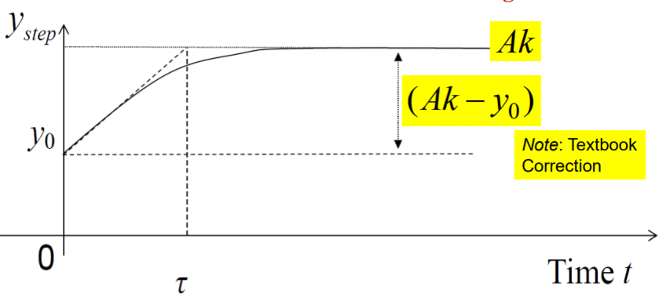

Figure E2: First order characteristic

Therefore, time constant is (Ak-y0)/(slope). Ak is steady state value which is average of 1.8417, 1.919, 1.9144, and 1.9143, which is 1.897357 V. y0 is average of 1.0421, 1.0531, 1.0539, 1.0556, and 1.0571, which is 1.0523302 V. Slope is change in signal over change in time. Since the step happened over one time sample, slope is (1.8417-1.0571)/(1/250), which is 196.15 V/s. Therefore, time constant is as follows:

Time constant = (Ak – y0) / (slope)

Time constant = (1.897357 - 1.0523302) / 196.15 s

Time constant = 0.00430806423 s