Ratthamnoon Prakitpong

#63205165

MECH421 Design Problem

Q1.

We already have Td = 0.0001 from HW7. To make this process easier, I assumed K2 = 0. The guess I made is:

P = tf([1],[.001 0 -2.5],'InputDelay',.0001);

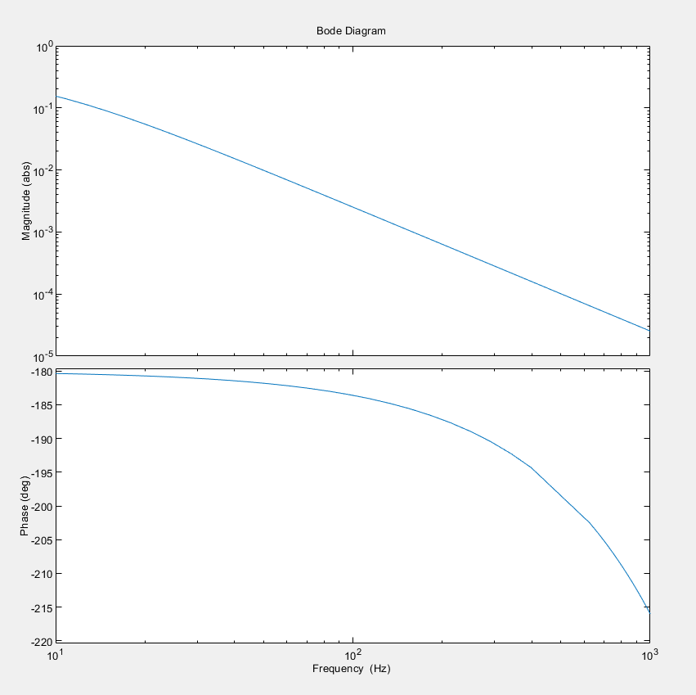

To compare the gain plots:

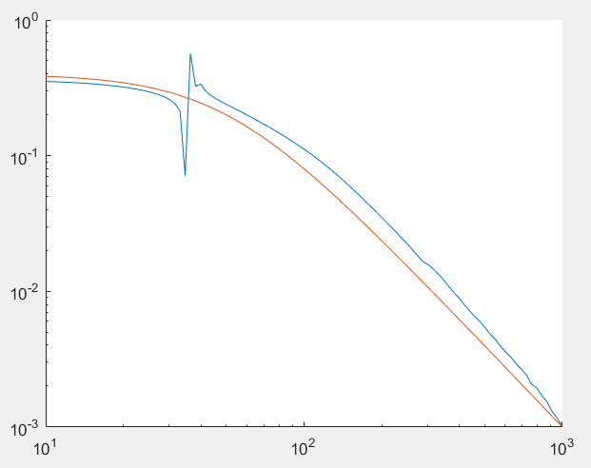

Red is from my estimate, blue is from data. The phase plot visually looks the same (steady state at -180, starts to dip at ~100 Hz), so comparison plot is omitted.

Q2.

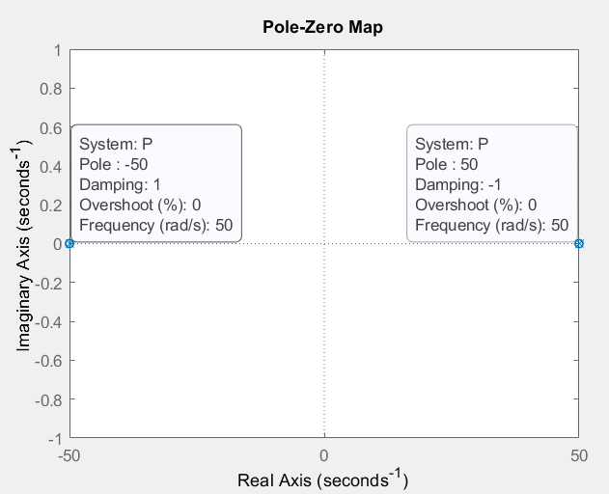

There is one unstable pole at 50 rad/s.

Q3.

After guess-and-check iterations, I found a suitable controller:

C = tf([1 1000],[1]);

• Stabilizing the closed-loop system => discussed in Q5

• Phase margin φm > 30◦ => discussed in Q4

• No integral control => no integral control (denominator = 1)

Q4.

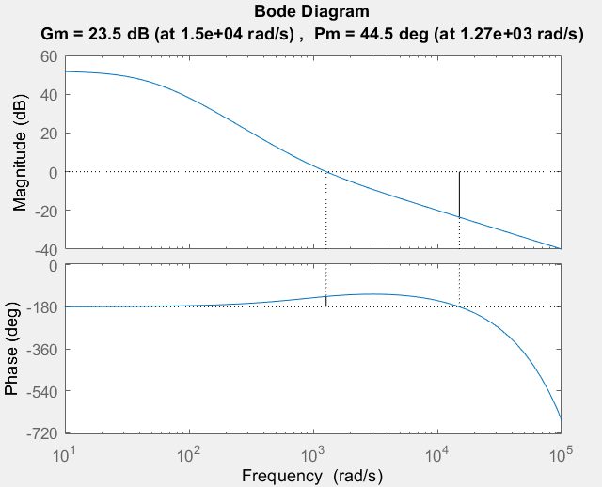

L=CP:

Phase margin = 44.5 deg > 30 deg

Crossover frequency = 1270 rad/s

Q5.

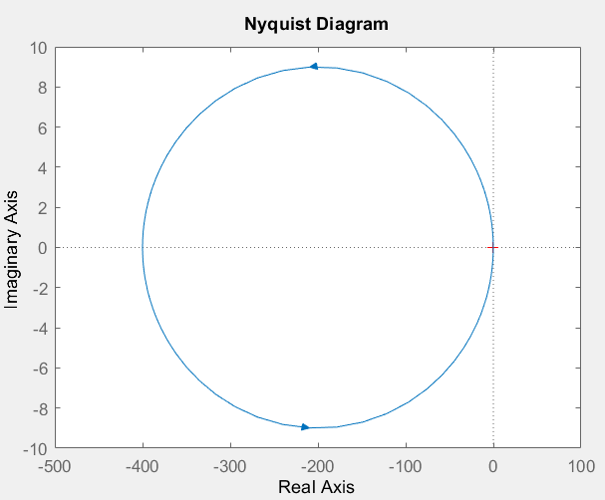

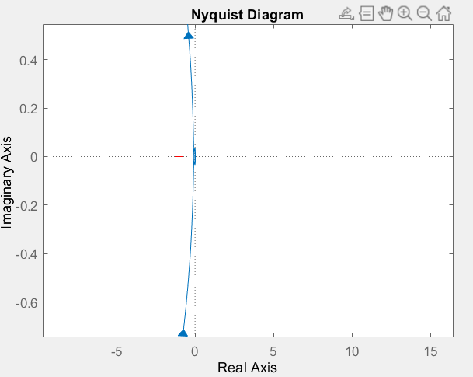

Number of poles of open loop transfer function in right half of s plane = P = 1 (at 50 rad/s, from Q2).

Number of encirclements around critical point = N = 1 (see above).

Number of zeros of closed 1+L in right half of s plane = Z = 0.

N = P – Z => Nyquist stability OK

Q6.

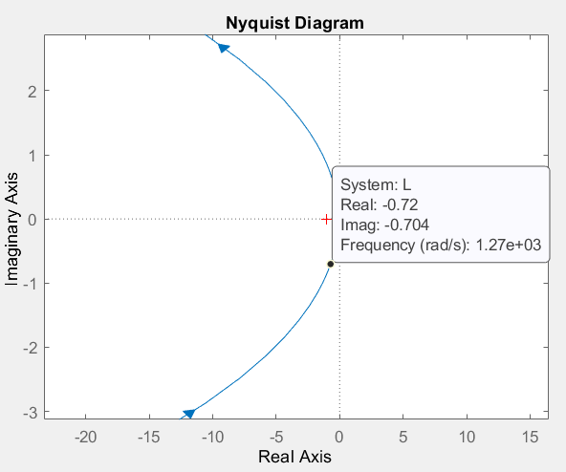

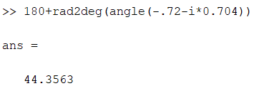

44.35 deg ~= 44.5 deg (from Q4)

Q7.

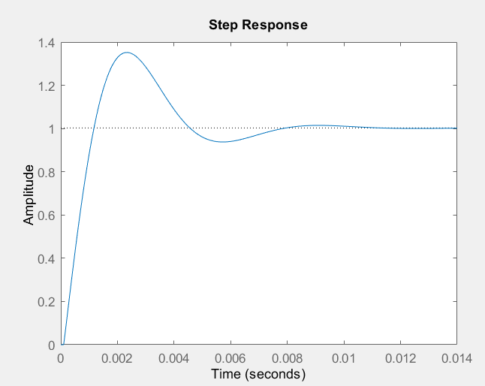

Appendix: MATLAB

clf;

% q1

a = load('MaglevPlant.mat');

x = a.Plant_frf(:,1);

y = a.Plant_frf(:,2);

gain = abs(y);

theory_phase = angle(y)*180/pi;

hold on;

set(gca, 'XScale', 'log', 'YScale', 'log');

loglog(x,gain);

%loglog(x,phase);

P = tf([1],[.001 0 -2.5],'InputDelay',.0001);

options = bodeoptions;

options.FreqUnits = 'Hz';

options.MagScale = 'log';

options.MagUnits = 'abs';

options.Xlim = [10,1000];

%bode(P,options);

[mag,theory_phase,wout] = bode(P,options);

theory_phase = squeeze(theory_phase)+360;

theory_gain = squeeze(mag);

%loglog(wout,squeeze(mag));

%loglog(wout,phase);

hold off;

%{

% tried this, didnt work, guess matched only 7%

guess = tfest(a.Plant_frf, 4, 2, .0001);

bode(guess,options);

%}

% q2

pzmap(P);

% q3

C = tf([1 1000],[1]);

L = P*C;

closedloop = L/(1+L);

% q4

margin(L);

% q5,6

nyquist(L);

% q7

step(closedloop);