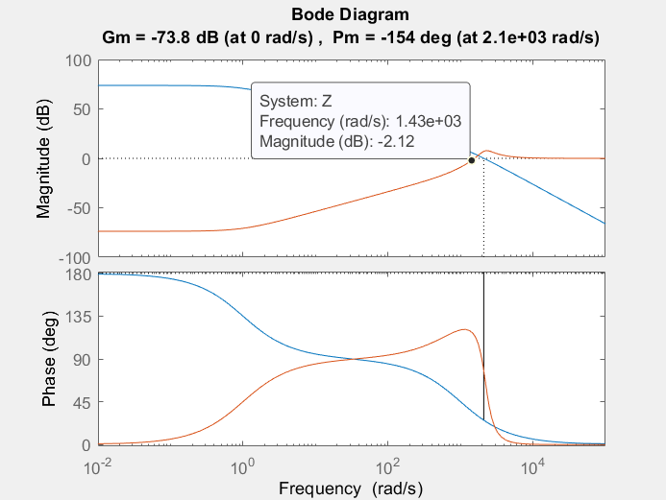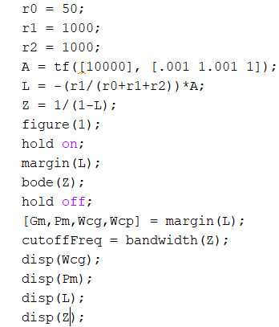

w_c = 0

pm = -154 deg

w_t = 1.43e3 rad/s

Shape of |L(jw)| and |Z(jw)| are approximately symmetric along 0dB line.

2C.

