Ratthamnoon Prakitpong

#63205165

a.

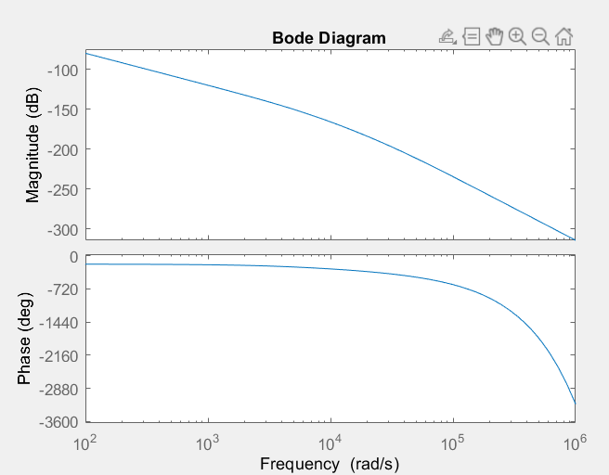

|  |
| --- |
| wa = 2*pi*10^3;  ws = 10*pi*10^3;  m = 1;  Ga = tf(1,[1/wa 1]);  Gs = tf(1,[1/ws 1]);  Gm = tf(1,[m 0 0]);  fs = 10000;  T = 1/fs;  syms s;  DAC = tf([10],[1], 'InputDelay',T/2);  Kf = 1;  ADC = 0.1;  % a  P = DAC*Ga*Kf*Gm*Gs*0.1;  bode(P); |

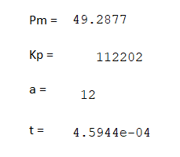b.



|  |
| --- |
| % b  w = 100*2*pi; % convert from hz to rad/s  phi = 45; % deg  phi = phi * pi/180;  a = 12; % guess and check, start from a=10  %lecture notes rule of thumb a=10 for pm~=55deg  t = 1/(sqrt(a)*w);  Kp = 112202; % at 100Hz, this K make gain ~= 0db  C = tf([Kp*a*t Kp], [t 1]);  L = C*P;  [Gm,Pm,Wcg,Wcp] = margin(L);  disp(Pm);  disp(Kp);  disp(a);  disp(t);  options = bodeoptions;  options.FreqUnits = 'Hz';  bode(L, options);  grid on; |

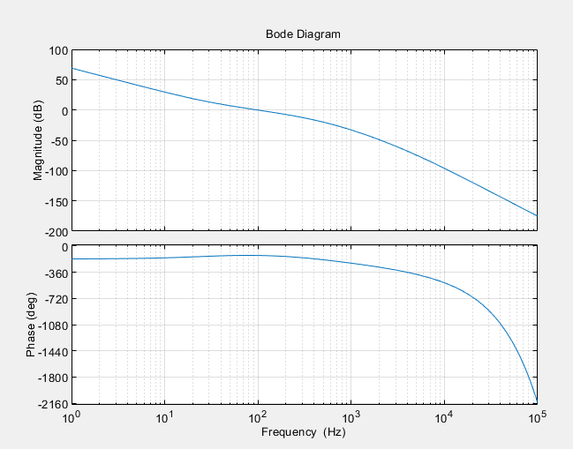

c.

Gxr:

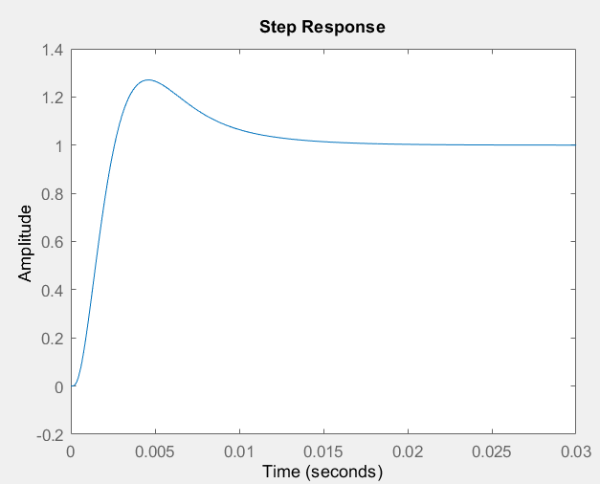

Gxd:

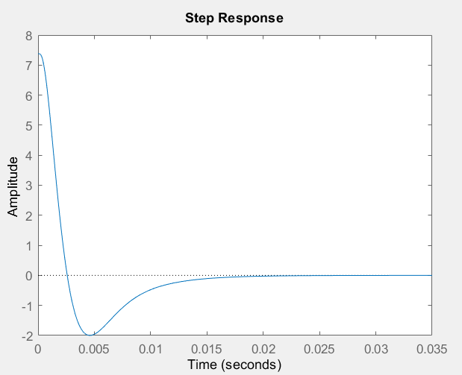

|  |
| --- |
| % c  Gxr = L/(1+L);  Gxd = Gm/(1+L);  step(Gxr);  step(Gxd); |

d.

Going back to bode plot from part b, we can approximate a corner at 40Hz.

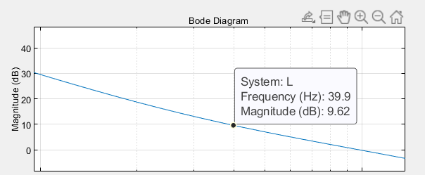

Bode plot of new L(s):

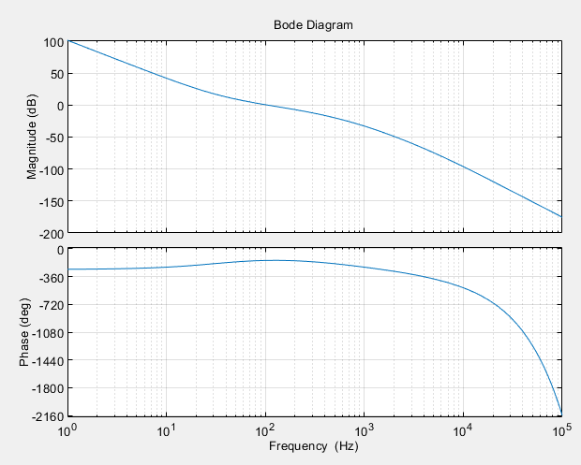

|  |
| --- |
| % d  wi = 40*2*pi; % hz to rad/s  Ti = 1/wi;  C = tf([Ti 1],[Ti 0])*C;  L = C*P;  bode(L, options);  grid on; |

Phase margin is still >40 deg, which fits the given specification.

e.

Gxr:

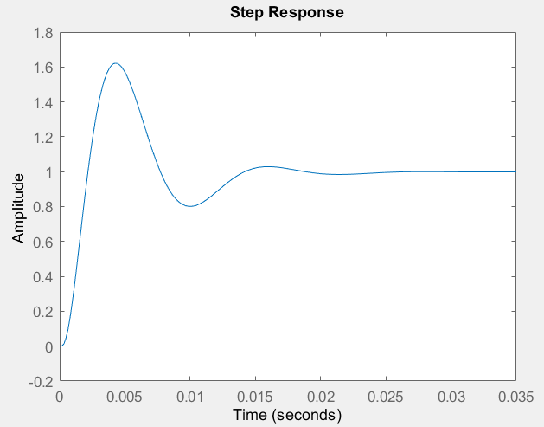

Gxd:

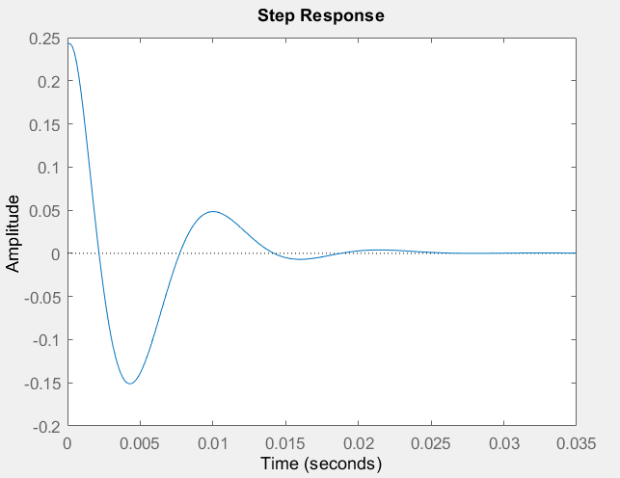

|  |
| --- |
| % e  Gxr = L/(1+L);  Gxd = Gm/(1+L);  step(Gxr);  step(Gxd); |

|  |  |  |
| --- | --- | --- |
|  | Without integral | With integral |
| Gxr |  |  |
| Gxd  (Overshoot given by MATLAB doesn’t make sense, but we can visually inspect) |  |  |

In both cases, settling time increased. In Gxd, overshoot decreased. In Gxr, overshoot increased. These are the results of the properties of an integrator.