MECH421 HW 7

Ratthamnoon Prakitpong

#63205165

A.

Bode of P:

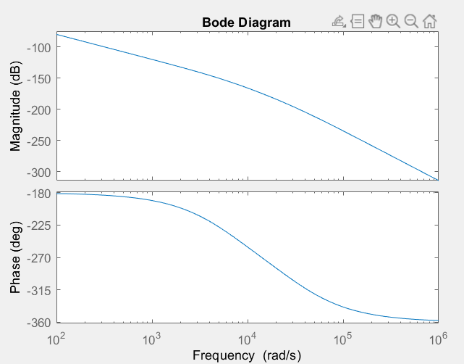

% q1

wa = 2*pi*10^3;

ws = 10*pi*10^3;

m = 1;

Kf = 1;

Ga = tf(1,[1/wa 1]);

Gs = tf(1,[1/ws 1]);

Gm = tf(1,[m 0 0]);

fs = 10000;

T = 1/fs;

P = Ga*Kf*Gm*Gs;

bode(P);

B.

Bode of P_delay and P_zoh:

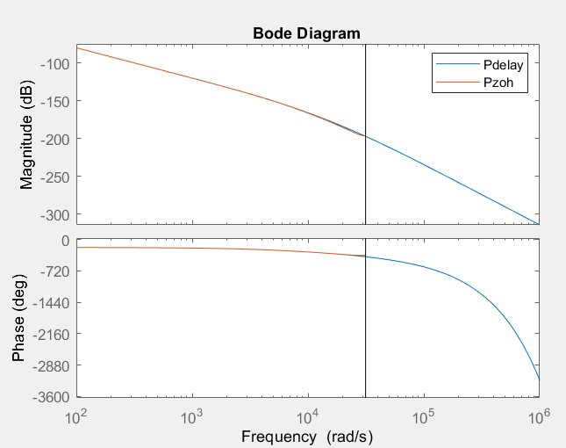

Zoomed in at P_zoh:

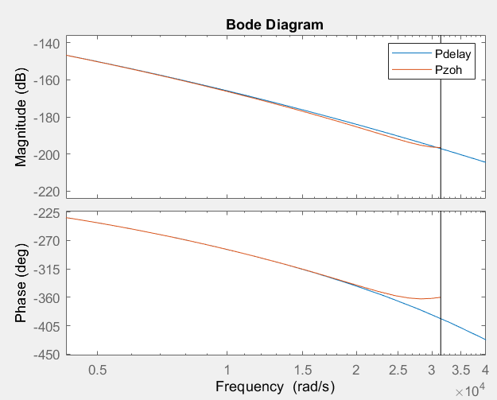

% q2

Pdelay = P*tf([1],[1], 'InputDelay',T/2);

Pzoh = c2d(P, T, 'zoh');

hold on;

legend on;

bode(Pdelay);

bode(Pzoh);

C.

Bode of C(s) and C(z):

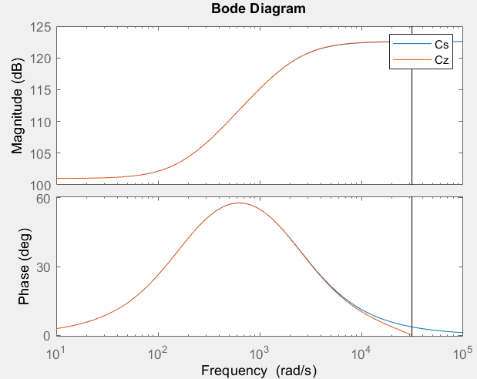

% q3

w = 100*2*pi; % from hw6, convert from hz to rad/s

phi = 45; % from hw6, deg

phi = phi * pi/180;

a = 12; % from hw6, guess and check

t = 1/(sqrt(a)*w);

Kp = 112202; % from hw6, at 100Hz, this K make gain ~= 0db

Cs = tf([Kp*a*t Kp], [t 1]);

Cz = c2d(Cs, T, 'tustin');

hold on;

legend on;

bode(Cs);

bode(Cz);

D.

