Ratthamnoon Prakitpong

#62105165

4.1.1

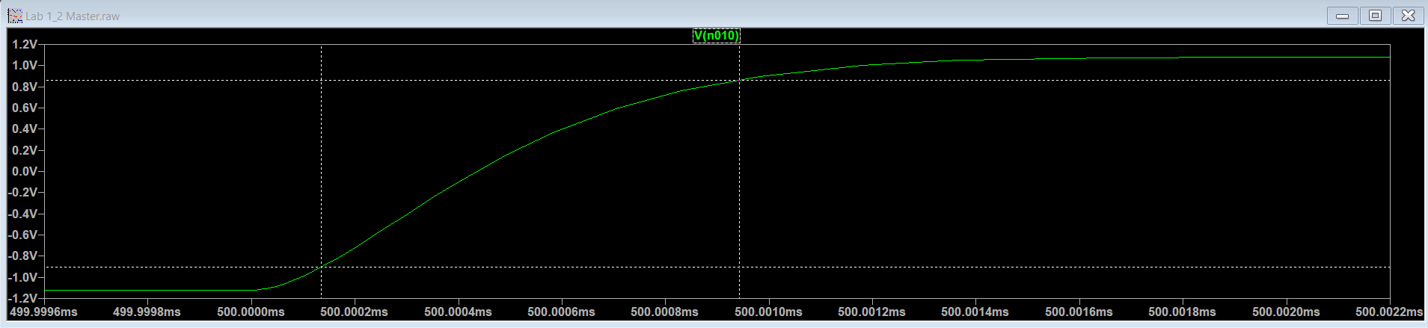Figure 1: Vo of 0.2V p2p

Steady state = 1.0791816V - (-1.1206958V) = 2.1998774V p2p

Overshoot = 1.0792908V = 2.1999867V p2p -> % = 0.0049685%

90% = 860mV -> t = 500.00094ms

10% = -900mV -> t = 500.00013ms -> dt = .00081ms

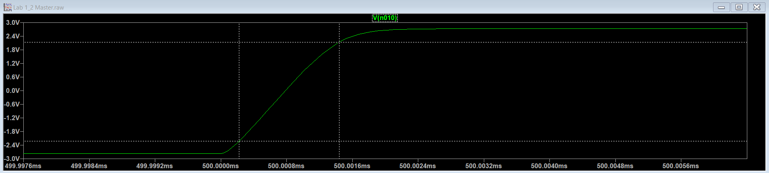Figure 2: Vo of 0.5V p2p

SS = 2.7290895V - (-2.7706039V) = 5.4996934V p2p

Overshoot = 2.7292024V = 5.4998107V p2p -> % = 0.0021328%

90% = 2.18V -> t = 500.00144ms

10% = -2.22V -> t = 500.00022ms -> dt = .00122ms

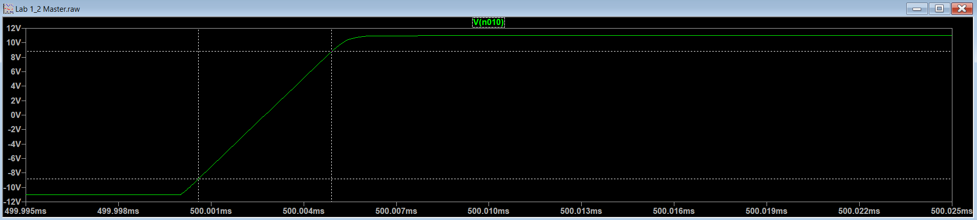Figure 3: Vo of 2V peak to peak

SS = 10.97863V - (-11.020144V) = 21.998774V p2p

Overshoot = 11.00192V = 22.022064V p2p -> % = 0.1058695%

90% = 8.79V -> t = 500.00490ms

10% = -8.82V -> t = 500.00059ms -> dt = .00431ms

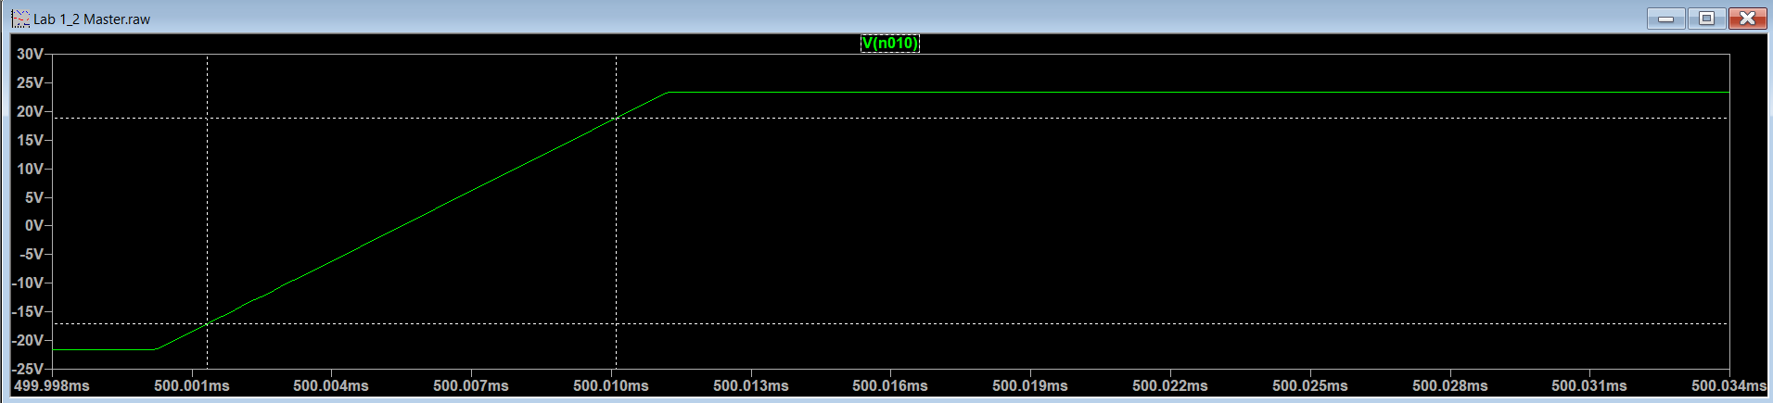Figure 4: Vo of 5V peak to peak

SS = 23.352053V - (-21.552312V) = 44.904366V p2p

Overshoot = 23.37276V = 44.925072V p2p -> % = 0.0461113%

90% = 18.86V -> t = 500.0101ms

10% = -17.06V -> t = 500.00132ms -> dt = .00878ms

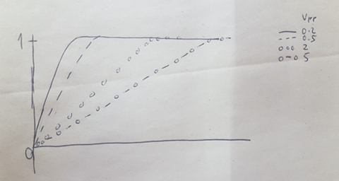

Figure 5: Drawn normalized ramp response of Vr = 0.2V, 0.5V, 2V, 5V peak to peak

Figure 6: Vo vs rise time plot

It seems that rise time is linearly correlated with input voltage. This makes sense as it would take more time to rise to steady state if input voltage is higher.

4.1.2

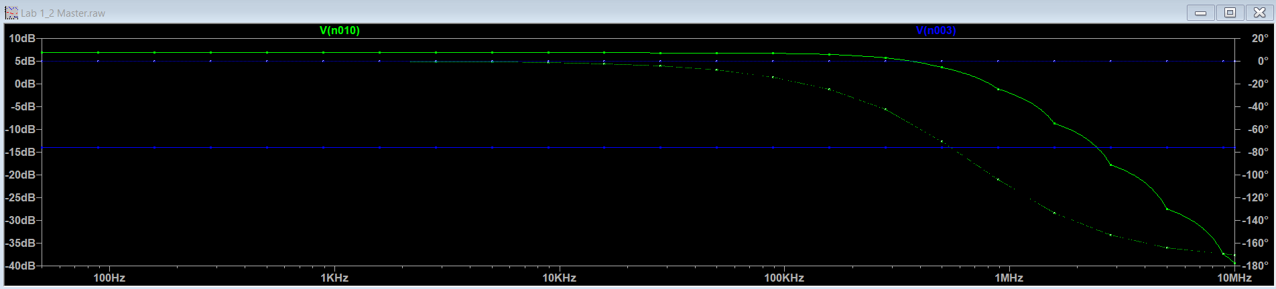Figure 7: Magnitude and phase shift of Vo (gree) and Vr (blue), ~20 evenly spaced points in log scale

Table 1: Values from ramp response

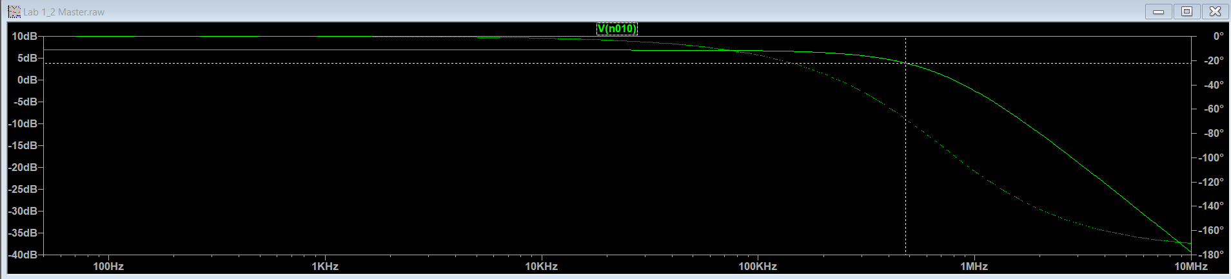Figure 8: Vr magnitude and phase shift

SS = 6.85dB

ss – 3dB = 3.85dB -> Freq = 480kHz

This is very different from the calculated 2.28e6 Hz. This could result from some bad estimation from PA13 response plot.

4.2.1

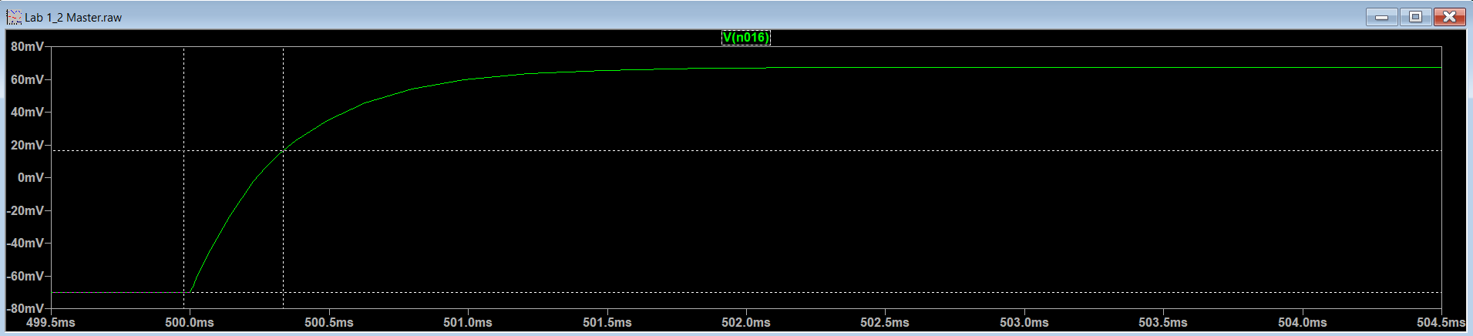Figure 9: Vio ramp response

SS = 67.42mV - (-70.02mV) = 137.45mV

t(v = -70.02mV) = 499.9757ms

0.63\*SS = 16.57mV -> t(16.57mV) = 503.32871ms

dt = 352.01us

Time constant from prelab = 1/3200 s^-1 -> t = 312.5us

Observed time constant and calculated time constant are approximately equal.

4.2.2

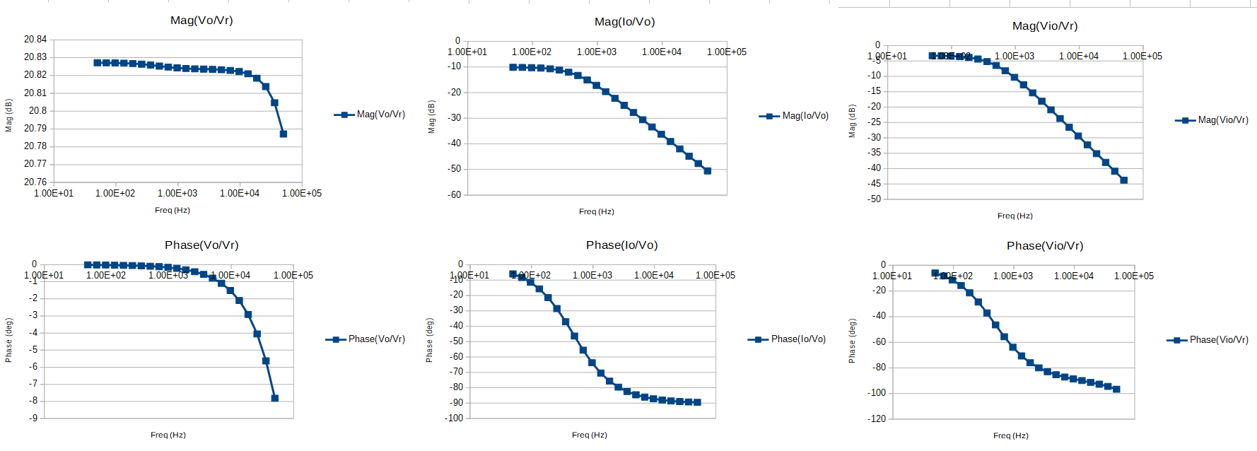Figure 10: Frequency responses

Based on prelab, we can see that function of Io/Vo = 1/(R+sL) = a/(1+s/b). Looking at the plot, we can see that a = -10dB = .316 and b = 3000 Hz, approximately. This results in R = 1/a = 3.16ohm, and L = 1/(ab) = .00105H; both values are approximately same as given in lab manual.

4.3

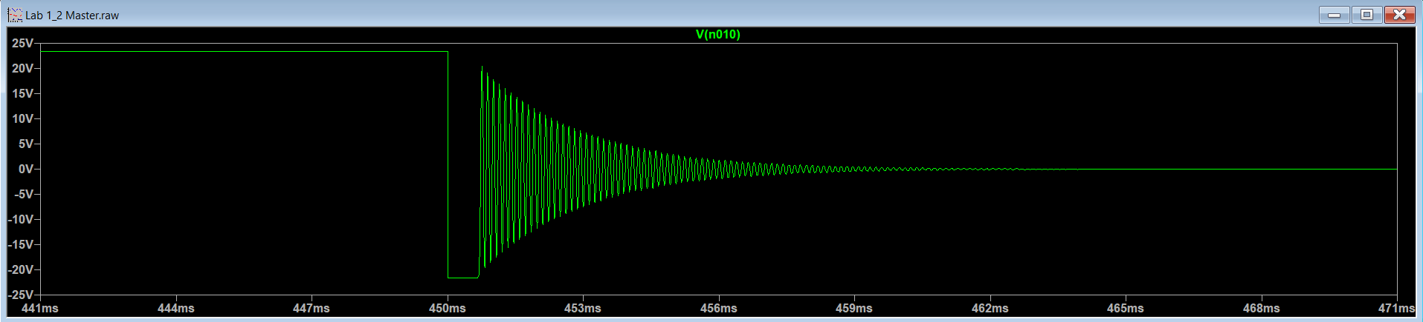Figure 11: Response with added capacitor

Adding a capacitor causes circuit to behave like a RC circuit, where current can’t drop to 0V suddenly, and so there’s a sinusoidal, curved discharge.