**Ratthamnoon Prakitpong**

**#63205165**

**4.1 Set the impedances Z1-Z5**

From my pre-lab:

Z1 = 2.2k ohm

Z2 = 22k ohm

Z3 = 5k ohm

Z4 = 14.54k ohm + 0.215 nF

Z5 = 1k ohm

I tried using these parameters but I couldn’t finish the simulation. I kept getting “time step too small error”, so I’m going to use values that are already in the asc file for this lab.

From asc file:

Z1 = 2.2k ohm

Z2 = 22k ohm

Z3 = 4.7k ohm

Z4 = 33k ohm + 4.7 nF

Z5 = 1k ohm

**4.2 Step responses**

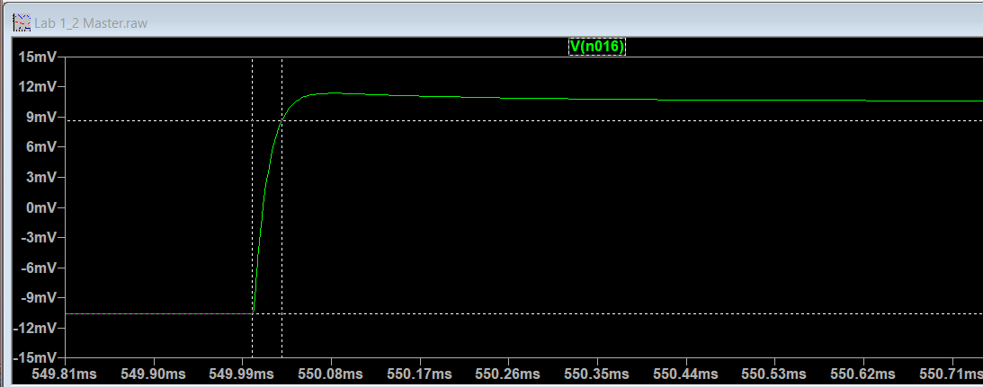Figure 1: Vio = 0.1 Vpp

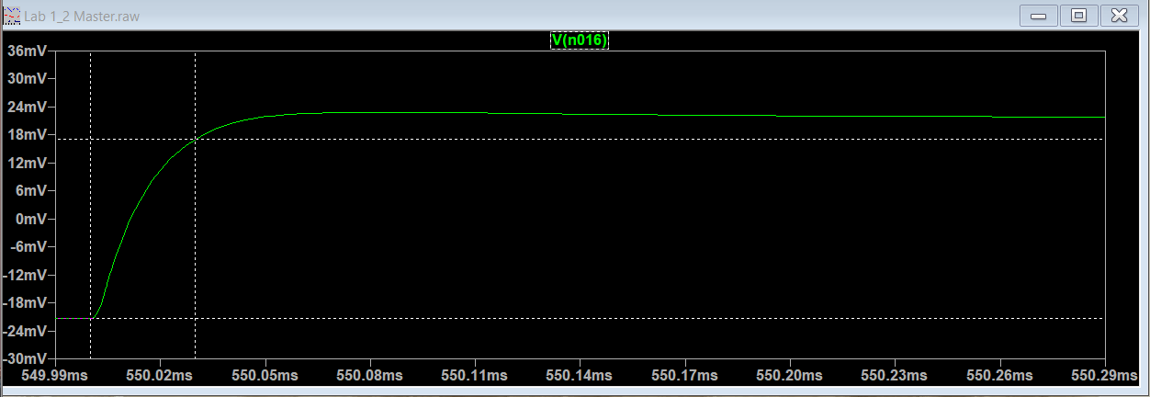Figure 2: Vio = 0.2 Vpp

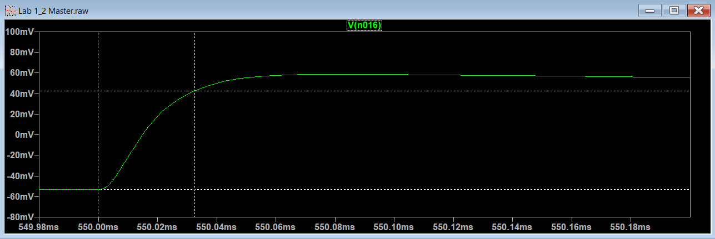Figure 3: Vio = 0.5 Vpp

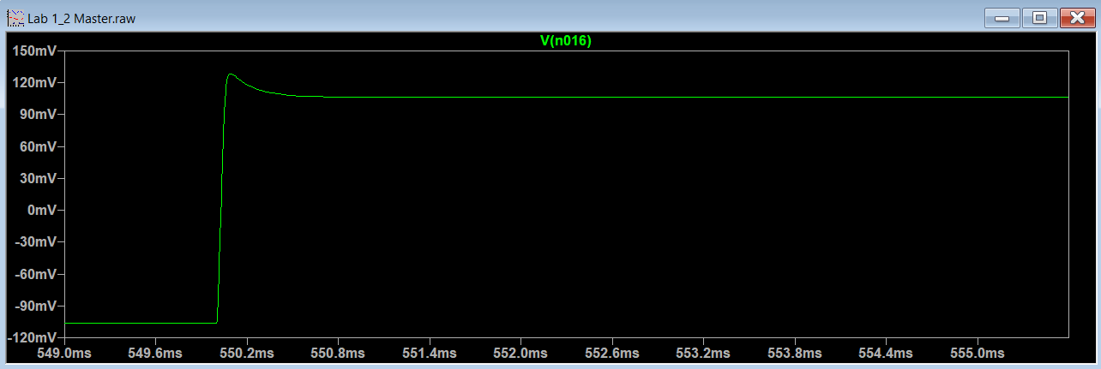Figure 4: Vio = 1 Vpp

Table 1: % overshoot and rise time of 4 step responses

While my prelab prediction uses different impedance values than the lab’s, I can still make some comparison, given that the prelab prediction is how the system is supposed to behave if the impedances are specified correctly. At Vir = 1 Vpp, steady state is 0.213V, which is very close to the targeted 0.2V. The rise time I got in my prediction is 69.02 us, which is also close to lab’s rise time of 39.24 us. The main difference is there’s overshoot in the lab, whereas there’s no overshoot in the prelab; this makes sense since this is a second order system, and I’ve made some simplifications to the transfer function for the prelab.

**4.3 Frequency responses**

Since the impedances are different, I’ll be using our targeted closed loop bandwidth of 5 kHz as w_h for this part, which means we’ll be measuring from 50 Hz to 25000 Hz.

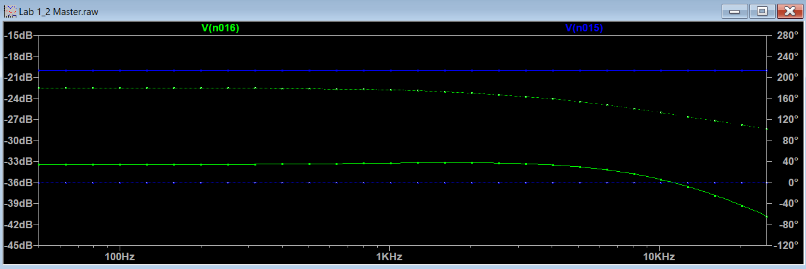Figure 5: Magnitude and phases of voltages; Vir in blue, Vio in green

Figure 6: Bode plot of Vio/Vir

Looking at the magnitude plot, we can say that the DC gain is -13.3467504229261 dB (averaging first 19 data points), so we can say that -13.3467504229261-3 = -16.3467504229261 dB. Interpolating from the plot, the frequency that that happened at is 1.28E+04 rad/s. In my prelab, -3dB bandwidth is at 3.1912e+04 rad/s. While they’re different, they’re fairly close (same order of magnitude) considering different impedances.

The data points are in Appendix A.

**4.4 Destabilize the current controller**

Since it took quite a bit of decreasing-by-factor-of-two steps, I’ll only be showing the notable ones.

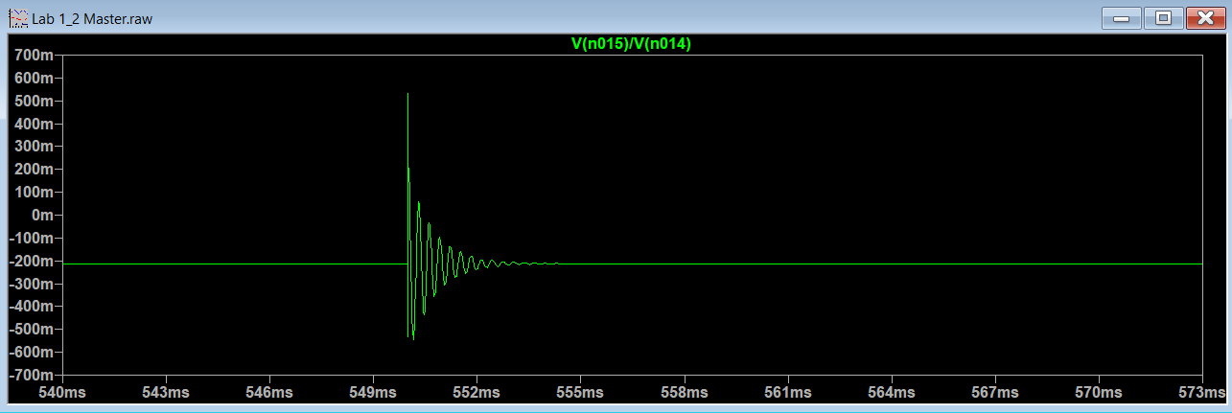Figure 7: Vio/Vir where R3 = 4.7kohm, C4 = 4.7nF, R5 = 1kohm

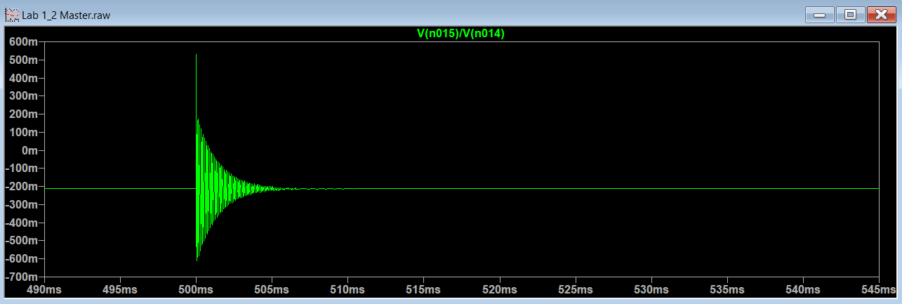Figure 8: Vio/Vir where R3 = 4.7kohm, C4 = 0.5875nF, R5 = 1kohm

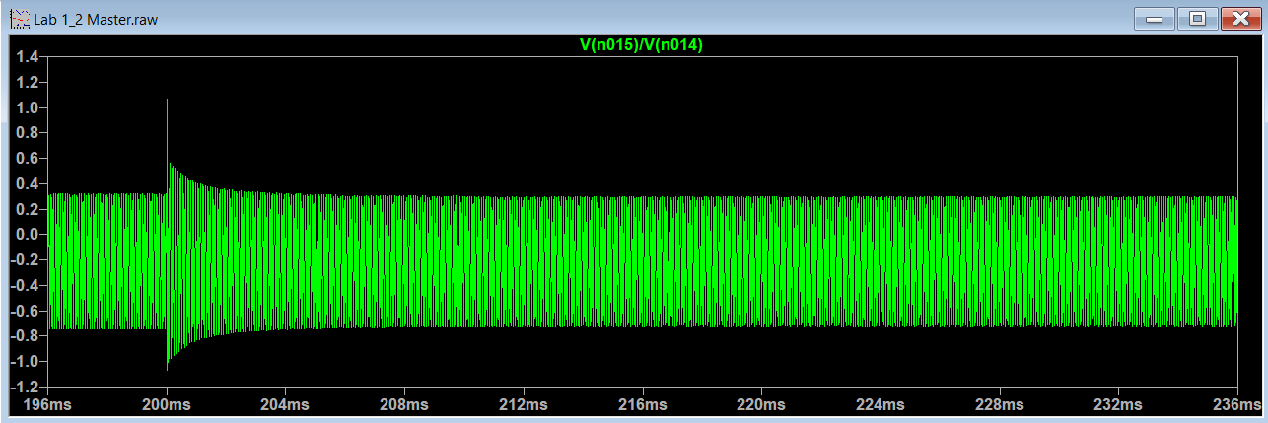Figure 9: Vio/Vir where R3 = 4.7kohm, C4 = 0.29375nF, R5 = 1kohm

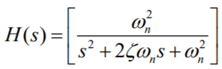Given a step response of a second order system with transfer function in this form:

We can say that the settling time of the system has the equation of:

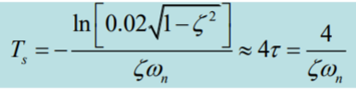

Where it is inversely proportional to damping ratio and natural frequency. Since C4 is a coefficient in our Vio/Vir transfer function, we correlate it to damping ratio and natural frequency. Therefore, when C4 decreases, damping ratio and natural frequency decreases, which increase settling time. At some point, Vir switches before settling time is reached, and Vir is unable to reach steady state, causing system to be unstable.

**Appendix A: Part 4.3 data points**

