Ratthamnoon Prakitpong

#63205165

1.

DC gain = -75.12 dB

-75.13 dB -3db = -78.13 dB

Bandwidth = 1.28KHz = 8042 rad/s

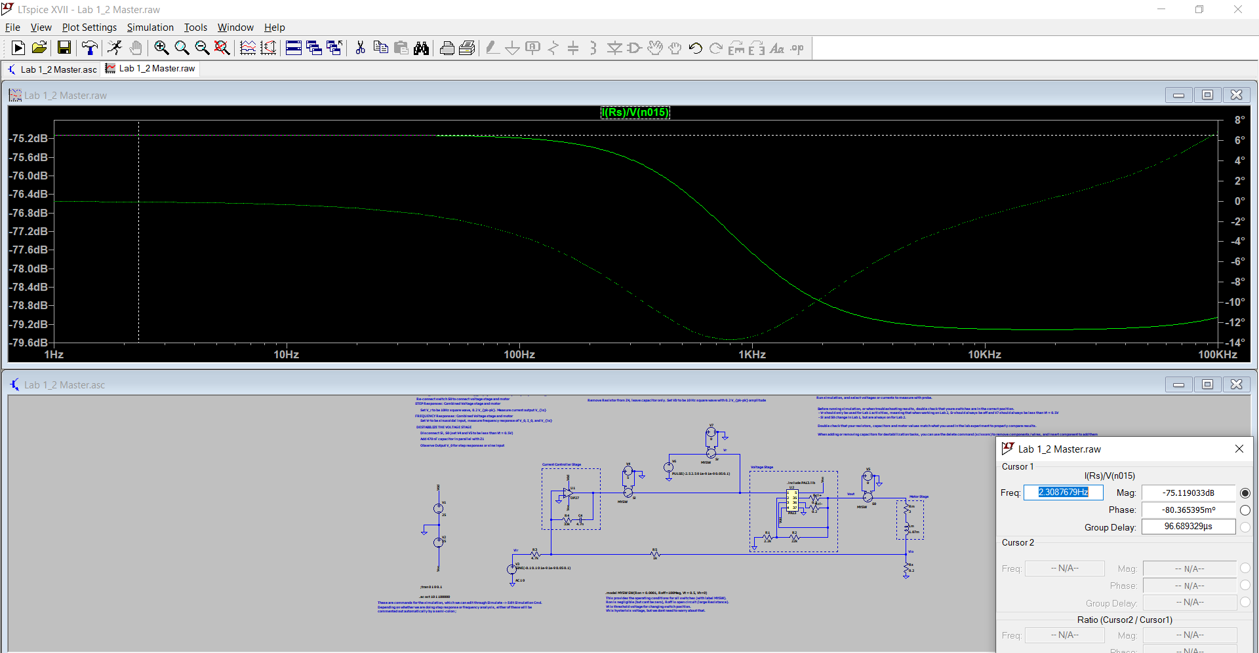

2.

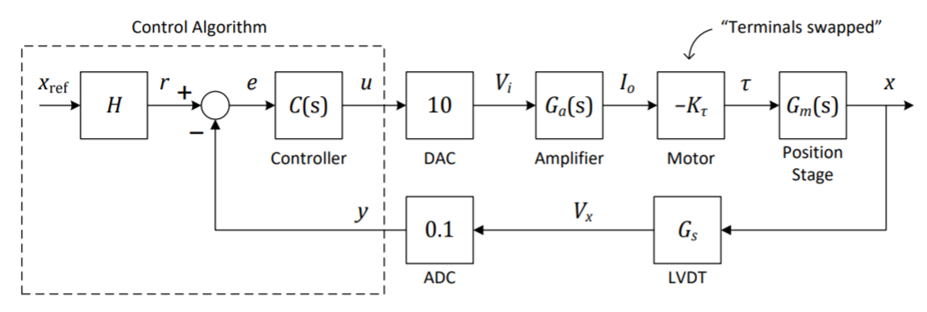P(s)

= Y(s)/U(s)

= 10*Ga(s)*-Kt*Gm(s)*Gs*0.1

Gs = Vx/x = 0.035 V/mm

Kt = 0.1963 Nm/A

Ga(s) = Io/Vi = -75.12 dB / (1+s/(1.28kHz)) = 0.000175388/(1+s/8042) [first order approx. works till ~5kHz]

Jsum = J1 + J2 + J3 + r*r*(m1+m2) = 0.0053 kgm2

T(t) = Jsum*a(t) -> T(s) = Jsum*X(s)*s2 -> Gm(s) = X(s)/T(s) = 1/(Jsums2)

P(s)

= 10*(0.000175388/(1+s/8042))*(-0.1963)*(1/(0.0053s2))*0.035*0.1

= -44456773269050453311/(195535487181321247129600*s^2*(s/8042 + 1))

= -0.0002274 / (0.0001243 s^3 + s^2)

3.

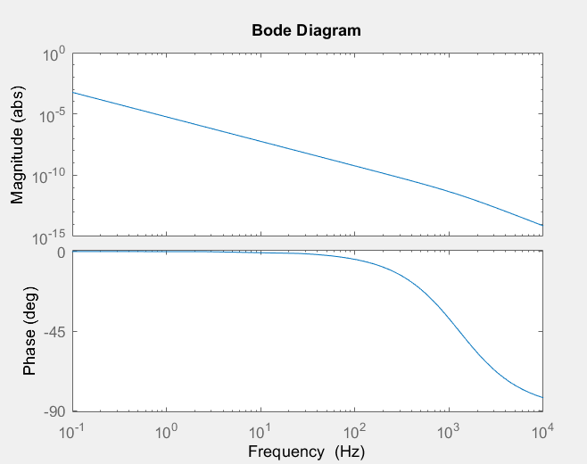

Gain discrepancies:

* At low frequencies, frequency is likely too low so system could not overcome frictions that we did not account for in our model.
* At high frequencies, there’s likely mechanical limits present in the system such that even when we want to run the system faster, gain can not decrease further, which is why we see an asymptotic behaviour at about 100Hz.
* We also made estimations with our amplifier, which may result in overall difference in gain.

Phase differences:

* Again, likely due to first order estimation of amplifier, which is why we might’ve lost an order in our model, so it only goes down to -90deg vs measurement going to -180deg.

4.

• Phase margin φm > 60◦

• As high a cross-over frequency as possible

We can use lead-lag compensator to satisfy this.

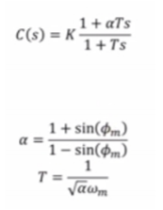

Given the data available for P(s), the highest P(s) we have frequency response for is about 100Hz, so we’ll pick that as our cross-over frequency. Since phi_m and w_m are given as 60 deg and 100 Hz, a and T can simply be solved. To get K, I’ve plotted C(s)P(s) on bode plot, found gain margin at 100Hz, then solve for K to shift gain at that frequency back to 0dB. Following those steps, I’ve found that I need to shift gain by K ~= 1000. Plotting everything on the bode plot, we can see that we’ve created 60 deg margin at 1000Hz, and we’ve shifted magnitude such that the system is stable.

• Zero steady-state error for a step position reference xref

e = r – y = Hxref – (P(s)C(s))e

e = (H/(1+P(s)C(s)))xref

e_ss

= lims->0 se(s)

= lims->0  s(H/(1+P(s)C(s)))xref

= lims->0  s(H/(1+P(s)C(s)))(1/s)

= lims->0  (H/(1+P(s)C(s)))

Therefore, we know that we have to make P(s)C(s) approach infinity as s approaches zero. We can use an integrator for this case, cascading it onto C(s).



We can see the resulting gain of P(s)C(s) below.

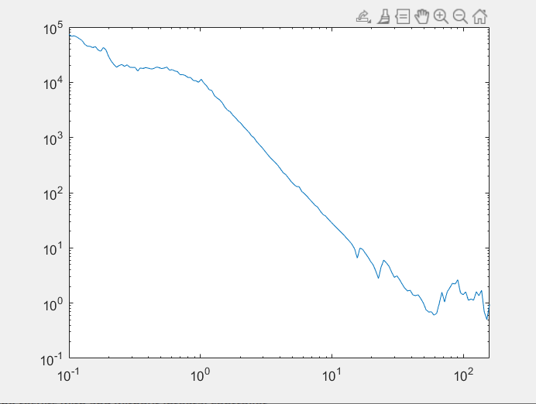

While I can’t add phase plot directly in MATLAB, I can show you C(s) and P(s) phases separately below.

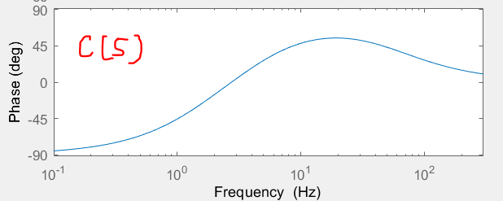

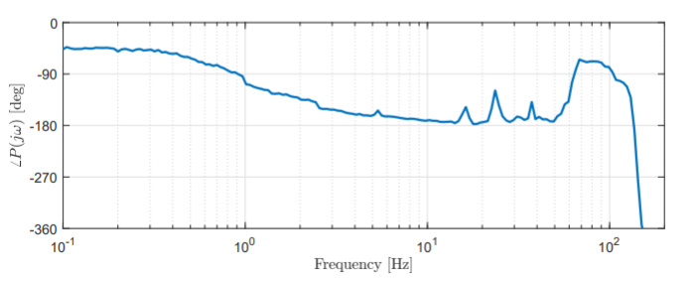

We can see that at frequency of 100Hz, sum of the two phases results in φm > 60◦.

We also need to find H for e = 0 and x = xref.

e = r – y = Hxref -0.1Gsx = 0

0 = Hx -0.1Gsx

H = 0.1Gs = 0.1*0.035 = 0.0035

5.

I’ll estimate the given P(s) as 1/((s+1)^2), which is valid up to about 100Hz.

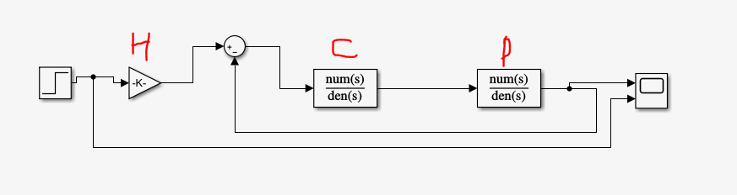

Steady state = 0.0035

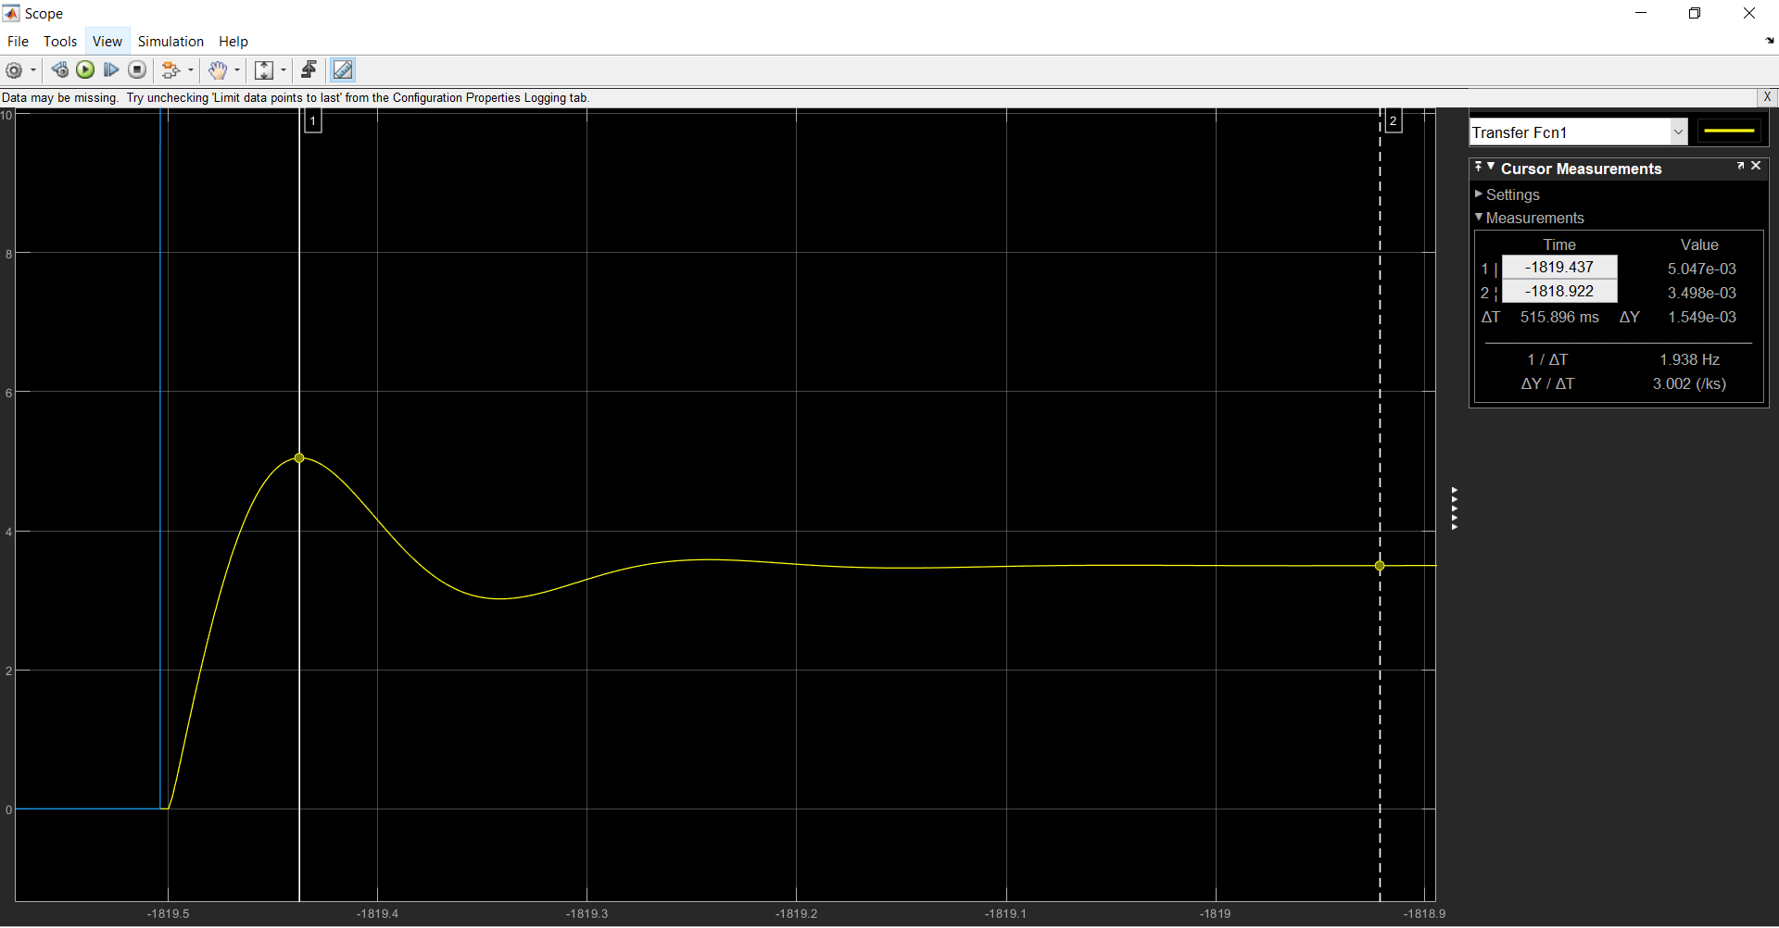Overshoot = (5.05-3.5)/3.5 ~= 45%

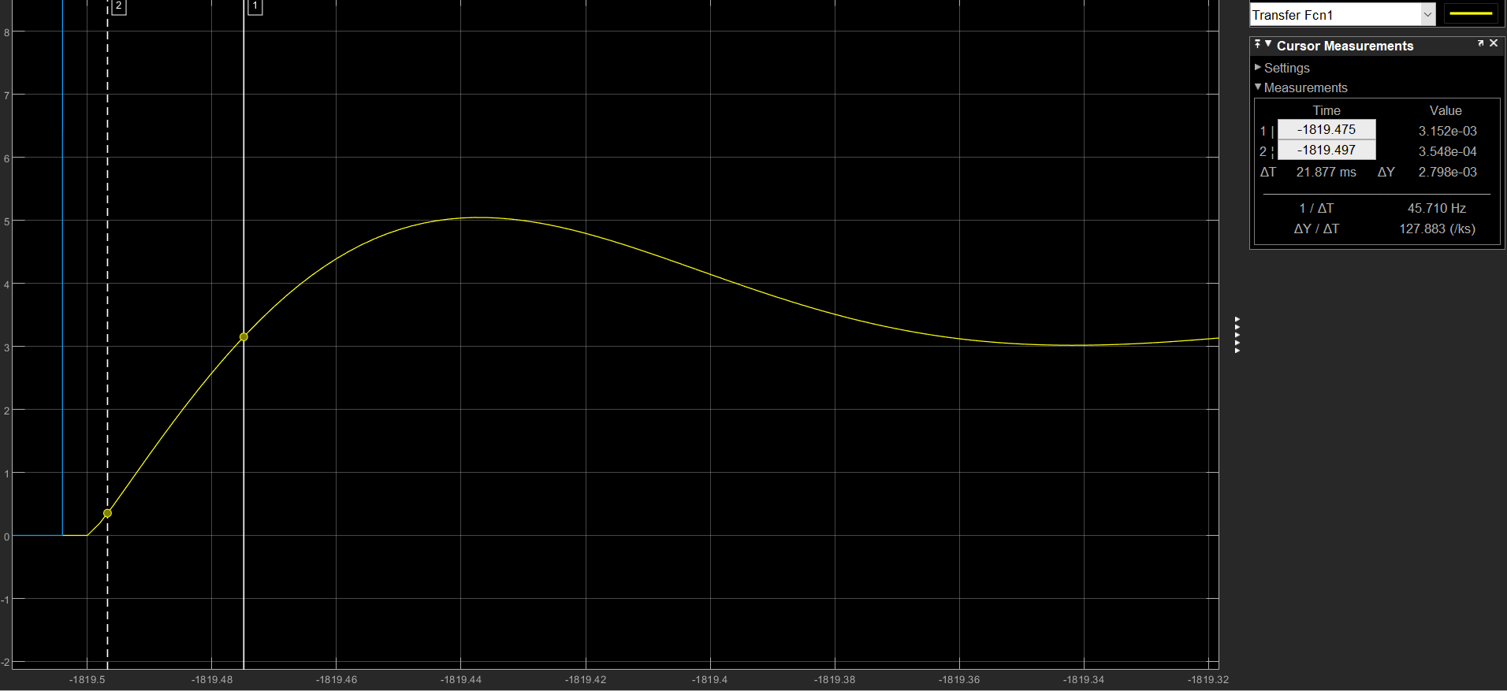

Rise time ~= 22ms

Appendix: MATLAB code

|  |
| --- |
| %Q2  J1 = 0.000190;  J2 = 0.000204;  J3 = 0.000166;  m1 = 0.4455;  m2 = 4.2882;  r = 0.0316;  Jsum = J1 + J2 + J3 + r*r*(m1+m2);  disp(Jsum);  syms s;  a = 10*(0.000175388/(1+s/8042))*(-0.1963)*(1/(0.0053*s*s))*0.035*0.1;  disp(a);  sys = tf([-44456773269050453311/195535487181321247129600], [1/8042 1 0 0]);  %Q3  h = bodeplot(sys);  setoptions(h,'FreqUnits','Hz','Xlim',[0.1,10000],'MagUnits','abs','MagScale','log');  %Q4  load('Lab3-Plant-FRF-2021');  freq = FRF(1,:);  P_mes = FRF(2,:);  Mag_mes = abs(P_mes);  Ang_mes = unwrap(angle(P_mes))*180/pi;  w = 100;  phi = 60; % deg  phi = phi * pi/180;  a = (1+sin(phi))/(1-sin(phi));  t = 1/(sqrt(a)*w);  K = 1000; % found that with K=1, mag at w is 1  Ki = w/10;  G = tf([1 Ki], [1 0]);  C = tf([K*a*t K], [t 1]);  C = C*G;  C_frf = [];  for i = freq(1,:)  j = evalfr(C,i);  C_frf = [C_frf j];  end  res = [];  for k = 1:size(C_frf,2)  temp = C_frf(k)*Mag_mes(1,k);  res = [res temp];  end  % gain P(s)C(s)  loglog(freq(:,1:160), res(:,1:160));  % phase P(s)  loglog(freq(:,1:160), Ang_mes(:,1:160));  % phase C(s)  bode(C); |