Ratthamnoon Prakitpong #63205165

1.

For both options, total profit is made up of 3 parameters:

Total profit ($) = Total revenue ($) – Production cost ($) – Shipping cost ($)

Option 1 equations for each parameters:

Production cost ($) = Produce total (kg) \* Production cost ($/kg)

Shipping cost ($) = Produce total (kg) \* Shipping cost($/kg)

Total revenue ($) = Caught outcome given uniform range of probability of getting caught \*

Some sales price from normal distribution,

looped by number of shipments

= ∑Number of shipments = Produce total (kg) / Cocaine per shipment (kg) (IF(RAND() > RANDBETWEEN(Uniform chance caught, lower (%), Uniform change caught, upper (%)), 1, 0) \* NORM.INV(RAND(), Sales price ($), Sale price stddev ($)))

Option 2 equations for each parameters:

Production cost ($) = Produce total (kg) \* Production cost ($/kg)

Shipping cost ($) = Produce total (kg) \* Shipping cost($/kg)

Total Revenue ($) = Caught outcome given fixed probability of getting caught \*

Some sales price from normal distribution,

looped by number of shipments

= ∑Number of shipments = Produce total (kg) / Cocaine per shipment (kg) (IF(RAND() > Chance caught (%)), 1, 0) \* NORM.INV(RAND(), Sales price ($), Sale price stddev ($)))

We will assume that shipment will be paid whether shipping is successful or not (we don’t want a mutiny within ranks). We can put given information and derived formula into some sheet software and repeat it 250 times:

Option 1 simulation sample:

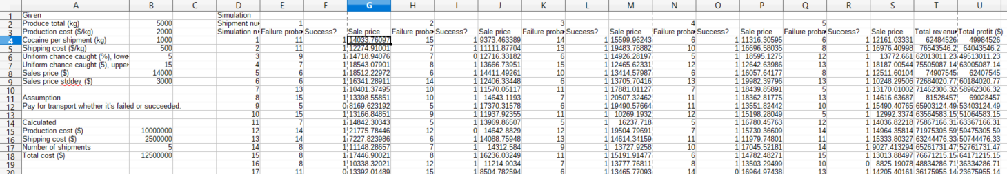

Option 2 simulation sample:

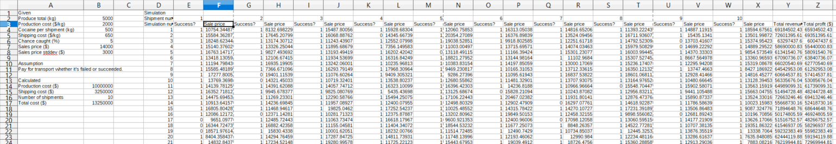

Sadly, the office software that I use can’t plot frequency histogram. Therefore, I’ve ran a simulation (data from that simulation Appendix A), copied out total profit, and put it into a python script that I wrote. A benefit of using python is that we can trust that popular python libraries are robust and there’s good internal logic for deciding bin size, number of bins, etc., so we can just plot our numbers with default settings. Also, we can make it calculate other values such as mean and standard deviation automatically for us:

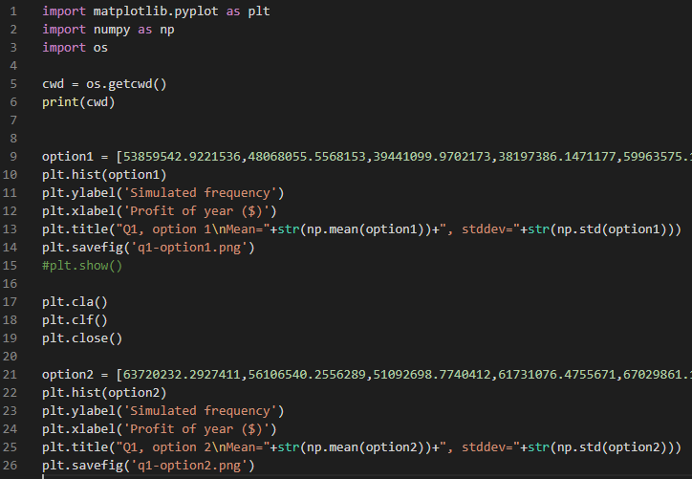

Option 1 frequency histogram:

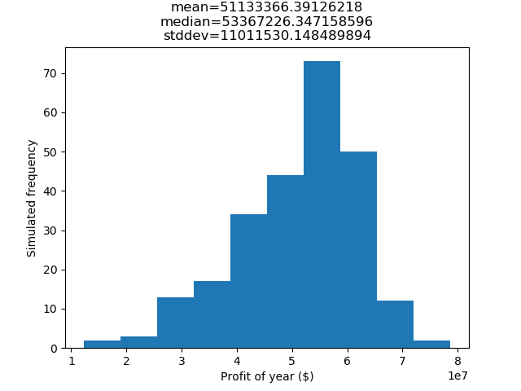Option2 frequency histogram:

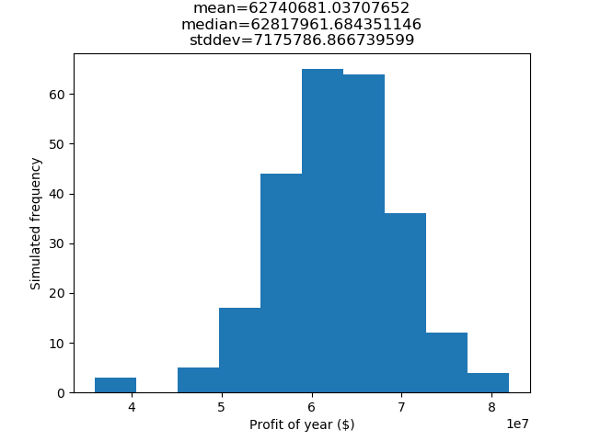

We can see that in 250 simulations, none of them lost money, so both options are at least viable. Comparing option 1 to option 2, option 1 has comparatively lower mean profit (by approx. $1mil) and higher standard deviation (by approx $4mil), which means that it’s the riskier option (smaller mean profit, but more potential to earn more, but also more potential to earn less).

Truck shipment is recommended, since it’ll make more money on an average year, and drug operations are often already very risky, so an obvious chance to lower risk is appreciated.

2.

There are four possible outcomes. We can put them in a spreadsheet to calculate outcomes:

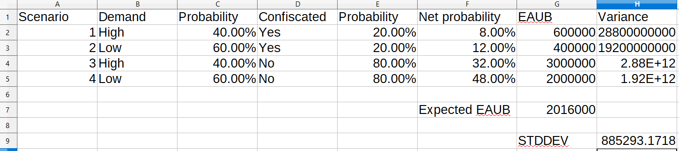

Calculating IRR:

PV of benefits – PV of costs = 0

$2016000(P/A, i, 5) - $2000000 = 0

[(1+i)5 – 1] / [i(1+i)5] - 2000000/2016000 = [(1+i)5 – 1] / [i(1+i)5] – 125/126 = 0

After interpolating in some sheet software:

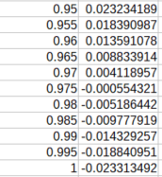

IRR = i = 0.9725 = 97.25%

This rate of return is very high.

Per rule of thumb (“If the expected present worth is at least double the standard deviation of the present worth, then the project is relatively safe.”), we can see that 2\*STDDEV = 1770586.344 < 2016000, therefore our expected value is at least double the standard deviation and our risk passes the rule of thumb test.

Therefore, we can see that the rate of return is very high, and the risk is acceptable, so moving forward with this investment is recommended.

Bonus:

Medellín Cartel

Appendix A in following pages: