MECH463 Lab: Natural Frequency and Radius of Gyration Measurement using a Bifilar Pendulum

Ratthamnoon Prakitpong

#63205165

**Introduction**

A bifilar pendulum has three vibration modes: translation along x, translation along y, and rotation about z, each having its own natural frequencies (which may not be unique). The natural frequencies are affected by a few factors, such as distance between strings, offset of center of mass from center of strings, or ratio of string lengths, all of which can be quantified. In addition to natural frequencies, we can also use the bifilar pendulum set-up to investigate an object’s center of percussion and radius of gyration. This lab is broken down into six experiments, each aimed at exploring the individual topics of this lab.

**Theory**

A bifilar pendulum has three vibration modes: translation along x, translation along y, and rotation about z. When string lengths are equal and offset of center of mass from center of strings is zero, natural frequencies of translation along x and translation along y can be solved with the equation below, where L is the length of the string, g is gravity’s acceleration, and f is natural frequency in Hz:

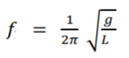

(Eq 1)

For rotation about z, natural frequency is below, where D is distance between strings, R is radius of gyration, and w is natural frequency in rad/s:

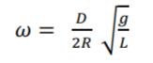

(Eq 2)

When the offset is not zero, the natural frequency of rotation about z becomes the equation below, where s is the offset of center of mass from center of strings:

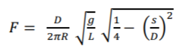

(Eq 3)

When the length of strings are unequal, there are two natural frequencies of rotation, one for each string. While the natural frequency calculations can be messy, it can be correlated with string lengths ratio and plotted neatly as:

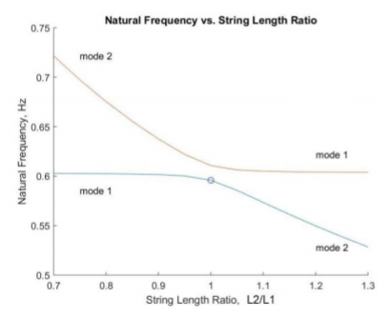

Fig 1: Sample plot of natural frequency vs string length ratio

To get individual frequencies experimentally, we can apply a force at center of percussion of each node of rotation, or keep that node still and apply a force about it, producing a nodal rotation with its frequency isolated. In a bifilar pendulum, if a rotation about z results in the first string staying still while second string is rotating, then second string’s location is the center of percussion for rotation the first string. Reaction force of a vibration is taken by the center of percussion, leaving no net force acting on the rotation axis.

We can also use a bifilar pendulum to get radius of gyration of an irregularly shaped object, by determining center of mass of object, making appropriate measurements, and isolating for R from Eq 3.

**Apparatus**

While the lab manual provides a good guideline on which materials to use, some are not in stock at nearby stores or not readily available. Materials used for this instance of the lab are as follows, with substitutions noted:

* Tape measure
* Yard stick (instead of meter stick)
* Dental floss (instead of string)
* Two sturdy tables (instead of one)
* Cardboard box and sheets, and heavy books
* Binder clip
* Packing tape
* Pencil
* Smartphone (instead of stopwatch)
* Zip tie

They are assembled as shown below:

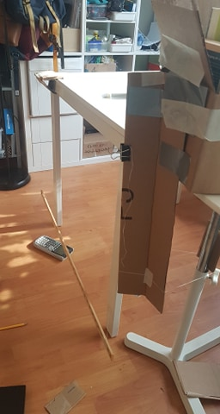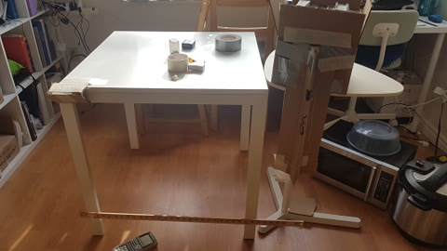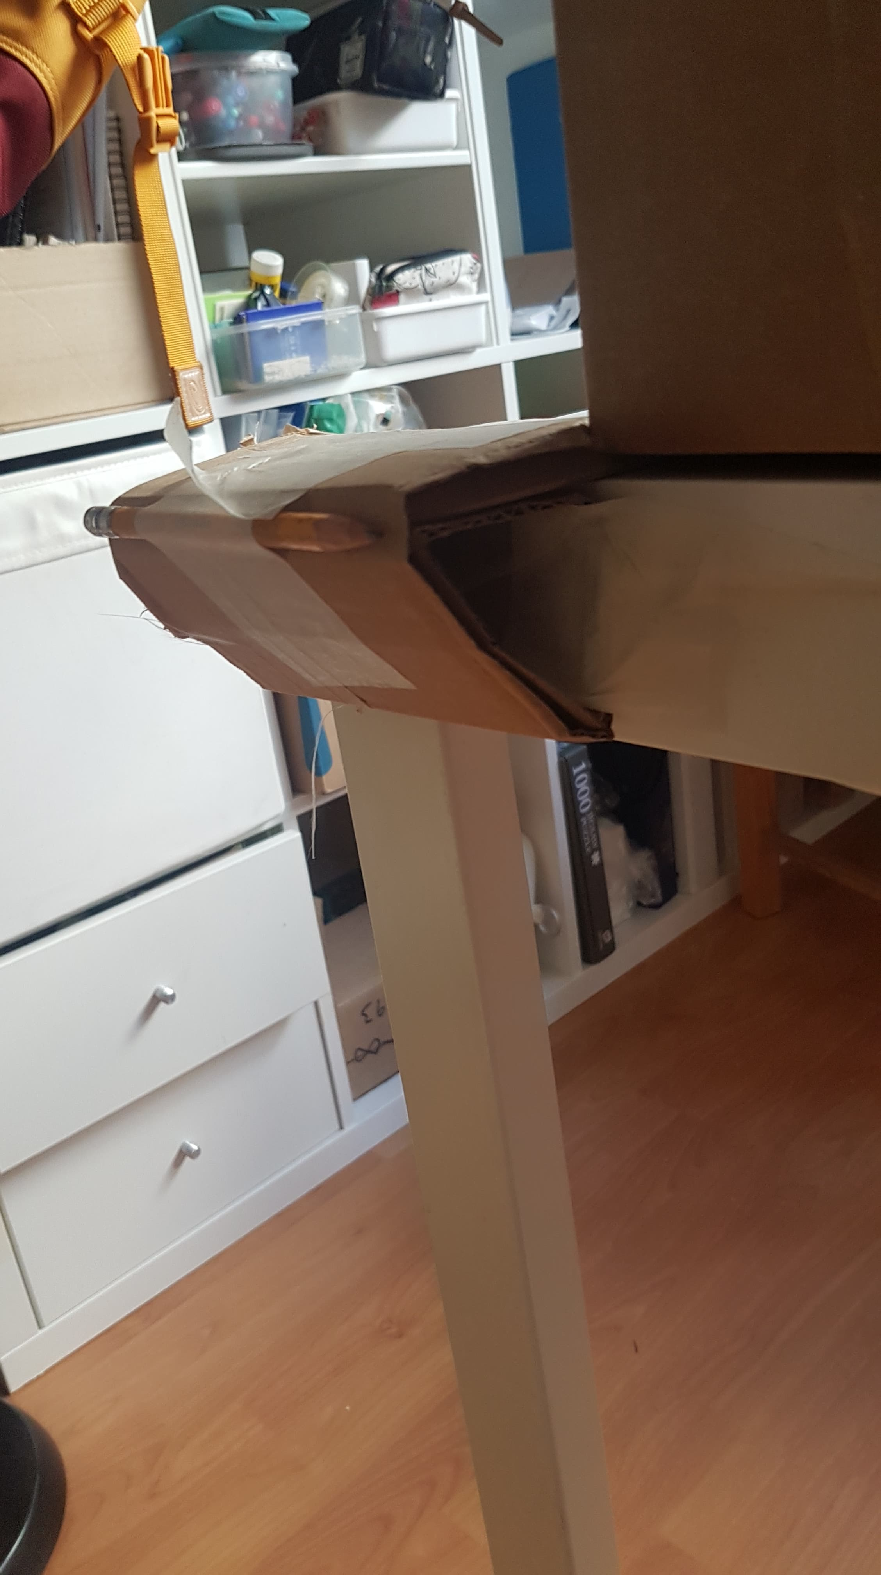

Fig 2: Experiment 1 set-up

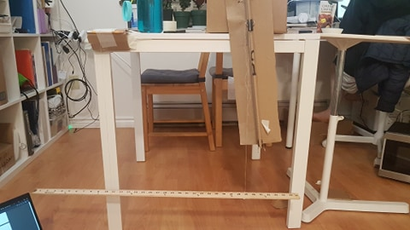

Fig 3: Experiment 2-5 set-up

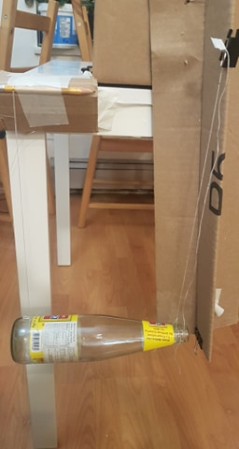

Fig 4: Experiment 6 set-up

To accommodate material differences, changes were made for this instance of the lab:

* My table is not wide enough for D = 90,80 cm cases, so I used two tables to give horizontal room to rest my second string pivot point (ie. box of books).
* My table doesn’t have overhangs so the yard stick kept hitting a table leg when vibrating, so I rolled leftover cardboard into a triangle-extrusion-like object and taped it to the table’s edge.
* String kept hitting the T-beam when vibrating, so I tilted it by a few degrees to give room.
* T-beam started falling from box of books after experiment 1, so I used zip tie instead of tape afterwards.
* The nearby store had yard sticks instead of meter sticks, so I rescaled some values from per 1 m to per 36 in (x * (36/100) = x_scaled).
* The yard stick has metal cap at their ends. While symmetric, the extra masses are not uniformly spread of length of stick, and may affect measurements.

**Procedure and Results**

*Experiment 1: Simple Pendulum Vibration*

With string separation D = 32.4 in (90 cm scaled), and string lengths L = 21 in, I let the yard stick translate about x and y, and measured the period of 10 cycles, and repeat the measurements three times. To change those to frequency in Hz, we can use the equation below:

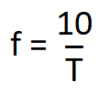

(Eq 4)

Where f is frequency, and T is period of 10 cycles. Places of f and T can be swapped if period is what we want from frequency.

To compare our experimental frequency to theoretical frequency, we can use Eq 1 to calculate our theoretical frequency based on L (here, L = 21 in). We can use this frequency to get theoretical period of ten cycles too. The values mentioned are shown below:



Table 1: Experiment 1 measurements and calculations

As we can see, experimental frequencies are a bit smaller than theoretical. This is likely due to human reaction delay when timing, resulting in ~0.5 s increase in ten cycles period time (~0.25 is average people’s reaction time for visual stimulus), hence lowered frequencies. Aside from that, the experimental and theoretical values matched up well.

*Experiment 2: Effect of String Separation*

Where string lengths are equal and are 21 in (0.5334 m), we will vary the string separation distance to see its effect on rotation about z (again, distances are scaled from 1 m to 36 in). For each distance, we’ll get the period of ten rotations about the yard stick’s center of mass (I took two measurements for each distance), and use Eq 4 to get natural frequency. We can revise Eq 2 to solve for R, as follows, where G is the f/D gradient:

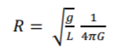

(Eq 5)

To get theoretical R, we can simplify and assume that the yard stick is a stick of uniform mass and solve for R as follows, where in this case, L is the length of the stick (here, L = 36 in):

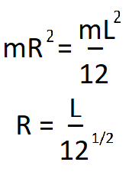

(Eq 6)

All values mentioned are shown below:



Table 2: Experiment 2 measurements and calculations

Fig 5: Natural frequency (Hz) vs string distance (in)

Our experimental R is very close to theoretical R, although a bit higher, and we can theorize why. Since we are using gradient value to calculate for R, R can not be affected by human delay in timing like experiment 1, since that error gives approximately the same offset to all period measurements so it would not affect the slope of plot. One possible error is the metal cap on the yard stick, which is unaccounted for in our simplified theoretical calculation. Accounting for it could increase our theoretical R by a tiny bit (~0.02) to match our experimental R.

*Experiment 3: Effect of Stick Offset*

Setting string separation distance D = 18 in (50 cm scaled) and string lengths L = 21 in, we create an offset from center of mass to center of strings, call it s, vary that, and measure its effects. Again, measuring period of ten oscillations and using Eq 4 to get the natural frequency, we can plot experimental natural frequency in Hz against s/D. To get theoretical natural frequency, we can use Eq 3 to solve for each s values, where R in Eq 3 was found experimentally in Experiment 2.

The values mentioned are shown below:



Table 3: Experiment 3 measurements and calculations

Fig 6: Natural frequency (Hz) vs s/D (not scaled)

While there are some errors that can be attributed to human error, the experimental values matches our theoretical value well. My skill at timing may have improved over the experiments. Additionally, the good thing about using our experimental R from Experiment 2 to calculate theoretical f is that the said R has already accounted for experimental inconsistencies (ex: non-uniformity of stick mass) that has happened in experimenting, and so with that accounted for when calculating theoretical values, it is not surprising that our theoretical values matches our experimental values well.

*Experiment 4: Center of Percussion Suspension*

Setting string separation distance D = 20.664 in (57.4 cm scaled) and string lengths L = 21 in, we measure the period of ten rotations around the yard stick’s center of mass, around string 1 (by tapping location of string 2), and around string 2 (by tapping on location of string 1). The time spans are as shown below:



Table 4: Experiment 4 measurements

When rotating around string 1, it is completely still because location of string 2 is its center of percussion. Since string 1 is still, there is only one vibration visible which is rotation about z (no translation), hence the measured period is approximately the same as when the yard stick is only rotating around its center of mass. This is also true when string 2 is nodal point, and consequently, that period is also approximately the same as period of center of mass rotation.

However, when rotating about some arbitrary point, sinusoidal vibration is smooth but nodal position gradually shifts around. This is because when starting said rotation, tapping at a point of the yard stick actually causes two modes of vibration: rotation about z and translation along x, summing up to get resultant vibration. Tapping anywhere other than the strings’ center of percussion will not cause zero net force at the strings because they’re not the strings’ center of percussion, and therefore the result vibration will not sum up to zero. Without a neat point where resultant forces sum to zero, nodal point will gradually shift around as the two vibrations continuously interfere with each other.

*Experiment 5: Unequal String Lengths*

Setting string distance D = 21.6 in (60 cm scaled) and string 1 length L1 = 21 in, we can vary the length of string 2 and see its effect on natural frequencies. Measuring two modes of vibration frequency (measurement method explained in theory section) using table of nodes in lab manual (after 1m to 36 in scaling), we can plot the string length ratios against the measured high and low natural frequencies.

Table 5: Experiment 5 measurements and calculations

Using the code that made Fig 1 with our parameters, we can generate a theoretical plot for comparison.

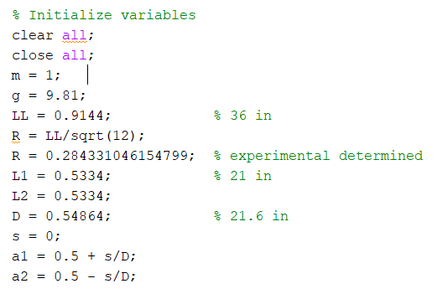

Fig 7: Changed parameters in bifilar.m

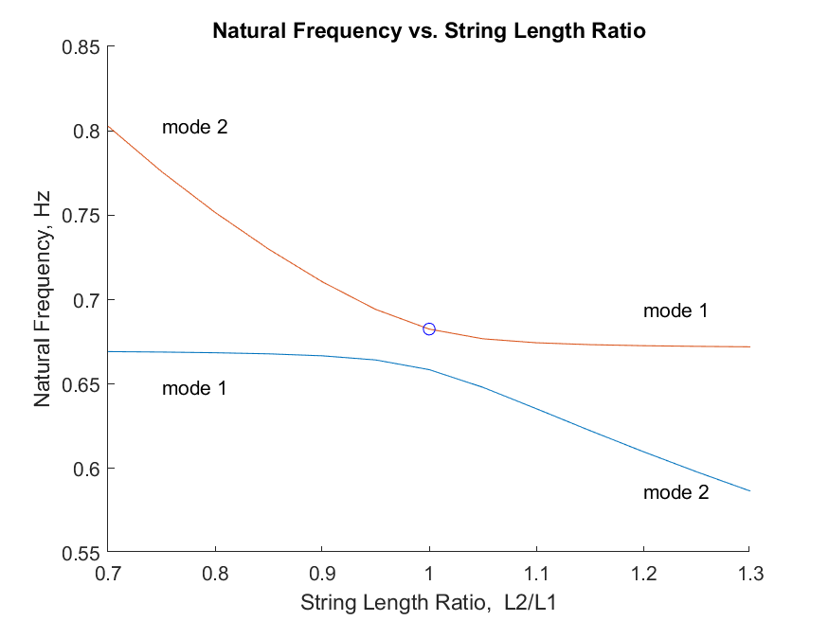Fig 8: Natural frequency vs string length ratio, theoretical (left) and experimental (not scaled) (right)

While there are error and measurement errors, the experimental plot overall matches the theoretical plot. Similar to Experiment 3 calculations, using R from Experiment 2 (instead of theoretical R) improves theoretical plot’s closeness to experimental plot.

*Experiment 6: Radius of Gyration Measurement*

Oscillating an irregular object on a bifilar pendulum and measuring the pendulum and the natural frequency of oscillation, we can find the object’s radius of gyration by isolating for R in Eq 3. I picked an empty sauce bottle as the object to be measured.



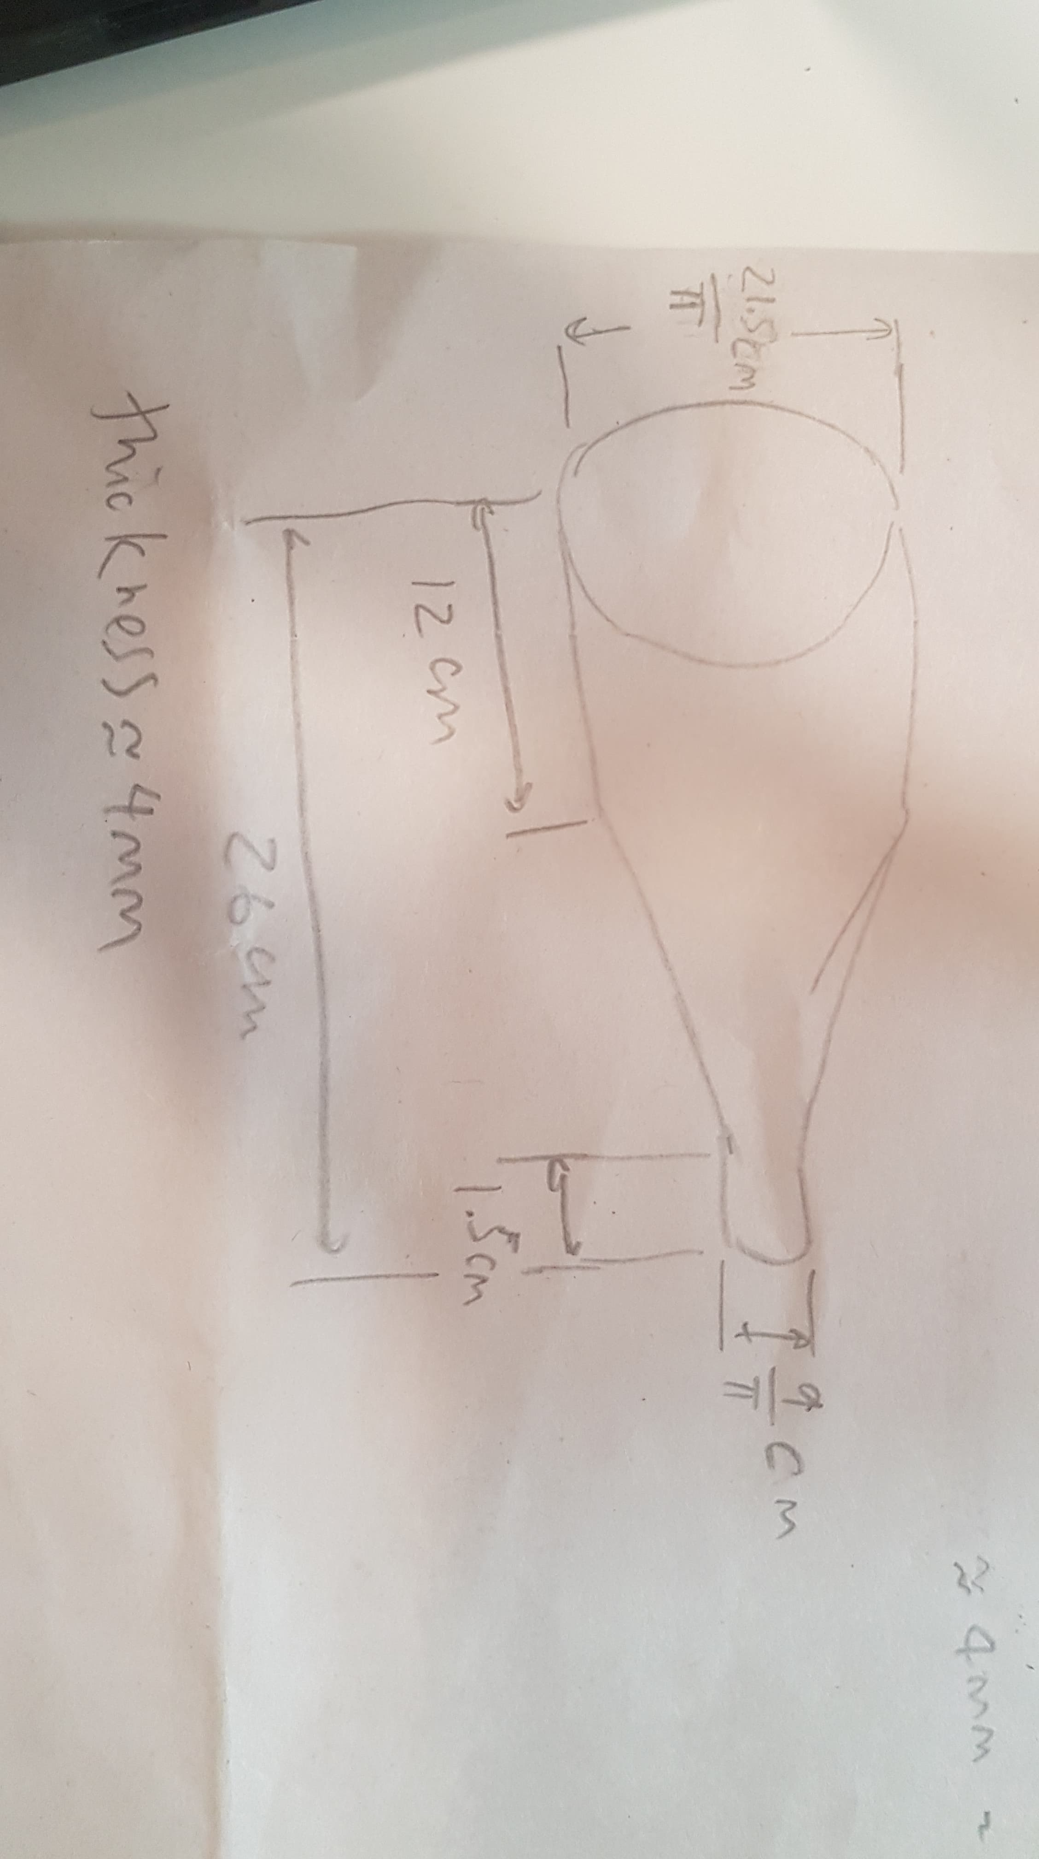Table 6: Experiment 6 measurements and calculations

To get theoretical radius of gyration, we first have to make measurements of the bottle.

Fig 9: Measurements of simplified bottle

Then, we can break the bottle down into simple shapes, calculate each moment of inertia, sum them up and divide by mass to get R2. However, an easier way for our case is to model the simplified bottle in a CAD software, then use the CAD software to calculate the radius of gyration for us.

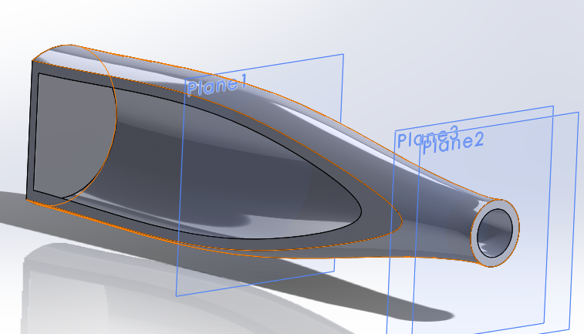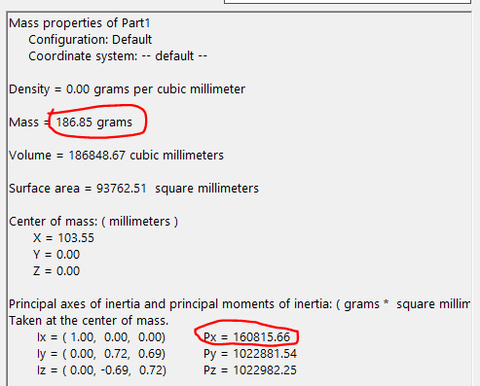Fig 10: CAD model (left) and its mass properties (right)

Taking those numbers, we can calculate our theoretical radius of gyration as:

Px = m * R * R

R = sqrt(Px / m) = sqrt(160815.66 / 186.85)

R = 29.34 mm = 0.0293 m

As we can see, the experimental and theoretical R are very different (0.0737 m vs 0.0293 m). However, consider that because we’re using an irregular object, there are more room for errors and more approximations/simplifications needed to get the values compared to the previous five. Some major ones are listed below:

* Irregular object meant that D, s, L are difficult to measure.
* Center of mass was approximated by balancing the bottle in my hand.
* Measurements were made with tape measure, which is less accurate than tools like caliper.
* Thickness measured at opening. Bottle thickness may be different than opening thickness.
* Model of bottle is simplified (no curved bottom, no grooves at opening, no grooves at bottom).

Given these possible sources of error, it is understandable that the two radius of gyrations are different. That said, the fact that they’re still in the same order of magnitude meant that our values are not that far off. With refinement, this method is an applicable way of accurately measuring radius of gyration in real world applications.

**Discussion**

Through six experiments, we’ve determined that:

* When string lengths are equal, translation along x and y has the same natural frequencies, behaving like a normal pendulum. Other natural frequencies investigated are all natural frequency of rotation about z.
* Increasing string separation distance increases natural frequency (we can use that gradient to solve for an object’s radius of gyration).
* Offseting center of mass from center of strings decreases natural frequency.
* If force is applied at center of percussion of a node, then the resultant force at node will be zero (and that node will be the node of vibration).
* Increasing string length ratio decreases lower frequency vibration mode’s natural frequency. Decreasing string length ratio increases higher frequency vibration mode’s natural frequency.
* We can determine radius of gyration of an irregular object by attaching it to a bifilar pendulum, measuring bifilar pendulum set up and the object’s natural frequency, and solving for R.

Notable significance and connections between the experiments are:

* Radius of gyration found in Experiment 2 are useful for accurate theoretical calculations in Experiment 3 and Experiment 5.
* Plots from Experiment 2 (f vs D) and Experiment 3 (f vs s) confirms the relationships of parameters shown in Eq 3 (linearly proportional and sqrt(1-s*s), respectively).
* Findings in Experiment 4 gives more options in how to start the vibration in Experiment 5, where some nodal points are harder to initiate when tapping at its center of percussion, or vice versa.
* Experimental data from Experiment 5 confirms the math behind bifilar.m to be true.
* Methods in Experiment 6 can be used in real world cases to find radius of gyration of an irregular object.

**Conclusions**

There are many ways a bifilar pendulum can be set up, and those set ups can affect the natural frequency of vibration. In this lab, we varied string separation distance, offset of center of mass from center of strings, and string length ratio, all of which the natural frequency data confirm the derived, mathematical relationships found in theory section. Additionally, we investigated center of percussion and radius of gyration, which findings can be generalized to find any irregular object’s radius of gyration.