René C. Rinfret  
MECH463  
UBC #34929091  
November 7th, 2013

MECH463: ADAMS Assignment One

# Assignment One - Summary

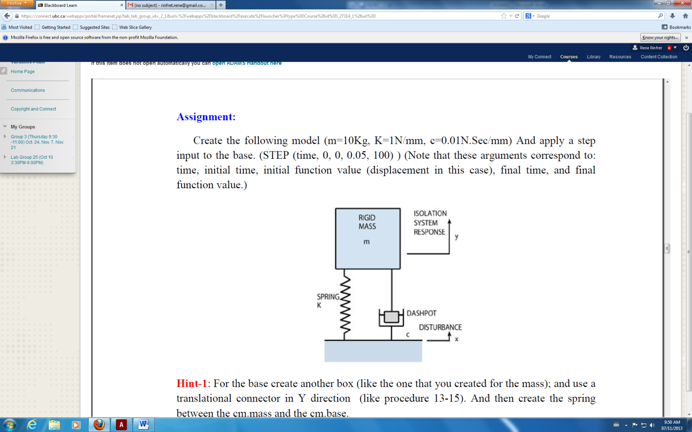

The primary objective of the tutorial was to model the behaviour of a SDOF spring-mass-damper system subject (see right) to a step change of position of a reference body. The model was constructed in ADAMS, which is a powerful software for modeling and analyzing the dynamics and vibration of complex mechanism. The response was examined over a five second time interval. The steps taken to generate the model are listed below and were given to students during this tutorial:

1. Create a block (**Block 1** and set its mass to be 10 kg. Set the mass moments of inertia to zero.

2. Reposition Block 1 so that its centre of mass is the absolute origin of the model space.

3. Create a translational joint at the centre of the Block 1, oriented along the vertical axis.

4. Create a second block (**Block 2**) a distance below Block 1. This is the base.

5. Reposition the x and z-coordinates of Block 2 so that its centre of mass lies directly below Block 1.

6. Create a translational joint (**Joint 2)** at the centre of the Block 1, oriented along the vertical axis.

a. Specify the motion of Block 2 by modifying the *Impose Motion(s)* field of

Joint 2.

b. Select disp(time) under “Tra Z” and input a step function as ‘STEP(time ,

0, 0, 0.05, 100)’

7. Add a spring through the ‘Force’ toolbox. Connect the ends to the centers of mass for each block.

8. Modify the spring to have a constant stiffness of k = 1 N/mm and a constant damping coefficient of c = 0.01 (N s)/mm.

After completing these steps, the simulation was carried out for 5 seconds with 500 steps. The data was processed in the built in post processor and the results have been included in the next section.

# Assignment One – Results

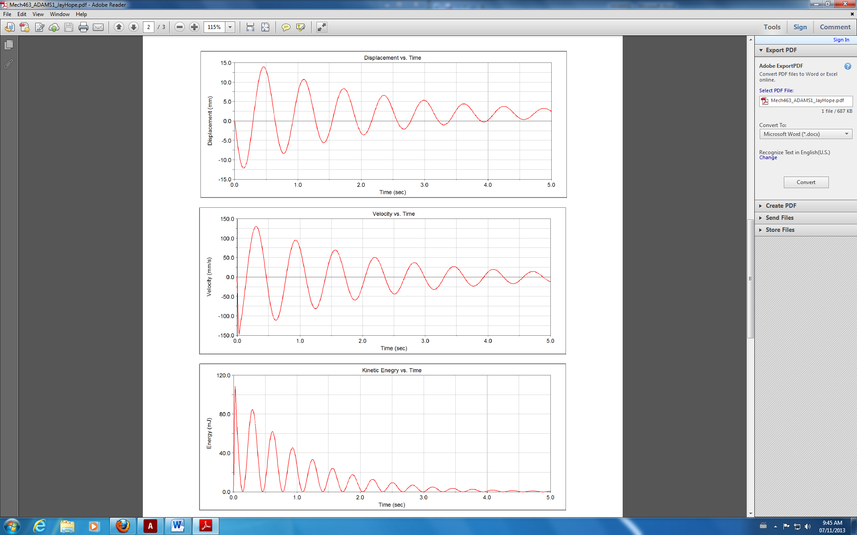The following are visual outputs for the Assignment 1 of the ADAMS Tutorial for MECH463. They were obtained given the steps from Page 1, and a screenshot was taken from the ADAMS output afterwards.

